Failing SSD
Incident:
- Failing SSD

Summary:
- After Windows failed to format a USB, the PC would crash frequently after removing the USB.

Actions taken:
- Windows tool, Event viewer:
  - Looked inside the application logs to find multiple windows error reporting
  - Event name: Blue Screen
- Windows cmd
  - Sfc /scannow
  - Dism /online /cleanup-image /restorehealth
  - Chkdsk /f /r
- Windows Device manager
  - Inspected driver status

Findings:
- ChatGPT
  - Created a prompt with a screenshot of windows event viewer application logs
  - ChatGPT stated,
    - Event ID 1001 is for a blue screen crash
    - P1: 133 value corresponds to “DPC_watchdog_violation”
    - P3: 1e00 commonly seen with storage controller related watchdog crashes
    - Strongly suggested that the diagnosis was failing internal SSD
- Crashes
  - Many crashes occurred a little bit after turning on the PC
  - Sfc /scannow
    - Ran this command twice successfully and nothing was fixed
    - The pc crashed many times after starting the scan
  - Dism /online /cleanup-image /restorehealth
    - This command failed to reach 100% multiple times
  - Chkdsk /f /r
    - Ran this command twice successfully (to 100%)
    - Screen would pop up stating that the device ran into a problem and couldn’t be repaired
  - Downloads
    - Crashes occurred after downloading anything
  - Filesystem
    - Indicated that it was not responding at times before crashing Windows
- Device manager
  - Inspected USB related drivers
    - They were working properly
- USB
  - Unable to see the usb filesystem before the incident
  - Couldn’t be formatted (corrupt USB)

Decision:
- Decided to save files into OneDrive
- Bought a new SSD and started a new clean install of windows 11

Resolution:
- After installing the new SSD and installing Windows 11, the symptoms stopped

Lessons learned:
- The USB most likely made the SSD become unstable.
- Be careful with corrupt USBs
  - If another corrupt USB appears, use Windows to fix the USB instead of trying to reformat the USB
Screenshots:
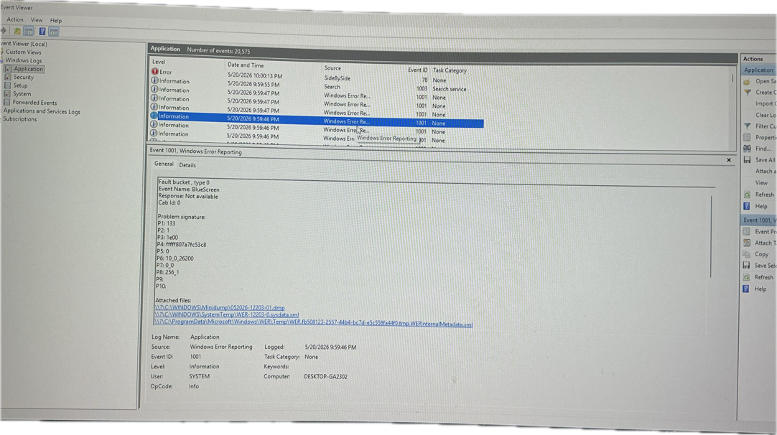
Screenshot sent to ChatGPT

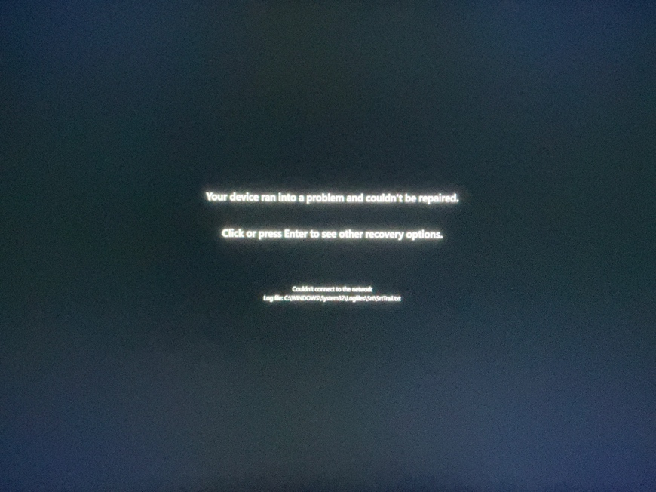
Screen after chkdsk commands

