This is a sample code of how to use an asp repeater to bind data.

The example below is a page that I built before for the company supervisor/managers to rate his or her subordinates’ competencies. (Ex. Professionalism, Communication...etc.)

NOTICE: This page will not work immediately if you run it in Visual Studio because you need a **database connection.**

Steps in this code sample:

1. Specify the name of the data in your front end code. Ex. Text='<%#Eval("Title") %>'
2. Create two objects. Competency and RatingItem.
3. Create two lists that hold these two objects separately.
4. Fill objects and put them into their respectively list.
5. Point the datasource of the repeater to the list.

Here is how the page looks like:

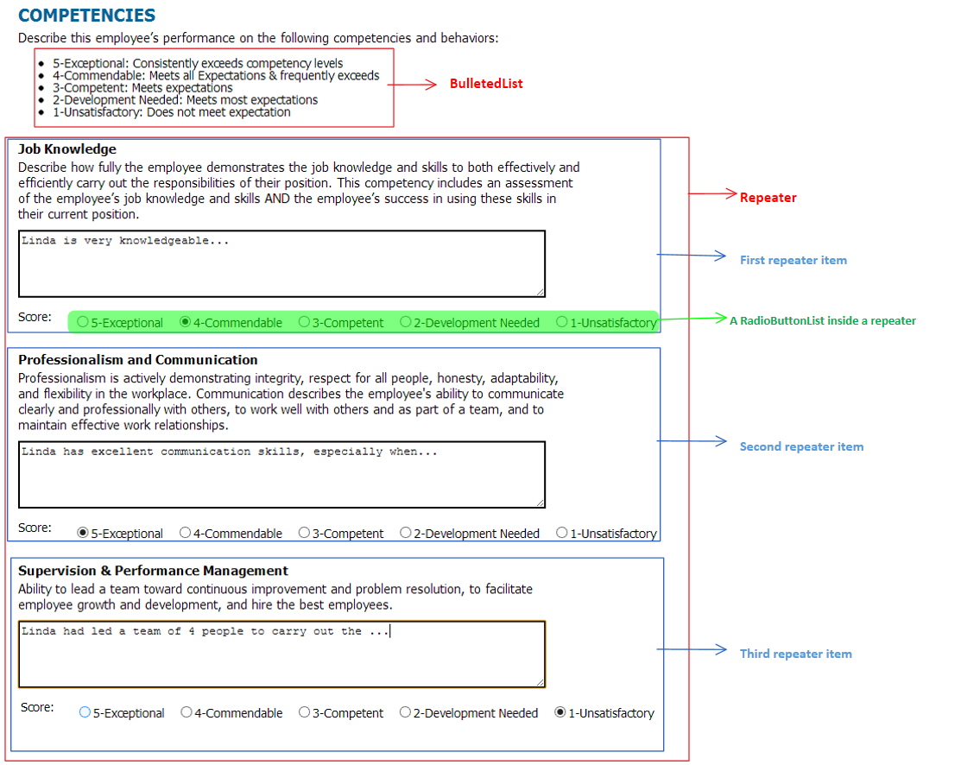

**Both BulletedList and RadioButtonList are repeaters as well. In this code sample, I handled them differently.**

1. A BulletedList also has a datasource property. However, in this sample I chose to bind the data to the BulletedList by simply doing BulletedList.Add(li), where li is a ListItem that has the value and text properties.
2. Notice that the RadioButtonList is inside the main Repeater. This makes our RadioButtonList **a repeater inside a repeater**. In order to “talk” to the RadioButtonList, which is not directly accessible, we need to perform the data binding during the ItemDataBound event of the main repeater.