ER-ДИАГРАММА
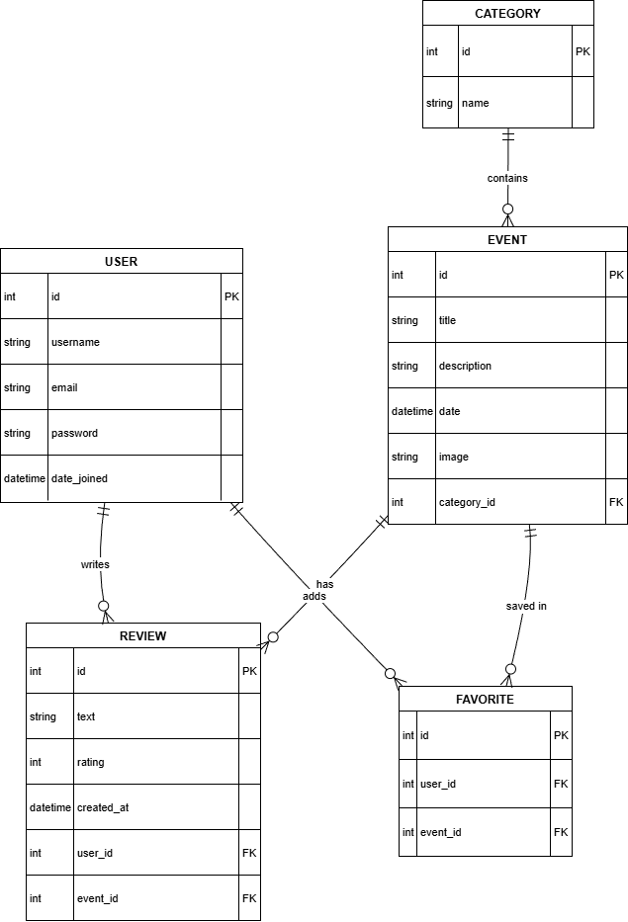
ЛОГИЧЕСКАЯ ДИАГРАММА
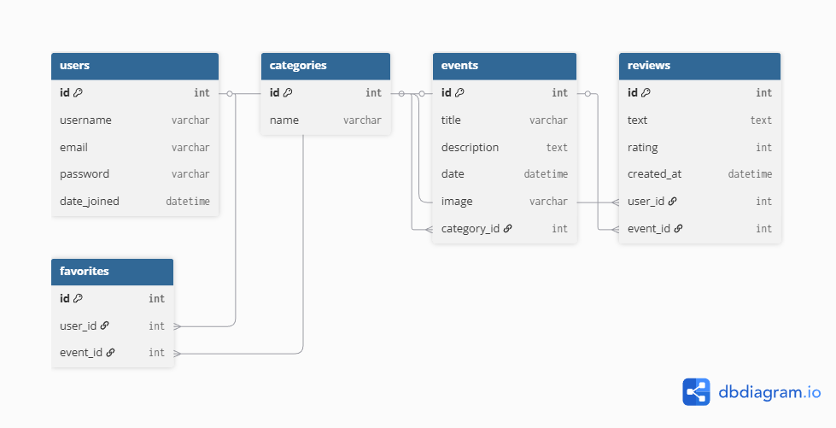
ФИЗИЧЕСКАЯ МОДЕЛЬ:
-- Таблица пользователей
CREATE TABLE users (
id SERIAL PRIMARY KEY,
username VARCHAR(150) NOT NULL UNIQUE,
email VARCHAR(255) NOT NULL UNIQUE,
password VARCHAR(255) NOT NULL,
date_joined TIMESTAMP NOT NULL DEFAULT CURRENT_TIMESTAMP
);

-- Таблица категорий
CREATE TABLE categories (
id SERIAL PRIMARY KEY,
name VARCHAR(100) NOT NULL UNIQUE
);

-- Таблица событий
CREATE TABLE events (
id SERIAL PRIMARY KEY,
title VARCHAR(255) NOT NULL,
description TEXT NOT NULL,
date TIMESTAMP NOT NULL,
image VARCHAR(255),
category_id INT NOT NULL,
CONSTRAINT fk_event_category
FOREIGN KEY (category_id)
REFERENCES categories(id)
ON DELETE CASCADE
);

-- Таблица отзывов
CREATE TABLE reviews (
id SERIAL PRIMARY KEY,
text TEXT NOT NULL,
rating INT NOT NULL CHECK (rating BETWEEN 1 AND 5),
created_at TIMESTAMP NOT NULL DEFAULT CURRENT_TIMESTAMP,
user_id INT NOT NULL,
event_id INT NOT NULL,
CONSTRAINT fk_review_user
FOREIGN KEY (user_id)
REFERENCES users(id)
ON DELETE CASCADE,
CONSTRAINT fk_review_event
FOREIGN KEY (event_id)
REFERENCES events(id)
ON DELETE CASCADE,
CONSTRAINT unique_user_event_review
UNIQUE (user_id, event_id)
);

-- Таблица избранного
CREATE TABLE favorites (
id SERIAL PRIMARY KEY,
user_id INT NOT NULL,
event_id INT NOT NULL,
CONSTRAINT fk_favorite_user
FOREIGN KEY (user_id)
REFERENCES users(id)
ON DELETE CASCADE,
CONSTRAINT fk_favorite_event
FOREIGN KEY (event_id)
REFERENCES events(id)
ON DELETE CASCADE,
CONSTRAINT unique_favorite
UNIQUE (user_id, event_id)
);

