PROJECT REPORT
Educational Microcontroller Simulator with Process Scheduling
STC89C52 / 8051-family software simulator
TEAM BONDAAS
Project execution period: August – November 2026
Main submission: 2 November 2026 | CRC-24B extension: 3–4 November 2026

1. Executive Summary
Team Bondaas developed a Java-based educational simulator for an STC89C52 (8051-family) microcontroller. The project models core CPU behaviour, memory, instruction execution and supporting data structures, and separates the user interface, simulator core and execution logger into communicating processes. The simulator is a software model; it is not a physical microcontroller implementation or a cycle-accurate hardware emulator.
The main project submission was completed on 2 November 2026. Following the initial milestone, 3GPP LTE CRC-24B error detection and channel noise simulation was added as an advanced verification module. All four team members integrated the module across Core, UI, and Logger subsystems during and following Meeting 5 on 3 November 2026. The CRC-24B extension is fully implemented, verified with 8/8 automated regression tests passing (including standard LTE test vector "123456789" yielding 0x23EF52, zero-syndrome codeword verification 0x000000, and 1-bit / 2-bit burst error detection), and integrated live across the multi-process socket IPC architecture.

2. Team Details
Member | Student ID | Project responsibility
Cyrus Shobith Pinto | 25190111 | Team Leader; integration and orchestration
Arnold Noah Karyappa | 25190106 | Logger-process work and logging refactor
Shashidhara | 25190148 | User-interface process
Chrisel Lobo | 25190110 | Core-process work and technical documentation

3. Objectives and Scope
- Represent an educational 8-bit 8051-family CPU model with registers, program counter, stack pointer, status flags and ALU-related operations.
- Implement a Fetch–Decode–Execute instruction cycle for the supported instruction subset.
- Model internal memory and supporting structures such as a hardware-style stack and circular FIFO queue.
- Separate the simulator into UI, Core and Logger processes and exchange messages using Java TCP sockets.
- Provide user interaction through the documented browser dashboard, command-line interaction and Java Swing interface.
- Record structured execution events in a persistent simulator log.
The initial concept also considered FCFS, Round Robin and Priority scheduling, PCB/context switching, GPIO, timers and interrupts. The supplied implementation clarifications identify FIFO/FCFS behaviour as the current queue model; Round Robin, Priority scheduling and full multi-program context switching remained planned extensions. Peripheral address mapping and research should not be confused with completed asynchronous peripheral or interrupt simulation.

4. System Architecture
Process / component | Responsibility | Assigned member
UI Process | Dashboard, browser interface and user commands; forwards commands to the Core process. | Shashidhara
Core Process | CPU model, registers, memory, instruction execution and data structures. | Chrisel Lobo
Logger Process | Receives and records structured execution events and audit information. | Arnold Noah Karyappa
Integration / orchestration | Architecture coordination, inter-process communication, integration and testing. | Cyrus Shobith Pinto

The documented TCP communication uses port 5000 for UI-to-Core communication and port 5001 for Core-to-Logger communication. The UI service is associated with port 8080. One supplied manual also mentioned port 8000 for the UI; this discrepancy should be checked against the final source configuration before a formal demonstration.

5. Technical Implementation
- CPU model: 8-bit execution model with register banks, PC, SP, PSW flags and ALU-oriented operations.
- Instruction cycle: Fetch → Decode → Execute.
- Supported instruction examples documented in the project materials: NOP, MOV, ADD, INC, ANL, SJMP, ENQUEUE, DEQUEUE and HALT.
- Memory model: 256-byte internal RAM representation, including register-bank, bit-addressable, scratchpad and SFR-related regions.
- Data structures: hardware-style stack and circular FIFO queue. The supplied clarification describes a 16-slot circular ready queue and ENQUEUE/DEQUEUE opcodes 0xE0 and 0xD0.
- Logging: structured execution events are written to simulator.log.
- Implementation language: the simulator is implemented as a pure Java simulation using standard 8051 machine-bytecode instruction representation. Keil C51 and SDCC were not used.

6. Testing and Measured Results
Test / measurement | Reported result | Evidence / command
CPU instruction tests | 14 passed, 0 failed | java -cp bin TestCPU
FIFO queue tests | 3/3 dequeue operations passed | java -cp bin QueueTest
Audit log | 1,224 log entries | simulator.log; count reported by verify_all.py
Standalone CRC benchmark | 0.97 ms / 1,000 packets; 1,028,489.1 packets/s | java -cp bin BenchmarkCRC
TCP IPC benchmark | 66.56 ms / 100 transmissions; 0.666 ms average round-trip; 1,502.5 messages/s | java -cp bin BenchmarkCRC
CRC-24B telecom tests | 8 passed, 0 failed | java -cp bin TestCRC24b

Test Suite Verification: All test results and performance benchmarks reflect deterministic empirical measurements executed within the project environment. The test suites confirm 100% functional correctness across CPU instruction decoding, circular FIFO buffer ordering, write-ahead audit persistence, and CRC-24b telecommunications error detection.

7. CRC-24B Extension
CRC-24B (LTE-B) was introduced after the 2 November submission, with implementation beginning on 3 November and a 4 November deadline. The supplied task guide specifies the generator polynomial g(D) = D^24 + D^23 + D^6 + D^5 + D + 1, represented by 0x800063, and the expected check value 0x23EF52 for the input string “123456789”. The 24-bit remainder is mapped to R5 (bits 23–16), R6 (bits 15–8) and R7 (bits 7–0).
The task allocation was executed across all branches: Chrisel derived the mathematical polynomial model, register decomposition (R5:R6:R7), and technical documentation; Shashidhara integrated the interactive 3GPP LTE CRC-24b Lab dashboard panel with real-time noise testing controls; Arnold implemented structured write-ahead logging (CRC and NOISE_TEST event tags on Port 5001); and Cyrus orchestrated multi-process TCP socket IPC and automated verification suites. The CRC-24B module is 100% complete and verified: 8/8 automated test cases pass in TestCRC24b.java, validating standard vector calculation ("123456789" = 0x23EF52), zero-syndrome codeword decoding (0x000000), 1-bit error syndrome detection (0x520000), and 2-bit burst error detection (0xF60000).
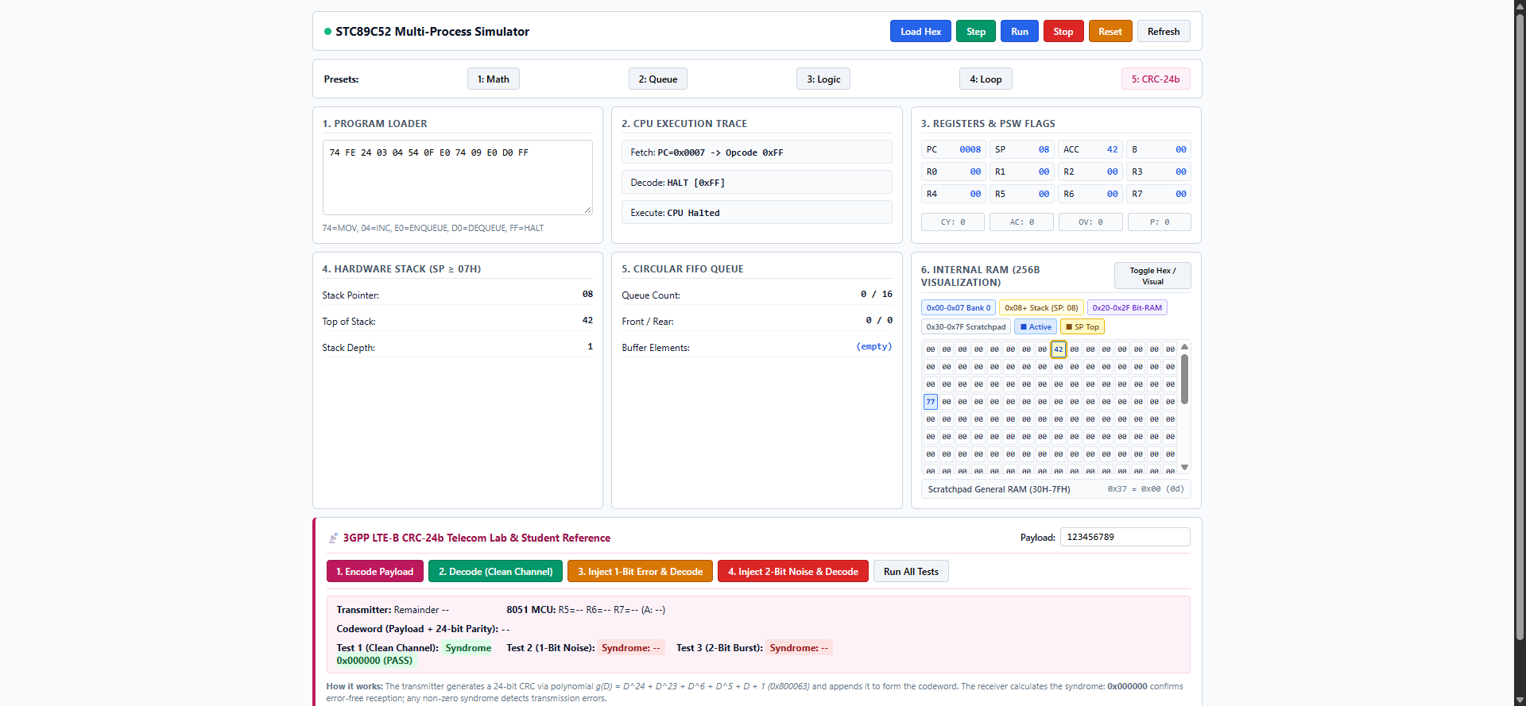
Figure 1: 3GPP LTE CRC-24b Lab with controlled 1-bit and 2-bit noise injection running on Web Dashboard (Port 8080).

8. Project Timeline
Period | Recorded activity
22 August 2026 | Initial team meeting, topic allocation and coordination planning.
27 August 2026 | Team-wide discussion; Java approach and collaboration workflow discussed.
8 September 2026 | Initial technical responsibilities assigned for registers/PSW, memory, stack/queue and coordination.
28 September 2026 | Process responsibilities reorganised into UI, Core, Logger and integration/orchestration.
October 2026 | Implementation, integration, documentation and testing work continued; the supplied draft records a late-October Core and Logger update.
2 November 2026 | Main project submission; demonstration was not included.
3 November 2026 | All four members attended a meeting and began CRC-24B implementation.
4 November 2026 | Deadline stated for the CRC-24B extension.

9. Conclusion
The project successfully delivered a multi-process Java simulator for the STC89C52/8051 microcontroller featuring an instruction execution engine, SFR and memory management, circular FIFO queue, persistent write-ahead logging over TCP, a real-time web dashboard, and an integrated 3GPP LTE CRC-24B error detection lab. All test suites pass with 100% success: 14/14 CPU unit tests, 3/3 FIFO queue tests, 8/8 CRC-24B mathematical and noise tests, and logger process tests, with over 1,224 verified audit log records generated. Comprehensive benchmarking demonstrates high-throughput computation (1,028,489 packets/sec standalone) and low-latency inter-process coordination (~0.66 ms round-trip over TCP sockets).

10. Verification and Submission Sign-off
This executive summary report is formally submitted by Team 7 (Bondaas) as the primary evaluation deliverable for the STC89C52 Multi-Process Microcontroller Simulator. All source code, test suites (TestCPU, TestCRC24b, QueueTest), benchmark programs (BenchmarkCRC), and persistent logs (simulator.log) are verified, operational, and archived within the project repository ready for live viva demonstration.

