2019.12.3
数据库
数据的数据metedata(元数据)

cpu>内存>磁盘>数据库 运行能力低
查询能力是最强的

nosql 不支持sql语
句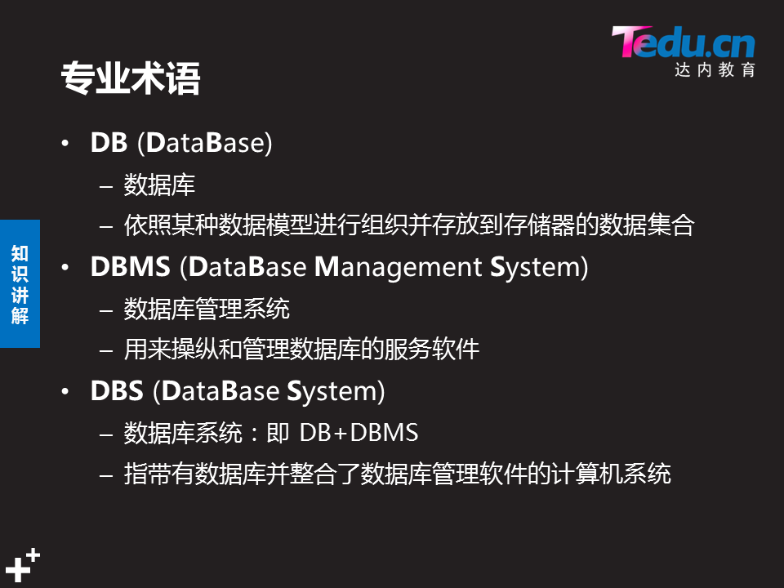
lnmp lamp
结合来用

user()表示当前用户
navicat
phpmysqladmin
mysql5.4------
mydqk8
utf 中文
utfmb4+ 表情+中文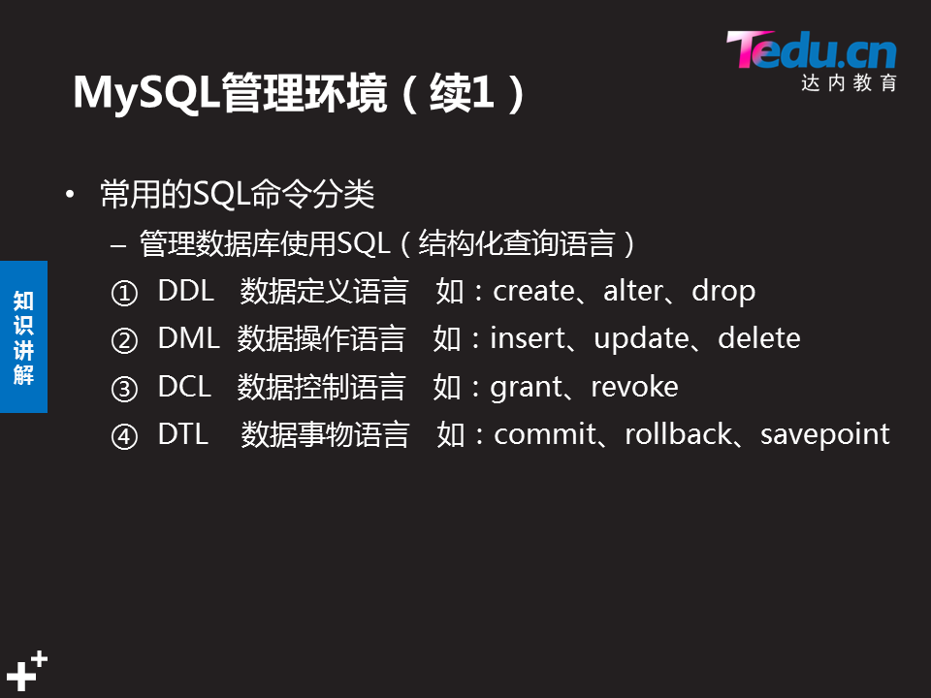

数值型:体重 身高 工资 金额 成绩
字符型:姓名 地址 单位 邮箱
枚举型:爱好 性别 专业 (选择型)
日期时间型:出生日期 注册日期

select curdate(); 当前日期

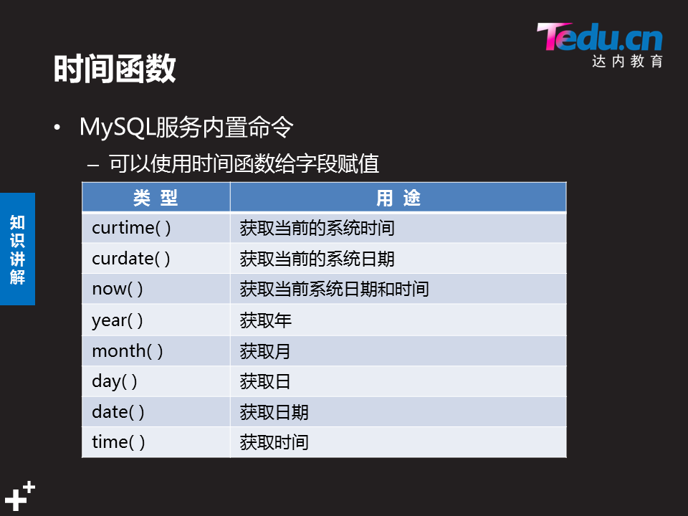

Top

NSD RDBMS1 DAY01
- 案例1：构建MySQL服务器
- 案例2：数据库基本管理
- 案例3：字符类型
- 案例4：数值类型
- 案例5：日期时间类型
- 案例6：枚举类型

1 案例1：构建MySQL服务器

1.1 问题
要求如下：
- 在IP地址192.168.4.50主机上部署mysql服务
- 设置数据库管理员root本机登录密码为tarena

1.2 方案
克隆新的虚拟机：
eth0网卡:192.168.4.50
主机名称:host50
下载软件mysql-5.7.17.tar
关闭防火墙（如果有的话）
关闭SELinux（如果有的话）

1.3 步骤
实现此案例需要按照如下步骤进行。
步骤一：准备工作
1）如果之前有mariadb，则需要先卸载，并删除对应的配置与数据：
- [root@localhost ~]# systemctl stop mariadb
2）删除/etc/my.cnf配置文件
此配置文件由RHEL自带的mariadb-libs库提供：
[root@localhost ~]# rm -rf /etc/my.cnf
3）删除数据
- [root@localhost ~]# rm -rf /var/lib/mysql/*
4）卸载软件包（没有会显示未安装软件包）
- [root@localhost ~]# rpm -e --nodeps mariadb-server mariadb
- 警告：/var/log/mariadb/mariadb.log 已另存为/var/log/mariadb/mariadb.log.rpmsave
步骤二：安装mysql软件包
1）解压mysql-5.7.17.tar 软件包
- [root@host50 ~]# tar -xvf mysql-5.7.17.tar //解压mysql整合包
- ./mysql-community-client-5.7.17-1.el7.x86_64.rpm
- ./mysql-community-common-5.7.17-1.el7.x86_64.rpm
- ./mysql-community-devel-5.7.17-1.el7.x86_64.rpm
- ./mysql-community-embedded-5.7.17-1.el7.x86_64.rpm
- ./mysql-community-embedded-compat-5.7.17-1.el7.x86_64.rpm
- ./mysql-community-embedded-devel-5.7.17-1.el7.x86_64.rpm
- ./mysql-community-libs-5.7.17-1.el7.x86_64.rpm
- ./mysql-community-libs-compat-5.7.17-1.el7.x86_64.rpm
- ./mysql-community-minimal-debuginfo-5.7.17-1.el7.x86_64.rpm
- ./mysql-community-server-5.7.17-1.el7.x86_64.rpm
- ./mysql-community-test-5.7.17-1.el7.x86_64.rpm
2）安装MySQL软件包
- [root@host50 ~]# yum -y install mysql-community-*.rpm //yum安装自动解决依赖
- ./mysql-community-client-5.7.17-1.el7.x86_64.rpm
- ./mysql-community-common-5.7.17-1.el7.x86_64.rpm
- ./mysql-community-devel-5.7.17-1.el7.x86_64.rpm
- ./mysql-community-embedded-5.7.17-1.el7.x86_64.rpm
- ./mysql-community-embedded-compat-5.7.17-1.el7.x86_64.rpm
- ./mysql-community-embedded-devel-5.7.17-1.el7.x86_64.rpm
- ./mysql-community-libs-5.7.17-1.el7.x86_64.rpm
- ./mysql-community-libs-compat-5.7.17-1.el7.x86_64.rpm
- ./mysql-community-minimal-debuginfo-5.7.17-1.el7.x86_64.rpm
- ./mysql-community-server-5.7.17-1.el7.x86_64.rpm
- ./mysql-community-test-5.7.17-1.el7.x86_64.rpm
3）启动MySQL数据库服务并设置开机自启
提示：第一次启动，需要初始化数据，会比较慢
- [root@host50 ~]# systemctl start mysqld //启动mysql服务
- [root@host50 ~]# systemctl enable mysqld //设置开机自启
- [root@host50 ~]# systemctl status mysqld //查看mysql服务状态
- ● mysqld.service - MySQL Server
- Loaded: loaded (/usr/lib/systemd/system/mysqld.service; enabled; vendor preset: disabled)
- Active: active (running) since 二 2018-08-28 10:03:24 CST; 8min ago
- Docs: man:mysqld(8)
- http://dev.mysql.com/doc/refman/en/using-systemd.html
- Main PID: 4284 (mysqld)
- CGroup: /system.slice/mysqld.service
- └─4284 /usr/sbin/mysqld --daemonize --pid-file=/var/r...

- 8月 28 10:02:56 localhost.localdomain systemd[1]: Starting MySQ...
- 8月 28 10:03:24 localhost.localdomain systemd[1]: Started MySQL...
- Hint: Some lines were ellipsized, use -l to show in full.
步骤三：连接MySQL服务器，修改密码
1）查看初始密码
- [root@host50 ~]#grep –i 'password' /var/log/mysqld.log
- 2017-04-01T18:10:42.948679Z 1 [Note] A temporary password is generated for root@localhost: mtoa>Av<p6Yk //随机生成的管理密码为mtoa>Av<p6Yk
2）使用初始密码连接mysql服务
- [root@host50 ~]# mysql -u root -p'mtoa>Av<p6Yk' //初始密码登录，
- mysql: [Warning] Using a password on the command line interface can be insecure.
- Welcome to the MySQL monitor. Commands end with ; or \g.
- Your MySQL connection id is 11
- Server version: 5.7.17

- Copyright (c) 2000, 2016, Oracle and/or its affiliates. All rights reserved.

- Oracle is a registered trademark of Oracle Corporation and/or its
- affiliates. Other names may be trademarks of their respective
- owners.

- Type 'help;' or '\h' for help. Type '\c' to clear the current input statement.
- mysql> //登录成功后，进入SQL操作环境
3）重置数据库管理员roo本机登录密码
- mysql> show databases;
- ERROR 1820 (HY000): You must reset your password using ALTER USER statement before executing this statement //提示必须修改密码
- mysql> alter user root@”localhost” identified by "123qqq…A"; //修改登陆密码
- Query OK, 0 rows affected (0.00 sec)
- mysql> exit //断开连接
- [root@host50 ~]#
4）修改密码策略
- [root@host50 ~]# mysql -uroot –p123qqq…A
- mysql>
- mysql>set global validate_password_policy=0; //只验证长度
- Query OK, 0 rows affected (0.00 sec)
- mysql>set global validate_password_length=6； //修改密码长度,默认值是8个字符
- Query OK, 0 rows affected (0.00 sec)
- mysql> alter user root@”localhost” identified by "tarena"; //修改登陆密码
- Query OK, 0 rows affected (0.00 sec)
- mysql>exit
5）使用修改后的密码登录
- [root@host50 ~]# mysql -uroot -ptarena //登录
- Welcome to the MySQL monitor. Commands end with ; or \g.
- Your MySQL connection id is 15
- Server version: 5.7.17 MySQL Community Server (GPL)

- Copyright (c) 2000, 2016, Oracle and/or its affiliates. All rights reserved.

- Oracle is a registered trademark of Oracle Corporation and/or its
- affiliates. Other names may be trademarks of their respective
- owners.
- mysql> show databases; //查看数据库
- +--------------------+
- | Database |
- +--------------------+
- | information_schema |
- | mysql |
- | performance_schema |
- | sys |
- +--------------------+
- 4 rows in set (0.00 sec)
- mysql>

2 案例2：数据库基本管理

2.1 问题
本案例练习对库、表、记录的基本管理，具体操作如下：
- 使用mysql命令连接数据库
- 练习库管理命令（查看、删除、创建库、切换）
- 练习表管理命令（查看、删除、创建表）
- 练习记录管理命令（插入、查看、修改、删除）
表－1 测试用表数据
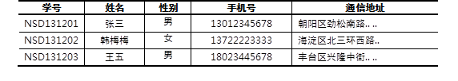

2.2 步骤
实现此案例需要按照如下步骤进行。
步骤一：使用mysql命令连接数据库
连接MySQL服务器时，最基本的用法是通过 -u 选项指定用户名、-p指定密码。密码可以写在命令行（如果不写，则出现交互，要求用户输入），当然基于安全考虑一般不推荐这么做：
- [root@dbsvr1 ~]# mysql -uroot -p123456 //紧挨着选项，不要空格
- mysql: [Warning] Using a password on the command line interface can be insecure.
- Welcome to the MySQL monitor. Commands end with ; or \g.
- Your MySQL connection id is 16
- Server version: 5.7.17 MySQL Community Server (GPL)

- Copyright (c) 2000, 2016, Oracle and/or its affiliates. All rights reserved.

- Oracle is a registered trademark of Oracle Corporation and/or its
- affiliates. Other names may be trademarks of their respective
- owners.

- Type 'help;' or '\h' for help. Type '\c' to clear the current input statement.

- mysql> exit //退出已登录的mysql> 环境
- Bye
默认情况下，msyql命令会连接本机的MySQL服务。但在需要的时候，可以通过 -h 选项指定远程主机；
- [root@dbsvr1 ~]# mysql -h 127.0.0.1 –u root –p
- Enter password:
- Welcome to the MySQL monitor. Commands end with ; or \g.
- Your MySQL connection id is 17
- Server version: 5.7.17 MySQL Community Server (GPL)

- Copyright (c) 2000, 2016, Oracle and/or its affiliates. All rights reserved.

- Oracle is a registered trademark of Oracle Corporation and/or its
- affiliates. Other names may be trademarks of their respective
- owners.

- Type 'help;' or '\h' for help. Type '\c' to clear the current input statement.

- mysql> exit //退出已登录的mysql环境
- Bye
步骤二：练习查看/删除/创建库的相关操作
以root用户登入“mysql> ”环境后，可以执行各种MySQL指令、SQL指令。基本的用法事项如下：
- 操作指令不区分大小写（库名/表名、密码、变量值等除外）。
- 每条SQL指令以 ; 结束或分隔。
- 不支持 Tab 键自动补齐。
- \c 可废弃当前编写错的操作指令。
1）查看现有的库
- mysql> show databases; //查看现有的库
- +--------------------+
- | Database |
- +--------------------+
- | information_schema | //信息概要库
- | mysql | //授权库
- | performance_schema | //性能结构库
- | sys | //系统元数据库
- +--------------------+
- 4 rows in set (0.15 sec)
2）切换/使用指定的库
- mysql> use sys; //切换到sys库
- Database changed
- mysql> select database(); //确认当前所在的库
- +------------+
- | DATABASE() |
- +------------+
- | sys |
- +------------+
- 1 row in set (0.00 sec)
切换到mysql库：
- mysql> use mysql; //切换到mysql库
- Reading table information for completion of table and column names
- You can turn off this feature to get a quicker startup with -A

- Database changed
- mysql> select database(); //确认当前所在的库
- +------------+
- | DATABASE() |
- +------------+
- | mysql |
- +------------+
- 1 row in set (0.00 sec)
- 5 rows in set (0.00 sec)
3）新建名为newdb的库，确认结果：
- mysql> create database newdb; //新建名为newdb的库
- Query OK, 1 row affected (0.00 sec)

- mysql> show databases;
- +--------------------+
- | Database |
- +--------------------+
- | information_schema |
- | mydb | //新建的mydb库
- | mysql |
- | newdb | //新建的newdb库
- | performance_schema |
- | sys |
- +--------------------+
- 6 rows in set (0.00 sec)
4）删除指定的库
- mysql> drop database newdb; //删除名为newdb的库
- Query OK, 0 rows affected (0.01 sec)

- mysql> show databases; //确认删除结果，已无newdb库
- +--------------------+
- | Database |
- +--------------------+
- | information_schema |
- | mydb |
- | mysql |
- | performance_schema |
- | sys |
- +--------------------+
- 5 rows in set (0.00 sec)
步骤三：练习查看/删除/创建表的相关操作
1）查看指定的库里有哪些表
查看mysql库里有哪些表：
- mysql> use mysql;
- Reading table information for completion of table and column names
- You can turn off this feature to get a quicker startup with -A

- Database changed
- mysql> show tables;
- +---------------------------+
- | Tables_in_mysql |
- +---------------------------+
- | columns_priv |
- | db |
- | engine_cost |
- | event |
- | func |
- | general_log |
- | gtid_executed |
- | help_category |
- | help_keyword |
- | help_relation |
- | help_topic |
- | innodb_index_stats |
- | innodb_table_stats |
- | ndb_binlog_index |
- | plugin |
- | proc |
- | procs_priv |
- | proxies_priv |
- | server_cost |
- | servers |
- | slave_master_info |
- | slave_relay_log_info |
- | slave_worker_info |
- | slow_log |
- | tables_priv |
- | time_zone |
- | time_zone_leap_second |
- | time_zone_name |
- | time_zone_transition |
- | time_zone_transition_type |
- | user | //存放数据库用户的表
- +---------------------------+
- 31 rows in set (0.00 sec)
2）查看指定表的字段结构
当前库为mysql，查看columns_priv表的结构，以列表形式展现：
- mysql> desc columns_priv\G //查看表结构，以列表形式展现，末尾不用分号
- *************************** 1. row ***************************
- Field: Host
- Type: char(60)
- Null: NO
- Key: PRI
- Default:
- Extra:
- *************************** 2. row ***************************
- Field: Db
- Type: char(64)
- Null: NO
- Key: PRI
- Default:
- Extra:
- *************************** 3. row ***************************
- Field: User
- Type: char(32)
- Null: NO
- Key: PRI
- Default:
- Extra:
- *************************** 4. row ***************************
- Field: Table_name
- Type: char(64)
- Null: NO
- Key: PRI
- Default:
- Extra:
- *************************** 5. row ***************************
- Field: Column_name
- Type: char(64)
- Null: NO
- Key: PRI
- Default:
- Extra:
- *************************** 6. row ***************************
- Field: Timestamp
- Type: timestamp
- Null: NO
- Key:
- Default: CURRENT_TIMESTAMP
- Extra: on update CURRENT_TIMESTAMP
- *************************** 7. row ***************************
- Field: Column_priv
- Type: set('Select','Insert','Update','References')
- Null: NO
- Key:
- Default:
- Extra:
- 7 rows in set (0.01 sec)
查看columns_priv表的结构，以表格形式展现：
- mysql> desc columns_priv; //查看表结构，以表格形式展现末尾需要有分号
- +-------------+----------------------------------------------+------+-----+-------------------+-----------------------------+
- | Field | Type | Null | Key | Default | Extra |
- +-------------+----------------------------------------------+------+-----+-------------------+-----------------------------+
- | Host | char(60) | NO | PRI | | |
- | Db | char(64) | NO | PRI | | |
- | User | char(32) | NO | PRI | | |
- | Table_name | char(64) | NO | PRI | | |
- | Column_name | char(64) | NO | PRI | | |
- | Timestamp | timestamp | NO | | CURRENT_TIMESTAMP | on update CURRENT_TIMESTAMP |
- | Column_priv | set('Select','Insert','Update','References') | NO | | | |
- +-------------+----------------------------------------------+------+-----+-------------------+-----------------------------+
- 7 rows in set (0.00 sec)
上述操作中，当引用非当前库中的表时，可以用“库名.表名”的形式。比如，切换为mysql库再执行“desc columns_priv;”，与以下操作的效果是相同的：
- mysql> desc mysql.columns_priv;
- +-------------+----------------------------------------------+------+-----+-------------------+-----------------------------+
- | Field | Type | Null | Key | Default | Extra |
- +-------------+----------------------------------------------+------+-----+-------------------+-----------------------------+
- | Host | char(60) | NO | PRI | | |
- | Db | char(64) | NO | PRI | | |
- | User | char(16) | NO | PRI | | |
- | Table_name | char(64) | NO | PRI | | |
- | Column_name | char(64) | NO | PRI | | |
- | Timestamp | timestamp | NO | | CURRENT_TIMESTAMP | on update CURRENT_TIMESTAMP |
- | Column_priv | set('Select','Insert','Update','References') | NO | | | |
- +-------------+----------------------------------------------+------+-----+-------------------+-----------------------------+
- 7 rows in set (0.00 sec)
3）在test库中创建一个名为pwlist的表
包括name、password两列，其中name列作为主键。两个字段值均不允许为空，其中密码列赋予默认空值，相关操作如下所述。
切换到mydb库：
- mysql> use mydb;
- Database changed
新建pwlist表：
- mysql> create table pwlist(
- -> name char(16) not null,
- -> password char(48)default '',
- -> primary key(name)
- -> );
- Query OK, 0 rows affected (0.38 sec)
确认新创建的表：
- mysql> show tables;
- +----------------+
- | Tables_in_mydb |
- +----------------+
- | pwlist | //新建的pwlist表
- +----------------+
- 1 rows in set (0.01 sec)
查看pwlist表的字段结构：
- mysql> desc pwlist;
- +----------+----------+------+-----+---------+-------+
- | Field | Type | Null | Key | Default | Extra |
- +----------+----------+------+-----+---------+-------+
- | name | char(16) | NO | PRI | NULL | |
- | password | char(48) | YES | | | |
- +----------+----------+------+-----+---------+-------+
- 2 rows in set (0.01 sec)
4）删除指定的表
删除当前库中的pwlist表：
- mysql> drop table pwlist;
- Query OK, 0 rows affected (0.01 sec)
确认删除结果：
- mysql> show tables;
- Empty set (0.00 sec)
5）在mydb库中创建一个学员表
表格结构及数据内容如表-1所示。
在MySQL表内存储中文数据时，需要更改字符集（默认为latin1不支持中文），以便MySQL支持存储中文数据记录；比如，可以在创建库或表的时候，手动添加“DEFAULT CHARSET=utf8”来更改字符集。
根据上述表格结构，创建支持中文的student表：
- mysql> CREATE TABLE mydb.student(
- -> 学号 char(9) NOT NULL,
- -> 姓名 varchar(4) NOT NULL,
- -> 性别 enum('男','女') NOT NULL,
- -> 手机号 char(11) DEFAULT '',
- -> 通信地址 varchar(64),
- -> PRIMARY KEY(学号)
- -> ) DEFAULT CHARSET=utf8; //手工指定字符集，采用utf8
- Query OK, 0 rows affected (0.31sec)
查看student表的字段结构：
- mysql> DESC mydb.student;
- +--------------+-------------------+------+-----+---------+-------+
- | Field | Type | Null | Key | Default | Extra |
- +--------------+-------------------+------+-----+---------+-------+
- | 学号 | char(9) | NO | PRI | NULL | |
- | 姓名 | varchar(4) | NO | | NULL | |
- | 性别 | enum('男','女') | NO | | NULL | |
- | 手机号 | char(11) | YES | | | |
- | 通信地址 | varchar(64) | YES | | NULL | |
- +--------------+-------------------+------+-----+---------+-------+
- 5 rows in set (0.00 sec)
查看student表的实际创建指令：
- mysql> SHOW CREATE TABLE mydb.student;
- +---------+------------------------------------------------------------------------------------------------------------------------------------------------------------------------------------------------------------------------------------------+
- |Table |Create Table |
- +---------+--------------------------------------------------------------------------------------------------------------------------------------------------------------------------------------------------------------------------------------------------------------------------------------------------------------------------------+
- | student | CREATE TABLE `student` (
- `学号` char(9) NOT NULL,
- `姓名` varchar(4) NOT NULL,
- `性别` enum('男','女') NOT NULL,
- `手机号` char(11) DEFAULT '',
- `通信地址` varchar(64) DEFAULT NULL,
- PRIMARY KEY (`学号`)
- ) ENGINE=InnoDB DEFAULT CHARSET=utf8 |
- +---------+--------------------------------------------------------------------------------------------------------------------------------------------------------------------------------------------------------------------------------------------------------------------------+
- 1 row in set (0.00 sec)
注意：若要修改MySQL服务的默认字符集，可以更改服务器的my.cnf配置文件，添加character_set_server=utf8 配置，然后重启数据库服务。
- [root@dbsvr1 ~]# vim /etc/my.cnf //修改运行服务配置
- [mysqld]
- .. ..
- character_set_server=utf8

- [root@dbsvr1 ~]# systemctl restart mysqld //重启服务
- .. ..
- [root@dbsvr1 ~]# mysql –u root -p
- Enter password:
- .. ..
- mysql> SHOW VARIABLES LIKE 'character%'; //确认更改结果
- +--------------------------+----------------------------+
- | Variable_name | Value |
- +--------------------------+----------------------------+
- | character_set_client | utf8 |
- | character_set_connection | utf8 |
- | character_set_database | utf8 |
- | character_set_filesystem | binary |
- | character_set_results | utf8 |
- | character_set_server | utf8 |
- | character_set_system | utf8 |
- | character_sets_dir | /usr/share/mysql/charsets/ |
- +--------------------------+----------------------------+
- 8 rows in set (0.03 sec)

3 案例3：字符类型

3.1 问题
- 按照 图-1 所示建表。
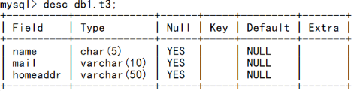
图－1

3.2 步骤
实现此案例需要按照如下步骤进行。
步骤一：创建a3表
1）新建db1库，并切换到db1库
- mysql> CREATE DATABASE db1;
- Query OK, 1 row affected (0.00 sec)
- mysql> USE db1;
- Database changed
2）新建t3表
- mysql> CREATE TABLE db1.t3 (
- -> name char(5) ,
- -> mail varchar(10),
- -> homedir varchar(50)
- -> );
- Query OK, 0 rows affected (0.61sec)
3) 查看a3表结构
- mysql> DESC db1.a3;
- +----------+----------------------+------+-----+---------+-------+
- | Field | Type | Null | Key | Default | Extra |
- +----------+----------------------+------+-----+---------+-------+
- | name | char(5) | YES | | NULL | |
- | mail | varchar(10) | YES | | NULL | |
- | homedir | varchar(50) | YES | | NULL | |
- +----------+----------------------+------+-----+---------+-------+
- 3 rows in set (0.00 sec)

4 案例4：数值类型

4.1 问题
按照 图-2 所示建表。
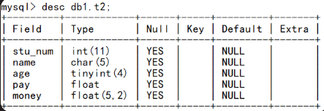
图－2

4.2 步骤
实现此案例需要按照如下步骤进行。
步骤一：创建t2表
1）切换到db1库
- mysql> USE db1;
- Database changed
2）新建t2表
- mysql> create table db1.t2(
- -> stu_num int,
- -> name char(5),
- -> age tinyint,
- -> pay float,
- -> money float(5,2)
- -> );
- Query OK, 0 rows affected (0.03 sec)
3) 查看t2表结构
- mysql> desc db1.t2;
- +---------+------------+------+-----+---------+-------+
- | Field | Type | Null | Key | Default | Extra |
- +---------+------------+------+-----+---------+-------+
- | stu_num | int(11) | YES | | NULL | |
- | name | char(5) | YES | | NULL | |
- | age | tinyint(4) | YES | | NULL | |
- | pay | float | YES | | NULL | |
- | money | float(5,2) | YES | | NULL | |
- +---------+------------+------+-----+---------+-------+
- 5 rows in set (0.00 sec)
- mysql>

5 案例5：日期时间类型

5.1 问题
练习如下时间函数的使用：
- now( ) year( ) month( ) day( ) date( ) time( )
- curtime( ) curdate( )
- 按照图-3所示建表
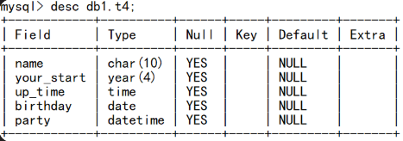
图－3

5.2 步骤
实现此案例需要按照如下步骤进行。
步骤一：练习时间函数的使用
1）使用now()查看当前的日期和时间
- mysql> SELECT now();
- +---------------------+
- | now() |
- +---------------------+
- | 2019-07-03 05:00:15 |
- +---------------------+
- 1 row in set (0.00 sec)
- mysql>
2）使用curdate()获得当前的日期
- mysql> SELECT curdate();
- +------------+
- | curdate() |
- +------------+
- | 2019-07-03 |
- 1 row in set (0.00 sec)
- mysql>
3）使用curtime()获得当前的时间
- mysql> SELECT curtime();
- +-----------+
- | curtime() |
- +-----------+
- | 04:04:55 |
- +-----------+
- 1 row in set (0.00 sec)
4）分别获取当前日期时间中的年份、月份、日
- mysql> SELECT year(now()) , month(now()) , day(now());
- +-------------+--------------+------------+
- | year(now()) | month(now()) | day(now()) |
- +-------------+--------------+------------+
- | 2019 | 7 | 3 |
- +-------------+--------------+------------+
- 1 row in set (0.00 sec)
- mysql>
5）获取系统日期
- mysql> select date(now());
- +-------------+
- | date(now()) |
- +-------------+
- | 2019-07-03 |
- +-------------+
- 1 row in set (0.00 sec)1 row in set (0.00 sec)
- Mysql>
步骤二：创建t4表
1）建表
- mysql> create table db1.t4(
- -> name char(10),
- -> your_start year,
- -> up_time time,
- -> birthday date,
- -> party datetime
- -> );
- Query OK, 0 rows affected (0.04 sec)

- mysql>
2) 查看表结构
- Mysql>
- mysql> desc db1.t4;
- +------------+----------+------+-----+---------+-------+
- | Field | Type | Null | Key | Default | Extra |
- +------------+----------+------+-----+---------+-------+
- | name | char(10) | YES | | NULL | |
- | your_start | year(4) | YES | | NULL | |
- | up_time | time | YES | | NULL | |
- | birthday | date | YES | | NULL | |
- | party | datetime | YES | | NULL | |
- +------------+----------+------+-----+---------+-------+
- 5 rows in set (0.00 sec)

- mysql>
3）插入记录
- mysql>

- mysql> insert into db1.t4 values("bob",1990,083000,20191120,2019082820000);
- Query OK, 1 row affected, 1 warning (0.01 sec)

- mysql> insert into db1.t4 values("tom",1991,090000,20191120,now());
- Query OK, 1 row affected (0.02 sec)

- mysql>
4）查看表记录
mysql>
mysql> select * from db1.t4;
+------+------------+----------+------------+---------------------+
| name | your_start | up_time | birthday | party |
+------+------------+----------+------------+---------------------+
| bob | 1990 | 08:30:00 | 2019-11-20 | 0000-00-00 00:00:00 |
| tom | 1991 | 09:00:00 | 2019-11-20 | 2019-07-03 05:12:41 |
+------+------------+----------+------------+---------------------+
2 rows in set (0.00 sec)
mysql>

6 案例6：枚举类型

6.1 问题
- 按照图-4所示建表
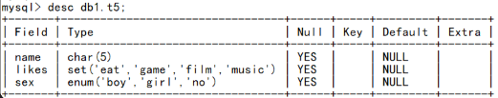
图－4

6.2 步骤
实现此案例需要按照如下步骤进行。
步骤一：创建t5表
1）建表
- mysql>
- mysql> create table db1.t5 (
- -> name char(5),
- -> likes set("eat","game","film","music"),
- -> sex enum("boy","girl","no")
- -> );
- Query OK, 0 rows affected (0.04 sec)
- Mysql>
2）查看表结构
- mysql>
- mysql> desc db1.t5;
- +-------+----------------------------------+------+-----+---------+-------+
- | Field | Type | Null | Key | Default | Extra |
- +-------+----------------------------------+------+-----+---------+-------+
- | name | char(5) | YES | | NULL | |
- | likes | set('eat','game','film','music') | YES | | NULL | |
- | sex | enum('boy','girl','no') | YES | | NULL | |
- +-------+----------------------------------+------+-----+---------+-------+
- 3 rows in set (0.00 sec)

- mysql>
3）插入表记录
- mysql>
- mysql> insert into db1.t5 values ("bob","eat,film,game","boy");
- Query OK, 1 row affected (0.03 sec)

- mysql>
4）查看表记录
- mysql> select * from db1.t5;
- +------+---------------+------+
- | name | likes | sex |
- +------+---------------+------+
- | bob | eat,game,film | boy |
- +------+---------------+------+
- 1 rows in set (0.00 sec)

- mysql>

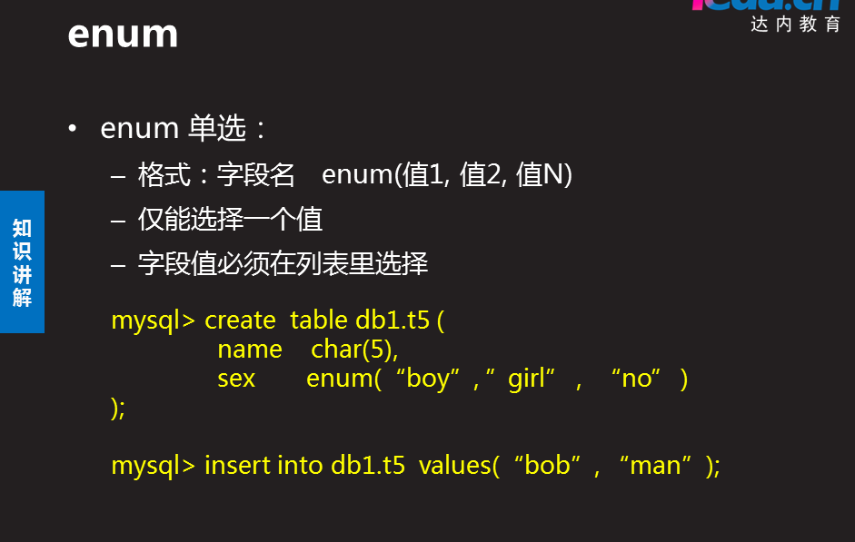

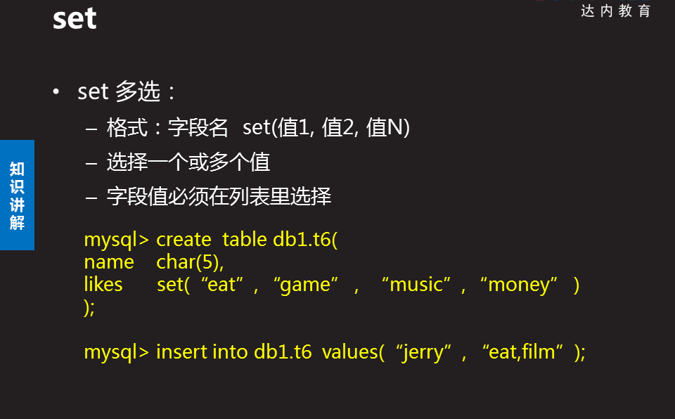

1 简述当前主流RDBMS软件有哪些？开源且跨平台的数据库软件有哪些？
参考答案
当前主流的数据库服务器软件有： Oracle 、 DB2 、 SQL SERVER 、MySQL 等 ，其中只有MySQL是既开源又跨平台的数据库服务软件。

2 简述MySQL数据库的服务进程名、默认端口、默认数据库目录？
参考答案
服务进程名：mysqld
默认监听端口号：3306
默认数据库目录：/var/lib/mysql

3 简述MySQL默认的4个库叫什么名字？哪个库里的数据不占用物理磁盘空间？
参考答案
MySQL默认的4个库分别是 information_schema 、performance_schema 、mysql 、sys 其中information_schema库不占用物理磁盘空间。

4 请列出MySQL常用的数据类型，并写出定义这些数据类型所使用的关键字。
参考答案
MySQL常用的数据类型有：字符类型、数值类型、日期时间类型、枚举类型
字符类型： char 、 varchar 、 blob、 text
数值类型： tinyint 、smallint 、int 、bigint 、float 、 double
日期时间类型： year 、 date 、 time 、 datetime 、 timestamp
枚举类型： enum 、 set

5 简述以下MySQL函数的功能。
year() 、date() 、month() 、day() 、time()、now()
参考答案
year() 获取指定时间中的年
date() 获取指定时间中的年月日
month() 获取指定时间中的月
day() 获取指定时间中的日期
time() 获取指定时间中的时间（小时分钟秒）
now() 获取当前时间（年月日小时分钟秒）

6 在studentdb库里创建stu_info表，结构要求如图-1所示。
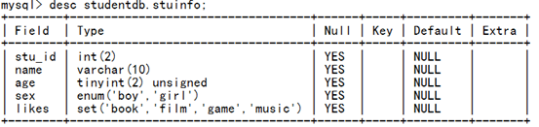
图-1
参考答案
- create database studentdb;
- create table studentdb.stuinfo(
- stu_id int(2),
- name varchar(10),
- age tinyint(2) unsigned,
- sex enum(“boy”,”girl”),
- likes set(“book”,”music”,”game”,”film”)
- );

panglj@tedu.cn nsd1909 姓名 中心

- 搭建数据库服务器
- 基本使用
连接方式:mysql命令
管理数据使用语言:sql
sql使用规则
管理表记录 select insert update delete

建库--->建表--->记录
- ,mysql数据类型
字符类型 数值类型(整数 浮点) 日期时间类型 枚举(menun/set)
year/date/time/datetime/timestamp

rdbms1 day2
表结构
- 约束条件:限制字段赋值
- 2修改表结构: 额外(extra)有自增长等:
- (“”)零个字符也不为空
- values("null",2)也不是空

- 空是(null) 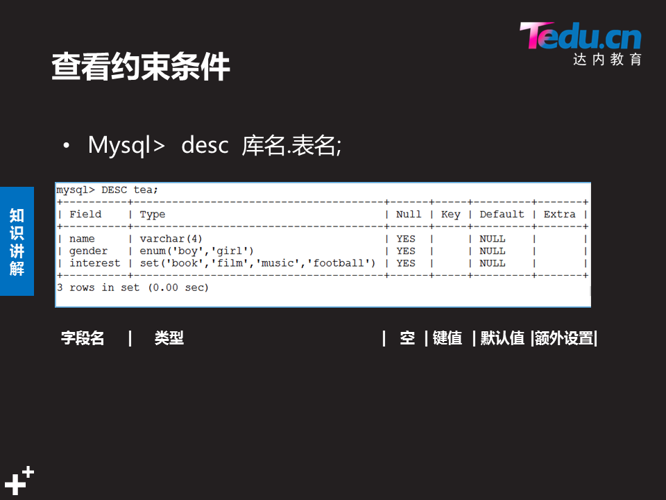

- mysql键值
普通索引 index
唯一索引 unique
全文索引 fulltext
外键 foreign key

修改表结构
5.7mysql以存储的为优先,不能与现有的冲突

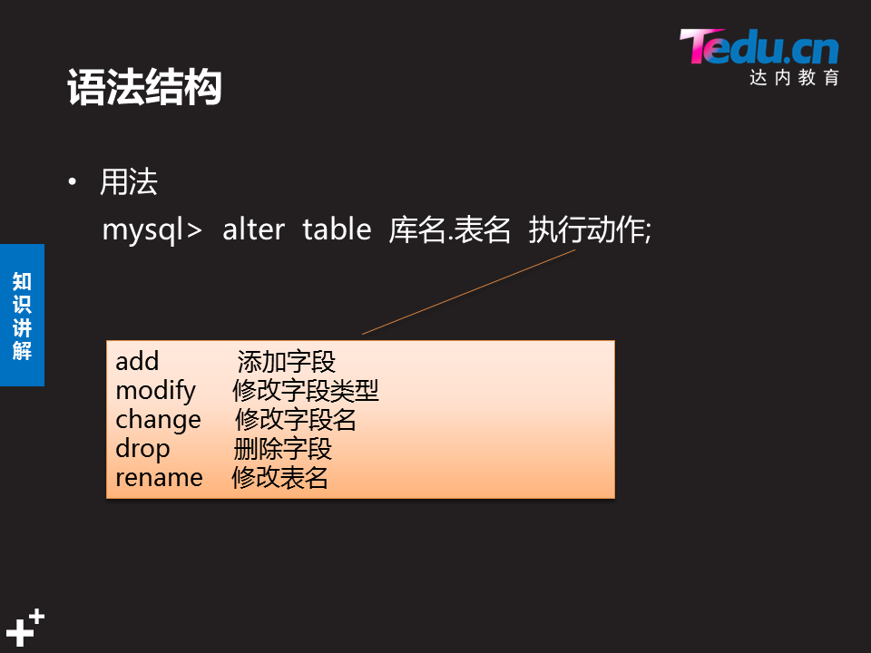
change用来字段重命名，不能修改字段类型和约束；
modify不用来字段重命名，只能修改字段类型和约束；
索引:二叉树
重点键值:各自的功能不同.共同点都可以约束字段赋值
普通索引的使用 :给字段排队,加快查询数据速度
主键的使用
外键的使用

显示库名:prompt mysql \d>
查看索引信息
删除索引
创建主键:建表时, 后加入的必须满足不能为空和重复
复合主键 表中多个列一起做主键
auto_increment 会记录上一次最大的值,自增长,必须是主键,不重复
(null,”12”,”kk”) 空是没给值
Top

NSD RDBMS1 DAY02
- 案例1：约束条件
- 案例2：修改表结构
- 案例3：index 普通索引
- 案例4：primary key 主键
- 案例5：foreign key 外键

1 案例1：约束条件

1.1 问题
具体要求如下：
- 如图-1所示设置约束条件
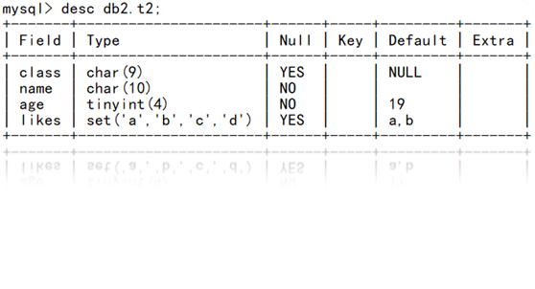
图－1

1.2 步骤
实现此案例需要按照如下步骤进行。
步骤一：设置约束
1）在db2库里创建t2表时设置字段约束条件
- mysql>

- mysql> create database db2; //建库
- Query OK, 1 row affected (0.00 sec)

- mysql> use db2; //切换库
- Database changed
- mysql> create table t2 ( //建表
- -> class char(9),
- -> name char(10) not null ,
- -> age tinyint not null default 19 ,
- -> likes set("a","b","c","d") default "a,b"
- -> );
- Query OK, 0 rows affected (0.05 sec)

- mysql> desc t2; //查看表结构
- +-------+----------------------+------+-----+---------+-------+
- | Field | Type | Null | Key | Default | Extra |
- +-------+----------------------+------+-----+---------+-------+
- | class | char(9) | YES | | NULL | |
- | name | char(10) | NO | | NULL | |
- | age | tinyint(4) | NO | | 19 | |
- | likes | set('a','b','c','d') | YES | | a,b | |
- +-------+----------------------+------+-----+---------+-------+
- 4 rows in set (0.00 sec)

- mysql>

- mysql> insert into t2 values (null,"bob",29,"c,d");
- Query OK, 1 row affected (0.05 sec)

- mysql> insert into t2(class,name) values ("nsd1902","tom");
- Query OK, 1 row affected (0.05 sec)

- mysql> insert into t2 values (null,null,null,null);
- ERROR 1048 (23000): Column 'name' cannot be null //不允许赋null值
- MariaDB [db2]>

- MariaDB [db2]> select * from db2.t1; //查看记录
- +---------+------+-----+-------+
- | class | name | age | likes |
- +---------+------+-----+-------+
- | NULL | bob | 29 | c,d |
- | nsd1902 | tom | 19 | a,b |
- +---------+------+-----+-------+
- 2 rows in set (0.00 sec)

- mysql>

2 案例2：修改表结构

2.1 问题
具体要求如下：
- 添加字段
- 修改字段名
- 修改字段类型
- 删除字段
- 修改表名

2.2 步骤
实现此案例需要按照如下步骤进行。
步骤一：添加字段
1）在studb库下创建tea6表
- Mysql> create database studb;
- mysql> CREATE TABLE studb.tea6(
- -> id int(4) ,
- -> name varchar(4) NOT NULL,
- -> age int(2) NOT NULL
- -> );
- Query OK, 0 rows affected (0.34 sec)
- mysql>
2）为tea6表添加一个address字段
- mysql> DESC tea6;
- +-------+------------+------+-----+---------+-------+
- | Field | Type | Null | Key | Default | Extra |
- +-------+------------+------+-----+---------+-------+
- | id | int(4) | YES | | NULL | |
- | name | varchar(4) | NO | | NULL | |
- | age | int(2) | NO | | NULL | |
- +-------+------------+------+-----+---------+-------+
- 3 rows in set (0.00 sec)
添加address字段：
- mysql> ALTER TABLE tea6 ADD address varchar(48);
- Query OK, 0 rows affected (0.84 sec)
- Records: 0 Duplicates: 0 Warnings: 0
添加后（默认作为最后一个字段）：
- mysql> DESC tea6;
- +---------+-------------+------+-----+---------+-------+
- | Field | Type | Null | Key | Default | Extra |
- +---------+-------------+------+-----+---------+-------+
- | id | int(4) | YES | | NULL | |
- | name | varchar(4) | NO | | NULL | |
- | age | int(2) | NO | | NULL | |
- | address | varchar(48) | YES | | NULL | |
- +---------+-------------+------+-----+---------+-------+
- 4 rows in set (0.00 sec)
3）在tea6表的age列之后添加一个gender字段
添加操作：
- mysql> ALTER TABLE tea6 ADD gender enum('boy','girl') AFTER age;
- Query OK, 0 rows affected (0.59 sec)
- Records: 0 Duplicates: 0 Warnings: 0
确认添加结果：
- mysql> DESC tea6;
- +---------+--------------------+------+-----+---------+-------+
- | Field | Type | Null | Key | Default | Extra |
- +---------+--------------------+------+-----+---------+-------+
- | id | int(4) |YES | | NULL | |
- | name | varchar(4) | NO | | NULL | |
- | age | int(2) | NO | | NULL | |
- | gender | enum('boy','girl') | YES | | NULL | |
- | address | varchar(48) | YES | | NULL | |
- +---------+--------------------+------+-----+---------+-------+
- 5 rows in set (0.00 sec)
步骤二：修改字段名和字段类型
将tea6表的gender字段改名为sex，并添加非空约束
修改操作：
- mysql> ALTER TABLE tea6 CHANGE gender
- -> sex enum('boy','girl') NOT NULL;
- Query OK, 0 rows affected (0.08 sec)
- Records: 0 Duplicates: 0 Warnings: 0
确认修改结果：
- mysql> DESC tea6;
- +---------+--------------------+------+-----+---------+-------+
- | Field | Type | Null | Key | Default | Extra |
- +---------+--------------------+------+-----+---------+-------+
- | id | int(4) | YES | | NULL | |
- | name | varchar(4) | NO | | NULL | |
- | age | int(2) | NO | | NULL | |
- | sex | enum('boy','girl') | NO | | NULL | |
- | address | varchar(48) | YES | | NULL | |
- +---------+--------------------+------+-----+---------+-------+
- 5 rows in set (0.00 sec)
步骤三：删除字段
删除tea6表中名为sex的字段：
- mysql> ALTER TABLE tea6 DROP sex; //删除操作
- Query OK, 0 rows affected (0.52 sec)
- Records: 0 Duplicates: 0 Warnings: 0

- mysql> DESC tea6; //确认删除结果
- +---------+-------------+------+-----+---------+-------+
- | Field | Type | Null | Key | Default | Extra |
- +---------+-------------+------+-----+---------+-------+
- | id | int(4) | YES | | NULL | |
- | name | varchar(4) | NO | | NULL | |
- | age | int(2) | NO | | NULL | |
- | address | varchar(48) | YES | | NULL | |
- +---------+-------------+------+-----+---------+-------+
- 4 rows in set (0.00 sec)

3 案例3：index 普通索引

3.1 问题
具体要求如下：
- 在已有表里添加index字段
- 建表时，添加index字段
- 查看表索引
- 删除表索引

3.2 步骤
实现此案例需要按照如下步骤进行。
步骤一：索引的创建与删除
1）创建表的时候指定INDEX索引字段
创建库home：
- mysql> create database home;
- Query OK, 1 row affected (0.00 sec)
允许有多个INDEX索引字段。比如，以下操作在home库中创建了tea4表，将其中的id、name作为索引字段：
- mysql> USE home;
- Database changed
- mysql> CREATE TABLE tea4(
- -> id char(6) NOT NULL,
- -> name varchar(6) NOT NULL,
- -> age int(3) NOT NULL,
- -> gender ENUM('boy','girl') DEFAULT 'boy',
- -> INDEX(id),INDEX(name)
- -> );
- Query OK, 0 rows affected (0.59 sec)
查看新建tea4表的字段结构，可以发现两个非空索引字段的KEY标志为MUL：
- mysql> DESC tea4;
- +--------+--------------------+------+-----+---------+-------+
- | Field | Type | Null | Key | Default | Extra |
- +--------+--------------------+------+-----+---------+-------+
- | id | char(6) | NO | MUL | NULL | |
- | name | varchar(6) | NO | MUL | NULL | |
- | age | int(3) | NO | | NULL | |
- | gender | enum('boy','girl') | YES | | boy | |
- +--------+--------------------+------+-----+---------+-------+
- 4 rows in set (0.00 sec)
2）删除现有表的某个INDEX索引字段
比如，删除tea4表中名称为named的INDEX索引字段：
- mysql> drop INDEX name ON tea4; //删除name字段的索引
- Query OK, 0 rows affected (0.18 sec)
- Records: 0 Duplicates: 0 Warnings: 0

- mysql> DESC tea4; //确认删除结果
- +--------+--------------------+------+-----+---------+-------+
- | Field | Type | Null | Key | Default | Extra |
- +--------+--------------------+------+-----+---------+-------+
- | id | char(6) | NO | MUL | NULL | |
- | name | varchar(6) | NO | | NULL | |
- | age | int(3) | NO | | NULL | |
- | gender | enum('boy','girl') | YES | | boy | |
- +--------+--------------------+------+-----+---------+-------+
- 4 rows in set (0.00 sec)
3）在已有的某个表中设置INDEX索引字段
比如，针对tea4表的age字段建立索引，名称为 nianling：
- mysql> CREATE INDEX nianling ON tea4(age); //针对指定字段创建索引
- Query OK, 0 rows affected (0.62 sec)
- Records: 0 Duplicates: 0 Warnings: 0

- mysql> DESC tea4; //确认创建结果
- +--------+--------------------+------+-----+---------+-------+
- | Field | Type | Null | Key | Default | Extra |
- +--------+--------------------+------+-----+---------+-------+
- | id | char(6) | NO | MUL | NULL | |
- | name | varchar(6) | NO | | NULL | |
- | age | int(3) | NO | MUL | NULL | |
- | gender | enum('boy','girl') | YES | | boy | |
- +--------+--------------------+------+-----+---------+-------+
- 4 rows in set (0.00 sec)
4）查看指定表的索引信息
使用SHOW INDEX 指令：
- mysql> SHOW INDEX FROM tea4\G
- *************************** 1. row ***************************
- Table: tea4
- Non_unique: 1
- Key_name: id
- Seq_in_index: 1
- Column_name: id
- Collation: A
- Cardinality: 0
- Sub_part: NULL
- Packed: NULL
- Null:
- Index_type: BTREE //使用B树算法
- Comment:
- Index_comment:
- *************************** 2. row ***************************
- Table: tea4
- Non_unique: 1
- Key_name: nianling //索引名称
- Seq_in_index: 1
- Column_name: age //字段名称
- Collation: A
- Cardinality: 0
- Sub_part: NULL
- Packed: NULL
- Null:
- Index_type: BTREE
- Comment:
- Index_comment:
- 2 rows in set (0.00 sec)
- Query OK, 0 rows affected (0.30 sec)
- Mysql>
- Query OK, 0 rows affected (0.47 sec)
- Records: 0 Duplicates: 0 Warnings: 0

4 案例4：primary key 主键

4.1 问题
具体要求如下：
- 建表时，创建主键
- 在已有表里添加主键
- 建表时创建复合主键
- 删除主键
- 设置字段值自增长

4.2 步骤
实现此案例需要按照如下步骤进行。
步骤一：练习主键的使用
1）建表时设置PRIMARY KEY主键索引
- Mysql> create database db2;
- mysql> CREATE TABLE db2.biao01(
- -> id int(4) PRIMARY KEY, //直接在字段定义时约束
- -> name varchar(8)
- -> );
- Query OK, 0 rows affected (0.19 sec)
或者：
- mysql> CREATE TABLE db2.biao02(
- -> id int(4),
- -> name varchar(8),
- -> PRIMARY KEY(id) //所有字段定义完，最后指定
- -> );
- Query OK, 0 rows affected (0.17 sec)
在建表的时候，如果主键字段为int类型，还可以为其设置AUTO_INCREMENT自增属性，这样当添加新的表记录时，此字段的值会自动从1开始逐个增加，无需手动指定。比如，新建一个tea6表，将id列作为自增的主键字段：
- mysql> CREATE TABLE db2.tea6(
- -> id int(4) AUTO_INCREMENT,
- -> name varchar(4) NOT NULL,
- -> age int(2) NOT NULL,
- -> PRIMARY KEY(id)
- -> );
- Query OK, 0 rows affected (0.29 sec)
2）删除现有表的PRIMARY KEY主键索引
如果要移除某个表的PRIMARY KEY约束，需要通过ALTER TABLE指令修改。比如，以下操作将清除biao01表的主键索引。
清除前（主键为id）：
- mysql> DESC db2.biao01;
- +-------+------------+------+-----+---------+-------+
- | Field | Type | Null | Key | Default | Extra |
- +-------+------------+------+-----+---------+-------+
- | id | int(4) | NO | PRI | NULL | |
- | name | varchar(8) | YES | | NULL | |
- +-------+------------+------+-----+---------+-------+
- 2 rows in set (0.00 sec)
清除操作：
- mysql> ALTER TABLE db2.biao01 DROP PRIMARY KEY;
- Query OK, 0 rows affected (0.49 sec)
- Records: 0 Duplicates: 0 Warnings: 0
清除后（无主键）：
- mysql> DESC db2.biao01;
- +-------+------------+------+-----+---------+-------+
- | Field | Type | Null | Key | Default | Extra |
- +-------+------------+------+-----+---------+-------+
- | id | int(4) | NO | | NULL | |
- | name | varchar(8) | YES | | NULL | |
- +-------+------------+------+-----+---------+-------+
- 2 rows in set (0.00 sec)
当尝试删除tea6表的主键时，会出现异常：
- mysql> ALTER TABLE tea6 DROP PRIMARY KEY;
- ERROR 1075 (42000): Incorrect table definition; there can be only one auto column and it must be defined as a key
这是因为tea6表的主键字段id具有AUTO_INCREMNET自增属性，提示这种字段必须作为主键存在，因此若要清除此主键必须先清除自增属性——修改id列的字段定义：
- mysql> ALTER TABLE tea6 MODIFY id int(4) NOT NULL;
- Query OK, 0 rows affected (0.75 sec)
- Records: 0 Duplicates: 0 Warnings: 0
然后再清除主键属性就OK了：
- mysql> ALTER TABLE tea6 DROP PRIMARY KEY; //清除主键
- Query OK, 0 rows affected (0.39 sec)
- Records: 0 Duplicates: 0 Warnings: 0

- mysql> desc tea6; //确认清除结果
- +-------+------------+------+-----+---------+-------+
- | Field | Type | Null | Key | Default | Extra |
- +-------+------------+------+-----+---------+-------+
- | id | int(4) | NO | | NULL | |
- | name | varchar(4) | NO | | NULL | |
- | age | int(2) | NO | | NULL | |
- +-------+------------+------+-----+---------+-------+
- 3 rows in set (0.01 sec)
3）为现有表添加PRIMARY KEY主键索引
重新为tea6表指定主键字段，仍然使用id列：
- mysql> ALTER TABLE tea6 ADD PRIMARY KEY(id); //设置主键字段
- Query OK, 0 rows affected (0.35 sec)
- Records: 0 Duplicates: 0 Warnings: 0

- mysql> DESC tea6; //确认设置结果
- +-------+------------+------+-----+---------+-------+
- | Field | Type | Null | Key | Default | Extra |
- +-------+------------+------+-----+---------+-------+
- | id | int(4) | NO | PRI | NULL | |
- | name | varchar(4) | NO | | NULL | |
- | age | int(2) | NO | | NULL | |
- +-------+------------+------+-----+---------+-------+
- 3 rows in set (0.00 sec)
4）建表时创建复合主键
- mysql>
- mysql> create table db2.t6(
- -> class char(7),
- -> name char(15),
- -> pay enum("yes","no") default "no",
- -> primary key(class,name,pay) //指定多个字段一起做主键
- -> );
- Query OK, 0 rows affected (0.04 sec)

- mysql> desc db2.t6;
- +-------+------------------+------+-----+---------+-------+
- | Field | Type | Null | Key | Default | Extra |
- +-------+------------------+------+-----+---------+-------+
- | class | char(7) | NO | PRI | | |
- | name | char(15) | NO | PRI | | |
- | pay | enum('yes','no') | NO | PRI | no | |
- +-------+------------------+------+-----+---------+-------+
- 3 rows in set (0.01 sec)

- mysql>

5 案例5：foreign key 外键

5.1 问题
具体要求如下：
- 创建员工表yg 如表-1所示
- 创建工资表gz如表-2所示 ,并设置外键实现同步更新与同步删除
- 测试外键
- 删除外键
表-1 员工表yg的数据

表-2 工资表gz的数据

步骤一：创建外键
1）创建yg表，用来记录员工工号、姓名，其中yg_id列作为主键，并设置自增属性
- mysql> CREATE TABLE yg(
- -> yg_id int primary key AUTO_INCREMENT,
- -> name char(16)
- -> )engine=innodb;
- Query OK, 0 rows affected (0.15 sec)
- Mysql>
2）创建gz表，用来记录员工的工资信息
其中gz_id需要参考员工工号，即gz表的gz_id字段设为外键，将yg表的yg_id字段作为参考键：
- mysql> CREATE TABLE gz(
- -> gz_id int,
- -> name char(16) ,
- -> gz float(7,2) ,
- -> FOREIGN KEY(gz_id) REFERENCES yg(yg_id) //创建外键
- -> ON UPDATE CASCADE ON DELETE CASCADE //同步更新、同步删除
- -> )engine=innodb;
- Query OK, 0 rows affected (0.23 sec)
- Mysql>
3）为yg表添加2条员工信息记录
因yg_id有AUTO_INCREMENT属性，会自动填充，所以只要为name列赋值就可以了。
插入表记录可使用INSERT指令，这里先执行下列操作，具体在下一章学习：
- mysql> INSERT INTO yg(name) VALUES('Jerry'),('Tom');
- Query OK, 2 rows affected (0.16 sec)
- Records: 2 Duplicates: 0 Warnings: 0
确认yg表的数据记录：
- mysql> SELECT * FROM yg;
- +-------+-------+
- | yg_id | name |
- +-------+-------+
- | 1 | Jerry |
- | 2 | Tom |
- +-------+-------+
- 2 rows in set (0.00 sec)
4）为gz表添加2条工资信息记录
同上，数据参考图-2，插入相应的工资记录（gz_id字段未指定默认值，也未设置自增属性，所以需要手动赋值）：
- mysql> INSERT INTO gz(gz_id,name,gz)
- -> VALUES(1,'Jerry',12000),(2,'Tom',8000)
- -> ;
- Query OK, 2 rows affected (0.06 sec)
- Records: 2 Duplicates: 0 Warnings: 0
确认gz表的数据记录：
- mysql> SELECT * FROM gz;
- +-------+-------+----------+
- | gz_id | name | gz |
- +-------+-------+----------+
- | 1 | Jerry | 12000.00 |
- | 2 | Tom | 8000.00 |
- +-------+-------+----------+
- 2 rows in set (0.05 sec)
5）验证表记录的UPDATE更新联动
将yg表中Jerry用户的yg_id修改为1234：
- mysql> update yg SET yg_id=1234 WHERE name='Jerry';
- Query OK, 1 row affected (0.05 sec)
- Rows matched: 1 Changed: 1 Warnings: 0
确认修改结果：
- mysql> SELECT * FROM yg;
- +-------+-------+
- | yg_id | name |
- +-------+-------+
- | 2 | Tom |
- | 1234 | Jerry |
- +-------+-------+
- 2 rows in set (0.00 sec)
同时也会发现，gz表中Jerry用户的gz_id也跟着变了：
- mysql> SELECT * FROM gz;
- +-------+-------+----------+
- | gz_id | name | gz |
- +-------+-------+----------+
- | 1234 | Jerry | 12000.00 |
- | 2 | Tom | 8000.00 |
- +-------+-------+----------+
- 2 rows in set (0.00 sec)
6）验证表记录的DELETE删除联动
删除yg表中用户Jerry的记录：
- mysql> DELETE FROM yg WHERE name='Jerry';
- Query OK, 1 row affected (0.05 sec)
确认删除结果：
- mysql> SELECT * FROM yg;
- +-------+------+
- | yg_id | name |
- +-------+------+
- | 2 | Tom |
- +-------+------+
- 1 row in set (0.00 sec)
查看gz表中的变化（Jerry的记录也没了）：
- mysql> SELECT * FROM gz;
- +-------+------+---------+
- | gz_id | name | gz |
- +-------+------+---------+
- | 2 | Tom | 8000.00 |
- +-------+------+---------+
- 1 row in set (0.00 sec)
7）删除指定表的外键约束
先通过SHOW指令获取表格的外键约束名称：
- mysql> SHOW CREATE TABLE gz\G
- *************************** 1. row ***************************
- Table: gz
- Create Table: CREATE TABLE `gz` (
- `gz_id` int(4) NOT NULL,
- `name` char(16) NOT NULL,
- `gz` float(7,2) NOT NULL DEFAULT '0.00',
- KEY `name` (`name`),
- KEY `gz_id` (`gz_id`),
- CONSTRAINT `gz_ibfk_1` FOREIGN KEY (`gz_id`) REFERENCES `yg` (`yg_id`) ON DELETE CASCADE ON UPDATE CASCADE
- ) ENGINE=InnoDB DEFAULT CHARSET=utf8
- 1 row in set (0.00 sec)
其中gz_ibfk_1即删除外键约束时要用到的名称。
删除操作：
- mysql> ALTER TABLE gz DROP FOREIGN KEY gz_ibfk_1;
- Query OK, 0 rows affected (0.01 sec)
- Records: 0 Duplicates: 0 Warnings: 0
确认删除结果：
- mysql> SHOW CREATE TABLE gz\G
- *************************** 1. row ***************************
- Table: gz
- Create Table: CREATE TABLE `gz` (
- `gz_id` int(4) NOT NULL,
- `name` char(16) NOT NULL,
- `gz` float(7,2) NOT NULL DEFAULT '0.00',
- KEY `name` (`name`),
- KEY `gz_id` (`gz_id`)
- ) ENGINE=InnoDB DEFAULT CHARSET=utf8
- 1 row in set (0.00 sec)

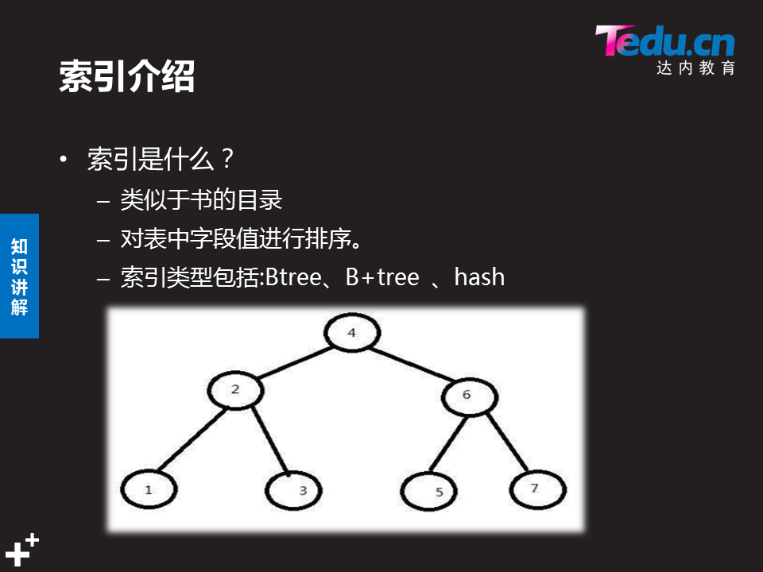

1 简述索引的优点与缺点？
参考答案
- 索引的优点：加快查询表记录的速度。
- 索引的缺点：会减慢写的速度(如： insert 、update )，占用物理存储空间。

2 简述普通索引与主键的约束规则。
参考答案
1）index普通索引
- 一个表中可以有多个INDEX字段
- 字段的值允许有重复，且可以赋NULL值
- 经常把做查询条件的字段设置为INDEX字段
- INDEX字段的KEY标志是MUL
2）primary key 主键
- 一个表中只能有一个primary key字段
- 对应的字段值不允许有重复，且不允许赋NULL值
- 如果有多个字段都作为PRIMARY KEY，称为复合主键，必须一起创建。
- 主键字段的KEY标志是PRI 、通常与 AUTO_INCREMENT 连用
- 经常把表中能够唯一标识记录的字段设置为主键字段[如：记录编号字段]

3 根据图-1显示，修改studentdb.stu_info表的结构,原表结构见DAY01练习的图-1。
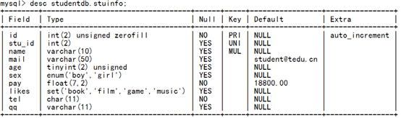
图-1
参考答案
- mysql> alter table studentdb.stuinfo add id int(2) zerofill primary key auto_increment first;

- mysql> create unique index stu_id on studentdb.stuinfo(stu_id);

- mysql> alter table studentdb.stuinfo add mail varchar(50) default "student@tedu.cn" after name;

- mysql> alter table studentdb.stuinfo add tel char(11) not null ,add qq varchar(11);

- mysql> alter table studentdb.stuinfo add pay float(7,2) not null default 18800 after sex;

- mysql> create index name on studentdb.stuinfo(name);

4 简述在表中创建外键字段要满足那些条件？
参考答案
foreign key 外键使用规则如下：
表的存储引擎必须是innodb
字段的数据类型要匹配
被参考的字段必须是key 中的一种 (通常使用primary key)



12.5
day3
数据导入导出
1.
- 数据导入:把系统文件内容存储到数据库表里
- 作用:批量存储数据到表
- 命令格式 load data
- 在mysql里加system 就可以用系统命令
/var/lib/mysql-files/ 默认导入导出文件夹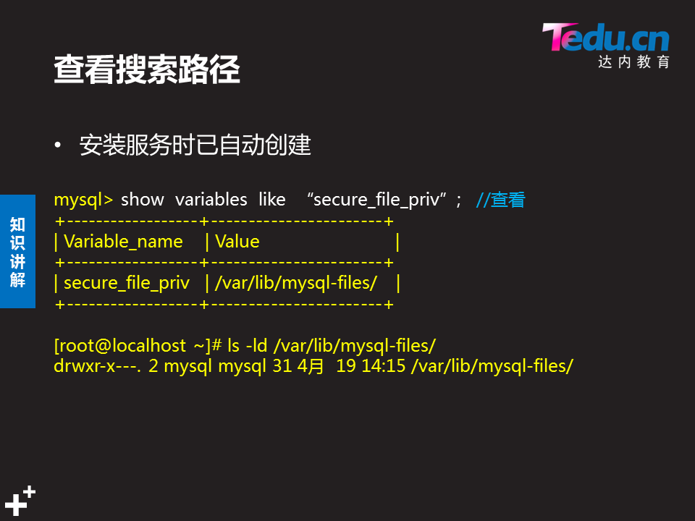
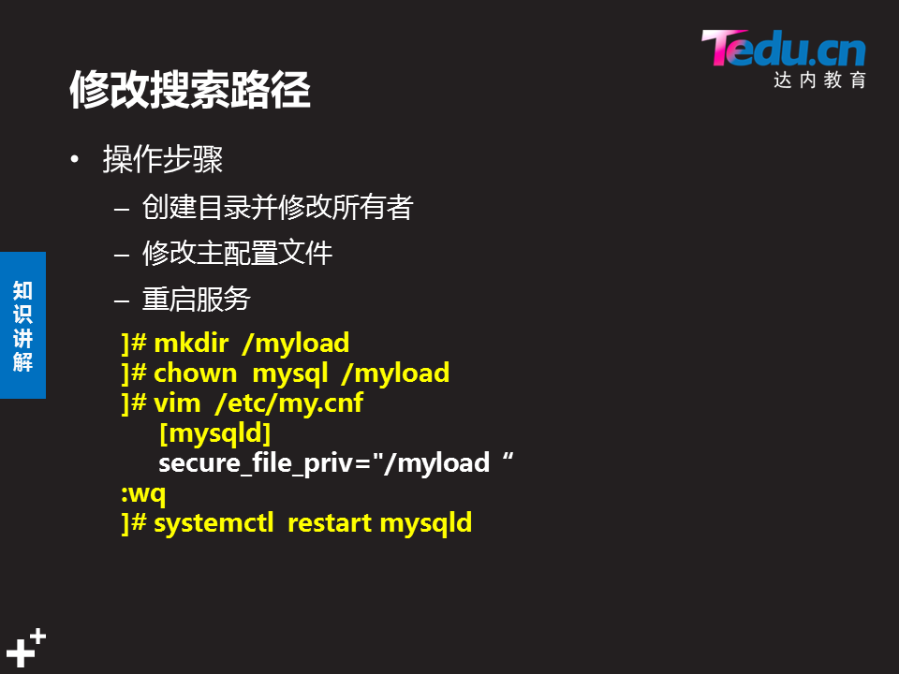
- show variables like "secure_file_priv";

- 数据导入: 把系统文件的内容存储到数据库的表里

- 命令格式： mysql> load data infile "目录名/文件名"
- into table 库名.表名
- fields terminated by "分隔符"
- lines terminated by "\n";

- 数据导入的步骤？
- 1 把系统文件拷贝的检索目录下
- 2 创建存储数据的库和表
- 3 导入数据
- 4 查看数据
- 例子： 把/etc/passwd 文件的内容存储到db3库下user表里
- mysql> system cp /etc/passwd /myload/
- mysql> system ls /myload
- mysql> create database db3 ;

- mysql> use db3;
- mysql> show tables;

- mysql> create table user (
- name char(50), password char(1) ,
- uid int , gid int , comment char(150),
- homedir char(150) , shell char(100)
- );

- mysql> desc user;

- mysql> load data infile "/myload/passwd" into table db3.user
- -> fields terminated by ":" lines terminated by "\n" ;

- mysql> alter table db3.user add
- -> id int primary key auto_increment first;

- mysql> select * from user ;

- mysql> select * from user where id = 1;

- 数据导出: 把数据库表里的记录，保存到系统文件里
- mysql> select name , uid , homedir from user where id <= 3
- into outfile "/myload/user1.txt";

插入数据:load data infile “/myload/passwd” into “db3.user” fields terminated by “:” lines terminated by “\n”;
主键:alter table user add id int primary key auto_increment first;
外键:create table gz(
gz_id int,
name char(5),
foreign key(gz_id) references db2.yg(yg_id)
on update cascade
on delete cascade)engine=innodb;

插入中文:
update db3.user set comment='架构师' where shell='nologin ';
报错:ERROR 1366 (HY000): Incorrect string value: '\xE6\x9E\xB6\xE6\x9E\x84...' for column 'comment' at row 2
修改前:ENGINE=InnoDB AUTO_INCREMENT=23 DEFAULT CHARSET=latin1
修改后:ENGINE=InnoDB AUTO_INCREMENT=23 DEFAULT CHARSET=utf8
修改表的默认字符集编码:
alter table db3.user convert to character set utf8 COLLATE utf8_general_ci;
逻辑非 ! not
逻辑或 or 或 || 某一个条件匹配即可
逻辑与 and 或 && 多个条件匹配
or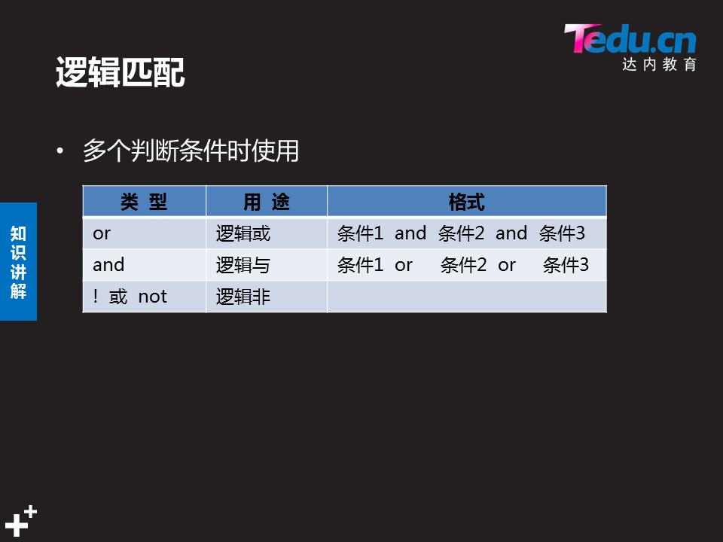
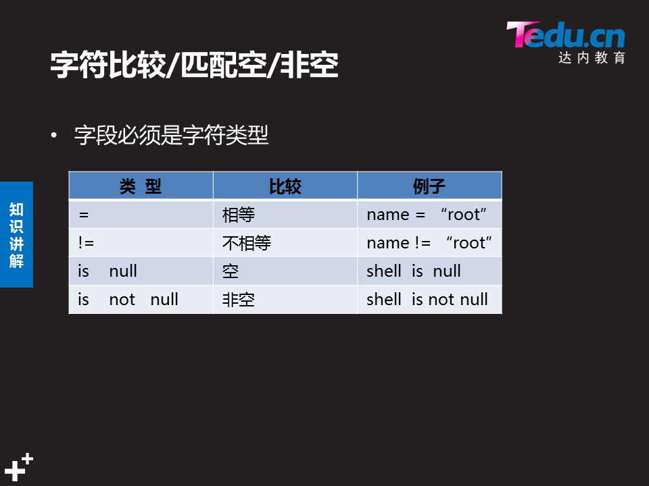

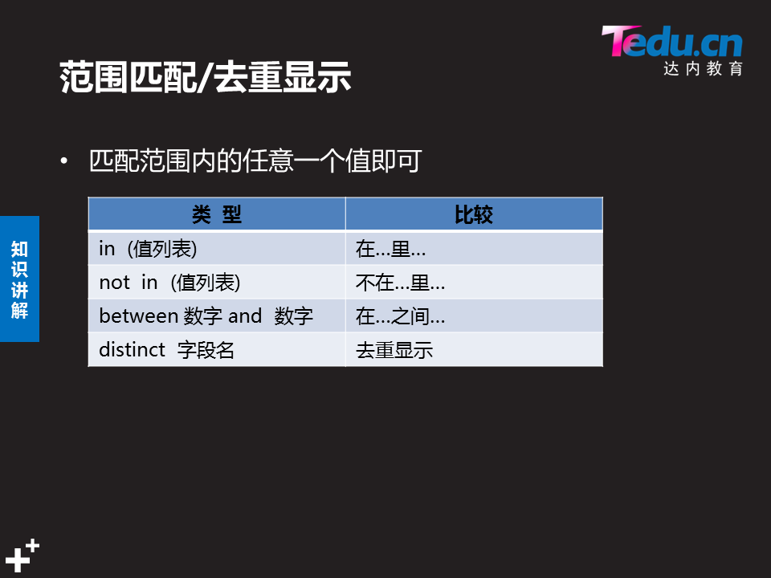

distinct 字段名 去重显示
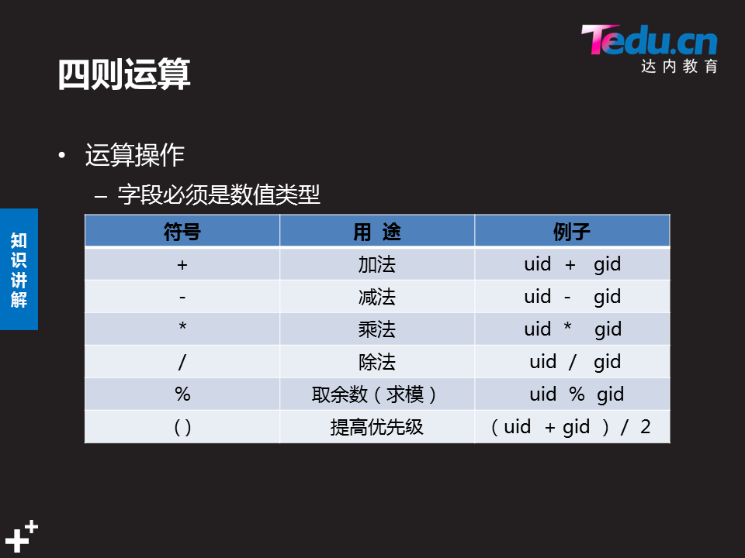
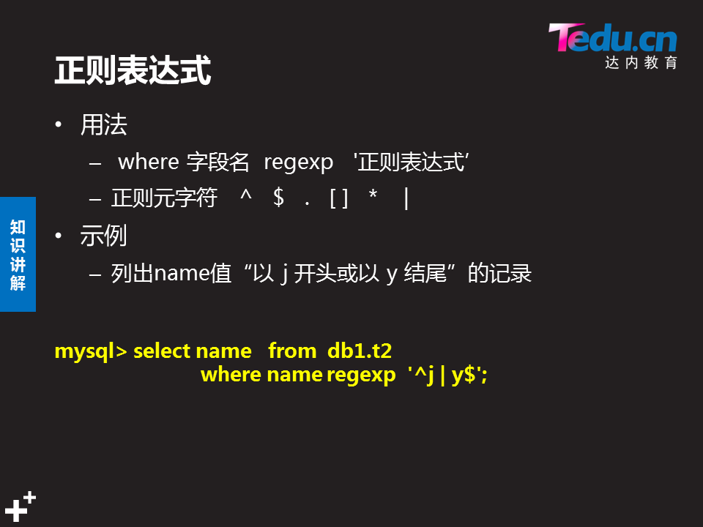
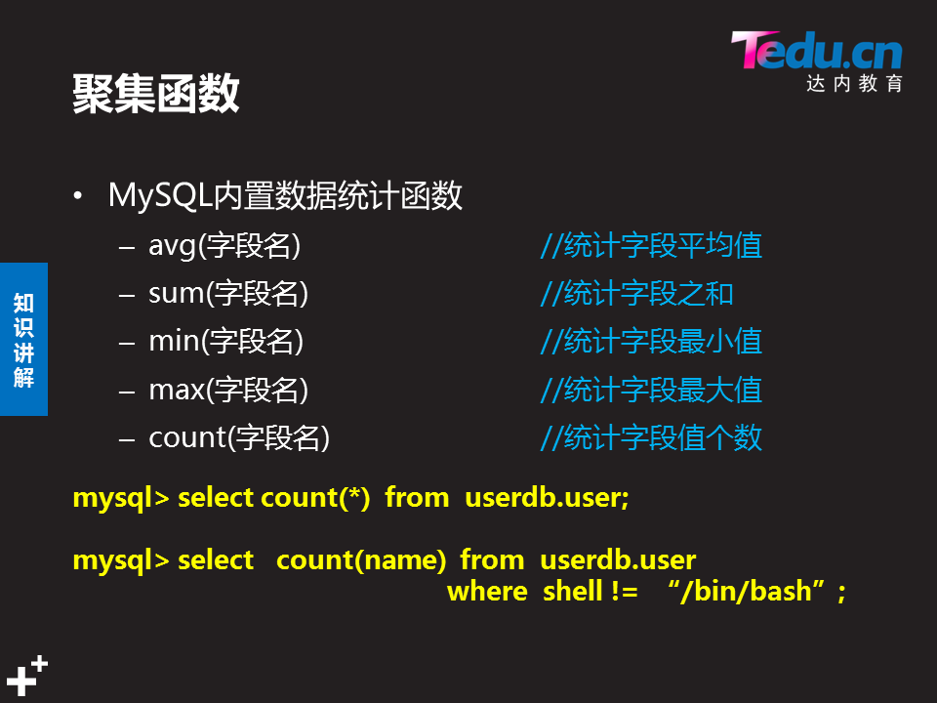

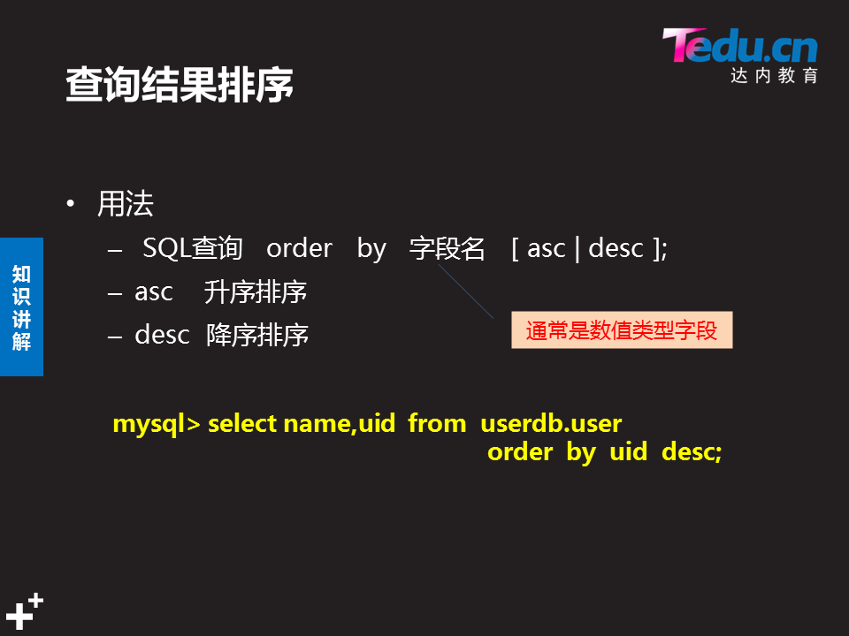
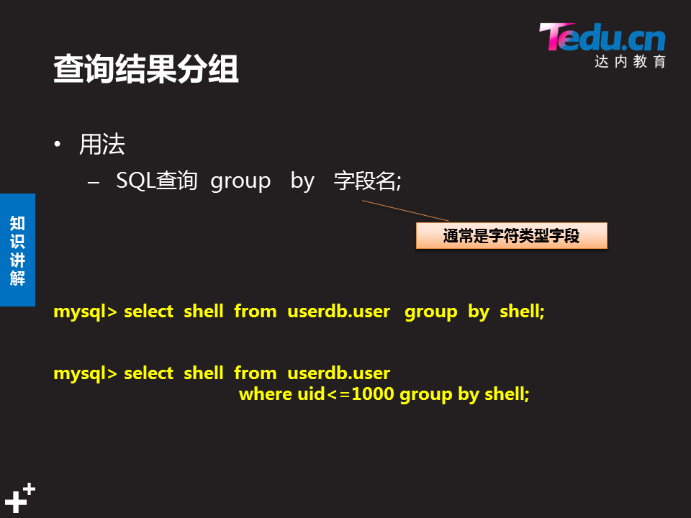
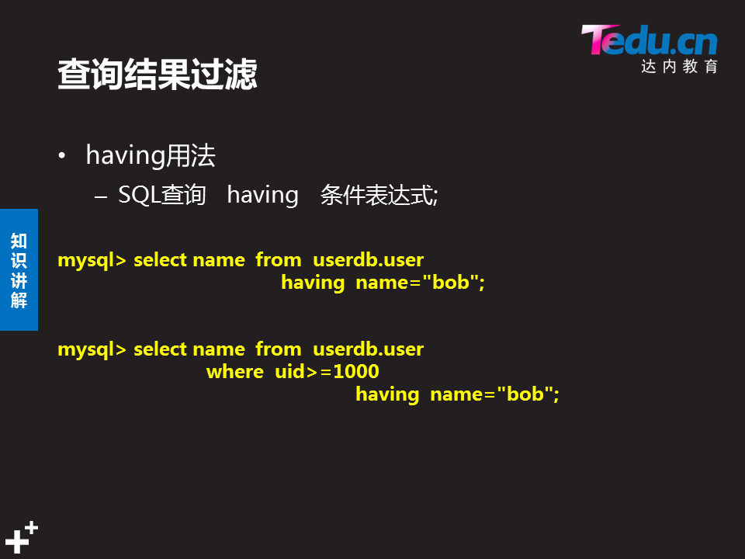
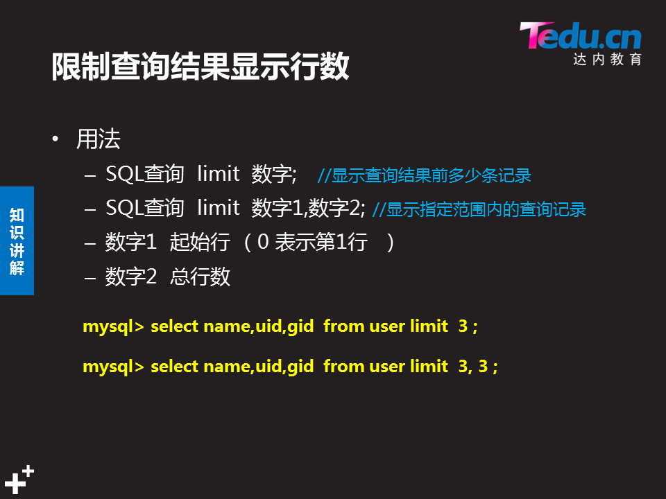mysql> select name,uid from user where uid>=10 and uid<=100
-> order by uid desc limit 3;

mysql> select name,shell from user where uid <= 10 group by name,shell having shell='/sbin/halt';

systemctl enable --now httpd

day4
虚拟库,在内存里information_schema
总结:授权:grant
撤销:revoke
mysql -uroot -p123456 [db3] < /db3_user.sql 完全备份可以不用写库名,用-A 和-B执行备份文件导入不需要加库名
备份文件会被锁表,
增量备份 使用binlog日志实现增量备份

show master status;

------------------------------
date5
root,密码管理
root的权限做
vim /etc/my.cnf
skip-grant-tables

desc mysql.user
authentication_string
select host,user,authentication_string from mysql.user;
update mysql.user set authentication_string=password(“密码”)
where host=’localhost’ and user=’root’;
flush privileges;
修改新密码
mysqladmin -hlocalhost -uroot -p password “A...qqq321”

binlog日志
show master status;查看日志是否起来,当前日志正在使用的日志

system ls /var/lib/mysql/host50-bin.*
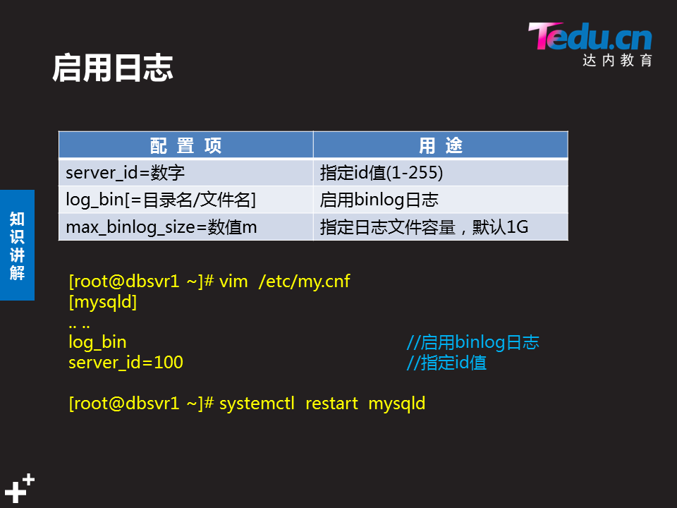

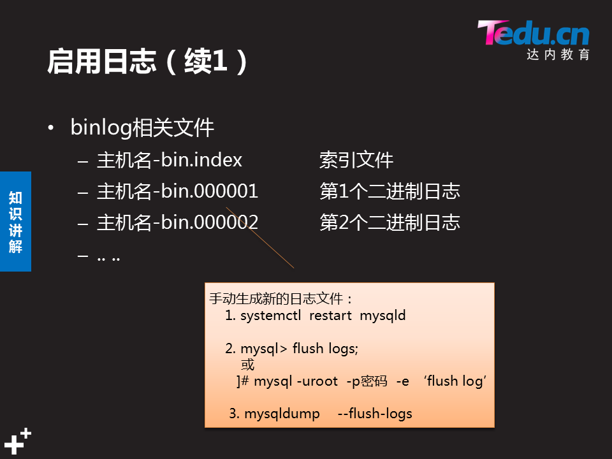
mysql -uroot -p123456 -e 'flush logs'

purge master logs to 'host50-bin.000003'

mysqldump -uroot -p123456 --flush-logs -B mysql db3 > /opt/two.sql
查看日志默认记录格式

表空间:存储数据的表文件
Top

NSD RDBM1 DAY04
- 案例1： 用户授权
- 案例2：root密码
- 案例3：数据备份与恢复
- 案例4：binlog日志
- 案例5：使用binlog日志恢复数据

1 案例1： 用户授权

1.1 问题
- 允许192.168.4.0/24网段主机使用root连接数据库服务器，对所有库和所有表有完全权限、密码为123qqq…A 。
- 添加用户dba007，对所有库和所有表有完全权限、且有授权权限，密码为123qqq…A 客户端为网络中的所有主机。
- 撤销root从本机访问权限，然后恢复。
- 允许任意主机使用webuser用户连接数据库服务器，仅对webdb库有完全权限，密码为123qqq…A 。
- 撤销webuser的权限，使其仅有查询记录权限。

1.2 步骤
实现此案例需要按照如下步骤进行。
步骤一：用户授权
1）允许root从192.168.4.0/24访问，对所有库表有完全权限，密码为123qqq…A
授权之前，从192.168.4.0/24网段的客户机访问时，将会被拒绝：
- [root@host120 ~]# mysql -u root -p -h 192.168.4.10
- Enter password: //输入正确的密码
- ERROR 2003 (HY000): Host '192.168.4.120' is not allowed to connect to this MySQL server
授权操作，此处可设置与从localhost访问时不同的密码：
- mysql> GRANT all ON *.* TO root@'192.168.4.%' IDENTIFIED BY 'tarena';
- Query OK, 0 rows affected (0.00 sec)
再次从192.168.4.0/24网段的客户机访问时，输入正确的密码后可登入：
- [root@host120 ~]# mysql -u root -p -h 192.168.4.10
- Enter password:
- Welcome to the MySQL monitor. Commands end with ; or \g.
- Your MySQL connection id is 20
- Server version: 5.7.17 MySQL Community Server (GPL)

- Copyright (c) 2000, 2016, Oracle and/or its affiliates. All rights reserved.

- Oracle is a registered trademark of Oracle Corporation and/or its
- affiliates. Other names may be trademarks of their respective
- owners.

- Type 'help;' or '\h' for help. Type '\c' to clear the current input statement.

- mysql>
从网络登入后，测试新建一个库、查看所有库：
- mysql> CREATE DATABASE rootdb; //创建新库rootdb
- Query OK, 1 row affected (0.06 sec)

- mysql> SHOW DATABASES;
- +--------------------+
- | Database |
- +--------------------+
- | information_schema |
- | home |
- | mysql |
- | performance_schema |
- | rootdb | //新建的rootdb库
- | sys |
- | userdb |
- +--------------------+
- 7 rows in set (0.01 sec)
2）在Mysql服务器上建立一个管理账号dba007，对所有库完全控制，并赋予其授权的权限新建账号并授权：
- mysql> GRANT all ON *.* TO dba007@localhost
- -> IDENTIFIED BY '123qqq…A '
- -> WITH GRANT OPTION;
- Query OK, 0 rows affected (0.00 sec)
查看dba007的权限：
- mysql> SHOW GRANTS FOR dba007@localhost;
- +-----------------------------------------------------------------------+
- | Grants for dba007@localhost |
- +-----------------------------------------------------------------------+
- | GRANT ALL PRIVILEGES ON *.* TO 'dba007'@'localhost' WITH GRANT OPTION |
- +-----------------------------------------------------------------------+
- 1 row in set (0.00 sec)
3）撤销root从本机访问的权限，然后恢复
注意：如果没有事先建立其他管理账号，请不要轻易撤销root用户的本地访问权限，否则恢复起来会比较困难，甚至不得不重装数据库。
撤销root对数据库的操作权限：
- mysql> REVOKE all ON *.* FROM root@localhost;
- Query OK, 0 rows affected (0.00 sec)
- mysql> SHOW GRANTS FOR root@localhost;
- +--------------------------------------------------------------+
- | Grants for root@localhost |
- +--------------------------------------------------------------+
- | GRANT USAGE ON *.* TO 'root'@'localhost' WITH GRANT OPTION |
- | GRANT PROXY ON ''@'' TO 'root'@'localhost' WITH GRANT OPTION |
- +--------------------------------------------------------------+
- 2 rows in set (0.00 sec)
验证撤销后的权限效果：
- mysql> exit //退出当前MySQL连接
- Bye
- [root@dbsvr1 ~]# mysql -u root -p //重新以root从本地登入
- Enter password:
- Welcome to the MySQL monitor. Commands end with ; or \g.
- Your MySQL connection id is 6
- Server version: 5.6.15 MySQL Community Server (GPL)

- Copyright (c) 2000, 2013, Oracle and/or its affiliates. All rights reserved.

- Oracle is a registered trademark of Oracle Corporation and/or its
- affiliates. Other names may be trademarks of their respective
- owners.

- Type 'help;' or '\h' for help. Type '\c' to clear the current input statement.

- mysql> CREATE DATABASE newdb2014; //尝试新建库失败
- ERROR 1044 (42000): Access denied for user 'root'@'localhost' to database 'newdb2014'
- mysql> DROP DATABASE rootdb; //尝试删除库失败
- ERROR 1044 (42000): Access denied for user 'root'@'localhost' to database 'rootdb'
尝试以当前的root用户恢复权限，也会失败（无权更新授权表）：
- mysql> GRANT all ON *.* TO root@localhost IDENTIFIED BY '1234567';
- ERROR 1045 (28000): Access denied for user 'root'@'localhost' (using password: YES)
怎么办呢？
退出当前MySQL连接，以上一步添加的管理账号dba007登入：
- mysql> exit //退出当前MySQL连接
- Bye
- [root@dbsvr1 ~]# mysql -u dba007 -p //以另一个管理账号登入
- Enter password:
- Welcome to the MySQL monitor. Commands end with ; or \g.
- Your MySQL connection id is 24
- Server version: 5.7.17 MySQL Community Server (GPL)

- Copyright (c) 2000, 2016, Oracle and/or its affiliates. All rights reserved.

- Oracle is a registered trademark of Oracle Corporation and/or its
- affiliates. Other names may be trademarks of their respective
- owners.

- Type 'help;' or '\h' for help. Type '\c' to clear the current input statement.
由管理账号dba007重新为root添加本地访问权限：
- mysql> GRANT all ON *.* TO root@localhost IDENTIFIED BY '1234567';
- Query OK, 0 rows affected (0.00 sec)
- mysql> SHOW GRANTS FOR root@localhost; //查看恢复结果
- +---------------------------------------------------------------------+
- | Grants for root@localhost |
- +---------------------------------------------------------------------+
- | GRANT ALL PRIVILEGES ON *.* TO 'root'@'localhost' WITH GRANT OPTION |
- | GRANT PROXY ON ''@'' TO 'root'@'localhost' WITH GRANT OPTION |
- +---------------------------------------------------------------------+
- 2 rows in set (0.00 sec)
退出，再重新以root登入，测试一下看看，权限又恢复了吧：
- mysql> exit //退出当前MySQL连接
- Bye
- [root@dbsvr1 ~]# mysql -u root -p //重新以root登入
- Enter password:
- Welcome to the MySQL monitor. Commands end with ; or \g.
- Your MySQL connection id is 25
- Server version: 5.7.17 MySQL Community Server (GPL)

- Copyright (c) 2000, 2016, Oracle and/or its affiliates. All rights reserved.

- Oracle is a registered trademark of Oracle Corporation and/or its
- affiliates. Other names may be trademarks of their respective
- owners.

- Type 'help;' or '\h' for help. Type '\c' to clear the current input statement.

- mysql> CREATE DATABASE newdb2014; //成功创建新库
- Query OK, 1 row affected (0.00 sec)
4）允许webuser从任意客户机登录，只对webdb库有完全权限，密码为 123qqq…A
添加授权：
- mysql> GRANT all ON webdb.* TO webuser@'%' IDENTIFIED BY '888888';
- Query OK, 0 rows affected (0.00 sec)
查看授权结果：
- mysql> SHOW GRANTS FOR webuser@'%';
- +----------------------------------------------------+
- | Grants for webuser@% |
- +----------------------------------------------------+
- | GRANT USAGE ON *.* TO 'webuser'@'%' |
- | GRANT ALL PRIVILEGES ON `webdb`.* TO 'webuser'@'%' |
- +----------------------------------------------------+
- 2 rows in set (0.00 sec)
5）撤销webuser的完全权限，改为查询权限
撤销所有权限：
- mysql> REVOKE all ON webdb.* FROM webuser@'%';
- Query OK, 0 rows affected (0.00 sec)
只赋予查询权限：
- mysql> GRANT select ON webdb.* TO webuser@'%';
- Query OK, 0 rows affected (0.00 sec)
确认授权更改结果：
- mysql> SHOW GRANTS FOR webuser@'%';
- +--------------------------------------------+
- | Grants for webuser@% |
- +--------------------------------------------+
- | GRANT USAGE ON *.* TO 'webuser'@'%' |
- | GRANT SELECT ON `webdb`.* TO 'webuser'@'%' |
- +--------------------------------------------+
- 2 rows in set (0.00 sec)

2 案例2：root密码

2.1 问题
具体要求如下：
- 恢复管理员root密码 123qqq…A
- 重置管理员root密码 A…qqq321

2.2 步骤
实现此案例需要按照如下步骤进行。
步骤一：恢复管理员root密码
1）首先停止已运行的MySQL服务程序
- [root@dbsvr1 ~]# systemctl stop mysqld.service //停止服务
- [root@dbsvr1 ~]# systemctl status mysqld.service //确认状态
- mysqld.service - MySQL Server
- Loaded: loaded (/usr/lib/systemd/system/mysqld.service; enabled)
- Active: inactive (dead) since 五 2017-04-07 23:01:38 CST; 21s ago
- Docs: man:mysqld(8)
- http://dev.mysql.com/doc/refman/en/using-systemd.html
- Process: 20260 ExecStart=/usr/sbin/mysqld --daemonize --pid-file=/var/run/mysqld/mysqld.pid $MYSQLD_OPTS (code=exited, status=0/SUCCESS)
- Process: 20238 ExecStartPre=/usr/bin/mysqld_pre_systemd (code=exited, status=0/SUCCESS)
- Main PID: 20262 (code=exited, status=0/SUCCESS)
2）然后跳过授权表启动MySQL服务程序
这一步主要利用mysqld的 --skip-grant-tables选项
修改my.cnf配置，添加 skip_grant_tables=1启动设置：
- [root@dbsvr1 ~]# vim /etc/my.cnf
- [mysqld]
- skip_grant_tables
- .. ..
- [root@dbsvr1 ~]# systemctl start mysqld.service

- [root@dbsvr1 ~]# service mysql status
- mysqld.service - MySQL Server
- Loaded: loaded (/usr/lib/systemd/system/mysqld.service; enabled)
- Active: active (running) since 五 2017-04-07 23:40:20 CST; 40s ago
- Docs: man:mysqld(8)
- http://dev.mysql.com/doc/refman/en/using-systemd.html
- Process: 11698 ExecStart=/usr/sbin/mysqld --daemonize --pid-file=/var/run/mysqld/mysqld.pid $MYSQLD_OPTS (code=exited, status=0/SUCCESS)
- Process: 11676 ExecStartPre=/usr/bin/mysqld_pre_systemd (code=exited, status=0/SUCCESS)
- Main PID: 11701 (mysqld)
- CGroup: /system.slice/mysqld.service
- └─11701 /usr/sbin/mysqld --daemonize --pid-file=/var/run/mysqld/mysqld.p...
3）使用mysql命令连接到MySQL服务，重设root的密码
由于前一步启动的MySQL服务跳过了授权表，所以可以root从本机直接登录
- [root@dbsvr1 ~]# mysql //直接回车即可

- Welcome to the MySQL monitor. Commands end with ; or \g.
- Your MySQL connection id is 4
- Server version: 5.7.17 MySQL Community Server (GPL)

- Copyright (c) 2000, 2016, Oracle and/or its affiliates. All rights reserved.

- Oracle is a registered trademark of Oracle Corporation and/or its
- affiliates. Other names may be trademarks of their respective
- owners.

- Type 'help;' or '\h' for help. Type '\c' to clear the current input statement.

- mysql>
进入 mysql> 环境后，通过修改mysql库中user表的相关记录，重设root用户从本机登录的密码：
- mysql> UPDATE mysql.user SET authentication_string=PASSWORD('123qqq…A')
- -> WHERE user='root' AND host='localhost'; //重设root的密码
- Query OK, 1 row affected, 1 warning (0.00 sec)
- Rows matched: 1 Changed: 1 Warnings: 1
- mysql> FLUSH PRIVILEGES; //刷新授权表
- Query OK, 0 rows affected (0.01 sec)
- mysql> exit //退出mysql> 环境
- Bye
通过执行“FLUSH PRIVILEGES;”可使授权表立即生效，对于正常运行的MySQL服务，也可以用上述方法来修改密码，不用重启服务。本例中因为是恢复密码，最好重启MySQL服务程序，所以上述“FLUSH PRIVILEGES;”操作可跳过。
4）重新以正常方式启动MySQL服务程序，验证新密码
如果前面是修改/etc/my.cnf配置的方法来跳过授权表，则重置root密码后，应去除相应的设置以恢复正常：
- [root@dbsvr1 ~]# vim /etc/my.cnf
- [mysqld]
- #skip_grant_tables=1 //注释掉或删除此行
- .. ..
按正常方式，通过mysql脚本重启服务即可：
- [root@dbsvr1 ~]# systemctl restart mysqld.service
验证无密码登录时，将会被拒绝：
- [root@dbsvr1 ~]# mysql -u root
- Enter password: //没有跳过授权表回车会报错
- ERROR 1045 (28000): Access denied for user 'root'@'localhost' (using password: NO)
只有提供重置后的新密码，才能成功登入：
- [root@dbsvr1 ~]# mysql -uroot –p123qqq…A
- Welcome to the MySQL monitor. Commands end with ; or \g.
- Your MySQL connection id is 4
- Server version: 5.7.17 MySQL Community Server (GPL)

- Copyright (c) 2000, 2016, Oracle and/or its affiliates. All rights reserved.

- Oracle is a registered trademark of Oracle Corporation and/or its
- affiliates. Other names may be trademarks of their respective
- owners.

- Type 'help;' or '\h' for help. Type '\c' to clear the current input statement.

- mysql>
步骤二：重置管理员root密码
正常的前提是：已知当前MySQL管理用户（root）的密码。
1）方法1，在Shell命令行下设置
使用mysqladmin管理工具，需要验证旧的密码。比如，以下操作将会把root的密码设置为 1234567：
- [root@dbsvr1 ~]# mysqladmin -uroot -p password 'A…qqq321'
- Enter password: //验证原来的密码
- mysqladmin: [Warning] Using a password on the command line interface can be insecure.
- Warning: Since password will be sent to server in plain text, use ssl connection to ensure password safety. //提示明文修改不安全，并不是报错
- [root@dbsvr1 ~]# mysql -uroot –pA…qqq321 //使用修改后的密码登录
- Welcome to the MySQL monitor. Commands end with ; or \g.
- Your MySQL connection id is 4
- Server version: 5.7.17 MySQL Community Server (GPL)

- Copyright (c) 2000, 2016, Oracle and/or its affiliates. All rights reserved.

- Oracle is a registered trademark of Oracle Corporation and/or its
- affiliates. Other names may be trademarks of their respective
- owners.

- Type 'help;' or '\h' for help. Type '\c' to clear the current input statement.

- mysql>
步骤三：修改管理员root密码的其他方法
1）方法1，以root登入mysql> 后，使用SET PASSWORD指令设置
这个与新安装MySQL-server后首次修改密码时要求的方式相同，平时也可以用：
- mysql> SET PASSWORD FOR root@localhost=PASSWORD('1234567');
- Query OK, 0 rows affected, 1 warning (0.00 sec)
2）方法2，以root登入mysql> 后，使用GRANT授权工具设置
这个是最常见的用户授权方式（下一节会做更多授权的练习）：
- mysql> GRANT all ON *.* TO root@localhost IDENTIFIED BY '1234567';
- Query OK, 0 rows affected, 1 warning (0.00 sec)
3）方法3，以root登入mysql> 后，使用UPDATE更新相应的表记录
这种方法与恢复密码时的操作相同：
- mysql> UPDATE mysql.user SET authentication_string=PASSWORD('1234567')
- -> WHERE user='root' AND host='localhost'; //重设root的密码
- Query OK, 0 rows affected, 1 warning (0.00 sec)
- Rows matched: 1 Changed: 0 Warnings: 1
- mysql> FLUSH PRIVILEGES; //刷新授权表
- Query OK, 0 rows affected (0.00 sec)
在上述方法中，需要特别注意：当MySQL服务程序以 skip-grant-tables 选项启动时，如果未执行“FLUSH PRIVILEGES;”操作，是无法通过SET PASSWORD或者GRANT方式来设置密码的。比如，验证这两种方式时，都会看到ERROR 1290的出错提示：
- mysql> SET PASSWORD FOR root@localhost=PASSWORD('1234567');
- ERROR 1290 (HY000): The MySQL server is running with the --skip-grant-tables option so it cannot execute this statement

- mysql> GRANT all ON *.* TO root@localhost IDENTIFIED BY '1234567';
- ERROR 1290 (HY000): The MySQL server is running with the --skip-grant-tables option so it cannot execute this statement

3 案例3：数据备份与恢复

3.1 问题
具体要求如下：
- 练习mysqldump命令的使用
- 使用 mysql 命令恢复删除的数据

3.2 步骤
实现此案例需要按照如下步骤进行。
步骤一：练习mysqldump命令的使用
1）备份MySQL服务器上的所有库
将所有的库备份为mysql-all.sql文件：
- [root@dbsvr1 ~]# mysqldump -u root -p --all-databases > /root/alldb.sql
- Enter password: //验证口令
- [root@dbsvr1 mysql]# file /root/alldb.sql //确认备份文件类型
- /root/alldb.sql: UTF-8 Unicode English text, with very long lines
查看备份文件alldb.sql的部分内容：
- [root@dbsvr1 ~]# grep -vE '^/|^-|^$' /root/alldb.sql | head -15
- CREATE DATABASE /*!32312 IF NOT EXISTS*/ `home` /*!40100 DEFAULT CHARACTER SET latin1 */;
- USE `home`;
- DROP TABLE IF EXISTS `biao01`;
- CREATE TABLE `biao01` (
- `id` int(2) NOT NULL,
- `name` varchar(8) DEFAULT NULL
- ) ENGINE=InnoDB DEFAULT CHARSET=latin1;
- LOCK TABLES `biao01` WRITE;
- UNLOCK TABLES;
- DROP TABLE IF EXISTS `biao02`;
- CREATE TABLE `biao02` (
- `id` int(4) NOT NULL,
- `name` varchar(8) DEFAULT NULL,
- PRIMARY KEY (`id`)
- ) ENGINE=InnoDB DEFAULT CHARSET=latin1;
- .. ..
注意：若数据库都使用MyISAM存储引擎，可以采用冷备份的方式，直接复制对应的数据库目录即可；恢复时重新复制回来就行。
2）只备份指定的某一个库
将userdb库备份为userdb.sql文件：
- [root@dbsvr1 ~]# mysqldump -u root -p userdb > userdb.sql
- Enter password: //验证口令
查看备份文件userdb.sql的部分内容：
- [root@dbsvr1 ~]# grep -vE '^/|^-|^$' /root/userdb.sql
- DROP TABLE IF EXISTS `stu_info`;
- CREATE TABLE `stu_info` (
- `name` varchar(12) NOT NULL,
- `gender` enum('boy','girl') DEFAULT 'boy',
- `age` int(3) NOT NULL
- ) ENGINE=InnoDB DEFAULT CHARSET=latin1;
- LOCK TABLES `stu_info` WRITE;
- .. ..
3）同时备份指定的多个库
同时备份mysql、userdb库，保存为mysql+userdb.sql文件：
- [root@dbsvr1 ~]# mysqldump -u root -p -B mysql userdb > mysql+test+userdb.sql
- Enter password: //验证口令
查看备份文件userdb.sql的部分内容：
- [root@dbsvr1 ~]# grep '^CREATE DATA' /root/mysql+userdb.sql
- CREATE DATABASE /*!32312 IF NOT EXISTS*/ `mysql` /*!40100 DEFAULT CHARACTER SET latin1 */;
- CREATE DATABASE /*!32312 IF NOT EXISTS*/ `userdb` /*!40100 DEFAULT CHARACTER SET latin1 */;
步骤二：使用mysql 命令恢复删除的数据
以恢复userdb库为例，可参考下列操作。通常不建议直接覆盖旧库，而是采用建立新库并导入逻辑备份的方式执行恢复，待新库正常后即可废弃或删除旧库。
1）创建名为userdb2的新库
- mysql> CREATE DATABASE userdb2;
- Query OK, 1 row affected (0.00 sec)
2）导入备份文件，在新库中重建表及数据
- [root@dbsvr1 ~]# mysql -u root -p userdb2 < /root/userdb.sql
- Enter password: //验证口令
3）确认新库正常，启用新库
- mysql> USE userdb2; //切换到新库
- Reading table information for completion of table and column names
- You can turn off this feature to get a quicker startup with -A

- Database changed
- mysql> SELECT sn,username,uid,gid,homedir //查询数据，确认可用
- -> FROM userlist LIMIT 10;
- +----+----------+-----+-----+-----------------+
- | sn | username | uid | gid | homedir |
- +----+----------+-----+-----+-----------------+
- | 1 | root | 0 | 0 | /root |
- | 2 | bin | 1 | 1 | /bin |
- | 3 | daemon | 2 | 2 | /sbin |
- | 4 | adm | 3 | 4 | /var/adm |
- | 5 | lp | 4 | 7 | /var/spool/lpd |
- | 6 | sync | 5 | 0 | /sbin |
- | 7 | shutdown | 6 | 0 | /sbin |
- | 8 | halt | 7 | 0 | /sbin |
- | 9 | mail | 8 | 12 | /var/spool/mail |
- | 10 | operator | 11 | 0 | /root |
- +----+----------+-----+-----+-----------------+
- 10 rows in set (0.00 sec)
4）废弃或删除旧库
- mysql> DROP DATABASE userdb;
- Query OK, 2 rows affected (0.09 sec)

4 案例4：binlog日志

4.1 问题
启用binlog日志，具体要求如下：
- 启用binlog日志，把日志文件存放到系统的/mylog目录下，日志文件为db50
- 手动创建3个新的日志文件
- 删除编号3之前的日志文件

4.2 步骤
实现此案例需要按照如下步骤进行。
步骤一：启用binlog日志
1）修改配置文件，并重启服务。
- [root@dbsvr1 ~]# vim /etc/my.cnf
- [mysqld]
- server_id=1 //指定server_id
- log-bin=/mylog/db50 //指定日志目录及名称
- :wq
- [root@dbsvr1 ~]# mkdir /mylog //创建目录
- [root@dbsvr1 ~]# chown mysql /mylog //修改所有者
- [root@dbsvr1 ~]# systemctl restart mysqld.service //重启服务
2）查看日志信息
- [root@dbsvr1 ~]#
- [root@localhost ~]# mysql -uroot -p123qqq...A //管理员登录
- mysql: [Warning] Using a password on the command line interface can be insecure.
- Welcome to the MySQL monitor. Commands end with ; or \g.
- Your MySQL connection id is 3
- Server version: 5.7.17-log MySQL Community Server (GPL)

- Copyright (c) 2000, 2016, Oracle and/or its affiliates. All rights reserved.

- Oracle is a registered trademark of Oracle Corporation and/or its
- affiliates. Other names may be trademarks of their respective
- owners.

- Type 'help;' or '\h' for help. Type '\c' to clear the current input statement.

- mysql> show master status; //查看日志信息
- +-------------+----------+--------------+------------------+-------------------+
- | File | Position | Binlog_Do_DB | Binlog_Ignore_DB | Executed_Gtid_Set |
- +-------------+----------+--------------+------------------+-------------------+
- | db50.000001 | 154 | | | |
- +-------------+----------+--------------+------------------+-------------------+
- 1 row in set (0.00 sec)

- mysql>
3）手动创建3个新的日志文件
- mysql>
- mysql> flush logs; //刷新日志
- Query OK, 0 rows affected (0.14 sec)

- mysql> flush logs; //刷新日志
- Query OK, 0 rows affected (0.11 sec)

- mysql> flush logs; //刷新日志
- Query OK, 0 rows affected (0.12 sec)

- mysql> system ls /mylog/ //查看日志文件
- db50.000001 db50.000002 db50.000003 db50.000004 db50.index
- mysql>
- mysql> show master status; //查看日志信息
- +-------------+----------+--------------+------------------+-------------------+
- | File | Position | Binlog_Do_DB | Binlog_Ignore_DB | Executed_Gtid_Set |
- +-------------+----------+--------------+------------------+-------------------+
- | db50.000004 | 154 | | | |
- +-------------+----------+--------------+------------------+-------------------+
- 1 row in set (0.00 sec)

- mysql>
4）删除编号3之前的日志文件
- mysql>

- mysql> purge master logs to "db50.000003"; //删除日志
- Query OK, 0 rows affected (0.05 sec)

- mysql> system ls /mylog/ //查看日志文件
- db50.000003 db50.000004 db50.index
- mysql>
- mysql> system cat /mylog/db50.index //查看索引文件
- /mylog/db50.000003
- /mylog/db50.000004
- mysql>

5 案例5：使用binlog日志恢复数据

5.1 问题
利用binlog恢复库表，要求如下：
- 启用binlog日志
- 创建db1库tb1表，插入3条记录
- 删除tb1表中刚插入的3条记录
- 使用mysqlbinlog恢复删除的3条记录

5.2 步骤
实现此案例需要按照如下步骤进行。
步骤一：启用binlog日志
1）调整/etc/my.cnf配置，并重启服务
- [root@dbsvr1 ~]# vim /etc/my.cnf
- [mysqld]
- server_id=1 //定义server_id
- log-bin=mysql-bin //定义日志名
- binlog_format=”mixed” //定义日志格式
- [root@dbsvr1 ~]# systemctl restart mysqld.service //重启服务
2）确认binlog日志文件
新启用binlog后，每次启动MySQl服务都会新生成一份日志文件：
- [root@dbsvr1 ~]# ls /var/lib/mysql/mysql-bin.*
- /var/lib/mysql/mysql-bin.000001 /var/lib/mysql/mysql-bin.index
其中mysql-bin.index文件记录了当前保持的二进制文件列表：
- [root@dbsvr1 ~]# cat /var/lib/mysql/mysql-bin.index
- ./mysql-bin.000001
重启MySQL服务程序，或者执行SQL操作“FLUSH LOGS;”，会生成一份新的日志：
- [root@dbsvr1 ~]# ls /var/lib/mysql/mysql-bin.*
- /var/lib/mysql/mysql-bin.000001 /var/lib/mysql/mysql-bin.index
- /var/lib/mysql/mysql-bin.000002

- [root@dbsvr1 ~]# cat /var/lib/mysql/mysql-bin.index
- ./mysql-bin.000001
- ./mysql-bin.000002
步骤二：利用binlog日志重做数据库操作
1）执行数据库表添加操作
创建db1·库tb1表，表结构自定义：
- mysql> CREATE DATABASE db1;
- Query OK, 1 row affected (0.05 sec)

- mysql> USE db1;
- Database changed
- mysql> CREATE TABLE tb1(
- -> id int(4) NOT NULL,name varchar(24)
- -> );
- Query OK, 0 rows affected (0.28 sec)
插入3条表记录：
- mysql> INSERT INTO tb1 VALUES
- -> (1,'Jack'),
- -> (2,'Kenthy'),
- -> (3,'Bob');
- Query OK, 3 rows affected (0.12 sec)
- Records: 3 Duplicates: 0 Warnings: 0
确认插入的表记录数据：
- mysql> SELECT * FROM tb1;
- +----+--------+
- | id | name |
- +----+--------+
- | 1 | Jack |
- | 2 | Kenthy |
- | 3 | Bob |
- +----+--------+
- 3 rows in set (0.00 sec)
2）删除前一步添加的3条表记录
执行删除所有表记录操作：
- mysql> DELETE FROM tb1;
- Query OK, 3 rows affected (0.09 sec)
确认删除结果：
- mysql> SELECT * FROM tb1;
- Empty set (0.00 sec)
步骤三：通过binlog日志恢复表记录
binlog会记录所有的数据库、表更改操作，所以可在必要的时候重新执行以前做过的一部分数据操作，但对于启用binlog之前已经存在的库、表数据将不适用。
根据上述“恢复被删除的3条表记录”的需求，应通过mysqlbinlog工具查看相关日志文件，找到删除这些表记录的时间点，只要恢复此前的SQL操作（主要是插入那3条记录的操作）即可。
1）查看mysql-bin.000002日志内容
- [root@dbsvr1 ~]# mysqlbinlog /var/lib/mysql/mysql-bin.000002
- /*!50530 SET @@SESSION.PSEUDO_SLAVE_MODE=1*/;
- /*!50003 SET @OLD_COMPLETION_TYPE=@@COMPLETION_TYPE,COMPLETION_TYPE=0*/;
- DELIMITER /*!*/;
- # at 4
- #170412 12:05:32 server id 1 end_log_pos 123 CRC32 0x6d8c069c Start: binlog v 4, server v 5.7.17-log created 170412 12:05:32 at startup
- # Warning: this binlog is either in use or was not closed properly.
- ROLLBACK/*!*/;
- BINLOG '
- jKftWA8BAAAAdwAAAHsAAAABAAQANS43LjE3LWxvZwAAAAAAAAAAAAAAAAAAAAAAAAAAAAAAAAAA
- AAAAAAAAAAAAAAAAAACMp+1YEzgNAAgAEgAEBAQEEgAAXwAEGggAAAAICAgCAAAACgoKKioAEjQA
- AZwGjG0=
- '/*!*/;
- # at 123
- #170412 12:05:32 server id 1 end_log_pos 154 CRC32 0x17f50164 Previous-GTIDs
- # [empty]
- # at 154
- #170412 12:05:59 server id 1 end_log_pos 219 CRC32 0x4ba5a976 Anonymous_GTID last_committed=0 sequence_number=1
- SET @@SESSION.GTID_NEXT= 'ANONYMOUS'/*!*/;
- # at 219
- #170412 12:05:59 server id 1 end_log_pos 310 CRC32 0x5b66ae13 Query thread_id=3 exec_time=0 error_code=0
- SET TIMESTAMP=1491969959/*!*/;
- SET @@session.pseudo_thread_id=3/*!*/;
- SET @@session.foreign_key_checks=1, @@session.sql_auto_is_null=0, @@session.unique_checks=1, @@session.autocommit=1/*!*/;
- SET @@session.sql_mode=1436549152/*!*/;
- SET @@session.auto_increment_increment=1, @@session.auto_increment_offset=1/*!*/;
- /*!\C utf8 *//*!*/;
- SET @@session.character_set_client=33,@@session.collation_connection=33,@@session.collation_server=8/*!*/;
- SET @@session.lc_time_names=0/*!*/;
- SET @@session.collation_database=DEFAULT/*!*/;
- CREATE DATABASE db1
- /*!*/;
- # at 310
- #170412 12:06:23 server id 1 end_log_pos 375 CRC32 0x2967cc28 Anonymous_GTID last_committed=1 sequence_number=2
- SET @@SESSION.GTID_NEXT= 'ANONYMOUS'/*!*/;
- # at 375
- #170412 12:06:23 server id 1 end_log_pos 502 CRC32 0x5de09aae Query thread_id=3 exec_time=0 error_code=0
- use `db1`/*!*/;
- SET TIMESTAMP=1491969983/*!*/;
- CREATE TABLE tb1(
- id int(4) NOT NULL,name varchar(24)
- )
- /*!*/;
- # at 502
- #170412 12:06:55 server id 1 end_log_pos 567 CRC32 0x0b8cd418 Anonymous_GTID last_committed=2 sequence_number=3
- SET @@SESSION.GTID_NEXT= 'ANONYMOUS'/*!*/;
- # at 567
- #170412 12:06:55 server id 1 end_log_pos 644 CRC32 0x7e8f2fa0 Query thread_id=3 exec_time=0 error_code=0
- SET TIMESTAMP=1491970015/*!*/;
- BEGIN
- /*!*/;
- # at 644
- #170412 12:06:55 server id 1 end_log_pos 772 CRC32 0x4e3f728e Query thread_id=3 exec_time=0 error_code=0 //插入表记录的起始时间点
- SET TIMESTAMP=1491970015/*!*/;
- INSERT INTO tb1 VALUES(1,'Jack'),(2,'Kenthy'), (3,'Bob')
- /*!*/;
- # at 772
- #170412 12:06:55 server id 1 end_log_pos 803 CRC32 0x6138b21f Xid = 10
- //确认事务的时间点
- COMMIT/*!*/;
- # at 803
- #170412 12:07:24 server id 1 end_log_pos 868 CRC32 0xbef3f472 Anonymous_GTID last_committed=3 sequence_number=4
- SET @@SESSION.GTID_NEXT= 'ANONYMOUS'/*!*/;
- # at 868
- #170412 12:07:24 server id 1 end_log_pos 945 CRC32 0x5684e92c Query thread_id=3 exec_time=0 error_code=0
- SET TIMESTAMP=1491970044/*!*/;
- BEGIN
- /*!*/;
- # at 945
- #170412 12:07:24 server id 1 end_log_pos 1032 CRC32 0x4c1c75fc Query thread_id=3 exec_time=0 error_code=0 //删除表记录的时间点
- SET TIMESTAMP=1491970044/*!*/;
- DELETE FROM tb1
- /*!*/;
- # at 1032
- #170412 12:07:24 server id 1 end_log_pos 1063 CRC32 0xccf549b2 Xid = 12
- COMMIT/*!*/;
- SET @@SESSION.GTID_NEXT= 'AUTOMATIC' /* added by mysqlbinlog */ /*!*/;
- DELIMITER ;
- # End of log file
- /*!50003 SET COMPLETION_TYPE=@OLD_COMPLETION_TYPE*/;
- /*!50530 SET @@SESSION.PSEUDO_SLAVE_MODE=0*/;
2） 执行指定Pos节点范围内的sql命令恢复数据
根据上述日志分析，只要恢复从2014.01.12 20:12:14到2014.01.12 20:13:50之间的操作即可。可通过mysqlbinlog指定时间范围输出，结合管道交给msyql命令执行导入重做：
- [root@dbsvr1 ~]# mysqlbinlog \
- --start-datetime="2017-04-12 12:06:55" \
- --stop-datetime="2017-04-12 12:07:23" \
- /var/lib/mysql/mysql-bin.000002 | mysql -u root -p
- Enter password: //验证口令
3）确认恢复结果
- mysql> SELECT * FROM db1.tb1;
- +----+--------+
- | id | name |
- +----+--------+
- | 1 | Jack |
- | 2 | Kenthy |
- | 3 | Bob |
- +----+--------+
- 3 rows in set (0.00 sec)

增量备份
lsn 日志序列号 :记录执行的sql命令的编号
存储引擎engine:必须innodb 才有事务日志文件

io relay两个进程

day2

mysql主从复制模式
复制模式:从服务把数据从主服务器同步到本机的工作模式
异步复制(默认). 全同步模式, 半同步模式.
- 配置半同步模式
查看是否允许加载模
show variables like ‘have_dynamic_loading’;

查看已经安装的模块
select

命令模式配置(好处:马上生效,无需重启服务)
修改配置文件(好处永久生效)
一主一从
一主多从
主从从
互为主从

数据读写分离
中间件mycat mysql-proxy maxscale 实现数据读写分离

多行注释：
1. 进入命令行模式，按ctrl + v进入 visual block模式，然后按j, 或者k选中多行，把需要注释的行标记起来
2. 按大写字母I，再插入注释符，例如//
3. 按esc键就会全部注释了

取消多行注释：
1. 进入命令行模式，按ctrl + v进入 visual block模式，按字母l横向选中列的个数，例如 // 需要选中2列
2. 按字母j，或者k选中注释符号
3. 按d键就可全部取消注释

测试读写分离
在客户端链接57,需要加端口区分,加-P读写分离端口 4016管理端口 4006读写分离端口
添加客户端使用的账号和密码

多实例:
一台物理主机运行多少个数据库服务
节约运维成本
提高硬件利用率

mv mysql-5.7.20-linux-glibc2.12-x86_64 /usr/local/mysql
echo "export PATH=/usr/local/mysql/bin:$PATH " >> /etc/bashrc
vim /etc/my.cnf
[mysqld_multi]
sock文件 紫色(s)
/etc/profile 改用户环境变量

还原51.53

----------------------------------------------------------
day3
数据分片
mycat实现数据分开管理的
开源java 中间件,架构在服务器和数据库间的软件
java环境
高并发生产环境,提供读写分离 数据分片
3.配置分片服务
安装软件{
装java环境java-1.8.0-openjdk.x86_64,解压包}
修改主配置文件{
xml是服务文件
另外是分片规则文件
<-----------
---------->
创建用户 server,xml
定义分片的表 schema.xml
<mycat:schema ...............>
<schema .......">

</schema>
</mycat:schema>

配置数据库服务器
- 测试配置
启动服务
查看

如果我有一个32核心的服务器，我就可以实现1个亿的数据分片，我有32核心的服务器么？没有，所以我至今无法实现1个亿的数据库分片。---Mycat's Plan
枚举法
类似(enum set) sharding-by-intfile
求模法
mod-long 求模法存储时候不适合主键自增长,表里,可以删掉
<tableRule name="mod-long">
<rule>
<columns>id</columns>
<algorithm>mod-long</algorithm>
<function name="mod-long" class="io.mycat.route.function.PartitionByMod">
<!-- how many data nodes -->
<property name="count">3</property>
</function>

-----------------------------------------------------------
day4
集群定义:多台服务器;一起提供相同服务
集群分类:
LB(负载均衡集群) 服务器平均分摊处理客户端的多次请求
HA(高可用集群) 主备模式,主宕机
LB:haproxy nginx LVS
HA:keepalive

yum 安装mha4mysql-node-0.56-0.el6.noarch.rpm
mkdir /etc/mha
server1
hostname=192.168.4.51
port=3306
candidate_master=1
........................
创建pxc集群
2.1 MHA软件部署的mysql集群维护时注意:
管理服务监控到主服务器宕机会自动停止.
宕机的服务器再添加到集群里,要手动配置主从及同步数据
客户连接访问的是vip地址
用来搭建的集群的服务器必须是主从结构
Pxc:
systemctl start mysql@bootstrap.service 只能打一次,初始化服务
mysql -uchun -p123456 -h192.168.4.59 -e 'select @@hostname' 查看现在正在进行链接用户过程.

庞丽静 静静老师
panglj@tedu.cn

上课文档

不迟到 不早退 专心听讲 认真实验

关系型数据库 RDBMS1 基础课程
RDBMS2 进阶课程
非系型数据库 NoSQL

监控与服务安全 security

项目2 project2

工作岗位 ：
数据库管理员、 DBA 、IDC监控 、linux运维

RDBMS1_DAY01
1 数据库服务概述
2 数据库基本管理

mysql> create database db1;

mysql> create table db1.stuinfo(name char(15) ,
homeaddr char(20) );

mysql> desc db1.stuinfo;

mysql> insert into db1.stuinfo values ("bob","USA"),
("lucy","USA"),("lilei","china");

mysql> select * from db1.stuinfo ;

mysql> update db1.stuinfo set homeaddr="beijing" ;

mysql> select * from db1.stuinfo;

mysql> delete from db1.stuinfo;

mysql> create table 学生信息表(姓名 char(15) , 性别 char(2) )DEFAULT CHARSET=utf8 ;
Query OK, 0 rows affected (0.22 sec)

mysql>
mysql> insert into db1.学生信息表 values ("张三丰" , "男人") ; Query OK, 1 row affected (0.03 sec)

mysql> select * from db1.学生信息表 ;
+-----------+--------+
| 姓名 | 性别 |
+-----------+--------+
| 张三丰 | 男人 |
+-----------+--------+

3 MySQL 数据类型

mysql> create table t1 (
-> class char(7) , name char(15) , email varchar(30)
-> );

mysql> insert into t1 values ("nsd19077","bob","bob@tedu.cn");
ERROR 1406 (22001): Data too long for column 'class' at row 1
mysql>
mysql> insert into t1 values ("nsd1907","bob","bob@tedu.cn");
Query OK, 1 row affected (0.04 sec)

mysql> create table t2 (
-> name char(10) , age tinyint ) ;

mysql> create table t3 ( name char(10) , age tinyint unsigned) ;

整数位.小数位 总位数
919.88 5

pay float
999.99
1000
0.00
-99999.99

mysql> create table t4 ( name char(10) , pay float(5,2) ) ;
Query OK, 0 rows affected (0.30 sec)

mysql> insert into t4 values ("john", 1000 ) ;
ERROR 1264 (22003): Out of range value for column 'pay' at row 1
mysql> insert into t4 values ("john", 999 ) ;
Query OK, 1 row affected (0.03 sec)

mysql> select * from t4;
+------+--------+
| name | pay |
+------+--------+
| john | 999.00 |
+------+--------+
1 row in set (0.00 sec)

mysql> insert into t4 values ("johnA", 999.12 ) ;
Query OK, 1 row affected (0.03 sec)

mysql> create table t5(
-> name char(10),
-> csnf year ,
-> up_time time ,
-> birthday date ,
-> party datetime
-> );

mysql> desc t5;

mysql> insert into t5 values ("bob",2000 , 083000 , 20191120 , 20200101203000);

mysql> select * from t5;

mysql> create table t6 (
-> name char(10) ,
-> sex enum("boy","girl","no"),
-> likes set("eat","game","piao","money")
-> );

mysql> insert into t6 values ("alices" , "man" , "eat,game");
ERROR 1265 (01000): Data truncated for column 'sex' at row 1
mysql>
mysql> insert into t6 values ("alices" , "no" , "eat,game,music");
ERROR 1265 (01000): Data truncated for column 'likes' at row 1
mysql>
mysql> insert into t6 values ("alices" , "no" , "eat,game,money");
Query OK, 1 row affected (0.04 sec)

mysql> select * from t6;

使用时间函数获取时间日期 给 日期时间类型的字段赋值
mysql> select curdate() ;
mysql> select curtime() ;
mysql> select now() ;

mysql> select year( now() );
mysql> select year( 20171120 ) ;
mysql> select month( now() );
mysql> select date( now() );
mysql> select day( now() );
mysql> select time( now() );

练习到 09:27

mysql> insert into t5 values ("tom", year(now()) , curtime() , curdate() , now() );

日期时间类型 datetime 和 timestamp 2种类型的区别

mysql> create table db1.t7 (
name char(10) ,
meetting datetime ,
party timestamp
);
mysql> insert into db1.t7
values ("bob",20191009112845,20191009213025);

mysql> insert into db1.t7(name,meetting)
values("tom",20191224204558);

mysql> insert into db1.t7(name,party)
values("jim",20170303100000);

mysql> select * from db1.t7;

year类型使用2位数字赋值的特点

mysql> insert into t5 (name , csnf )
values ("john",21) , ("jerry", 71 ),("jack",2071) ;

RDBMS1_DAY01 的 内容总结：
1 什么是数据库 数据库软件有那些 和什么服务一起使用
2 搭建MySQL数据库服务器
3 连接服务的方式 SQL使用规则 基本操作
4 MySQL数据类型： 字符类型 数据类型 日期时间 枚举

++++++RDBMS1_DAY02
1 表结构
1.1 约束条件

create table db1.t8 (
name char(10) not null,
age tinyint unsigned default 19 ,
class char(7) not null default "nsd1907",
pay float(7,2) default 28000
);

mysql> insert into db1.t8(name)values("bob");
select * from db1.t8;

mysql> insert into db1.t8
values ("tom",21 , "nsd1908" , 28888.88) ;
select * from db1.t8 ;

mysql> insert into db1.t8 values (null , 28 , null , 30088);
ERROR 1048 (23000): Column 'name' cannot be null

mysql> insert into db1.t8 values ("jerry" , 28 , null , 30088);
ERROR 1048 (23000): Column 'class' cannot be null

mysql> insert into db1.t8
values ("jerry" , 28 , "nsd1907" , 30088);
select * from db1.t8 ;

create table db1.t9 (
name char(10) not null,
homeaddr char(30) not null default "" );

mysql> create table db1.t9 (
name char(10) not null,
homeaddr char(30) not null default "" );

mysql> insert into db1.t9 values (null ,null);

mysql> insert into db1.t9 values ("bob" ,null);

mysql> insert into db1.t9 values ("bob" ,"bj");

mysql> insert into db1.t9 values ("null" ,"null");

mysql> insert into db1.t9(name) values ("jerry");

mysql> select * from db1.t9;

1.2 修改表结构

mysql> alter table db1.t1
add school char(15) not null default "tarena" ;

mysql> alter table db1.t1
add age tinyint unsigned default 19 after name ;

mysql> alter table db1.t1
add stu_num int first;

mysql> desc db1.t1;
mysql> select * from db1.t1;

mysql> delete from db1.t1;

mysql> alter table db1.t1
modify name varchar(15) not null default "" ;

mysql> alter table db1.t1
modify name varchar(15) not null default ""
after stu_num;

mysql> alter table db1.t1 change stu_num stu_id int ;

mysql> alter table db1.t1 change
school xuexiao varchar(30) default "tedu" ;

mysql> alter table db1.t1 drop email;

mysql> desc db1.t1;

mysql> use db1;
mysql> alter table t9 rename school;
mysql> show tables;

mysql> alter table db1.t1
add qq char(11) ,
add iphone char(11) ,
modify class char(9),
change name user varchar(15) not null default "" ,
drop xuexiao;
2 键 值
2.1 普通索引index 使用
2.1.1 使用规则
mysql> use db1;
mysql> create index yyy on t3(age);
mysql> create index xxx on t3(name);
mysql> desc t3;
mysql> show index from t3 \G;

mysql> drop index yyy on t3;
mysql> desc t3;
mysql> show index from t3 \G;

mysql> drop index xxx on t3;
mysql> desc t3;
mysql> show index from t3 \G;

mysql> create database db2;
Query OK, 1 row affected (0.00 sec)

mysql> create table db2.t1(
-> name char(10),
-> age int,
-> sex enum("b","g"),
-> index(name) , index(sex)
-> );
Query OK, 0 rows affected (0.49 sec)

mysql> desc db2.t1;

1.2 primary key 主键的使用
1.2.1 主键规则

mysql> use db2;
mysql> create table t8(
-> name char(10) primary key ,
-> age int,
-> class char(7)
-> );

create table t9 (
name char(10),age int, class char(7),primary key(name)
);

insert into t9 values (null,19,"nsd1907");
insert into t9 values ("bob",19,"nsd1907");
select * from t9;

insert into t9 values ("bob",19,"nsd1907");

复合主键：多个字段都作为主键必须一起创建。
多条记录时 复合主键字段的值 不能同时相同

PRI PRI PRI
姓名 班级 学费
name class pay
bob nsd1907 yes
bob nsd1908 no
bob nsd1907 no

create table db2.pay(
name char(10), class char(7), pay enum("yes","no"),
primary key(name,class,pay)
);

insert into db2.pay values ("bob","nsd1907","yes");
insert into db2.pay values ("bob","nsd1907","no");
insert into db2.pay values ("bob","nsd1908","yes");

select * from db2.pay ;

primary key 与 auto_increment 连用：作用是让字段自增长的方式赋值 i++ i=i+1

行号 id
姓名 name
年龄 age
班级 class

id name age class
1 bob 19 nsd1907
2 bob 21 nsd1907
3 tom 21 nsd1907
4 jerry 21 nsd1907

create table db2.t3(
id int primary key auto_increment,
name char(10), age tinyint unsigned,class char(7) default "nsd1907");

mysql> insert into db2.t3( name , age ) values ("bob" , 19 );
mysql> insert into db2.t3( name , age ) values ("tom" , 16 );
mysql> insert into db2.t3( name , age ) values ("john" , 27 );

mysql> select * from db2.t3;
mysql> select * from db2.t3 where id = 2 ;

myql> insert into db2.t3 values (6 , "lili" , 18 , "nsd1906");
mysql> insert into db2.t3 values (null , "hmm" , 28 , "nsd1906");

mysql> select * from db2.t3;

mysql> alter table db2.t8 drop primary key ;
mysql> alter table db2.pay drop primary key ;

mysql> alter table db2.t3 modify id int not null ;

主键字段不允许赋null值 且值不允许重复

创建主键 创建复合主键 主键与auto_increment 删除主键

在已有表里创建主键（ 练习到 09：30 ）

mysql> delete from db2.pay;
mysql> alter table db2.pay add primary key(name);
mysql> alter table db2.pay drop primary key;
mysql> alter table db2.pay add primary key(name,class,pay);
mysql> alter table t1 add stu_num tinyint primary key auto_increment first;
mysql> select * from db1.t8 ; desc db1.t8 ;
mysql> alter table db1.t8 add id int primary key auto_increment first;

mysql> insert into db1.t8(name,age,class,pay)
-> values
-> ("john",27,"nsd1906",40000);

mysql> select * from db1.t8;

外键的使用:限制字段赋值，插入记录时，字段值在另一个表字段值范围内选择。

使用规则
表存储引擎必须是innodb
字段类型要一致
被参照字段必须要是索引类型的一种(primary key)

yg
yg_id yg_name
1 bob
2 bob
3 tom
4 lili

mysql> create table db2.yg(
yg_id int primary key auto_increment ,
yg_name char(10)
)engine=innodb;

mysql> desc db2.yg;
mysql> insert into db2.yg(yg_name)
values("bob"),("bob"),("tom"),("lili");

mysql> select * from db2.yg;

gz
外键 ---> yg_tab(yg_id)

gz_id gz
1 30000
3 35000
8 40000

create table db2.gz(
gz_id int , gz float(7,2),
foreign key(gz_id) references db2.yg(yg_id)
on update cascade on delete cascade
)engine=innodb ;

mysql> desc db2.gz
mysql> show create table gz \G;

mysql> insert into gz values (1,25000);
mysql> insert into gz values (2,35000);
mysql> insert into gz values (3,45000);
mysql> insert into gz values (4,55000);
mysql> select * from gz;
ql> insert into gz values (5,25000);
ERROR 1452 (23000): Cannot add or update a child row: a foreign key constraint fails (`db2`.`gz`, CONSTRAINT `gz_ibfk_1` FOREIGN KEY (`gz_id`) REFERENCES `yg` (`yg_id`) ON DELETE CASCADE ON UPDATE CASCADE)
mysql>

mysql> update db2.yg set yg_id=8 where yg_id=1;
mysql> select * from db2.gz;

mysql> delete from yg where yg_id = 2 ;
mysql> select * from db2.gz;

mysql> alter table gz add primary key (gz_id);

mysql> insert into gz values (8,35000);
mysql> insert into gz values (null,35000);

mysql> show create table gz\G;
mysql> alter table gz drop foreign key gz_ibfk_1 ;

mysql> show create table gz\G;
mysql> insert into gz values (18,35000);
mysql> select * from gz ;
+++++RDBMS1_DAY03
1 数据导入与导出
数据导入与导出默认检索的目录
查看检索目录
mysql> show variables like "%file%" ;
mysql> show variables like "secure_file_priv" ;
]# ls /var/lib/mysql-files

修改检索目录
]# vim /etc/my.cnf
[mysqld]
secure_file_priv="/myload"
:wq

[root@host50 ~]# mkdir /myload
[root@host50 ~]#
[root@host50 ~]# chown mysql /myload
[root@host50 ~]#
[root@host50 ~]# systemctl restart mysqld
[root@host50 ~]#
[root@host50 ~]# mysql -uroot -p123456
mysql> show variables like "secure_file_priv";

数据导入: 把系统文件的内容存储到数据库的表里

命令格式： mysql> load data infile "目录名/文件名"
into table 库名.表名
fields terminated by "分隔符"
lines terminated by "\n";

数据导入的步骤？
1 把系统文件拷贝的检索目录下
2 创建存储数据的库和表
3 导入数据
4 查看数据
例子： 把/etc/passwd 文件的内容存储到db3库下user表里
mysql> system cp /etc/passwd /myload/
mysql> system ls /myload
mysql> create database db3 ;

mysql> use db3;
mysql> show tables;

mysql> create table user (
name char(50), password char(1) ,
uid int , gid int , comment char(150),
homedir char(150) , shell char(100)
);

mysql> desc user;

mysql> load data infile "/myload/passwd" into table db3.user
-> fields terminated by ":" lines terminated by "\n" ;

mysql> alter table db3.user add
-> id int primary key auto_increment first;

mysql> select * from user ;

mysql> select * from user where id = 1;

数据导出: 把数据库表里的记录，保存到系统文件里
mysql> select name , uid , homedir from user where id <= 3
into outfile "/myload/user1.txt";

mysql> select name , uid , homedir from user where id <= 3
into outfile "/myload/user2.txt" fields terminated by "###" ;

mysql> select name , uid , homedir from user where id <= 3
into outfile "/myload/user3.txt"
fields terminated by "###" lines terminated by "!!!!";

]# ls /myload/
]# cat /myload/user1.txt
]# cat /myload/user2.txt
]# cat /myload/user3.txt

2 管理表记录
插入表记录 insert into （练习到15：35）
mysql> insert into db3.user
values (22,"bob","x",3000,3000,"test user","/home/bob","/bin/bash");

mysql> insert into db3.user
values
(23,"boba","x",3001,3001,"test user","/home/boba","/bin/bash"),
(24,"bobb","x",3002,3002,"test user","/home/bobb","/bin/bash");

mysql> insert into db3.user (name,uid,gid)
values ("tom",4001,4001);

mysql> insert into db3.user (name,uid,gid)
values ("toma",4002,4002),("jerry",4003,4003),("john",4004,4004);

查询表记录 select 字段名列表 from 库.表 where 条件;

select name , uid , shell from db3.user ;

select * from db3.user ;

select * from db3.user where id <= 3 ;

select name , uid , shell from db3.user where id <= 3 ;

更新表记录: 修改记录字段的值
update 库.表 set 字段=值,字段=值 where 条件 ；

1 修改所有行
mysql> update db3.user set password="a" , comment="student";
mysql> select password , comment from db3.user;

2 修改指定行
mysql> update db3.user set password="x" , comment="root" where id = 1 ;
mysql> select id , password , comment from db3.user;

删除表记录 delete from 库.表 where 条件 ;

mysql> delete from db2.yg;
mysql> delete from db3.user where id >= 22 ;
休息到 16：30

3 匹配条件
3.1 基本匹配条件 （适用于 select / update / delete ）
1 数值比较 = != > >= < <=
mysql> select * from user where uid = 2 ;
mysql> select name , uid , gid from user where uid = gid ;
mysql> select name , uid , gid from user where uid != gid ;
mysql> select * from user where id <= 10 ;

2 字符比较 = !=
mysql> select name from user where name = "mysql" ;
mysql> select name , shell from user where shell != "/bin/bash";

3 is null 空
is not null 非空
mysql> select id , name from user where name is null ;
mysql> select id , name from user where name is not null ;

4 逻辑匹配 多个判断条件
逻辑与 and 多个判断条件必须同时成立
逻辑或 or 多个判断条件某个条件成立即可
逻辑非 取反 ！ not
mysql> select name , uid , gid , shell from user
where name="root" and uid=100 and gid=100 ;

mysql> select name , uid , gid , shell from user
where name="root" or uid=100 or gid=100 ;

5 匹配范围内的任意一个值即可
mysql> select name , uid from user where uid in (1,10,25);

mysql> select name from user
where name in ("mysql" , "bin" ,"httpd" ,"root");

mysql> select name , shell from user
where shell not in ("/bin/bash" ,"/sbin/nologin");

mysql> select * from user where id between 10 and 20 ;
mysql> select name ,uid from user where uid between 10 and 20 ;

mysql> select distinct gid from user;
mysql> select distinct shell from user;

3.2 高级匹配条件 （适用于 select / update / delete ）
1 模糊查询 like '表达式'
_ 表示1个字符

% 表示0~n个字符

mysql> select name from user where name like '____';
mysql> select name from user where name like '%a%';
mysql> select name from user where name like '%_____%';

2 正则表达式
where 字段名 regexp '正则表达式’
正则元字符 ^ $ . [ ] * |

mysql> select name from user where name regexp '^a|t$' ;
mysql> select name from user where name regexp '^[abc]' ;
mysql> select name ,uid from user where uid regexp '^...$';
mysql> select name ,uid from user where uid regexp '^..$';

3 四则运算 + - * / %

mysql> select name , uid from user where uid % 2 = 0;
mysql> update user set uid=uid+1 where id <= 5 ;
mysql> select name ,uid from user where id <= 5;
mysql> update user set uid=uid-1 where id <= 5 ;

mysql> alter table user add age tinyint unsigned
default 19 after name ;

mysql> select name , 2019 - age csnf from user
where name = "root" ;

mysql> select name , 2019 - age csnf from user;

mysql> select name ,uid , gid , uid+gid he , (uid+gid)/2 pjz
from user where name="bin";

3.3 操作查询结果 （对查询出来的数据再做处理）
聚集函数:mysql服务内置的对数据做统计的命令

mysql> select count(*) from user;

mysql> select count(name) from user where shell = "/bin/bash";

mysql> select count(name) from user
where shell != "/sbin/nologin";

mysql> select avg(uid) from user;
mysql> select sum(uid) from user;
mysql> select min(uid) from user;
mysql> select max(uid) from user;
mysql> select max(uid) from user where id <= 10;

查询结果排序 order by 字段 [asc|desc]
mysql> select name ,uid from user where id <= 15
order by uid ;

mysql> select name ,uid from user where id <= 15
order by uid desc;

查询结果分组 group by 字段
mysql> select gid from user group by gid;

查询结果过滤:在查找出来的记录里查找数据

mysql> select name from user where uid > 5;

mysql> select name from user where uid > 5
having name="root";

mysql> select name from user where uid > 5
having name in ("mysql","shutdown");

限制查询结果显示行数
limit 数字；
limit 数字1 ， 数字2 ；
mysql> select name , uid from user where id <= 10 ;
mysql> select name , uid from user where id <= 10 limit 1;
mysql> select name , uid from user where id <= 10 limit 2;

mysql> select name , uid from user where id <= 10 limit 0,2;
mysql> select name , uid from user where id <= 10 limit 1,2;
mysql> select name , uid from user where id <= 10 limit 2,2;

4 MySQL管理工具-phpmyadmin
命令行
工具软件：提供图形界面对数据做管理
web页面
软件自带的图形界面

[root@room9pc17 ~]# scp /linux-soft/03/mysql/phpMyAdmin-2.11.11-all-languages.tar.gz root@192.168.4.50:/root/

安装phpmyadmin软件操作如下：
102 yum -y install httpd php php-mysql
103 systemctl start httpd ;
104 systemctl enable httpd ;
106 tar -zxvf phpMyAdmin-2.11.11-all-languages.tar.gz
110 mv phpMyAdmin-2.11.11-all-languages /var/www/html/admin
111 cd /var/www/html/admin/
113 cp config.sample.inc.php config.inc.php
114 vim config.inc.php
$cfg[‘blowfish_secret’] = ‘plj123’; //cookies参数
$cfg[‘Servers’][$i][‘host’] = ‘localhost’; //数据库服务器IP地
:wq
打开真机浏览器访问 软件
http://192.168.4.50/admin
用户 root
密码

++++++RDBMS1_DAY04
1 用户授权:在数据库服务器上添加新的连接用户
撤销权限：删除添加的用户对数据的访问权限
删除用户：把新添加的用户删除
授权库：mysql库 保存新添加的用户信息和权限信息

2 root密码（操作系统管理员root用户有权限配置）
2.1 修改数据库管理员root用户本机登陆密码

2.2 恢复数据库管理员root用户本机登陆密码

3 物理备份 192.168.4.50
34 cp -r /var/lib/mysql /root/mysql.bak
35 ls /root/
36 ls /root/mysql.bak/
37 scp -r /root/mysql.bak root@192.168.4.51:/tmp/

物理恢复 192.168.4.51
150 systemctl stop mysqld
155 rm -rf /var/lib/mysql
156 cp -r /tmp/mysql.bak /var/lib/mysql
159 chown -R mysql:mysql /var/lib/mysql
162 ls /var/lib/mysql
163 systemctl start mysqld
164 systemctl status mysqld
165 mysql -uroot -p123456
mysql> show databases;

完全+增量
1 完全 10 10
2 增量 3 3
3 增量 6 6
4 增量 4 4
5
6
7 增量

完全+差异
1 完全 10 10
2 差异 3 3
3 差异 6 9
4 差异 4 13
5
6
7
完全备份 192.168.4.50
39 mkdir /mybak
40 ls /mybak
41 mysqldump -uroot -p123456 -A > /mybak/all.sql
42 ls /mybak/
43 vim /mybak/all.sql
44 mysqldump -uroot -p123456 db2 > /mybak/db2.sql
45 ls /mybak/
]# scp db2.sql root@192.168.4.51:/tmp/
]# scp /mybak/all.sql root@192.168.4.51:/tmp/

完全恢复 192.168.4.51
]# mysql -uroot -p123456
mysql> drop database db2;
mysql> create database db2;
mysql> exit
]# mysql -uroot -p123456 db2 < /tmp/db2.sql

[root@host51 ~]# mysql -uroot -p123456 < /tmp/all.sql
3 增量备份:binlog日志
3.1 启用日志并指定目录和日志名

]# vim /etc/my.cnf
[mysqld]
log_bin=/logdir/plj
server_id=50
:wq
]# systemctl restart mysqld
]# ls /logdir/

]# mysql -uroot -p123456
mysql> show master status;
mysql> create database db5;
mysql> create table db5.t1(id );
mysql> insert into db5.t1 values(100);
mysql> insert into db5.t1 values(200);
mysql> insert into db5.t1 values(300);
mysql> show master status;
mysql> select * from db5.t1;
3.2 手动生成新的日志文件
]# systemctl restart mysqld

]# mysqldump -uroot -p123456 --flush-logs db5 > /root/db5.sql

]# mysql -uroot -p123456 -e "flush logs"

mysql> flush logs

3.3 删除已有的日志文件
mysql> purge master logs to "plj.000004" ;
mysql> reset master ;

]# rm -rf /logdir/*

使用日志恢复数据
]# mysqlbinlog 日志文件 | mysql -uroot -p密码

192.168.4.50: 休息到11：25
]#mysqldump -uroot -p123456 db3 > /root/db3.sql
]#mysql -uroot -p123456
mysql>reset master;
mysql> show master status;
mysql> create table db3.tea(name char(10));
mysql> insert into db3.tea values("bob");
mysql> insert into db3.tea values("tom");
mysql> show master status;
mysql> select * from db3.tea;

]# scp /root/db3.sql root@192.168.4.51:/root/
]# scp /logdir/plj.000001 root@192.168.4.51:/root/
192.168.4.51
mysql> drop database db3;
mysql> create database db3;
mysql> exit
]# mysql -uroot -p123qqq...A db3 < /root/db3.sql
]# mysqlbinlog /root/plj.000001 | mysql -uroot -p123qqq...A

mysql> use db3;
mysql> show tables;
mysql> select * from tea;

+++修改日志格式
]# vim /etc/my.cnf
[mysqld]
binlog_format="mixed"
:wq
]# systemctl restart mysqld
mysql> show variables like "binlog_format";

+++读取日志文件指定范围记录的sql命令恢复数据。
]# mysqlbinlog 选项 日志文件 | mysql -uroot -p密码

[root@host50 ~]# scp /logdir/plj.000002 root@192.168.4.51:/root/

[root@host51 ~]# mysqlbinlog /logdir/plj.000002 | grep -i insert
[root@host51 ~]# mysqlbinlog /logdir/plj.000002
[root@host51 ~]#mysqlbinlog --start-position=293 --stop-position=1504 /root/plj.000002 | mysql -uroot -p123qqq...A

[root@host51 ~]# mysql -uroot -p123qqq...A -e 'select * from db3.tea'

[root@host51 ~]# mysql -uroot -p123qqq...A -e 'delete from db3.tea'

[root@host51 ~]# mysqlbinlog --start-datetime="2019-10-14 11:47:39" --stop-datetime="2019-10-14 11:52:32" /root/plj.000002 | mysql -uroot -p123qqq...A

[root@host51 ~]# mysql -uroot -p123qqq...A -e 'select * from db3.tea'

+++++RDBMS1_DAY05 innobackupex <选项>
1 安装percona软件

innobackupex 命令的常用选项
--user --password --no-timestamp
--apply-log --export import --copy-back

2 完全备份与恢复
[root@host50 ~]# innobackupex --user root --password 123456 /allbak --no-timestamp

[root@host50 ~]# ls /allbak
练习10分钟到 16：50
[root@host50 ~]# scp -r /allbak root@192.168.4.51:/tmp/

192.168.4.51:
]# rpm -ivh libev-4.15-1.el6.rf.x86_64.rpm
]# yum -y install percona-xtrabackup-24-2.4.7-1.el7.x86_64.rpm

]# systemctl stop mysqld
]# rm -rf /var/lib/mysql/*

]# innobackupex --apply-log /tmp/allbak/
]# innobackupex --copy-back /tmp/allbak/
]# chown -R mysql:mysql /var/lib/mysql
]# systemctl start mysqld
]# mysql -uroot -p123456
mysql> show databases;

3 在完全备份恢复单张表的数据
192.168.4.51:
mysql> delete from b;
mysql> select * from b;
mysql> delete from b;
mysql> select * from b;
步骤如下： 练习15分钟到 17：50
1 删除表空间
mysql> alter table db5.b discard tablespace;
2 导出表信息
]# innobackupex --apply-log --export /tmp/allbak
3 拷贝表信息文件到数据库目录下
]# cp /tmp/allbak/db5/b.{cfg,exp,ibd} /var/lib/mysql/db5/
4 修改表信息文件的所有者及组用户为mysql
]# chown mysql:mysql /var/lib/mysql/db5/b.*
5 导入表空间
mysql> alter table db5.b import tablespace;
6 删除数据库目录下的表信息文件
mysql> system rm -rf /var/lib/mysql/db5/b.cfg
mysql> system rm -rf /var/lib/mysql/db5/b.exp
7 查看表记录
mysql> select * from db5.b;

4 增量备份与恢复 innobackupex
增量备份：备份上次备份后，所有新禅产生的数据

50备份
周一 完全备份
]# innobackupex --user root --password 123456 /fullbak --no-timestamp
]# ls /fullbak
mysql> insert into db5.a values(301); 多写几条
mysql> insert into db5.b values(908); 多写几条

周二 增量备份
]# innobackupex --user root --password 123456 --incremental /new1dir --incremental-basedir=/fullbak --no-timestamp
]# ls /new1dir
mysql> insert into db5.a values(401); 多写几条
mysql> insert into db5.b values(808); 多写几条

周三 增量备份
]# innobackupex --user root --password 123456 --incremental /new2dir --incremental-basedir=/new1dir --no-timestamp
]# ls /new2dir
mysql> insert into db5.a values(501); 多写几条
mysql> insert into db5.b values(708); 多写几条

scp -r /fullbak root@192.168.4.51:/tmp/
scp -r /new1dir root@192.168.4.51:/tmp/
scp -r /new2dir root@192.168.4.51:/tmp/

51恢复

[root@host51 ~]# systemctl stop mysqld
[root@host51 ~]# rm -rf /var/lib/mysql/*
]# ls /tmp/
]# innobackupex --apply-log --redo-only /tmp/fullbak/

]# innobackupex --apply-log --redo-only /tmp/fullbak/ --incremental-dir=/tmp/new1dir

]# innobackupex --apply-log --redo-only /tmp/fullbak/ --incremental-dir=/tmp/new2dir

]# innobackupex --copy-back /tmp/fullbak/

]# ls /var/lib/mysql -l
]# chown -R mysql:mysql /var/lib/mysql
]# systemctl start mysqld
]# mysql -uroot -p123456
mysql> select * from db5.a;
mysql> select * from db5.b; 休息到 10：20

+++++RDBMS2_DAY01 MYSQL主从同步
1 MYSQL主从同步介绍

2 配置MYSQL主从同步

51:
]# mysqldump -uroot -p123456 --master-data db5 > /root/db5.sql
]# scp /root/db5.sql root@192.168.4.52:/root/

52:
mysql> create database db5;
]# mysql -uroot -p123qqq...A db5 < /root/db5.sql

mysql> select count(*) from db5.a;
mysql> select count(*) from db5.b;

]# grep master51 /root/db5.sql

mysql> change master to master_host="192.168.4.51" ,
master_user="repluser" ,master_password="123qqq...A" ,
master_log_file="master51.000001" , master_log_pos=441 ;

mysql> start slave ;

mysql> show slave status\G;
Master_Host: 192.168.4.51
Slave_IO_Running: Yes
Slave_SQL_Running: Yes

Slave_IO_Running: Connecting

Last_IO_Error: error connecting to master 'repluser@192.168.4.51:3306' - retry-time: 60 retries: 49

Slave_SQL_Running: No
Last_SQL_Error:

stop slave ;
change master to 选项目=值 ， 选项目=值 ；
start slave ;
show slave status \G;

3 验证配置

4 主从同步扩展
配置一主多从
配置主从从

[root@53 ~]# mysql -uroot -p123qqq...A -e 'grant all on gamedb.* to yaya88@"%" identified by "123qqq...A"'

[root@50 ~]# mysql -h192.168.4.53 -uyaya88 -p123qqq...A
mysql> create database gamedb;
mysql> create table gamedb.t1 ( id int);
mysql> insert into gamedb.t1 values(100);
mysql> select * from gamedb.t1;

[root@50 ~]# mysql -h192.168.4.54 -uyaya88 -p123qqq...A -e 'select * from gamedb.t1'

[root@50 ~]# mysql -h192.168.4.55 -uyaya88 -p123qqq...A -e 'select * from gamedb.t1'

配置主主结构：（ 把数据库服务器192.168.4.56 和 192.168.4.57 配置为主主结构）

修改复制模式？
主服务器修改为半同步复制模式
从服务器修改为半同步复制模式

1 命令行加载模块
mysql> show variables like 'have_dynamic_loading'; 查看
mysql> install plugin rpl_semi_sync_master SONAME "semisync_master.so";
mysql> install plugin rpl_semi_sync_slave SONAME "semisync_slave.so";

mysql> select plugin_name, plugin_status from information_schema.plugins where plugin_name like '%semi%';

2 命令行启用模块
mysql> set global rpl_semi_sync_slave_enabled=1;
mysql> set global rpl_semi_sync_master_enabled=1;
mysql> show variables like "rpl_semi_sync_%_enabled";

3 修改配置文件永久有效
]# vim /etc/my.cnf
[mysqld]
[mysqld]
plugin-load = "rpl_semi_sync_master=semisync_master.so;rpl_semi_sync_slave=semisync_slave.so"
rpl_semi_sync_master_enabled=1
rpl_semi_sync_slave_enabled=1

+++RDBMS2_DAY02
1 数据读写分离
1.1 数据读写分离介绍
1.2 为什么要配置数据读写分离
1.3 配置数据读写分离
1.3.1 配置mysql主从同步
1.3.2 配置读写分离服务器
1 安装软件
2 修改主配置文件
3 配置数据库服务器
4 启动服务
5 查看进程信息
6 访问管理服务查看监控信息

1.4 验证配置
1.4.1 在主服务器添加访问数据的连接用户
1.4.2 在客户端连接读写分离服务器访问数据

2 多实例服务(克隆1台新的虚拟机器 eth0 192.168.4.58)
2.1 多实例服务 介绍
在1台物理服务器上运行多个数据库服务

2.2 为什么要使用多实例服务

2.3 配置多实例服务
2.4 启动服务
2.5 客户端连接多实例服务
2.6 使用多实例服务

++++RDBMS2_DAY03 数据分片
1 数据分片概述
1.1

2 部署MyCAT服务
2.1 安装软件
2.2 修改文件
2.2.1 定义客户端连接mycat服务的用户 server.xml
2.2.2 配置数据分片 schema.xml

]# sed -i '56,77d' /usr/local/mycat/conf/schema.xml
]# sed -i '39,42d' /usr/local/mycat/conf/schema.xml
]# sed -i '16,18d' /usr/local/mycat/conf/schema.xml
]# sed -i '45,47d' /usr/local/mycat/conf/schema.xml
]# sed -i '43d' /usr/local/mycat/conf/schema.xml

]# vim /usr/local/mycat/conf/schema.xml
<mycat .....>
<schema .....> //定义分片信息

<table>.....</table> //定义表名
<table ..... />
</schema>

<dataNode .... /> //指定数据节点名

<dataHost .... > //数据库服务器主机名（ip）

<heartbeat>select user()</heartbeat>

<writeHost ....>
</writeHost >
</dataHost>
</mycat>
2.3 在数据库服务器添加授权用户和创建存储数据库
2.4 启动服务

3 测试配置
3.1 客户端连接56主机存取数据
[root@host50 ~]# mysql -h192.168.4.56 -P8066 -uroot -p123456
mysql> show databases;
mysql> use TESTDB;
mysql> show tables;
mysql> create table employee(ID int primamry key auto_increment , sharding_id int , name char(10) , sex enum("m","w"));

添加新库，新表 192.168.4.56

+++++RDBMS2_DAY04 (MHA集群)
集群定义：多台服务一起提供相同的服务
集群类型：LB HA HPC
部署过那些集群：LB HA
使用的是什么软件： LVS 、 Nginx 、Haproxy 、keepalived

1 MHA集群概述
1.1 MHA介绍
1.2 MHA-manager mha-node
1.3 拓扑结构
1.4 集群环境准备
1 安装依赖软件perl
2 配置SSH免密登陆
3 配置mysql一主多从结构

2 部署MHA集群
2.1 配置管理主机192.168.4.57
1 安装mha软件
cd mha-soft-student
yum -y install perl*
]# yum -y install perl-ExtUtils-*
]# yum -y install perl-CPAN*
]# yum -y install mha4mysql-node-0.56-0.el6.noarch.rpm
]# tar -zxf mha4mysql-manager-0.56.tar.gz
]# cd mha4mysql-manager-0.56
]# perl Makefile.pl
]# make
]# make install
2 创建主配置文件app1.cnf
]# mkdir /etc/mha
]# cp mha4mysql-manager-0.56/samples/conf/app1.cnf /etc/mha/
]# vim /etc/mha/app1.cnf
[server default] //管理服务的默认配置
manager_workdir=/etc/mha
manager_log=/etc/mha/manager.log
master_ip_failover_script=/etc/mha/master_ip_failover
ssh_user=root
ssh_port=22
repl_user=repluser
repl_password=123qqq...A
user=root
password=123qqq...A
[server1] //定义1台数据库服务器
hostname=192.168.4.51
port=3306
candidate_master=1

[server2] //定义2台数据库服务器
hostname=192.168.4.52
port=3306
candidate_master=1

[server3] //定义3台数据库服务器
hostname=192.168.4.53
port=3306
candidate_master=1
:wq
创建故障切换脚本
[root@mgm57 ~]# cp mha-soft-student/master_ip_failover /etc/mha/
[root@mgm57 ~]#
[root@mgm57 ~]# chmod +x /etc/mha/master_ip_failover
[root@mgm57 ~]#
[root@mgm57 ~]# vim +35 /etc/mha/master_ip_failover
my $vip = “192.168.4.100/24”; //定义vip地址
my $key = “1”; //定义地址编号
my $ssh_start_vip = “/sbin/ifconfig eth0:$key $vip”; //绑定vip地址
my $ssh_stop_vip = “/sbin/ifconfig eth0:$key down”; //释放vip地址
:wq

2.2 配置数据库服务器
2.2.1 把vip地址手动部署在当前的主服务器51 上
host51~]# ifconfig eth0:1 192.168.4.100/24
host51~]# ifconfig eth0:1

2.2.2 在所有数据库服务器上安装mha_node包
]#yum -y install mha4mysql-node-0.56-0.el6.noarch.rpm

2.2.3 在所有数据库服务器上做授权用户
host51 mysql> grant all on *.* to root@"%"
identified by "123qqq...A"; //监控用户

[root@host53 ~]# mysql -uroot -p123qqq...A -e 'show grants for root@"%"'

[root@host53 ~]# mysql -uroot -p123qqq...A -e 'show grants for root@"%"'

2.2.4 在从服务器53和52 添加数据同步连接用户repluser
mysql> grant replication slave on *.* to
repluser@”%” identified by "123qqq...A";

2.2.5 启用51主机的半同步复制及禁止自动删除中继日志文件
]# vim /etc/my.cnf
[mysqld]

log-bin=master51 //日志名
server_id=51
plugin-load = "rpl_semi_sync_master=semisync_master.so;rpl_semi_sync_slave=semisync_slave.so"

rpl_semi_sync_master_enabled=1
rpl_semi_sync_slave_enabled=1

relay_log_purge=0
:wq

[root@host51 ~]# systemctl restart mysqld

2.2.6 启用52主机的半同步复制及禁止自动删除中继日志文件和启用binlog日志文件
[root@host52 ~]# vim /etc/my.cnf
[mysqld]
log-bin=master52

plugin-load = "rpl_semi_sync_master=semisync_master.so;rpl_semi_sync_slave=semisync_slave.so"

rpl_semi_sync_master_enabled=1
rpl_semi_sync_slave_enabled=1

relay_log_purge=0
:wq

[root@host52 ~]# systemctl restart mysqld

2.2.7 启用53主机的半同步复制及禁止自动删除中继日志文件和启用binlog日志文件

[root@host53 ~]# vim /etc/my.cnf
[mysqld]
log-bin=master53

plugin-load = "rpl_semi_sync_master=semisync_master.so;rpl_semi_sync_slave=semisync_slave.so"

rpl_semi_sync_master_enabled=1
rpl_semi_sync_slave_enabled=1

relay_log_purge=0
:wq

[root@host53 ~]# systemctl restart mysqld

[root@host52 ~]# mysql -uroot -p123qqq...A -e 'show slave status\G' | grep -i "192.168.4.51"

[root@host52 ~]# mysql -uroot -p123qqq...A -e 'show slave status\G' | grep -i "yes"

[root@host53 ~]# mysql -uroot -p123qqq...A -e 'show slave status\G' | grep -i "192.168.4.51"

[root@host53 ~]# mysql -uroot -p123qqq...A -e 'show slave status\G' | grep -i "yes"

配置数据节点总结：
1安装mha-node软件
2在主服务器51 主机手动设置vip地址 192.168.4.100
3添加监控用户root 123qqq...A
4在从服务器52和53主机添加repluser 123qqq...A
5在主服务器启用半同步复制模式 禁用自动删除中继日志文件
6在从服务器52和53 启用半同步复制模式 禁用自动删除中继日志文件并启用binlog日志文件
7重启mysql服务
8查看从服务器的状态

3 测试配置
3.1 测试集群环境
3.1.1 测试ssh配置
[root@mgm57 ~]# masterha_check_ssh --conf=/etc/mha/app1.cnf
All SSH connection tests passed successfully.

3.1.2 测试主从同步配置
[root@mgm57 ~]# masterha_check_repl --conf=/etc/mha/app1.cnf
MySQL Replication Health is OK!

排错 + 休息到 16：50

3.2 启动管理服务
[root@mgm57 ~]# masterha_manager --conf=/etc/mha/app1.cnf --remove_dead_master_conf --ignore_last_failover

[root@mgm57 ~]# masterha_check_status --conf=/etc/mha/app1.cnf
app1 (pid:24311) is running(0:PING_OK), master:192.168.4.51

[root@mgm57 ~]# cd /etc/mha/
[root@mgm57 mha]# ls
app1.cnf manager.log
app1.master_status.health master_ip_failover

客户端连接vip地址访问数据库服务
]# mysql -h192.168.4.100 -uyaya55 -p123qqq…A
Mysql> show grants;
Mysql> insert into db9.a values(100);
Mysql> select * from db9.a;

测试高可用
停止主服务器51的数据库服务
客户端50依然可以访问192.168.4.100 连接数据库服务器

修复故障的服务器51 步骤如下：
启动mysql服务
与主服务器数据一致
指定主服务器信息
启动slave进程，查看状态信息

修改主配置文件app1.cnf 添加51主机
测试主从同步
重启管理服务
查看服务状态

+++++RDBMS2_DAY05

MHA
环境准备： 安装依赖软件perl ssh免密登陆 一主多从
配置管理主机 ： 安装软件 修改app1.cnf 创建故障切换脚 本 指定vip地址
配置数据库服务器： 安装软件 用户授权 主服务器手动配置vi p地址
启动管理服务： 测试ssh配置 测试主从同步配置 启动服务

测试高可用：当前主服务器宕机 客户端依然可以访问vip地址 连接数据库服务

把宕机的服务器添加到集群里：
启动服务 数据一致 在app1.cnf文件添加主机
测试配置 启动管理服务
一、PXC集群
1.1 相关概念 ？
1.2 主机名映射
1.3 部署pxc集群
1.3.1 在3台服务器上分别安装pxc软件
1.3.2 分别修改3台服务器的配置文件
mysqld.cnf wsrep.cnf

1.3.3 启动服务
在71 主机启动集群服务
]#systemctl start mysql@bootstrap.service

在72 和73 分别启动数据库服务
]# systemctl start mysql

管理员登陆查看状态
show status like "%wsrep%";

1.3.4 客户端访问集群存取数据
50~]# mysql -h192.168.4.71/72/73 -u用户 -p密码

1.3.4 集群的高可用功能

1.3.5 故障自动恢复

192.168.4.71 主机的恢复步骤
]# systemctl stop mysql@bootstrap.service

]# vim /etc/percona-xtradb-cluster.conf.d/wsrep.cnf
wsrep_cluster_address=gcomm://192.168.4.72,192.168.4.73
:wq
]# systemctl start mysql
]# netstat -utnlp | grep :3306
]# netstat -utnlp | grep :4567

]# vim /etc/percona-xtradb-cluster.conf.d/wsrep.cnf
wsrep_cluster_address=gcomm://192.168.4.72,192.168.4.73,192.168.4.71
:wq

二、mysql存储引擎
2.1 存储引擎介绍
2.2 修改数据库服务存储引擎
2.3 修改表的存储引擎
2.4 建表指定表使用的存储引擎
2.5 myisam存储引擎的特点
2.6 innodb存储引擎的特点
2.7 验证事务的特性

+++++NoSQL_DAY01
一、Redis服务
1.1 概念
1.2 Redis介绍
1.3 搭建Redis服务器
1.3.1 安装软件
1.3.2 初始化配置
1.3.3 连接服务，存取数据
1.3.4 服务停止/启动

1.4 常用管理命令
1.5 配置文件解析
1.6 修改服务的ip地址、端口和密码

二、部署LNMP+Redis
2.1 部署LNMP
2.2 运行 Redis服务
2.3 配置PHP支持Redis服务
2.4 测试配置

练习 ：在192.168.4.51 部署LNMP环境，网站服务nginx 把
数据存储在本机内存里。
1 部署LNMP环境
2 配置PHP 支持redis
3 在192.168.4.51 本机运行redis
4 编写php脚本把数据存储在本机redis服务里

+++++NoSQL_DAY02 redis集群 （分布式高可用集群 同时能够实现数据的自动同步）
1 配置管理主机57
1.1 部署运行环境
1.2 创建ruby脚本
1.3 查看脚本的帮助信息

2 创建集群
2.1 在所有redis服务上启用集群配置
2.2 创建集群
[root@mgm57 ~]# redis-trib.rb create --replicas 1 192.168.4.51:6351 192.168.4.52:6352 192.168.4.53:6353 192.168.4.54:6354 192.168.4.55:6355 192.168.4.56:6356
>>> Creating cluster
>>> Performing hash slots allocation on 6 nodes...
Using 3 masters:
192.168.4.51:6351
192.168.4.52:6352
192.168.4.53:6353
Adding replica 192.168.4.55:6355 to 192.168.4.51:6351
Adding replica 192.168.4.56:6356 to 192.168.4.52:6352
Adding replica 192.168.4.54:6354 to 192.168.4.53:6353
M: 0485e29dd89daf554ae692d8db075053ecb48b7f 192.168.4.51:6351
slots:0-5460 (5461 slots) master
M: 2177e779eb903705c11cada246ab9a7c16e238cd 192.168.4.52:6352
slots:5461-10922 (5462 slots) master
M: d53322e8d9890e5b788054a1ae6182bb2e65c64b 192.168.4.53:6353
slots:10923-16383 (5461 slots) master
S: 7f3d606f6b3a13c41babb77842b5f8db205586a2 192.168.4.54:6354
replicates d53322e8d9890e5b788054a1ae6182bb2e65c64b
S: 5d3b2565bdb59191270e111540961e0309856800 192.168.4.55:6355
replicates 0485e29dd89daf554ae692d8db075053ecb48b7f
S: f59bfc7d31b17e25655fdb6f9c947b6996d3d620 192.168.4.56:6356
replicates 2177e779eb903705c11cada246ab9a7c16e238cd
Can I set the above configuration? (type 'yes' to accept): yes
>>> Nodes configuration updated
>>> Assign a different config epoch to each node
>>> Sending CLUSTER MEET messages to join the cluster
Waiting for the cluster to join...
>>> Performing Cluster Check (using node 192.168.4.51:6351)
M: 0485e29dd89daf554ae692d8db075053ecb48b7f 192.168.4.51:6351
slots:0-5460 (5461 slots) master
1 additional replica(s)
S: 5d3b2565bdb59191270e111540961e0309856800 192.168.4.55:6355
slots: (0 slots) slave
replicates 0485e29dd89daf554ae692d8db075053ecb48b7f
M: 2177e779eb903705c11cada246ab9a7c16e238cd 192.168.4.52:6352
slots:5461-10922 (5462 slots) master
1 additional replica(s)
S: 7f3d606f6b3a13c41babb77842b5f8db205586a2 192.168.4.54:6354
slots: (0 slots) slave
replicates d53322e8d9890e5b788054a1ae6182bb2e65c64b
S: f59bfc7d31b17e25655fdb6f9c947b6996d3d620 192.168.4.56:6356
slots: (0 slots) slave
replicates 2177e779eb903705c11cada246ab9a7c16e238cd
M: d53322e8d9890e5b788054a1ae6182bb2e65c64b 192.168.4.53:6353
slots:10923-16383 (5461 slots) master
1 additional replica(s)
[OK] All nodes agree about slots configuration.
>>> Check for open slots...
>>> Check slots coverage...
[OK] All 16384 slots covered.
[root@mgm57 ~]#

[root@mgm57 ~]# redis-trib.rb info 192.168.4.56:6356
[root@mgm57 ~]# redis-trib.rb check 192.168.4.56:6356

192.168.4.55:6355> cluster info
192.168.4.55:6355> cluster nodes

2.3 在客户端访问集群存/取数据
[root@host50 ~]# redis-cli -c -h 192.168.4.51 -p 6351

二、管理集群
2.1 测试高可用功能
2.2 添加新的redis服务器到集群
1 添加master主机 192.168.4.58
运行redis服务并且启用了集群配置
在管理主机把58添加到集群里做主服务器

2 添加slave主机 192.168.4.59
运行redis服务并且启用了集群配置 (15:51)
在管理主机把59添加到集群里做从服务器

2.3 删除集群中的redis服务器
1 删除slave服务器
2 删除master服务器
释放占用的hash slots
删除主机

2.4 把删除的redis服务器，再添加到集群里 58 /59
1 启动redis服务
2 清除集群信息 > cluster reset
3 在管理主机执行添加主机命令

2.5 把集群中的服务器还原对独立redis服务器
[root@hostA ~]# redis-cli -h 192.168.4.51 -p 6351 shutdown
[root@hostA ~]# rm -rf /var/lib/redis/6379/*

[root@hostA ~]# vim +851 /etc/redis/6379.conf
#cluster-enabled yes
#cluster-config-file nodes-6379.conf
#cluster-node-timeout 5000
:wq

[root@hostA ~]# /etc/init.d/redis_6379 start
Starting Redis server...
[root@hostA ~]#
[root@hostA ~]# netstat -utnlp | grep redis-server
tcp 0 0 192.168.4.51:6351 0.0.0.0:* LISTEN 9983/redis-server 1
[root@hostA ~]#
[root@hostA ~]# redis-cli -h 192.168.4.51 -p 6351
192.168.4.51:6351> cluster info
ERR This instance has cluster support disabled
192.168.4.51:6351>
192.168.4.51:6351> keys *
(empty list or set)
192.168.4.51:6351>
+++++NoSQL_DAY03
一、redis主从复制
1.1 相关命令
slaveof 主服务器ip 端口
slaveof no one
info replication

config get 配置项
config set 配置项 值
config rewrite

vim /etc/redis/6379.conf
282 slaveof 主服务器ip 端口

1.2 工作过程
master ----> slave (1) 完全同步
（2) 增量同步
配置带验证的主从复制
主服务器有连接密码
masterauth

哨兵服务：

vim /etc/sentinel.conf
bind 0.0.0.0
port 26379
sentinel monitor server51 192.168.4.51 6351 1
sentinel auth-pass server51 123456
:wq

]# redis-sentinel /etc/sentinel.conf

数据类型
位存储 setbit 变量名 第几位 值(0|1)

1G=1024M
1M=1024K
1K=1024bytes
1bytes=8位
1位

1K 1024*8

bit 100111111111100000 365

