ISURA FASHION
INCEPTION REPORT
Development of the Isura Fashion Fashion Ecommerce Platform

Document ID | ISF-INC-2026-001
Project | Isura Fashion — Fashion Ecommerce Platform
Client | Isura Fashion | Kigali, Rwanda
Programme | SPEDO501 · Perform DevOps · Year 3 SPE
School / cohort | Rwanda Coding Academy · 2026–2027
Prepared by | Cyuzuzo · Year 3 Software Programming & Embedded Systems
Version / date | v1.0 — Initial baseline · 26 September 2026

Related documents: ISF-SRS-2026-001 · ISF-UAT-2026-001
STATUS: BASELINED — academic project draft

Table of Contents
- 1 Executive summary
- 2 Project background and programme context
- 3 Scope of work
- 4 Project organisation and team
- 5 Development methodology (including SRS/UAT binding)
- 6 Technical architecture overview
- 7 Project work plan, Gantt and milestones
- 8 Effort and resources
- 9 Communication and reporting
- 10 Risk register
- 11 Quality and UAT approach
- 12 Assumptions and dependencies
- 13 Immediate next steps
- Annex A Gantt · Annex B Document set

1. Executive summary
This Inception Report starts the Isura Fashion SPEDO501 project. It binds the SRS requirements and UAT acceptance approach to a practical development plan, milestones, risks, resources and governance. The project delivers a web storefront, REST API, database, payment adapter, containers, CI/CD and observability.

2. Project background and programme context
SPEDO501 requires trainees to configure an environment, execute tests, monitor logs and prepare documentation against a running scenario. Isura Fashion is the selected fashion ecommerce scenario.
Party | Representative | Role
Isura Fashion | Product Owner / SME | Client; UAT lead; release authority
Year 3 SPE student | Cyuzuzo | Build, test, operate, document
RCA trainer | Technical authority / QA lead | Baseline documents and assess
RTB / RCA | Awarding body | Summative assessment

3. Scope of work
Component | Description | SRS / UAT | Milestone
Web storefront | React catalogue, filters, cart, login, checkout, wishlist | UC-IF-01..10 | M2–M3
REST API + DB | Auth, catalogue, cart, orders, payment adapter, admin | FR-* | M2–M3
Payment adapter | MoMo/Card stub: success, decline, 45s timeout | UC-IF-08 / CO-008..012 | M3
Containers + K8s | Dockerfiles, Compose, Deployment/Service, scale 3→5 | FR-DEV-01..02 | M2
CI/CD | Build, test, deploy on push | FR-DEV-03 | M2
Testware | Plan, EP/BVA, 12+ cases, RTM, performance/security | UAT pack | M3
Observability | JSON logs, Prometheus, Loki, Grafana, 2 alerts | FR-OBS / NF | M4
LO4 reports | Findings, UAT report, metrics, recommendations | LO4 | M5
Out of scope: native mobile apps; payment gateway internals/live charges; multi-vendor marketplace; WMS/ERP; live production customer data; public launch without trainer approval.

4. Project organisation and team
Role | Who | Accountability
Product Owner | Isura Fashion | Prioritise; accept SRS; UAT; sign-off
Tech lead / trainer | RCA trainer | Baseline; defects; assessment
Developer | Cyuzuzo | Frontend/backend integration, tests, documentation
DevOps | Project role | Docker, K8s, pipeline, Grafana, alerts
QA / test lead | Project role | RTM, test execution, UAT facilitation

5. Development methodology

5.1 Sprint structure (mapped to the scheme of work)
Sprint | Weeks | Focus | Review gate
S0 Inception | W1–W2 | Report, SRS, UAT pack, repo | M1 accepted
S1 Environment | W2–W6 | Docker, K8s, Git, CI/CD | M2 services + pipeline
S2 Storefront core | W3–W10 | Auth, catalogue, cart, wishlist, checkout | PO demo
S3 Test & UAT | W8–W13 | EP/BVA, tests, performance, security, UAT | M3 executed pack
S4 Observe | W12–W15 | Logs, dashboards, alerts | M4 evidence
S5 Close | W16–W18 | Findings, UAT, recommendations, demo | M5 sign-off
Exam | W19 | Written + practical | Module exam

5.2 Ceremonies and artifacts
- Stand-up each lab day: blockers, commits and failing tests.
- Weekly review: demo completed use cases against the SRS.
- Milestone review: Product Owner + trainer.
- Every UAT Fail receives a Defect ID.
- RTM maps every High requirement to a UAT ID before closure.
- Change requests are written and impact-assessed; no silent scope additions.

5.3 How this report, the SRS and UAT fit together
V-Model left arm | Right arm / test | Governing document
Requirements gathering | Acceptance tests / UAT | SRS §5 + UAT
System design | System/E2E tests + JMeter | SRS §3, §10 + UAT NF
Module design | API + DB + adapter integration | SRS §6, §7
Unit design | JUnit/RTL/TDD tests | SRS functional requirements
Coding | Pipeline test before deploy | FR-DEV-03

6. Technical architecture overview
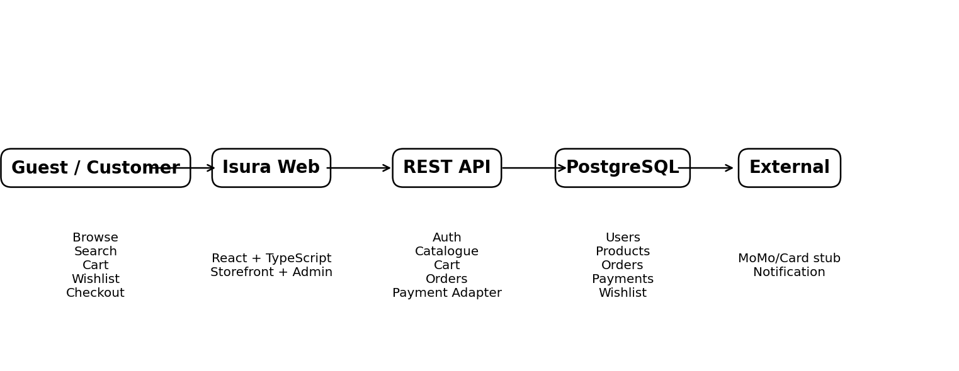
Figure 6.1 — Architecture overview. UAT executes against the staging/UAT environment.

7. Project work plan and schedule
Week | Dates | Tasks | Deliverable / gate
1 | 26 Sep–2 Oct | Kick-off; requirements; draft SRS/UAT | M1 draft
2 | 3–9 Oct | Baseline docs; Docker | M1
3 | 10–16 Oct | Compose services | Healthy compose
4 | 17–23 Oct | K8s Deployment/Service; scale | kubectl evidence
5 | 24–30 Oct | Git workflow; hardening | PR history
6 | 31 Oct–6 Nov | CI/CD Build-Test-Deploy | M2
7 | 7–13 Nov | LO1 CAT | CAT evidence
8 | 14–20 Nov | V-Model/STLC | Requirements register
9 | 21–27 Nov | Test plan; RTM | rtm.csv
10 | 28 Nov–4 Dec | EP/BVA; decision tables; TDD | Lab 3/3A
11 | 5–11 Dec | Execute; regression; JMeter; security | Lab 4
12 | 12–18 Dec | UAT session 1; JSON logging | M3
13 | 19–25 Dec | Grafana golden signals | Dashboard
14 | 26 Dec–1 Jan | Loki; dashboard completion | M4 prep
15 | 2–8 Jan | Alert rules | Evidence
16 | 9–15 Jan | Findings + UAT 2 | UAT report
17 | 16–22 Jan | Recommendations; 5 Whys | LO4 pack
18 | 23–29 Jan | Integrated demo | M5
19 | 30 Jan | Exam | Summative

7.1 Milestone acceptance criteria
Milestone | Trigger | Evidence
M1 | Inception accepted; SRS baselined; UAT issued | Signed report + SRS + UAT
M2 | Containers/K8s healthy; pipeline green | Lab 1–2
M3 | High UAT cases executed; no untested High FR | UAT Dashboard + RTM
M4 | Four golden signals + two alerts | Grafana screenshots
M5 | UAT verdict; LO4 reports; demo | Sign-off + findings

8. Effort and resources
Resource | Allocation | Notes
Contact hours | 80 h | SPEDO501 structure
LO1 | 30 h | Environment
LO2 | 20 h | Testing
LO3 | 20 h | Observability
LO4 | 10 h | Documentation/UAT
Compute | Lab PCs + AWS Free Tier/kind/minikube | No production spend without approval
Tools | GitHub/GitLab, Docker, K8s, JMeter/Gatling, Grafana, Issues/Jira | Project tools
UAT | ≥2 shoppers + 1 admin + Product Owner | Prefer independent participants

9. Communication and reporting
Channel | Frequency | Audience | Owner
Stand-up | Each lab day | Project | Developer
Weekly demo | Friday | Trainer + PO | Team lead
Defect SLA | 24h to triage | QA/developer | QA lead
Milestone review | End M1–M5 | PO + trainer | Trainer
Escalation | Same day if UAT blocked | Trainer | Team lead

10. Risk register
ID | Risk | L | I | Mitigation
R01 | UAT environment not smoke-tested | M | H | Mandatory smoke checklist
R02 | Payment timeout after Paid creates inconsistency | M | H | Explicit timeout requirement + CO-011
R03 | Native-app/live-payment scope creep | M | H | Out-of-scope list in all documents
R04 | Only E2E tests, no unit tests | H | M | TDD + pipeline test stage
R05 | Wishlist persistence not tested | M | H | Dedicated UAT case + RTM check
R06 | Cluster/Docker unavailable | M | M | Week 2 dry-run; Compose fallback
R07 | Developers act as UAT signers | H | M | Independent PO/shoppers where possible
R08 | Sensitive data in logs | L | H | SEC rules + log review

11. Quality and UAT approach
- First-time shopper can register, browse, apply ISURA2026 and complete successful MoMo checkout unaided.
- Gold customer receives free shipping below 50,000 RWF when Gold tier applies.
- MoMo timeout never leaves order Paid; recoverable PaymentTimedOut state shown.
- Admin can publish a product and ship a Paid order using quick-start guidance.
- Record task success rate, time-on-task and 1–5 satisfaction.
Entry: M2 environment, SRS baseline, UAT pack, seed data and green smoke test. Exit: High UAT cases Pass or formally waived, no open Critical defects, and Product Owner/QA sign-off.

12. Assumptions and dependencies
ID | Assumption / dependency | Owner | Needed by
A01 | Docker/Git and cluster available | Trainer/RCA IT | Week 2
A02 | PO available for demos/UAT | Trainer | Week 8
A03 | Payment stub controllable | Developer | Week 10
A04 | SRS/UAT remain version-locked | QA | Ongoing
A05 | No real customer data | All | Ongoing
A06 | Report accepted within five working days | PO + trainer | Week 2

13. Immediate next steps
# | Action | Owner | Deadline
1 | Accept Inception Report | PO + trainer | 2 Oct 2026
2 | Baseline SRS | Developer + trainer | 2 Oct 2026
3 | Issue UAT pack with Not Executed statuses | QA | 2 Oct 2026
4 | Create Git repo, board and RTM | Developer | 30 Sep 2026
5 | Schedule UAT sessions | QA | 20 Nov 2026
6 | Confirm Docker/K8s availability | Trainer | 30 Sep 2026

Annex A — Gantt overview
The work-plan table in §7 is the Gantt baseline. M1–M5 mark the five internal quality gates; UAT appears in Weeks 12–13 and Week 16.

Annex B — Document set
ID | Document | When used
ISF-INC-2026-001 | This Inception Report | M1
ISF-SRS-2026-001 | Software Requirements Specification | Design/verification
ISF-UAT-2026-001 | UAT Test Pack (Excel) | Validation M3/M5
rtm.csv | Requirement Traceability Matrix | STLC
Lab reports 1–7 | Formative evidence | Continuous

