浙江大学城市学院实验报告
课程名称 跨平台脚本开发技术
实验项目名称 实验七 对象进阶2
学生姓名 吴成洋 专业班级 软件工程1404 学号 31401417
实验成绩 指导老师（签名 ） 日期
注意：
- 务请保存好各自的源代码，已备后用。
- 请把作业保存为pdf上传到BB平台，请务必在截止日期前提交。
实验目的：
掌握JS中的对象的原型、原型链、继承的原理与应用。
实验内容：
- JavaScript面向对象编程练习题：
1）定义父类：Shape(形状)类，Shape只有一个属性color，并有相应的getColor和setColor方法。
2） Shape类有两个子类：Rectangle(矩形)类和Circle(圆形)类，子类继承了父类的color属性和getColor、setColor方法。
3）为两个子类增加相应的属性和getArea方法，可调用getArea方法获得矩形和圆形的面积。
用你学过的所有继承方法去实现上面功能。
实验步骤：
1、
//原型链
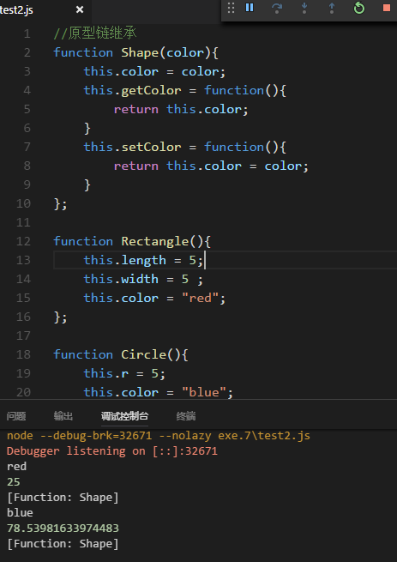
代码如下：
//原型链继承
function Shape(color){
this.color = color;
this.getColor = function(){
return this.color;
}
this.setColor = function(){
return this.color = color;
}
};

function Rectangle(){
this.length = 5;
this.width = 5 ;
this.color = "red";
};

function Circle(){
this.r = 5;
this.color = "blue";
};

Rectangle.prototype = new Shape();
Circle.prototype = new Shape();

Rectangle.prototype.getArea = function(){
return this.length * this.width;
}

Circle.prototype.getArea = function(){
return this.r * this.r * Math.PI;
}

var Rectangle1 = new Rectangle();
var Circle1 = new Circle();

console.log(Rectangle1.color);
console.log(Rectangle1.getArea());
console.log(Rectangle1.constructor);

console.log(Circle1.color);
console.log(Circle1.getArea());
console.log(Circle1.constructor);

//借用构造函数继承
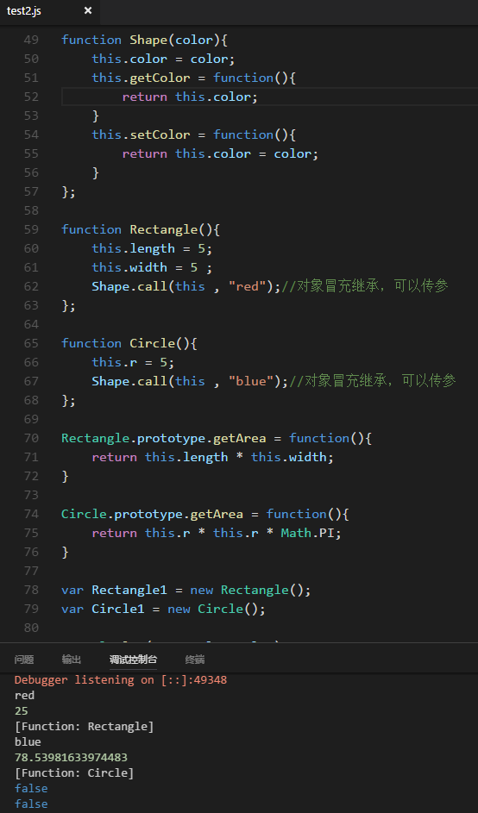
代码如下：
function Shape(color){
this.color = color;
this.getColor = function(){
return this.color;
}
this.setColor = function(){
return this.color = color;
}
};

function Rectangle(){
this.length = 5;
this.width = 5 ;
Shape.call(this , "red");//对象冒充继承，可以传参
};

function Circle(){
this.r = 5;
Shape.call(this , "blue");//对象冒充继承，可以传参
};

Rectangle.prototype.getArea = function(){
return this.length * this.width;
}

Circle.prototype.getArea = function(){
return this.r * this.r * Math.PI;
}

var Rectangle1 = new Rectangle();
var Circle1 = new Circle();

console.log(Rectangle1.color);
console.log(Rectangle1.getArea());
console.log(Rectangle1.constructor);

console.log(Circle1.color);
console.log(Circle1.getArea());
console.log(Circle1.constructor);

console.log(Rectangle1.getColor == Circle1.getColor);
console.log(Rectangle1.setColor == Circle1.setColor);

//组合继承
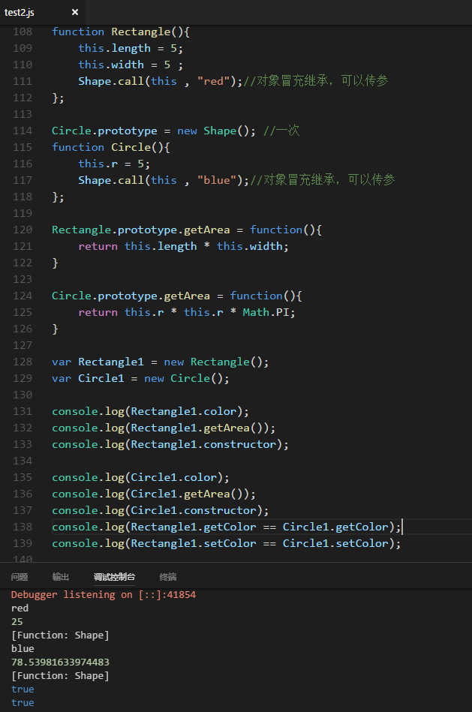
代码如下：
function Shape(color){
this.color = color;
};

Shape.prototype.getColor = function() {
return this.color;
};

Shape.prototype.setColor = function(color) {
return this.color = color;
};

Rectangle.prototype = new Shape(); //一次
function Rectangle(){
this.length = 5;
this.width = 5 ;
Shape.call(this , "red");//对象冒充继承，可以传参
};

Circle.prototype = new Shape(); //一次
function Circle(){
this.r = 5;
Shape.call(this , "blue");//对象冒充继承，可以传参
};

Rectangle.prototype.getArea = function(){
return this.length * this.width;
}

Circle.prototype.getArea = function(){
return this.r * this.r * Math.PI;
}

var Rectangle1 = new Rectangle();
var Circle1 = new Circle();

console.log(Rectangle1.color);
console.log(Rectangle1.getArea());
console.log(Rectangle1.constructor);

console.log(Circle1.color);
console.log(Circle1.getArea());
console.log(Circle1.constructor);
console.log(Rectangle1.getColor == Circle1.getColor);
console.log(Rectangle1.setColor == Circle1.setColor);

//原型式继承
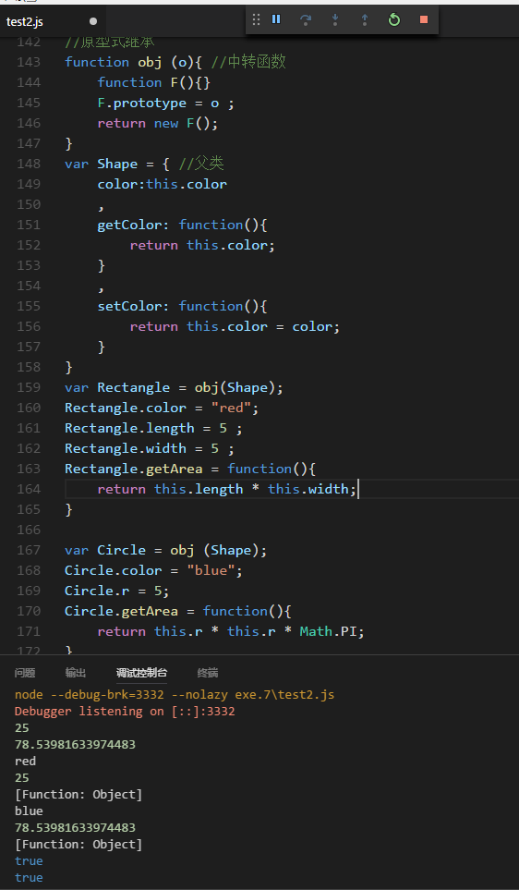
代码如下：
//原型式继承
function obj (o){ //中转函数
function F(){}
F.prototype = o ;
return new F();
}
var Shape = { //父类
color:this.color
,
getColor: function(){
return this.color;
}
,
setColor: function(){
return this.color = color;
}
}
var Rectangle = obj(Shape);
Rectangle.color = "red";
Rectangle.length = 5 ;
Rectangle.width = 5 ;
Rectangle.getArea = function(){
return this.length * this.width;
}

var Circle = obj (Shape);
Circle.color = "blue";
Circle.r = 5;
Circle.getArea = function(){
return this.r * this.r * Math.PI;
}

console.log(Rectangle.color);
console.log(Rectangle.getArea());
console.log(Rectangle.constructor);

console.log(Circle.color);
console.log(Circle.getArea());
console.log(Circle.constructor);
console.log(Rectangle.getColor == Circle.getColor);
console.log(Rectangle.setColor == Circle.setColor);

//寄生式继承
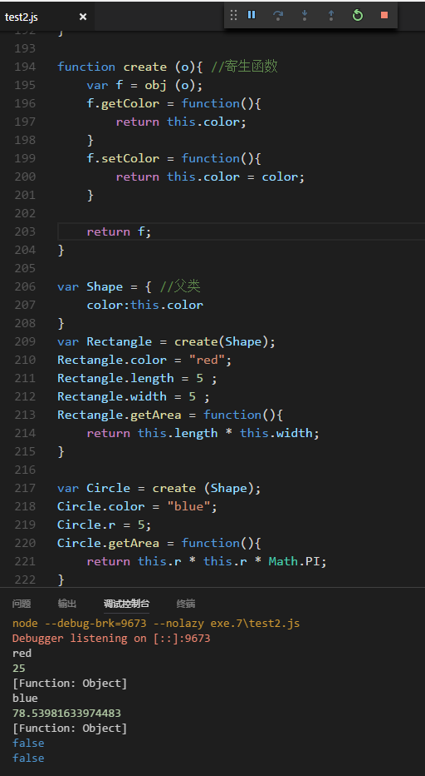
代码如下：
function obj (o){ //中转函数
function F(){}
F.prototype = o ;
return new F();
}

function create (o){ //寄生函数
var f = obj (o);
f.getColor = function(){
return this.color;
}
f.setColor = function(){
return this.color = color;
}

return f;
}

var Shape = { //父类
color:this.color
}
var Rectangle = create(Shape);
Rectangle.color = "red";
Rectangle.length = 5 ;
Rectangle.width = 5 ;
Rectangle.getArea = function(){
return this.length * this.width;
}

var Circle = create (Shape);
Circle.color = "blue";
Circle.r = 5;
Circle.getArea = function(){
return this.r * this.r * Math.PI;
}

console.log(Rectangle.color);
console.log(Rectangle.getArea());
console.log(Rectangle.constructor);

console.log(Circle.color);
console.log(Circle.getArea());
console.log(Circle.constructor);
console.log(Rectangle.getColor == Circle.getColor);
console.log(Rectangle.setColor == Circle.setColor);

//寄生组合式继承
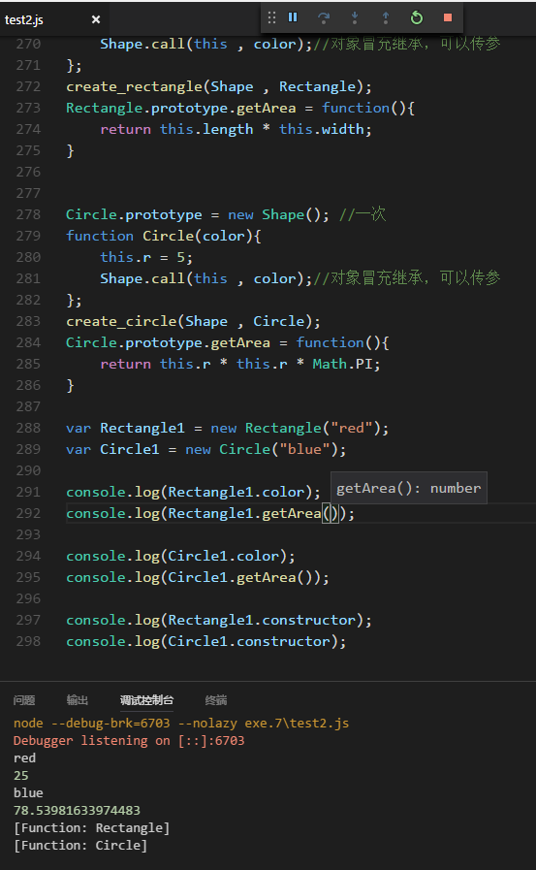
代码如下：
function obj (o){ //中转函数
function F(){}
F.prototype = o ;
return new F();
}

function create_rectangle(Shape , Rectangle ){//寄生函数1
var f = obj (Shape.prototype);
f.constructor = Rectangle;
Rectangle.prototype = f;
}

function create_circle(Shape , Circle){//寄生函数2
var f = obj (Shape.prototype);
f.constructor = Circle;
Circle.prototype = f;
}

function Shape(color){
this.color = color;
}

Shape.prototype.getColor = function() {
return this.color;
};

Shape.prototype.setColor = function(color) {
return this.color = color;
};

//Rectangle.prototype = new Shape(); //一次
function Rectangle(color){
this.length = 5;
this.width = 5 ;
Shape.call(this , color);//对象冒充继承，可以传参
};
create_rectangle(Shape , Rectangle);
Rectangle.prototype.getArea = function(){
return this.length * this.width;
}

Circle.prototype = new Shape(); //一次
function Circle(color){
this.r = 5;
Shape.call(this , color);//对象冒充继承，可以传参
};
create_circle(Shape , Circle);
Circle.prototype.getArea = function(){
return this.r * this.r * Math.PI;
}

var Rectangle1 = new Rectangle("red");
var Circle1 = new Circle("blue");

console.log(Rectangle1.color);
console.log(Rectangle1.getArea());

console.log(Circle1.color);
console.log(Circle1.getArea());

console.log(Rectangle1.constructor);
console.log(Circle1.constructor);

