浙江大学城市学院实验报告
课程名称 跨平台脚本开发技术
实验项目名称 实验十 文档对象模型（DOM）
学生姓名 吴成洋 专业班级 软件工程1404 学号 31401417
实验成绩 指导老师（签名 ） 日期
注意：
- 务请保存好各自的源代码，已备后用。
- 请把作业保存为pdf上传到BB平台，请务必在截止日期前提交。
实验目的：
1、掌握JS中的模块定义与使用。
2、了解编程语言及其解释器的原理与实现
实验内容：
1. 阅读课件讲义并运行讲义示例程序
2. 教材P181 习题13.15.1，13.15.2，13.15.3
3. 教材P196 习题14.16.1，14.16.2，14.16.3
实验步骤：
1、
已阅读讲义实例
2、
2.1、
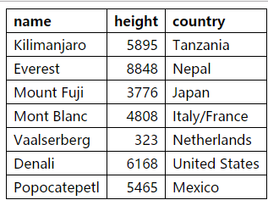
代码如下：
<!doctype html>
<script src="mountains.js"></script>
<script src="13_dom.js"></script>

<table>
<tr>
<th>name</th>
<th>height</th>
<th>country</th>
</tr>
<tr>
<td>Killmanjaro</td>
<td>5895</td>
<td>Tanzania</td>
</tr>
</table>

<style>
/* Defines a cleaner look for tables */
table { border-collapse: collapse; }
td, th { border: 1px solid black; padding: 3px 8px; }
th { text-align: left; }
</style>

<body>
<script>
function buildTable(data) {
var table = document.createElement("table");
var fields = Object.keys(data[0]);
var headRow = document.createElement("tr");

fields.forEach(function(field){
var headCell =document.createElement("th");
headCell.textContent = field;
headRow.appendChild(headCell);
});
table.appendChild(headRow);

data.forEach(function(object) {
var row = document.createElement("tr");
fields.forEach(function(field){
var cell = document.createElement("td");
cell.textContent = object[field];
if(typeof object[field] == "number")
cell.style.textAlign = "right";
row.appendChild(cell);
});
table.appendChild(row);
});
return table;
}

document.body.appendChild(buildTable(MOUNTAINS));
</script>
</body>

2.2、
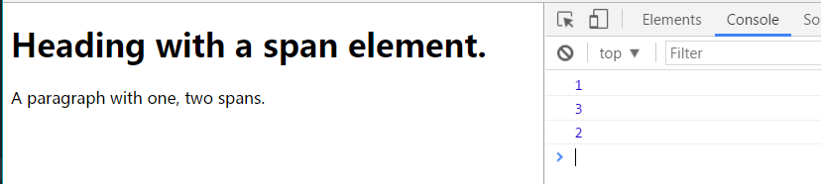
<!doctype html>
<script src="mountains.js"></script>
<script src="13_dom.js"></script>

<h1>Heading with a <span>span</span> element.</h1>
<p>A paragraph with <span>one</span>, <span>two</span>
spans.</p>

<script>
function byTagName(node, tagName) {
var found = [];
tagName = tagName.toUpperCase();

function explore(node) {
for (var i = 0; i < node.childNodes.length; i++) {
var child = node.childNodes[i];
if (child.nodeType == document.ELEMENT_NODE) {
if (child.nodeName == tagName)
found.push(child);
explore(child);
}
}
}

explore(node);
return found;
}
console.log(byTagName(document.body, "h1").length);
// → 1
console.log(byTagName(document.body, "span").length);
// → 3
var para = document.querySelector("p");
console.log(byTagName(para, "span").length);
// → 2
</script>
2.3、
<!doctype html>
<script src="mountains.js"></script>
<script src="13_dom.js"></script>

<img src="cat.jpg" id="cat" style="position: absolute">
<img src="hat.jpg" id="hat" style="position: absolute">

<body>

<script>
var cat = document.querySelector("#cat");
var hat = document.querySelector("#hat");
var angle = 0;
var lastTime = null ;
function animate(time){
if (lastTime != null ){
angle +=(time - lastTime) * 0.0015;
}
lastTime = time;

cat.style.top =(Math.sin(angle)*50+80)+"px";
cat.style.left = (Math.cos(angle)*200+230)+"px";
var hatAngle = angle + Math.PI;
hat.style.top =(Math.sin(angle)*50+80)+"px";
hat.style.left = (Math.cos(angle)*200+230)+"px";
requestAnimationFrame(animate);
}
requestAnimationFrame(animate);

</script>
</body>
3、
3.1、
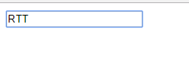
代码如下：
<!doctype html>

<input type="text">
<script>
var field = document.querySelector("input");
field.addEventListener("keydown",function(event){
if(event.keyCode == "Q".charCodeAt(0)||
event.keyCode == "W".charCodeAt(0)||
event.keyCode == "X".charCodeAt(0))
event.preventDefault();
});
</script>

3.2、
代码如下：
<!doctype html>

<style>
.trail { /* className for the trail elements */
position: absolute;
height: 6px; width: 6px;
border-radius: 3px;
background: teal;
}
body {
height: 300px;
}
</style>

<body>
<script>
var dots = [];
for (var i = 0 ; i < 12 ;i++)
{
var node = document.createElement("div");
node.className = "trail";
document.body.appendChild(node);
dots.push(node);
}
var currentDot = 0;
addEventListener("mousemove",function(event){
var dot = dots[currentDot];
dot.style.left = (event.pageX)+"px";
dot.style.top = (event.pageY)+"px";
currentDot = (currentDot + 1) % dots.length;
});

</script>
</body>

3.3、
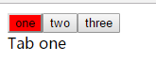
代码如下：
<!doctype html>

<div id="wrapper">
<div data-tabname="one">Tab one</div>
<div data-tabname="two">Tab two</div>
<div data-tabname="three">Tab three</div>
</div>
<script>
function asTabs(node) {
var tabs = [];
for (var i = 0; i < node.childNodes.length; i++) {
var child = node.childNodes[i];
if (child.nodeType == document.ELEMENT_NODE)
tabs.push(child);
}

var tabList = document.createElement("div");
tabs.forEach(function(tab, i) {
var button = document.createElement("button");
button.textContent = tab.getAttribute("data-tabname");
button.addEventListener("click", function() { selectTab(i); });
tabList.appendChild(button);
});
node.insertBefore(tabList, node.firstChild);

function selectTab(n) {
tabs.forEach(function(tab, i) {
if (i == n)
tab.style.display = "";
else
tab.style.display = "none";
});
for (var i = 0; i < tabList.childNodes.length; i++) {
if (i == n)
tabList.childNodes[i].style.background = "red";
else
tabList.childNodes[i].style.background = "";
}
}
selectTab(0);
}
asTabs(document.querySelector("#wrapper"));
</script>

