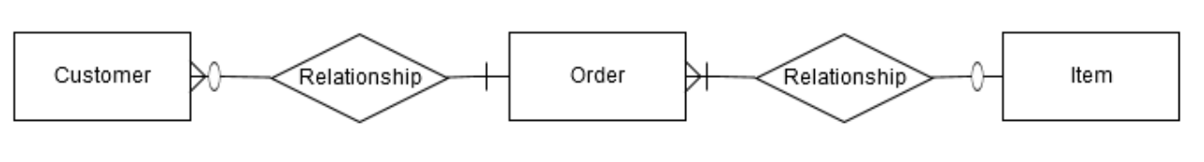ERD for IMS showing relationships between different elements.

* A customer may have 1 or many orders.
* An order must have 1 customers.
* An order must have 1 or many items.
* An item may have 1 and only one order.