|  |  |  |  |  |  |  |
| --- | --- | --- | --- | --- | --- | --- |
| Risk | Risk Level | Persons at Risk | Actions taken to lower risk | Actions by whom | Actions on | New level of Risk |
| Fire Hazards | Serious 1D | Connor | Make Fire extinguisher location is known and emergency services | Connor | Attempt to put out flame, otherwise call emergency services and contact Vinesh via mobile Teams app | Medium 1E |
| Loose Cables and trip hazards | Medium 4B | Connor | Maintain good cable management, table and rearrange cables as required. | Connor | Passively monitor throughout.  Contact Vinesh via mobile Teams app if there are any serious issues, in which case see Major Physical injury. | Low 4D |
| Minor Physical Injury | Medium 3D | Connor | Know locations of first aid supplies. Any injury that is untreatable from first aid supplies is classified as a Major Physical Injury | Connor | At time of incident, deal with injury | Low 4D |
| Major Physical Injury | Serious 1D | Connor | Administer first aid from supplies and contact emergency services | Connor | At time of incident deal with injury.  Contact Vinesh via mobile Teams app at earliest opportunity | Medium 2D |
| Power cut | Medium 2E | Connor | Back up project to cloud regularly and ensure appropriate electrical maintenance | Connor | Contact Vinesh via mobile Teams app if issue has not been resolved in good time. | Medium 2E |
| System failures | Serious 1D | Connor | Back up project regularly and ensure appropriate electrical maintenance | Connor | Contact Vinesh via mobile Teams app at time of incident | Medium 3D |
| Connection Issues | Serious B3 | Connor | Use devices a way that does not ‘stress’ bandwidth  Ensure router is setup and maintained correctly  Have an internet service that actually works | Connor  NowTV | Contact Vinesh via mobile team app if situation becomes serious enough to cause issues. Only contact when work is affected to avoid constant messaging | Serious B3 |
| Complete Connection Failure | Serious 1D | Connor | Same as connection issues | Connor  NowTV | Contact Vinesh via mobile Teams app | Serious 1D |
| Server Failures | Medium 1E | Connor | Back up project regularly on local systems.  Maintain proper server maintenance and 'smart' servers | Connor  Google | Contact Vinesh via mobile Teams app at time of incident | Medium 1E |
| Unable to contact Vinesh | Various according to previous issues | Connor | - | Connor | Attempt to contact Alan Davies via team apps or other instructors | Low 4E |

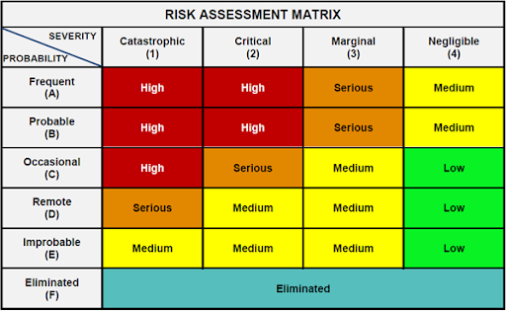

This is the matrix that has been used to judge risk level. Catastrophic is used to define 'Project failed completely', Critical has been used to define 'Project possibly failed, or seriously set back', Marginal has been used to define 'Serious set backs that do not prevent project completion' and Negligible has been used to define all other situations.