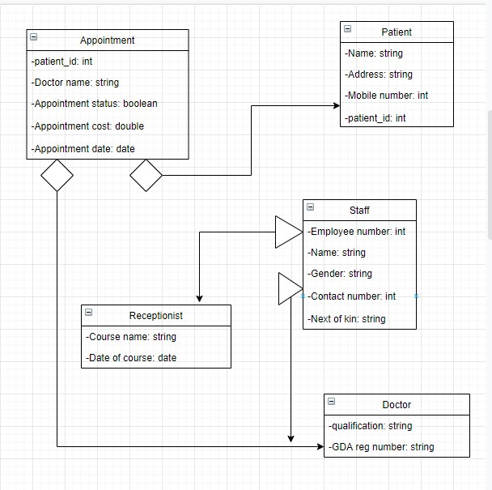

Part2:

By using a whileloop to make it loop forever. We can also use an ArrayList for storing more elements. We can also make multiple extends for better management of the staff members