Backup

We all know that computers break down, we lose USBs, files get corrupted, and we delete files and folders by accident…

And of course it always happens when stress levels are at their highest and minds are on assignments due in tomorrow…

So Backup!! (And think in pairs.)

Reasonable minimum:
- 2 by 16 or 32GByte USB Memory Sticks
- 2 by 480GByte SSD or 1-2TByte hard disk drives
- And/or Cloud-based backup

(You may have to call in all your future birthday presents…)

Remember:
- USBs are good for day to day backup of materials and work.
  - Back up the same material on both USBs for added protection and security.
  - Don’t be quick to copy over previous versions of work.
  - USBs are easy to lose (the dog ate it, etc) – add a lanyard and store them in a clean and water resistant pencil case.
- Portable hard drives are also good for day to day backup of class work.
  - Back up the same material on both hard drives for added protection and security.
  - Don’t be quick to copy over previous versions of work.
  - Portable hard drives can be dropped – carry them in a clean and water resistant case with padding.
- Powered hard disk drives are good for monthly or quarterly back of all your work and computer hard drive content.
  - Don’t be quick to copy over prior work - make multiple copies.
  - When space begins to run out delete the oldest and/or alternate copies first, or buy new hard disk drives.
  - Powered hard disk drives also need to be treated with care – possibly carry and store them in their original padding in their original boxes, and don’t carry them around unnecessarily.
  - You might alternate the drives – backup on one HDD one month, the other the next month.
  - Keep one off-site – Cloud and/or secured in clean and dry unattached shed or garage, or possibly with a family member that you visit reasonably regularly.

- If your computer/laptop has partitions (eg: drives C and D) aim to keep work and other material on D drive – in case your operating system becomes corrupted.
- If someone you know is looking to throw out an older PC or laptop, ask for it as a backup – so you are not without a computer at critical assessment times.
  - Don’t forget to start it up from time to time – to keep the internal battery charged and check on its working condition.
  - Set it up with the software you may need in an emergency.
- Priority: if you are one of those people who downloads the entire internet onto your computer, your personal stuff (songs, stories, poems, artwork, games you’ve written, diary entries, family photos, etc) and college work get priority on this backup media.

Activity One - Google

Using Google or equivalent, source the cheapest Australian pricing you can on the following backup media (including postage if applicable):
- USB memory sticks
- Portable hard drives
- Powered external hard disk drives
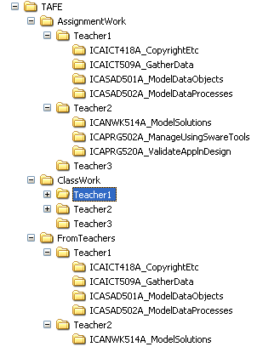

Hard Drive Organisation

Keep your files organised in a logical manner, as exampled right.

Keep folder and file names short – as sometimes files with long names and files buried deep in a directory structure can fail to back up properly.

Activity Two - Wikipedia

Using Wikipedia, find the shortest link distance between the entry: Hard Disk Drive and: Occupational Safety and Health.

Re-usability

Your courses with TAFE and university are your doorway to your future work/career/achievements – whether working for someone else or starting you own business.

With this in mind, almost every written activity, task and assignment you complete through your various courses has the potential for future re-usability. For instance:

- An OHS review might offer you information for home or future office use now and into the future, and the document created might become a template for other such reviews later.
- Every network or project plan will offer you a reference to a similar plan required for a future project – a starter file, a template, a guide – a re-usable reference, a record of your experience.
- Every program or design you might create can be developed or prepared so that parts can be efficiently taken and used in other programs or designs – saving enormous amounts of time with each new development or project.

If you think of each in-class activity and assignment as having the potential for re-usability, you will see and gain real value from your coursework – now and into the future.

Activity Three - Re-usability

List five (5) documents, designs, programs, plans or other items you have developed in the past (including assignments at school) that you have re-used at some point.

Templates

As discussed in the Re-usability section, always prepare documents, plans, programs, designs, etc with a view to using them as templates or starter files, or reusing them as a whole sometime in the future.

Further to this, consistent presentation is important. Imagine for a moment you start your own business or you are working for a newly developing section or business. The documents and other soft-copy items that you will start to prepare should present a consistent look and feel.

For instance, if you prepare every document from scratch you may find that over time you use a range of presentation styles – as your mood dictates.

One approach to ensuring consistency of style and design is to pre-prepare a standard set of templates. Take 2 to 3 hours out and just concentrate on creating a set of documents (for instance) that look and feel the same – that look like they come from the one group, organisation or business. And then consider how your web-site might have the same look and feel.

Four fairly standard types of documents used by groups, organisations and businesses are:
- Memo or email.
- Single page report or information sheet with title and footer.
- Short multipage report or information sheet with title, header and footer.
- Longer report or information document with a cover page and contents.

Most of these incorporate:
- A header and/or footer.
- The longer documents require a title section and headings throughout the document.
- Some require a signature (eg email) or a sign off section (eg: report to the manager or a client).
- Longer documents often require a table of contents, and some documents an index at the back.

Some of the advantages of using a word processor (and we have been waiting many millennium to get these - so be grateful and in awe):
- Spelling and grammar checker.
- The document footer can be made up of fields that auto-update as say the file name, page or date changes.
- The table of contents can be automatically generated if you make use of heading styles throughout your document. This also helps you establish a consistent use of fonts, colours, paragraph spacing, etc.
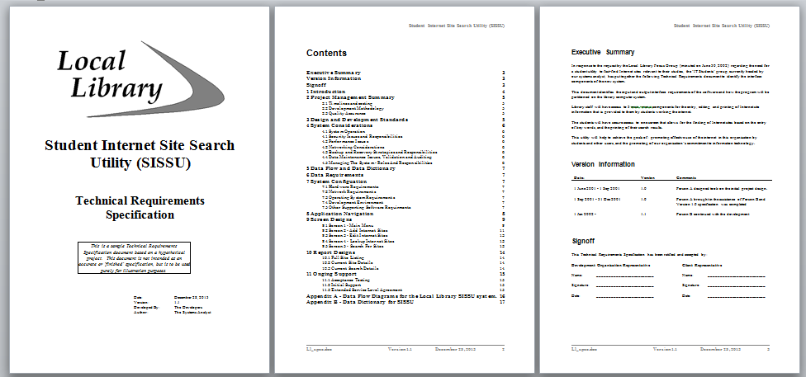
Your instructor will illustrate examples of each of these types of documents, go through the various sections and features and show you how to correctly set up footers and tables of contents. Then it will be your turn…

Activity Four - Templates

Prepare a set of consistent templates in your word processor of choice:
- Memo or email.
- Single page report or information sheet with title and a footer.
- Short multipage report or information sheet with title, header and footer.
- Longer report or information document with a cover page and contents.

