Calculating Database Size, Sample Data and Queries

Based on the Orderform table structure:

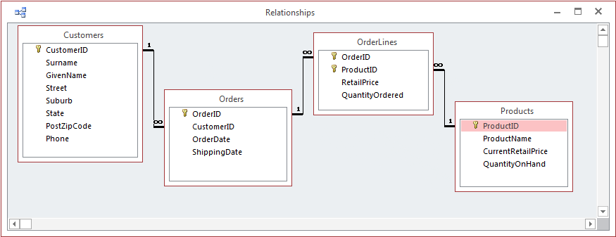

Database size:

- Depending on your data dictionary (ies), you could add a column for the size of one data entry for each field.
- Then make an initial rough estimate of the number of records for each table, and add this number to each row of that table in the next field.
- Then add a third column where you multiply the values in the first 2 of these new columns.
- Then sum the total of the third column.
- (See example: DatabaseSizeCalculationExample.xls.)

- You could look up the equivalent size (Bytes) for the various data types - int, date, etc. (VarChar(20) would be 20 Btyes, for instance.)
  - Info for MS Access (https://support.microsoft.com/en-us/office/data-types-for-access-desktop-databases-df2b83ba-cef6-436d-b679-3418f622e482)
- Sample numbers of records might be:
  - Clients = 50, Orders = 200, OrderLines = 800, Products = 40

Making up Sample data:

- You could add one or two customers. (Customer names could be (for instance): First and Second, or Customer 1 and Customer 2)
- You could then add one or two products. (Product names could be: Product 1 and Product 2)
- You could add 2 sample entries in the next table - Orders - (joined one-to-many from Customers).
- And then you could add 4 sample entries in the next table - OrderLines - (joined one-to-many from both Orders and Products).

Sample queries:

- For AT2, 3 queries and associated reports are required from the list of reports in the original scenario.
- You could copy the SQL code or take a screen image of each query and add to your ICTDBS506 assignment report.
- After each query, you could add a screen image of each of the associated reports.
- Note: in LibreOffice Base (and MS Access) you can create each query and then use a report wizard to generate each report.
- The sample data will provide the detail to fill out (populate) your reports.

Example query and report for the Orderform sample database:

SELECT Orders.OrderID, Orders.CustomerID, Orders.OrderDate, Orders.ShippingDate, Customers.Surname, Customers.GivenName, Customers.Street, Customers.Suburb, Customers.State, Customers.PostZipCode, Customers.Phone
FROM Customers INNER JOIN Orders ON Customers.CustomerID = Orders.CustomerID
WHERE (((Orders.OrderID)=[Forms]![OrdersMF]![txtOrderID]));

