
A discussion of the automation for the Search Utility
in the sample Dave the DJ database solution.

IPO Chart

Input | Process | Output
Search String | Filter the tracks list where the Music Item name, Artist or Track name contain the specified search string | Track details

TOE Chart

Task | Object | Event
Filter the list of tracks | txtSearchString | Lost Focus
Log a track in the Search Log | cmdLog | Click
Print the Search Log | cmdPrint | Click
Provide Help information | cmdHelp | Click
Close the form | cmdClose | Click

Screen Image

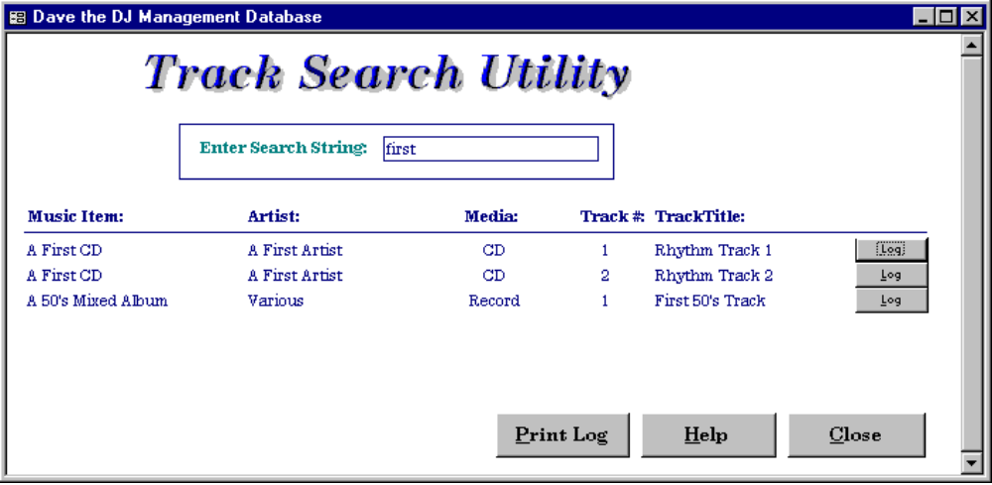

Filter the list of tracks

1. A search string is typed in by the user. The user then TAB’s off the search string field and a module of code is executed:

Private Sub txtSearchString_AfterUpdate()
On Error GoTo ErrorHandler
Me.RecordSource = "qryTrackSearchUtilityMF"
Exit Sub
ErrorHandler:
MsgBox Err.Description
End Sub

2. The code re-queries the form. The query under the form reads the txtSearchString and uses it to filter the records on the form:

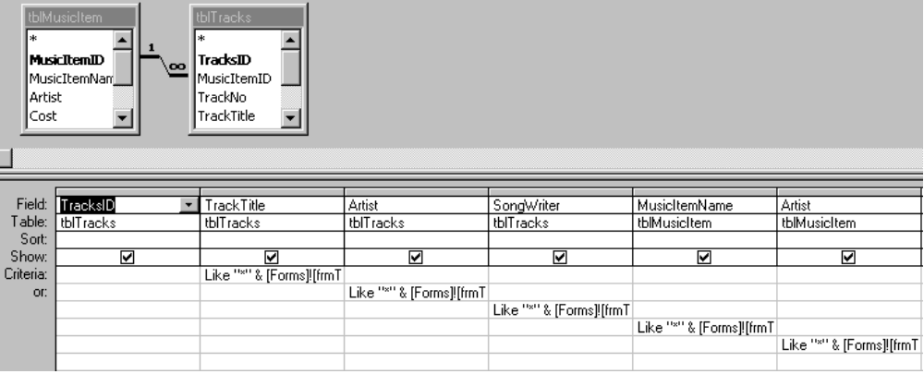

3. Note the expression in the Criteria under each of the TrackTitle, Artist etc columns:

Like "*" & [Forms]![frmTrackSearchUtilityMF]![txtSearchString] & "*"

Log a track in the Search Log

1. The user would click on the Log button to add the associated track to the Search Log table. This action would execute the following module of code, which turns off the query messages and executes the qryAppendToSearchLog append query:

Private Sub cmdLog_Click()
On Error GoTo ErrorHandler
DoCmd.SetWarnings False
DoCmd.OpenQuery "qryAppendToSearchLog"
DoCmd.SetWarnings True
Exit Sub
ErrorHandler:
MsgBox Err.Description
End Sub

record the trackID, the EventTypeID and the current date and time.

2. The qryAppendToSearchLog append query grabs the EventTypeID from the combo box at the top of the Sets forms and the TrackID next to the Log button on the Track Search Utility form, and creates a record in the Search Log table - tblSearchLog:

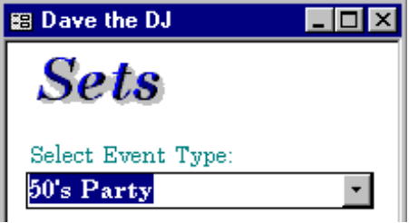 | 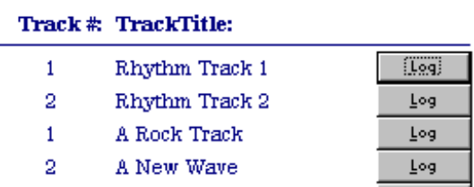

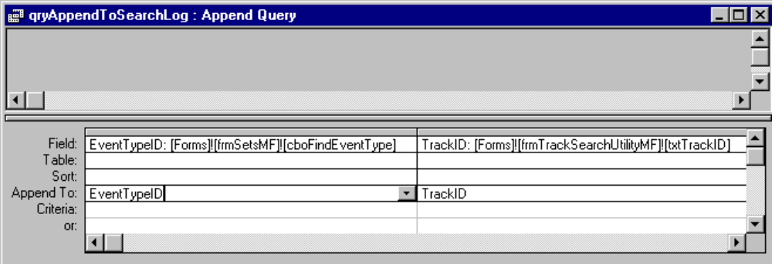

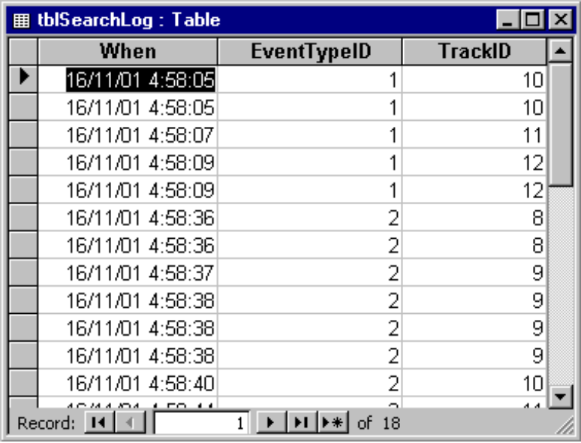

Print the Search Log

1. The user clicks on the Print Log button to print the search log report. Note that this report is grouped by EventTypeID:

