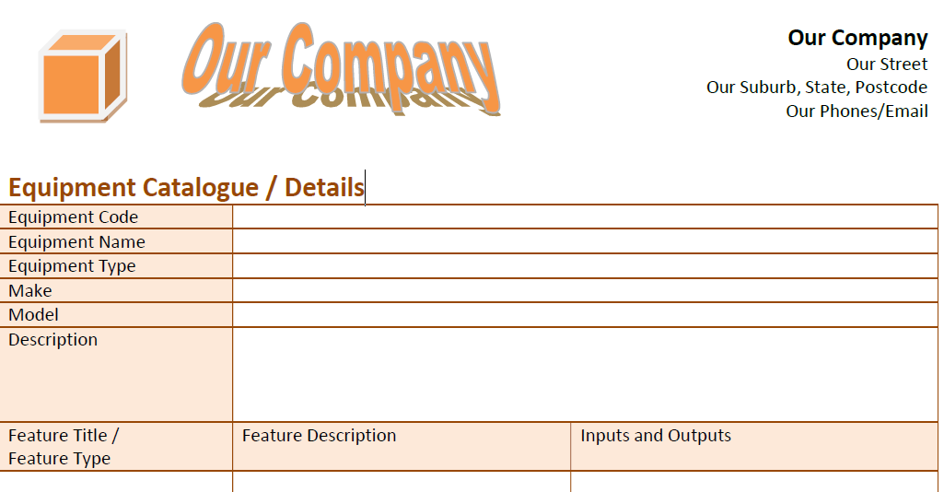

Our Company - Normalisation for Form 1

Original Un-normalised Data Elements
Note: The Identifying Attributes have been highlighted with an underline and in bold type:

{ EquipmentCode, EquipmentName, EquipmentType, Make, Model, Description, { FeatureID, FeatureTitle, FeatureType, FeatureDescription, InputsAndOutputs }, AdditionalInformation }

There are no calculated fields, so no change required:

{ EquipmentCode, EquipmentName, EquipmentType, Make, Model, Description, { FeatureID, FeatureTitle, FeatureType, FeatureDescription, InputsAndOutputs }, AdditionalInformation }

First Normal Form
In this step, the Inner Repeating Groups are removed:

{ EquipmentCode, EquipmentName, EquipmentType, Make, Model, Description, AdditionalInformation }

{ EquipmentCode, FeatureID, FeatureTitle, FeatureType, FeatureDescription, InputsAndOutputs }

Second Normal Form
In this step, the Transitive Dependencies are identified and removed:

{ EquipmentCode, EquipmentName, EquipmentType, Make, Model, Description, AdditionalInformation }

{ EquipmentCode, FeatureID }

{ FeatureID, FeatureTitle, FeatureType, FeatureDescription, InputsAndOutputs }

Third Normal Form
In this step, the Partial Dependencies are identified and removed. In this instance, no Partial Dependencies have been identified, so no change from Second Normal Form:

Equipment: { EquipmentCode, EquipmentName, EquipmentType, Make, Model, Description, AdditionalInformation }

EquipmentFeatureLink: { EquipmentCode, FeatureID }

Features { FeatureID, FeatureTitle, FeatureType, FeatureDescription, InputsAndOutputs }

Note: Depending on the data being entered for the attribute (field) - InputsAndOutputs, and the client’s preference, this field could be expanded into a further one, possibly two, relations (tables).

