Create a database, create tables, alter table structure and table properties and test database with specific queries
TASK 1. Create database and tables
In this task you must create a database and four (4) tables within Microsoft SQL Server. This is just a subset of a database to practice your practical skills on this topic. Before you start creating the tables and columns you need to select a naming convention and use it consistently.
  - Create a database and name it: Orderform

2.2 Using an appropriate naming convention, create four (4) tables using the details provided below for table names and column headings:
Table 1 - Customers: CustomerID, Surname, GivenName, Street, Suburb, State, PostZipCode, Phone
Table 2 – Orders: OrderID, CustomerID, OrderDate, ShippingDate
Table 3 - OrderLines: OrderID, ProductID, RetailPrice, QuantityOrdered
Table 4 – Products: ProductID, ProductName, CurrentRetailPrice, QuantityOnHand

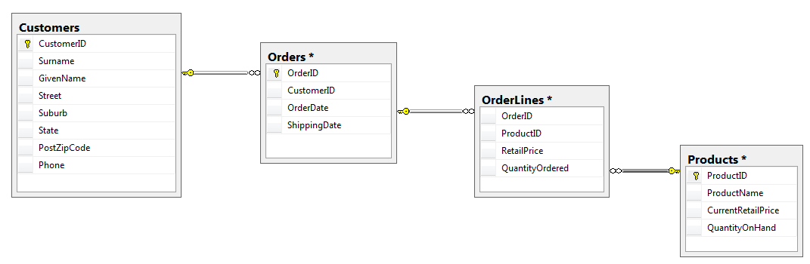

Directions:

Create each table in Microsoft SQL Server directly
Repeat:
Open one of the .csv files in Microsoft Excel and copy the data to the clipboard.
Open (Edit Top 200 Rows for) the corresponding table in MS SQL Server.
Click on the record selector on the right of the first record and paste the data.
For all .csv files.

  - Identify the relation and cardinality ratio between the four tables and link the Primary Keys (PKs) and Foreign keys (FK). Provide a small diagram (a mini ERD) that displays the table relationships and the cardinality ratio (e.g. one-to-one or many-to-one)

  - Identify and properly create the primary keys (PK) for each table. The PK must be set to auto_increment.

  - For each column, select the appropriate precision parameters. These may include: data type, range, attributes, default value, uniqueness and nullability.

- Export a script file from Microsoft SQL Server and save it with a filename such as: Orderform_Database_Script.sql
- Include this file in your activity folder and reference this file in your documentation.

  - Once the tables have been created, identify which columns have been indexed by the system and explain why.

- See also: Orderform_Database_Script.sql

Task 2. Alter table structure

  - Write an SQL statement to alter the Products table and include an extra column named Cost Price. (Follow the naming convention you have decided on in Task 1.)

ALTER TABLE Products
ADD CostPrice MONEY NOT NULL;

  - Write an SQL statement to alter the Orders table to ensure that the date the order was delivered (ShippingDate) also includes the time.

ALTER TABLE Orders
ALTER COLUMN ShippingDate datetime;

  - Alter the Orders table to add a CHECK constraint to ensure that the OrderDate field is never before “1/1/2024”.

ALTER TABLE Orders
ADD CHECK (OrderDate > '1/01/2024')

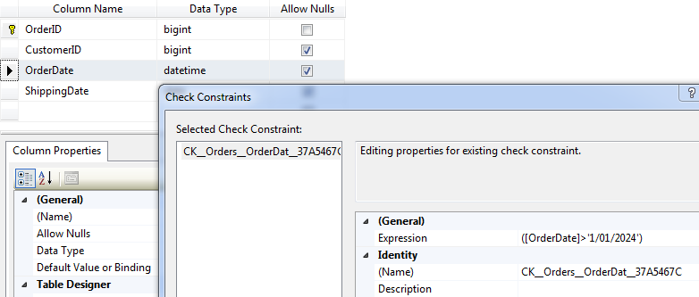

Task 3. Populate the database using CSV files

  - Using the .csv files provided in the data folder (…\Orderform_Data\CSV_Orderform_Data\), import the data into the corresponding tables. Each csv file corresponds to one of the tables:

- Customers.csv
- Orders.csv
- OrdersLines.csv
- Products.csv

- Copy screen images of sample data:
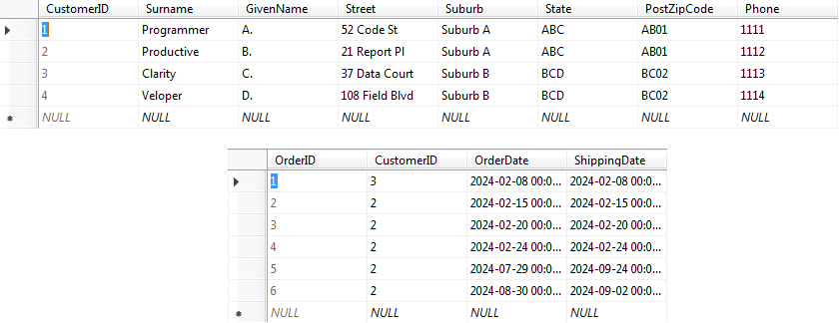

Task 4. Testing the tables with calculations, date and aggregate functions and text/string operations.
NOTE: For each of the following tasks, provide a copy of the SQL query and the results.

  - The computer company requiring the Orderform database occasionally has a 10%-off sale. Write an SQL statement to list the current product price and the on-sale price for just the computer systems.

SELECT ProductName, CurrentRetailPrice, ROUND(CurrentRetailPrice * 0.9, 2) AS OnSalePrice
FROM dbo.Products
WHERE (ProductName LIKE 'System%')
ORDER BY ProductName

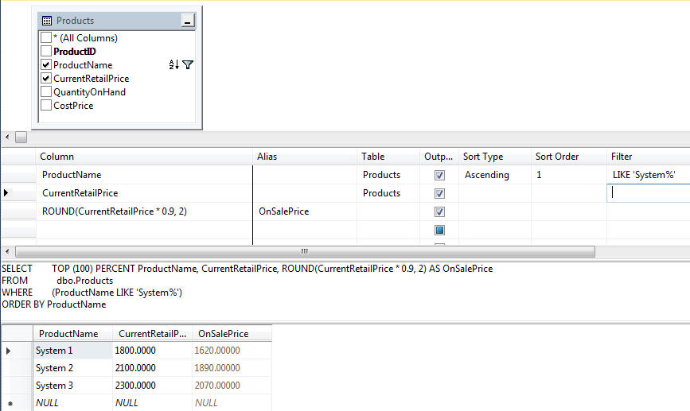

  - Write an SQL statement using date functions to retrieve all orders to be shipped on a Thursday.

SELECT OrderID, DATENAME(weekday, ShippingDate) AS ShippingDay, ShippingDate
FROM dbo.Orders
WHERE (DATENAME(weekday, ShippingDate) = 'Thursday')
ORDER BY ShippingDate

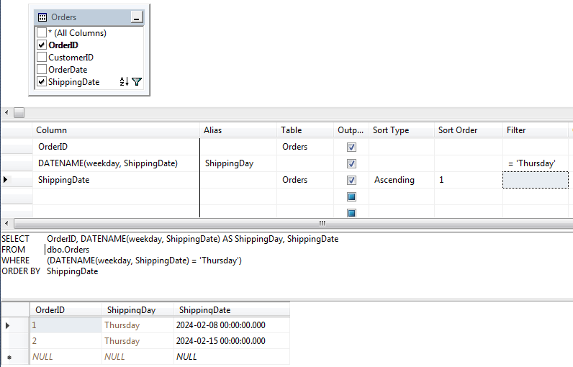

  - Write an SQL statement using functions to retrieve the count of all order lines, and the sum of all order values, for Suburb A.

SELECT COUNT(dbo.OrderLines.OrderID) AS NumOrderLInes, SUM(dbo.OrderLines.RetailPrice * dbo.OrderLines.QuantityOrdered) AS Value
FROM dbo.Orders INNER JOIN
dbo.Customers ON dbo.Orders.CustomerID = dbo.Customers.CustomerID INNER JOIN
dbo.OrderLines ON dbo.Orders.OrderID = dbo.OrderLines.OrderID
WHERE (dbo.Customers.Suburb = 'Suburb A')

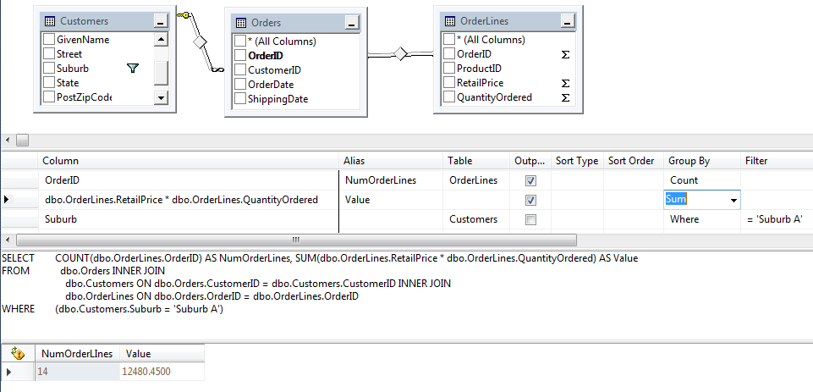

  - Write an SQL statement using aggregate functions to retrieve the number of customers that live in each PostZipCode. Display two columns, the first column will display the PostZipCode and the second column will display number of customers that live in each PostZipCode. Provide an alias for the second column so the heading displayed in the results is “Number of Customers”.

SELECT TOP (100) PERCENT PostZipCode, COUNT(CustomerID) AS [Number of Customers]
FROM dbo.Customers
GROUP BY PostZipCode

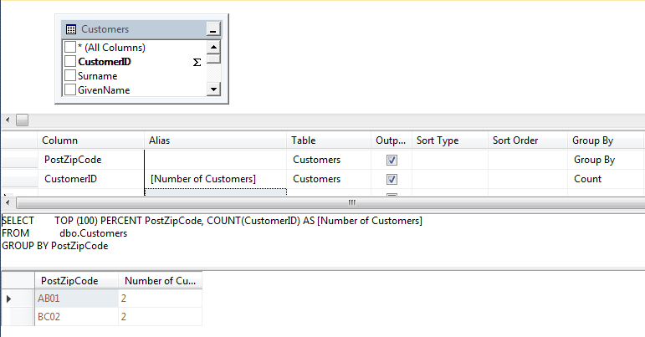

  - Write an SQL statement to retrieve the list of products in the Products table that start with the word: ‘Our’. Use the concat() function to return the ProductName with the prefix Product: (eg: Product: Our Cables and Product: Our Modem). Add an alias to this column: ‘Product’. Add the CurrentRetailPrice and QuantityOnHand to the second and third columns.

(Note: Concat is considered a text operation.)

SELECT { fn CONCAT('Product: ', ProductName) } AS Product, CurrentRetailPrice, QuantityOnHand
FROM dbo.Products
WHERE ({ fn CONCAT('Product: ', ProductName) } LIKE '%Our%')
ORDER BY Product

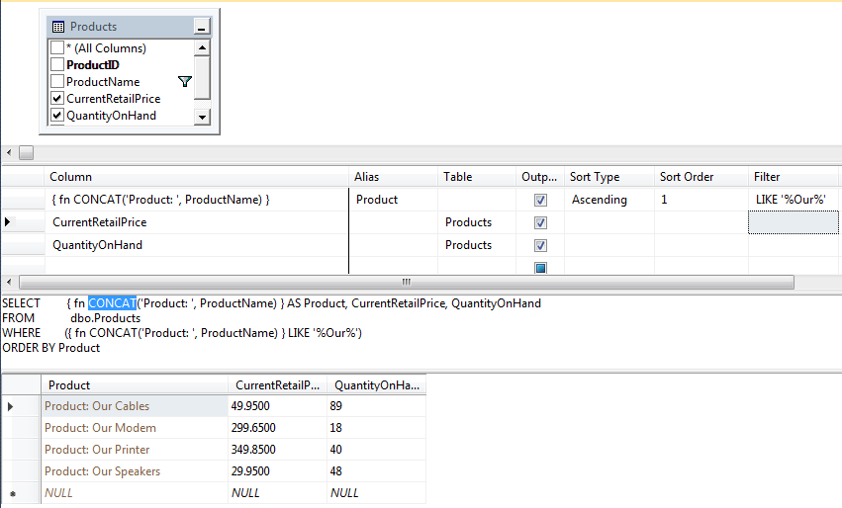

  - Write an SQL transaction to insert the following new record into two tables (Customers and Orders) in a single transaction statement using two views:

{ Customer … Order…
Record: { Person, Sample, 4 Sample Rd, Suburb C, CDE, CD08, 1115, 4, 3/9/2024, 4/9/2024 }
(Note: The CustomerID and OrderID have not been included in this sample data record.)

Partial Solution1:

SET XACT_ABORT ON;

BEGIN TRANSACTION;

INSERT INTO Customers (Surname, GivenName, Street, Suburb, State, PostZipCode, Phone)
VALUES ('Person', 'Sample', '4 Sample Rd', 'Suburb C', 'CDE', 'CD08', '1115');

DECLARE @InsertedID INT;
SET @InsertedID = SCOPE_IDENTITY();

INSERT INTO Orders (CustomerID, OrderDate, ShippingDate)
VALUES (@InsertedID, 3/9/2024, 4/9/2024);

COMMIT TRANSACTION;

NOTE:
- You may to remove or allow for the CHECK_CONSTRAINT added in a previous question
(ie: Qn 2.9).
- Replace one of the tables presented above with an equivalent view.

Partial Solution2:

