Erin’s Electronics Engineering

Erin owns and runs an electronics engineering firm which primarily manufactures and supplies specialised electronic equipment for various trade and industry groups. Some of the electronic equipment is custom designed and developed, while other items are sold as part of a general product line.

A client may ring Erin s Electronics Engineering firm and specify their requirement for a specialised piece of equipment. The client and request details are recorded in a request log book. At other times, Erin or other members of the firm may consider a new piece of equipment to add to the product line. The details of such equipment is also added to the request log. The originator of the new product line item is recorded, though client details are not relevant.

On a biweekly basis, a development meeting is held and the new request log entries are discussed by the engineers. A project manager is selected for each development project and their name is recorded against the request in the log. The project manager is responsible for the development of the specified product.

After analysis of each project is completed, a list of electronic components is generated and a copy is placed in Erin s in-tray. Erin is responsible for creating weekly orders for the firm s various component suppliers. These orders do not need to be tracked by the database.

Erin has asked your development team to consider the development of a database to assist in the management of development requests. Although the system could assist in the management of other business tasks, such as orders and invoicing, Erin wishes to restrict the initial database system to the management of specialised client requests, new product line items and component lists.

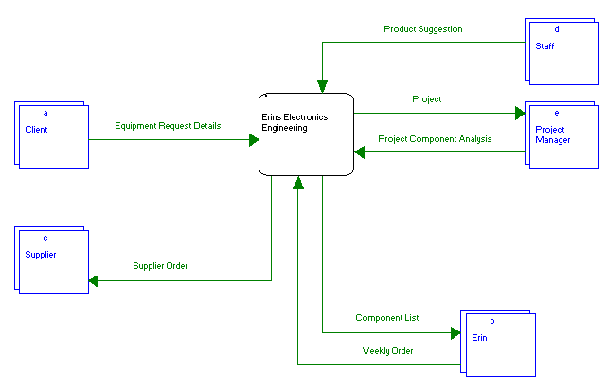

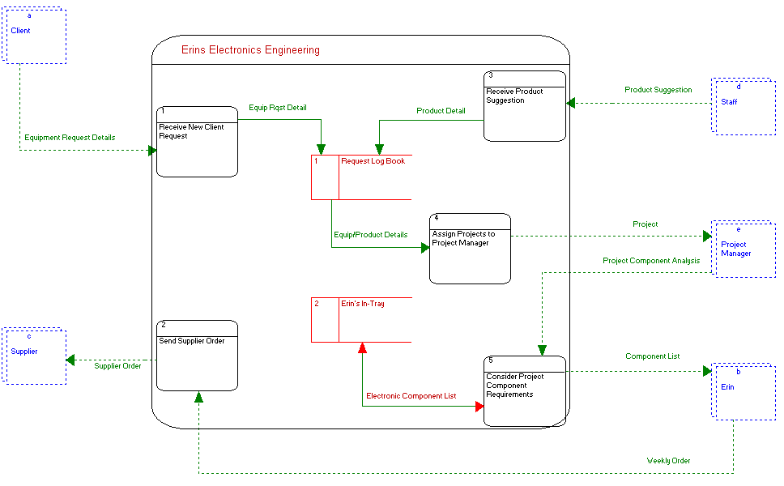

Chris’ Chess Competition

Chris organises regular chess tournaments every 3 months. Each tournament is played over a weekend and is usually restricted to 10 competitors. Each competitor must play every other competitor once, and the competitor who wins the largest number of matches is declared the winner. One or more tiebreaker games may have to be played.

Chris currently uses a paper-based 10 by 10 grid with players names down one side and across the top, and games results are recorded within the grid. Total wins are determined after all games have been played.

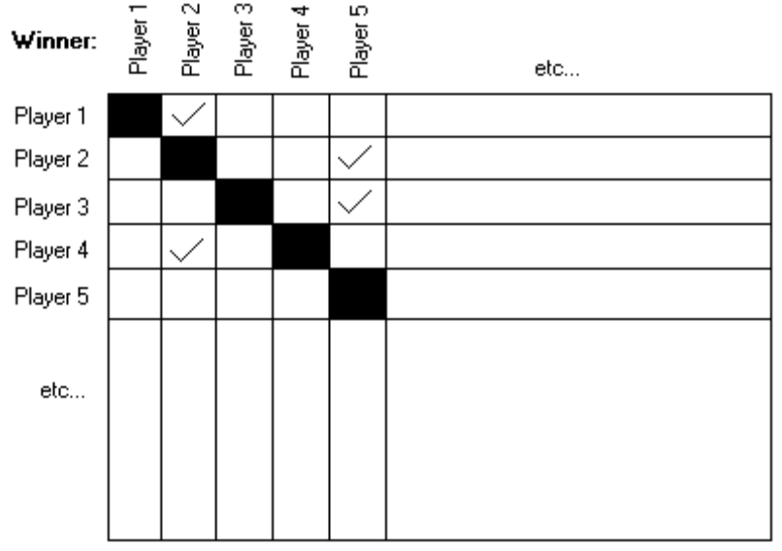

Chris is responsible for alerting a marketing officer that a new tournament is being organised. Subsequently, potential players contact Chris directly with their name and contact details. Chris accepts the first 10 callers and confirms their status as a competitor in the next tournament. Any further callers are placed on a waiting list queue and may be confirmed as competitors if existing competitors indicate their inability to play.

Once the tournament is complete, Chris sends a summary of the results to a local paper for publication.

Chris has asked your development team to consider the development of a database to manage the tournament details including player details and game results. The system should allow Chris to print summary results for the local paper as well as game summary slips for each competitor. The system should also be able to generate annual tournament statistics, including most improved player(s) and the highest scoring chess player(s).

