Vincents Video Loans Counter

A member comes to the loans desk of Vincent’s Video Rentals. The member hands over his/her membership card and the video loans. The membership card has a barcode which is scanned by the loans officer at the counter. If the member forgets his/her card, the loans officer can ask for the member’s name and cross check their membership by asking for their home address or phone number. Membership information is drawn from the membership file.

As part of this membership validation process, the loans officer is able to identify whether the current member has monies owing from late videos. At this point the member is informed of any outstanding debt.

Once the membership has been established, the loans officer takes the videos required and opens each cover to check that the video inside the cover matches the title displayed on the cover. If one or more videos do not match, then the loans officer asks a shop assistant to check for the correct video.

Each video has a barcode and each is scanned by the loans officer. The details of the video are read from the video file, and the loan is subsequently recorded in the loans file. Once the video loans have been entered, the customer is told the amount payable. The customer pays the required monies and is handed the videos, their change and their membership card. The payment details are finalised in the loans file.

Creating a Context Level Diagram

STEP 1 - Add the System

Script:
- A member comes to the loans desk of Vincent’s Video Rentals



STEP 2 - Add the External Entities

Script:
- A member comes to the loans desk of Vincent’s Video Rentals
- The loans officer asks a shop assistant to check for the correct video (NOTE: it has been assumed that the shop assistant is not directly attached to the Loans Counter - this may or may not be a fair assumption, it is just an interpretation.)

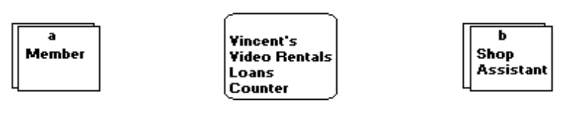

STEP 3 - Add the External Data Flow Lines

Script:
- The member hands over his/her membership card and the video loans.
- the loans officer can ask for the member’s name and cross check their membership by asking for their home address or phone number.
- At this point the member is informed of any outstanding debt.
- If one or more videos do not match, then the loans officer asks a shop assistant to check for the correct video.
- Once the video loans have been entered, the customer is told the amount payable.
- The customer pays the required monies…
- … and is handed the videos, their change and their membership card.

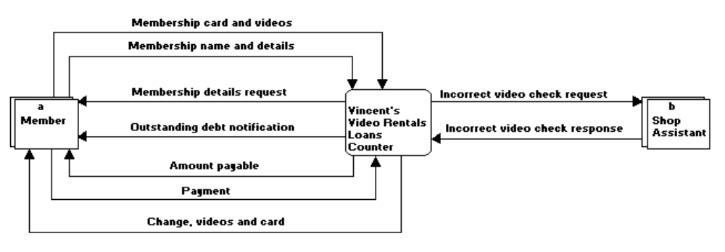

Creating a Level 0 Diagram

STEP 1 - Draw the boundary and external components

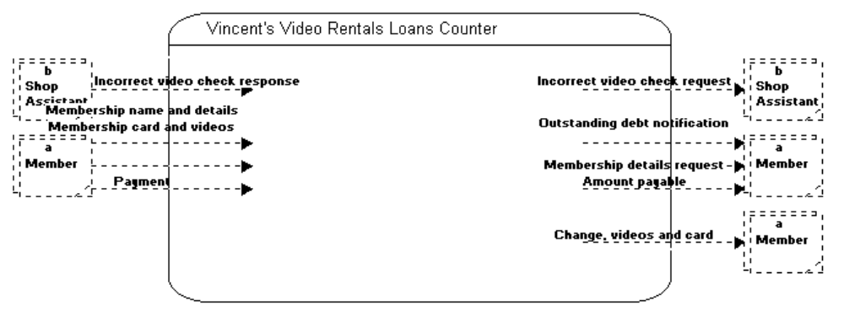

STEP 2 - Determine, draw and label internal processes

Script:
- scanned by the loans officer at the counter
- the loans officer takes the videos required and opens each cover to check that the video inside
- Each video has a barcode and each is scanned by the loans officer
- Once the video loans have been entered, the customer is told the amount payable

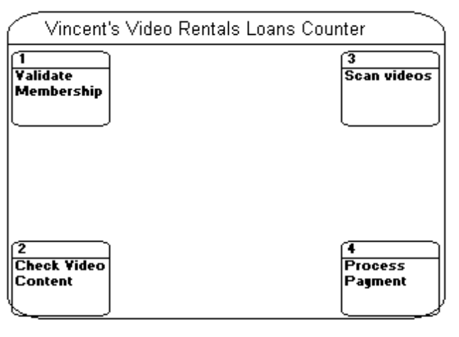

STEP 3 - Join internal processes to external components with existing data flow lines

Script:
- The member hands over his/her membership card and the video loans.
- the loans officer can ask for the member’s name and cross check their membership by asking for their home address or phone number.
- At this point the member is informed of any outstanding debt.
- If one or more videos do not match, then the loans officer asks a shop assistant to check for the correct video.
- Once the video loans have been entered, the customer is told the amount payable.
- The customer pays the required monies…
- … and is handed the videos, their change and their membership card.

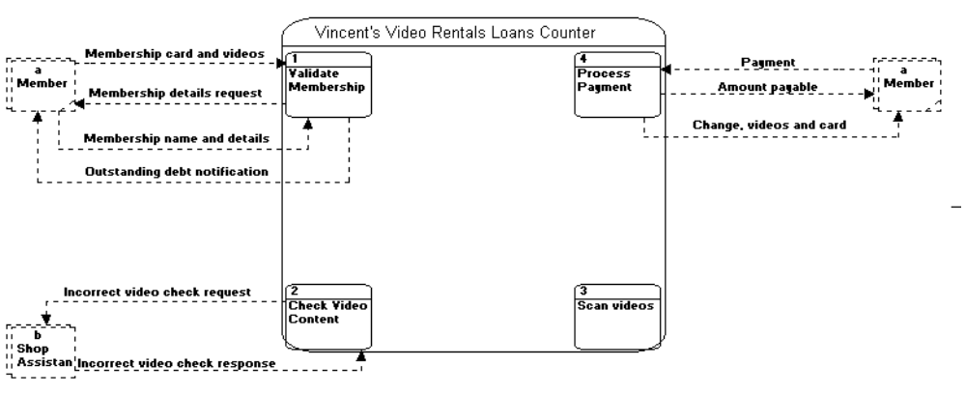

STEP 4 - Separately list all data stores

Script:
- Membership information is drawn from the membership file.
- The details of the video are read from the video file, and the loan is subsequently recorded in the loans file.
- The payment details are finalised in the loans file.

List:
- Membership File
- Video File
- Loans File

STEP 5 - Check which data stores need to be on the current diagram

Data Store Process linked to this store
Membership File 1. - Draws information regarding the current member
Video File 3. - Reads information regarding the current video
Loans File 1. - Un-stated, but the member number would have to be added to the Loans File for the current loan.
3. - Adds (writes) the current video to the loan details.
4. - Adds the payment details to the Loans File

STEP 6 - Draw in appropriate data stores

Note:
- The Member File is only accessed in Process 1. Since this process is to be expanded on as a further Level 1 diagram, this data store will not be included on the Level 0 diagram.
- The Loans File is only accessed by Process 3. Since Process 3 will not be expanded on, the Loans File will be included on this Level 0 diagram.

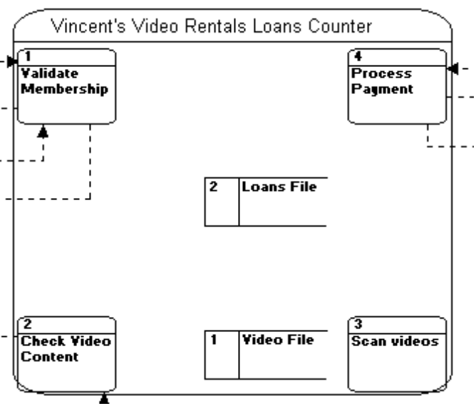

STEP 7 - Add in internal data flows

Note:
- Lines have been added from the Video File to process 3, and from processes 1, 3 and 4 to the Loans File. These are in accordance to step 5 above.
- After the members has handed over their videos and membership card at process 1, they have been forwarded on to each of the processes in turn.

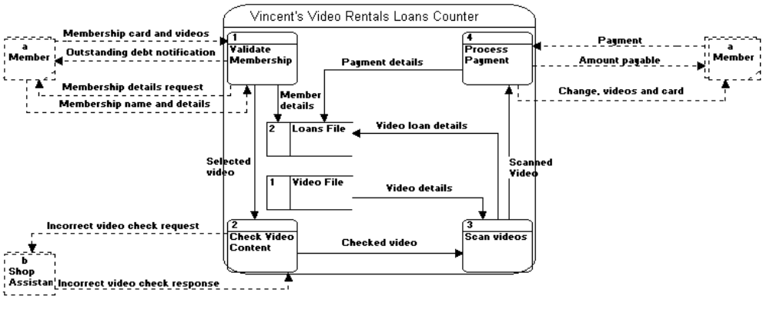

Creating a Level 1 Diagram - Validate Membership

STEP 1 - Draw the boundary and external components

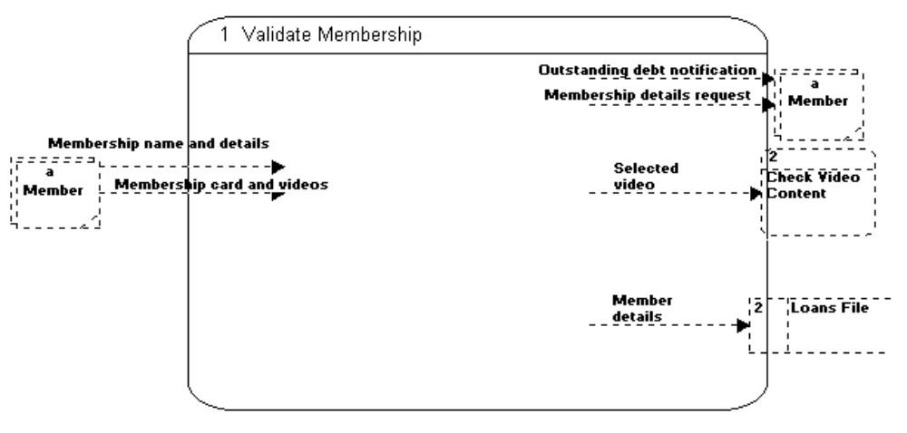

STEP 2 - Determine, draw and label internal processes

Script:
- A member comes to the loans desk of Vincent’s Video Rentals. The member hands over his/her membership card and the video loans. The membership card has a barcode which is scanned by the loans officer at the counter. If the member forgets his/her card, the loans officer can ask for the member’s name and cross check their membership by asking for their home address or phone number. Membership information is drawn from the membership file.

Rationale:

- The loans officer receives videos and possibly the membership card - Receive Videos.
- If there is no card given, then the loans officer must side track to - Get personal details.
- Once the membership has been validated, the membership details are viewed on the computer - View membership details.
- If there is an outstanding debt, then the member is notified - Notify outstanding debt.

Note:

- The script does not identify what happens if the member is not valid. This would be an area of clarification with the client at a further interview.
- The script also does not clarify what would happen if the member did not have sufficient funds to pay or wished to debate the late fee.

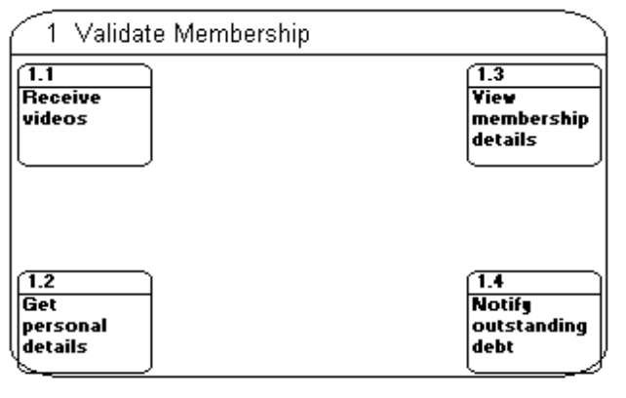

STEP 3 - Join internal processes to external components with existing data flow lines

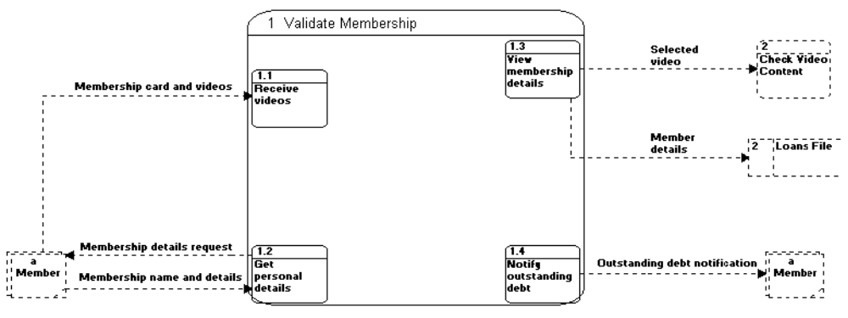

STEP 4 - Draw in appropriate data stores

Data Store Process linked to this store
Membership File 1. - Draws information regarding the current member
Loans File 1. - Un-stated, but the member number would have to be added to the Loans File for the current loan.

STEP 5 - Add in internal data flows

Rationale:

- The member hands over the card and videos to Process 1.1. These are passed on to Process 1.3
- If the card is not handed in at Process 1, then the request is transferred to Process 1.2. The videos are passed to Process 1.3
- Once the member has given his/her name, the Membership details are found and the address is checked. The verified details are passed to Process 1.3
- In Process 1.3 the Members File is accessed to bring up the member’s details (if not already done so in Process 1.2).
- The videos are passed on to the external Process 2 and the member’s details are recorded in the external Loans File.
- If the member has an outstanding debt, then control is passed to Process 1.4.

