**Do you know**

Set 1

1.A bug does not always move to a new location, it always move in a circle at the end：

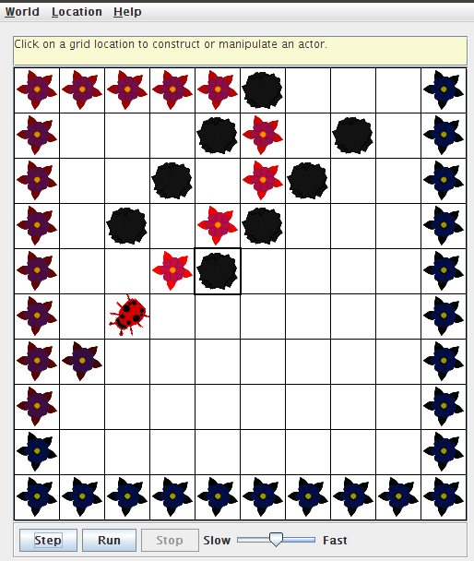

2. A bug will walk to the **north** at the beginning, but it will move in **clockwise direction** when it came across the wall or an actor or a rock.

3. The bug will **turn around** all the time if it does not move.

4. A bug will leave a pink flower hehind when it moves and the color of flowers will turn into purple slowly.

5. When a bug is at the end of an edge of the grid, it will move in clockwise direction.

6. When a bug has a rock in the location immediately in front of it, it will turn around **by 45degreee** each time and then **move** if there is a way to go.

7. A flower does not move

8. The color of a flower is pink at first, and then it will turn into purple.

9. A rock does not move or have any other behavior

10. There can’t be more than one actor (bug, flower, rock) be in the same location in the grid at  
the same time.

**Exercises**

1. Test the setDirection method with the following inputs and complete the table, giving the compass direction each input represents.

|  |  |
| --- | --- |
| **Degrees** | **Compass Direction** |
| **0** | **North** |
| **45** | **Northeast** |
| **90** | **East** |
| **135** | **Southeast** |
| **180** | **South** |
| **225** | **Southwest** |
| **270** | **West** |
| **315** | **Northwest** |
| **360** | **North** |

1. The bug can be moved towards everywhere inside the grid.

We can take the grid as a matrix and the bug can be move from (0,0) to (9,9)

If we try to move the bug outside the grid, then a error will occur.

1. We can use the method void setColor(java.awt.Color) to Change the color of a bug, flower or a rock.
2. The bug will disapeare