Advantest V93000
DUT Board Design Planner
for
<Company Name>
<Device Name>

February 16, 2014
Revision 1.6

Advantest America, Inc.
3061 Zanker Road
San Jose, CA 95134
Tele: (408) 456-5109

Customer Support Center
800-447-8378 (Toll-free within the United States)
512-257-5910 (North America and International)
866-310-0369 (Toll-free Fax)
512-257-6036 (Fax)
support_americas@advantest.com (Internet email)

Warranty
The material contained in this document is provided “as is,” and is subject to being changed, without notice, in future editions. Further, to the maximum extent permitted by applicable law, Advantest disclaims all warranties, either express or implied, with regard to this manual and any information contained herein, including but not limited to the implied warranties of merchantability and fitness for a particular purpose. Advantest shall not be liable for errors or for incidental or consequential damages in connection with the furnishing, use, or performance of this document or of any information contained herein. Should Advantest and the user have a separate written agreement with warranty terms covering the material in this document that conflict with these terms, the warranty terms in the separate agreement shall control.
Printed in February 2014 in the U.S.A.
Table Of Contents
1 Introduction 5
2 Revision History 6
3 References 7
3.1 Device Specific References 7
3.2 Half Size DUT Board 7
3.3 Small DUT Board 7
3.4 Large DUT Board 7
3.5 HSSI DUT Board 7
3.6 Small Stiffener 8
3.7 Large Stiffener 8
3.8 Stiffener Inlays 8
3.9 Handler Specific References 9
3.10 Data Sheets for Bill of Material Items 9
4 Deliverables 10
5 Timeline 11
6 Roles and Responsibilities 12
7 Contacts 12
8 DUT Board Manufacturer 12
9 DUT Board General Information 13
9.1 Handler Information 13
10 Tester Configuration 14
11 Bill of Material 15
12 Handler Interface 17
13 Silkscreen Requests 19
14 Design Detail 19
14.1 Trace Design Rules 20
14.2 DUT Board Stack-up 21
14.3 Device Power Supply Connections 22
14.4 Device Power Supply Decoupling 23
14.5 Signal Pin Routing 24
14.6 Analog Pin Routing 26
14.7 RF Pin Routing 27
14.8 Utility Relays 28
14.9 Test Points 29
14.10 External Circuitry 30
15 DUT Board Development Process 31
16 Schematic Checklist 32
17 Layout Checklist 35
18 Definitions, Acronyms and Abbreviations 39

Introduction
This document describes the requirements to design the <Company Name> <Device Name> DUT board for use on a Advantest V93000 SOC Test System.
The DUT board will have the following characteristics:
- The DUT board will support testing up to <x> devices in parallel.
- To accommodate test systems with fewer resources, the DUT board will configured so that it will be possible to test a single device.
- The DUT board will be compatible with V93000 Single Density and Pin Scale systems.
- The DUT board will be compatible with V93000 <L-Test Heads>, <S-Test Heads>, <C-Test Heads> and <A-Test Heads>.
- The DUT board will be capable of being docked to a <Handler Name and Model> device handler.
- The DUT board may be used for <room>, <hot> and <cold> temperature testing.

Revision History

Revision | Date | Author | Description
1.0
1.1
1.2
1.3
1.4
1.5
1.6

References

Device Specific References
- Advantest V93000 DUT Board Design Planner for the <Company Name> <Device Name> (Word – <Document Name>.docx) – This document.
- Advantest V93000 <Company Name> <Device Name> Pin List (Excel – <Document Name>.xlsx)
- <Device Name> Data Sheet (PDF - <Document Name>.pdf)
- <Device Name> Pin or Ball Map Drawing (PDF - <Document Name>.pdf)
- <Device Name> Package Drawing (PDF - <Document Name>.pdf)
- V93000 - Advantest Technical Documentation Center
See the DUT Board Design Guidelines, especially the ’Drawings’ section under System Reference > DUT Board Design Guidelines > Drawings, Product Numbers and Commercial Parts
Among others, you’ll find detailed technical drawings for these parts:
- Half Size DUT Board
- Small DUT Board
- Large DUT Board
- HSSI DUT Board
- Small Stiffener
- Large Stiffener
- Stiffener Inlays

Check for the latest version under
https://www.advantest.com/V93000/help/index.jsp
If you don’t have access, ask your Advantest representative for a copy of the standalone DUT Board Design Guide which you can install on your own computer.

Handler Specific References
- XXX Handler Design Rules (PDF – XXX DUT Board Design Guide.pdf)

Data Sheets for Bill of Material Items
- XXX Data Sheet (PDF – <Document Name>.pdf)
http://www.<link>
- YYY Data Sheet (PDF – <Document Name>.pdf)
http://www.<link>
- ZZZ Data Sheet (PDF - <Document Name>.pdf)
http://www.<link>
- <Socket> Drawing, p/n <xxx> (PDF – <Document Name>.pdf)

Deliverables
The deliverables of this Advantest offering are as follows:
- Qty <n> DUT Boards
- Qty <n> Sockets
- Qty <n> Manual Actuators
- Qty <n> Cables
- Pin List – DUT pin to tester channel map
- Schematic in PDF and native EDA format (if available)
- Layout in PDF and native EDA format (if available)
- Bill of Materials (BOM)
- Checklists
- TDR report (if available)
- DRC report (if available)
- Manufacturing fabrication drawings (if available)
- Layer stack-up
- Board material
- Drill drawing
- Assembly Drawing
- Reference designators
- Component values (reference BOM)
- Rework instructions (if necessary)

Timeline
Design Starts: <Date>
Schematic: (<n> days)
Schematic Review: (<n> days)
Component Placement: (<n> days)
Placement Review: (<n> days)
Layout: (<n> days)
Layout Review: (<n> days)
Fabrication: (<n> days)
Assembly: (<n> days)
Delivery Date: <Date>

Roles and Responsibilities
<Who> will pay for the design and manufacture of the DUT boards described in this document?
<Who> will provide the components to assemble the DUT boards described in this document?
<Who> will assemble the DUT boards described in this document?

Contacts
Contact name: Applications Engineer Backup Applications Engineer
Phone number:
Mobile number:
Fax number:
E-mail address:
Company name:
Company address:

Contact name: Customer Backup Customer
Phone number:
Fax number:
E-mail address:
Company name:
Company address:

Shipping Address: Shipping Contact
Phone number:
Fax number:
E-mail address:
Company name:
Company address:

DUT Board Manufacturer
Contact name: Sales Contact Engineering Contact
Phone number:
Mobile number:
Fax number:
E-mail address:
Company name:
Note: If available, list a previous design reference for the same device on another tester and/or a similar device on this tester.

DUT Board General Information
Device type: <Digital, DC, Baseband, Memory, RF, etc.>
Board type: Production – Hand Test – Handler
Multi-site: <No, Dual, Quad, Octal>
Temperature testing: <No, Hot, Cold>
Standard impedance: Single Ended: 50 Ω (±5%)
Differential: 100 Ω (±5%)
Max frequency: <400> MHz
Max data rate: <800> Mbps
Board thickness: <0.150”>
Board material: <FR4, Getek, Rogers, Nelco, etc.>
Tester configuration See section 10.0
Bill of material See section 11.0
Silkscreen requests: See section 13.0
Trace design rules: See section 14.1
Board stack-up See section 14.2
External circuitry required: See section 14.6

Handler Information
Board style: SOC DUT interface E6908C
Stiffener: Small DUT board stiffener, SOC Style DUT interface (E6980DA)
Stiffener Inlay: Port Scale RF Adapter Stiffener Inlay for Seiko-Epson NS6040 (N2394A-008)
Package type(s): MBGA
Socket type(s):
Device orientation: See section 12.0
Mounting holes: See section 12.0
Keep-out areas: See section 12.0

Tester Configuration
Tester model: Advantest V93000 <C400, Cx00e, Pxxx, PSxxx> SOC series with a <A-Test Head>, <C-Test Head>, <S-Test Head> or <L-Test Head>
Manipulator type: <default, tumble, linear, etc.>
Power supplies installed: MSDPS1-4
Power supply usage: See section 14.3
Power supply decoupling See section 14.4
Tester I/O pins installed: 10101 to 12416 (384 Pins)
Tester I/O pin usage: See section 14.5
Analog pins installed: Not used
Analog pin usage: N/A
RF pins installed: Not used
RF pin usage: N/A
Utility relay usage: N/A
The diagram below shows the configuration of the target test system:

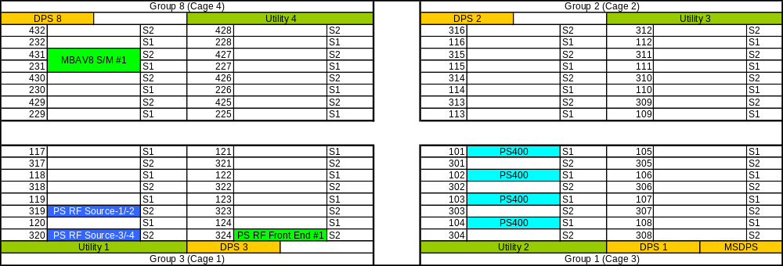

- Tester Configuration

Bill of Material
The following table lists the material required for one DUT board. Most part numbers include a link to the data sheet. The contacts listed in this Design Planner can provide data sheets for those parts that do not have a link.

Qty | Reference Designator | Supplier | Part No. | Description
1 | R1 | AAA | <datasheet link> | RES, 0R18, 1W, 5%, 2512
2 | R2,R3 | BBB | <datasheet link> | RES, 46R4, 1/4W, 1%, 1206
2 | R4,R5 | CCC | <datasheet link> | RES, 68R, 1/4W, 1%, 1206
2 | XR1, XR2 | DDD | <datasheet link> | RES, 2.7K, 1/8W, 1% ,0805
1 | L1 | EEE | <datasheet link> | INDUCTOR, PWR, 15 uH, 1040 mA, 30%
2 | L2,L3 | FFF | <datasheet link> | INDUCTOR, PWR, 100 uH, 540 mA, 30%
2 | L4, L5 | GGG | <datasheet link> | FERRITE CHIP, 120R, 200 mA, 0603
3 | C1,C10,C11 | HHH | <datasheet link> | CAP, 0.1uF, 50V, X7R, 0805
1 | XC1 | III | <datasheet link> | CAP, 0.1uF, 50V, X7R, 0805
1 | C16 | JJJ | <datasheet link> | CAP, 1 uF, 16V, X7R, 1206
6 | C4,C5,C6,C7,C8,C9 | KKK | <datasheet link> | CAP, 2.2 uF, 25V, X5R, 1210
1 | C2 | LLL | <datasheet link> | CAP, 100 uF, 20V, TANT, D
2 | D1,D2 | MMM | <datasheet link> | LED, 565NM, GRN, DIFF, 0603
2 | U1, U2 | NNN | <datasheet link> | DC/DC Converter, 5V, 200 mA
1 | XU1 | OOO | <datasheet link> | IC, 4K, SOIC, 8PIN, SERIAL, EEPROM
1 | Stiffener | Advantest | <datasheet link> | FRAME, V93000, SMALL, ASSY
10 | Stiffener Parts | Advantest | <datasheet link> | SCR, FL, M3X12, MM, PHL90CS
1 | RF Adapter Plate Kit | Advantest | <datasheet link> | Port Scale RF Adapter Plate Kit
2 | J101,J102,J103,J104,J105,J106,J201,J202,J203,J204,J205,J206 | Advantest | <datasheet link> | Port Scale RF Adapter Plate Cables 4" - Qty 6
2 | J101,J102,J103,J104,J105,J106,J201,J202,J203,J204,J205,J206 | Advantest | <datasheet link> | Port Scale RF DUT Board SMP Connectors - 6
1 | RF Stiffener Inlay | Advantest | <datasheet link> | Port Scale RF Adapter Stiffener Inlay
1 | J101,J102,J103,J104,J105,J106,J201,J202,J203,J204,J205,J206 | Advantest | <datasheet link> | Bullet, female-female, SMP, bag of 12
2 | DUT1,DUT2 | PPP | <datasheet link> | Socket, LFCSP, 32-Lead, SMD, 0.5mm-Pitch
2 | DUT1,DUT2 | QQQ | <datasheet link> | Manual Actuator
8 | DUT1,DUT2 | RRR | <datasheet link> | NUT, SELFCLINCHING, M2.5, MM, PEMNUT

Handler Interface
Manufacturer:
Model number:
Control interface: <Ethernet, serial, GPIO, GPIB>
Docking type: <hard, soft>
Manipulator type: <default, tumble, linear, etc.>

Devices are oriented per the standard handler quad-site layout as shown in Figure 2:
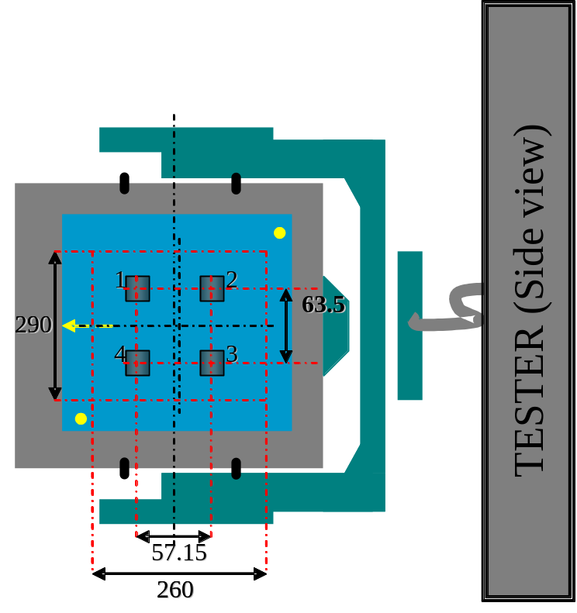
- Device Orientation
Viewing test head from top, with cables to the right: Pin A1 (BGA) is to upper left.
Sites are numbered clockwise, starting from upper left.
Sockets are on 57.15mm centers left to right.
Sockets are on 63.50mm centers top to bottom.
There is a 290mm H x 260mm W keep-out area.

List any mechanical considerations for the DUT board, such as mounting holes.
List other mechanical considerations for the DUT board, such as keep-out areas required by the CUH plate, inlay plate, etc.

Silkscreen Requests
Use the <Customer Name> logo and device ID on the top of the DUT board:
<Customer Logo> <Device Logo and/or Name>
Use the Advantest logo on the top of the DUT board:

V93000

Label the socket pin numbers on both sides of the DUT board.
Label each site number on both sides of the DUT board.
Label pin A1 for BGAs on all sites outside the socket area on the top of the DUT board.
Label all device power supplies and their associated pin names.
Label all components’ polarity.
If space allows, include a pin map on top of the DUT board.

Design Detail
Please refer to the Advantest V93000 DUT Board Small Interface Drawing (ZIP – E6980-96540_P.zip) for mechanical details concerning the E6980B DUT interface.
Please refer to the Advantest V93000 Small Stiffener Assembly E6980DA for Small DUT Board (ZIP – E6980-64110_G.zip) for mechanical information related to the DUT board stiffener that will be used with this interface.
The DUT sockets should be placed on the top of the DUT board. All other components should be placed on the bottom.

Trace Design Rules
Lines
- All traces are strip line.
- All single ended traces should have 8 mils finished line width.
- No 90 degree bends are allowed.
- All traces should have rounded corners and be less than 45 degrees.
- All traces should be short as possible.
- All trace layers are 1.0 oz copper.
- Signal traces must not be within 50 mils of reference plane, parallel splits or splits in the ground/voltage plane.
- Minimum distance between traces is 40 mils except differential pairs.
- Minimum clearance to pads is 8 mils.
- Differential pins should route as follows:
  - Match positive and negative length to ±10 mils.
  - Each positive and negative pair should have 8 mils air gap.
  - Avoid loops to match length.
Reference Planes
- All power layers are1.0 oz copper. All ground layers are 1.0 oz.
- Power planes must have 0.05-inch clearance to exposed board edge.
Vias:
- All vias should have 12 mil holes with 0.5 oz plate up.
- All vias in the vicinity of the DUT sockets should be filled to prevent condensation formed during cold temperature testing from reaching the back side of the board.

DUT Board Stack-up
The DUT Board layer stack-up may be done per the designer’s standard configuration. For example:

Layer |  | Layer |  |  |  | Dielectric | Trace
Number |  | Name | Impedance | Layer Type | 1 oz | Height | Width
 |  |  |  |  | 0.7
Layer 1 |  | TOP | 50 Ohms +/- 5 % | Component / RF Signal | 1.4 |  | 15
 |  |  |  |  |  | 8
Layer 2 |  | GND |  | Ground Plane | 1.4
 |  |  |  |  |  | 8
Layer 3 |  | INR1 | 50 Ohms +/- 5 % | Analog Signal | 1.4 |  | 8
 |  |  |  |  |  | 8
Layer 4 |  | GND |  | Ground Plane | 1.4
 |  |  |  |  |  | 8
Layer 5 |  | INR2 | 50 Ohms +/- 5 % | Analog Signal | 1.4 |  | 8
 |  |  |  |  |  | 8
Layer 6 |  | GND |  | Ground Plane | 1.4
 |  |  |  |  |  | 4
Layer 7 |  | PWR1 |  | Power Plane | 1.4
 |  |  |  |  |  | 4
Layer 8 |  | GND |  | Ground Plane | 1.4
 |  |  |  |  |  | 15
Layer 9 |  | GND |  | Ground Plane | 1.4
 |  |  |  |  |  | 4
Layer 10 |  | PWR2 |  | Power Plane | 1.4
 |  |  |  |  |  | 4
Layer 11 |  | GND |  | Ground Plane | 1.4
 |  |  |  |  |  | 8
Layer 12 |  | INR3 | 50 Ohms +/- 5 % | Digital Signal / Utility | 1.4 |  | 8
 |  |  |  |  |  | 8
Layer 13 |  | GND |  | Ground Plane | 1.4
 |  |  |  |  |  | 8
Layer 14 |  | INR4 | 50 Ohms +/- 5 % | Digital Signal | 1.4 |  | 8
 |  |  |  |  |  | 8
Layer 15 |  | GND |  | Ground Plane | 1.4
 |  |  |  |  |  | 8
Layer 16 |  | BOT | 50 Ohms +/- 5 % | Component / RF Signal | 1.4 |  | 15
 |  |  |  |  | 0.7
 |  |  |  |  | 23.8 | 111

Device Power Supply Connections
The following table should be used for routing power and ground to the device:

Site | Power Supply | BGA  Ball Count | Tester Supply
1 | Vcore | 10 | DPS31
 | Vext | 1 | DPS32
 | Vrtc | 1 | DPS33
 | Vpll | 1 | DPS34
2 | Vcore | 10 | DPS11
 | Vext | 1 | DPS12
 | Vrtc | 1 | DPS13
 | Vpll | 1 | DPS14

The Advantest V930000 <Device Name> Pin List (Excel – <Document Name>.xls) provides the list of DUT pads for each power supply and ground.
For each device power supply, connect appropriate DUT pin(s) to the respective device power supply plane. Each site should have it’s own power planes.
Connect each DPS sense+ pogo pad (make sure pogo via is isolated from the plane and only connected by trace) to a corresponding DUT power pin close to the center of the device.
Connect each DPS sense- pogo pad (make sure pogo via is isolated from the ground plane and only connected by trace) to the DUT ground plane near the force sense connection for the respective power supply.
Make a provision to connect each of the power supply guard lines to ground through a 100 K Ohm resistor.

Device Power Supply Decoupling
The following table should be used to add decoupling capacitors to each power supply.

Site | Power Supply | 10 µF | 0.1 µF
1 | Vcore | 1 | 4
 | Vext | 1 | 1
 | Vrtc | 1 | 1
 | Vpll | 1 | 3
2 | Vcore | 1 | 4
 | Vext | 1 | 1
 | Vrtc | 1 | 1
 | Vpll | 1 | 3

Pads should be provided in convenient locations near the device package for mounting the larger decoupling capacitors (i.e. 10 µF). The smaller decoupling capacitors (i.e. 0.1 µF) should be mounted as close to the device as possible.
Quantities of 10.0 µF and 0.1 µF capacitors are estimates only. The designer should provide space to place as many as two times the number of capacitors specified.

Signal Pin Routing
Trace connections: Best route
Trace type: Unless otherwise specified, all DUT signals will have no length requirement but should be routed as short as practical.
Equal trace length spec: Not required
Matched length for specified pins: Not required
DUT signal pins may be routed to Advantest V93000 channels at the designer’s convenience within the guidelines specified below. The Advantest V930000 <Device Name> Pin List (Excel – <Document Name>.xls) provides the list of DUT pads to be connected to channels.
Please assign channels as follows:

Site | Groups | Channels
1 | 3 & 4 | 11701 to 12416  12501 to 13216
2 | 1 & 2 | 10101 to 10801  10901 to 11616

Please assign one tester channel in the range of tester channels in the table below to the DPS trigger:

Site | DPS | Channels
1 | DPS3 | 11701 to 12416

Analog Pin Routing
Trace connections: Best route
Trace type: Unless otherwise specified, all DUT signals will have no length requirement but should be routed as short as practical.
Equal trace length spec: Not required
Matched length for specified pins: Please match trace lengths for differential signals I & IB, I_S & IB_S, I_D & IB_D, Q & QB, Q_S & QB_S and Q_D & QB_D.
Please assign analog channels per the following table:

 |  | Site 1 |  |  | Site 2
Signal | DUT | Slot | Unit | Pin | Slot | Unit | Pin
I_S | 2 | 431 | 1 | 16B | 431 | 3 | 16B
IB_S | 3 | 431 | 5 | 12B | 431 | 7 | 12B
Q_S | 23 | 431 | 2 | 15B | 431 | 4 | 15B
QB_S | 22 | 431 | 6 | 11B | 431 | 8 | 11B
I_M | 2 | 231 | 9 | 8B | 231 | 11 | 6B
IB_M | 3 | 231 | 13 | 4B | 231 | 15 | 2B
Q_M | 23 | 231 | 10 | 7B | 231 | 12 | 5B
QB_M | 22 | 231 | 14 | 3B | 231 | 16 | 1B
REF_OP_M | 21 | 231 | 25 | 8B | 231 | 26 | 7B

RF Pin Routing
Trace connections: Best route, microstrip transmission line on outer layer, >10 mil trace width
Trace type: Unless otherwise specified, all DUT signals will have no length requirement but should be routed as short as practical.
Use microstrip transmission line on outer layer with at least 10 mil trace width.
Avoid sharp corners at trace bends. Use rounded corner with radius greater than 3 trace widths.
Equal trace length spec: Not required
Matched length for specified pins: Not required
Please assign RF channels per the following table:

Signal | DUT | Slot | Unit | Conn | Slot | Unit | Conn
RX850 | 32 | 324 | 1A1 | J102 | 324 | 1C1 | J202
RX900 | 30 | 324 | 1B1 | J101 | 324 | 1D1 | J201
TXOP_LO | 10 | 324 | 2A1 | J105 | 324 | 2C1 | J205
TXOP_HI | 11 | 324 | 2B1 | J105 | 324 | 2D1 | J205
RX1800 | 28 | 324 | 3A1 | J103 | 324 | 3C1 | J203
RX1900 | 26 | 324 | 3B1 | J104 | 324 | 3D1 | J204

RF connections on the DUT board should use tester-side SMP connectors as described in Appendix A.

Utility Relays
Please assign utility relays per the following table:

 | Site 1 |  |  |  | Site 2
Signal | Relay | Unit | Block | Pin | Relay | Unit | Block | Pin
VDD_CAP | K101 | 101 | U1 | 2B | K201 | 201 | U2 | 2B
VBAT_CAP | K102 | 102 | U1 | 3A | K202 | 202 | U2 | 3A
REFIN_R | K103 | 103 | U1 | 3B | K203 | 203 | U2 | 3B
REFINB_R | K104 | 104 | U1 | 4A | K204 | 204 | U2 | 4A
I_R | K105 | 105 | U1 | 5B | K205 | 205 | U2 | 5B
IB_R | K106 | 106 | U1 | 6A | K206 | 206 | U2 | 6A
Q_R | K107 | 107 | U1 | 6B | K207 | 207 | U2 | 6B
QB_R | K108 | 108 | U1 | 7A | K208 | 208 | U2 | 7A

Utility relays have the following actions:

Signal | Off Condition | On Condition
VDD_CAP | Caps Connected to VDD | Caps Disconnected from VDD
VBAT_CAP | Caps Connected to VBAT | Caps Disconnected from VBAT
REFIN_R | Crystal Connected to REFIN | Tester Connected to REFIN
REFINB_R | Crystal Connected to REFINB | REFINB Disconnected
I_R | Source Disconnected from I | Source Connected to I
IB_R | Source Disconnected from IB | Source Connected to IB
Q_R | Source Disconnected from Q | Source Connected to Q
QB_R | Source Disconnected from QB | Source Connected to QB

Test Points
Please assign test points per the following table:

Signal | Site 1 | Site 2
VDD | TP101 | TP201
VAFC | TP102 | TP202
VCC_REF | TP103 | TP203
I | TP104 | TP204
IB | TP105 | TP205
Q | TP106 | TP206
QB | TP107 | TP207
GND | TP108 | TP208
VBAT | TP109 | TP209
REFIN | TP110 | TP210

External Circuitry
Please connect the XXX serial ERPROM per the diagram in Figure 3:

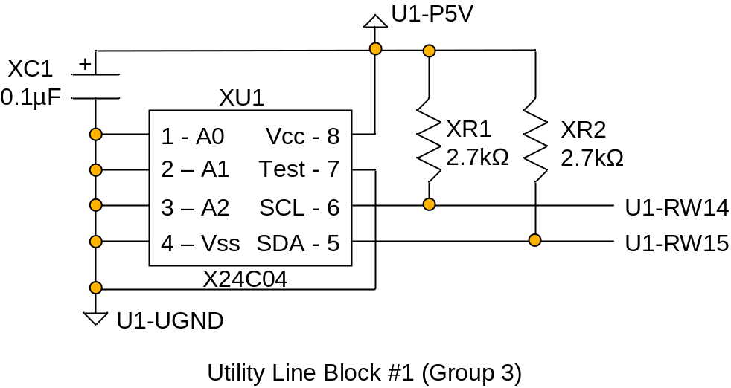
- DUT ID EEPROM Circuit Drawing
For additional information regarding the DUT ID EEPROM reference the XXX Data Sheet (PDF - <Document_Name.pdf).

DUT Board Development Process

High Level Checklist
Fill Out Design Planner Document
Conduct Design Planner Review with Team and DUT Board Vendor
Send Design Planner to DUT Board Vendor
Receive Schematic
Conduct Schematic Review (use Schematic Checklist from Section 16)
Receive Layout
Conduct Layout Review (use Layout Checklist from Section 17)
Board Fabrication
Board Assembly
Verify Board
Gain Customer Acceptance

Schematic Checklist

Gather information required to support schematic design
DUT data sheet or equivalent
DUT pin list
Specifications to be met by test solution
DUT board specifications required to meet test solution
Transmission line impedance requirements at DUT interface
Single-ended vs. differential transmission line requirements
Frequency of operation for all DUT signal pins
Tester configuration
Tester resources required to meet test solution
Optional:
Schematic/netlist of customer evaluation board, or recommended DUT connections
Known noise generators from DUT (what pins generate noise?)
Known sensitivity issues at DUT (what pins are sensitive to noise?)
Socket information for generating schematic symbol
Review DUT pin connections and test requirements
Identify all signal pins and their type (Input, Output, I/O, Analog, etc.)
Identify tester resource connections at each signal pin
Identify all ground pins and their type (DGND, AGND, RFGND, etc.)
Specify transmission line routing for all critical signal paths
Transmission line impedance and tolerance
Transmission line type (microstrip, stripline)
Differential or single-ended
Length matching requirements for differential pairs
Identify signal paths that require isolation for sensitive signals, or for noise generators
Specify power supply decoupling requirements
Determine voltage and current requirements for each DUT power supply
Determine voltage tolerance requirements for each power supply
Determine any current steps during test, if applicable (i.e. changing state between quiescent and operational)
Determine target impedance for power distribution network to meet power supply noise requirements (i.e. how much ripple noise is acceptable?)
Determine frequency range requirements for power distribution network (typically the DUT operating frequency range)
Choose capacitor array components to meet impedance requirement for power distribution network
Choose bulk capacitor components to meet voltage tolerance requirements
Optional:
Simulate the capacitor array network using vendor-supplied models to verify the impedance profile over the operating frequency range
Specify supporting circuits and components
Select relays with operational frequency range to support test solution
Verify relay switching current does not exceed Utility resource capabilities
Add relay driver for switching relays with higher current requirements
Add filter network to utility power as recommended in the System Reference or DUT Board Design Guide documentation
Add buffer amplifier at DUT analog outputs that cannot drive a capacitive load
Add calibration paths for phase-critical analog signal paths (i.e. I/Q pairs)
Add test points at net nodes where probing will be useful for debugging or troubleshooting (i.e. DC power supplies, analog signals, triggers, etc.)
Verify that added test points won’t degrade signal integrity (avoid high-speed signal paths or high-frequency analog signal paths)
Optional:
Add EEPROM for board identification and connect to utility resources as shown in System Reference or DUT Board Design Guide
Add LED indicator circuits for each DPS for easy identification of active power

Layout Checklist

Review requirements specified in schematic
Tester resource connections to DUT pins
Ground separation for different signal types (DGND, AGND, RFGND, etc.)
Transmission line impedance and tolerance
Differential transmission lines
Length matching requirements
Sensitive or noisy signal paths that require isolation
Power supply decoupling
Supporting circuits and components (relays, active components, etc.)
Specify device socket
Select socket to fit DUT package
Verify signal path through socket will support operational frequency range of DUT
Determine socket lifecycle and maintenance requirements for application (characterization vs. production vs. HVM)
Verify socket will meet lifecycle and maintenance requirements
Review socket mechanical drawing and determine any special requirements for mounting on DUT board
Verify component footprints for all new or critical components
Verify footprint in layout matches vendor specification
Verify orientation is correct (does vendor specification show top view or bottom view?)
Verify component pinout in layout matches vendor specification and is in correct orientation
Verify pad size, pitch, finished hole size (FHS) of vias, via pad size, via clearance on ground planes
Specify board material and stackup
Choose low-loss dielectric to minimize loss for critical high-frequency signal paths (i.e. Getek, Nelco 4000-7, or Rogers 4350)
Choose thick dielectric to allow for wide traces to reduce conductive loss for critical high-frequency signal paths (typically 10 mils)
Choose thin dielectric between power and ground planes to increase capacitance (typically ≤ 4 mils)
Mix expensive low-loss dielectric layers and cost-effective FR4 or Getek to minimize total cost (use low-loss dielectric only where necessary)
Group signal layers by type (i.e. digital, analog, RF, utility, power)
Specify thick copper for high-current power planes (≥ 1 oz. copper)
Surround each signal layer with ground planes for isolation
Balance plane layers and signal layers throughout the stackup to improve manufacturability and prevent warpage
Verify transmission line structures
Verify trace width in layout meets impedance requirement
Verify trace width and spacing in layout meets differential impedance requirement
Verify separation from other traces is sufficient to minimize crosstalk (typically ≥ 5 trace widths)
Add ground stitch vias to increase isolation of critical traces
Minimize trace bends or other discontinuities across signal path
Use curved bends to minimize discontinuity at angle transitions
Ensure that trace is centered over ground where routed through via array with reduced ground region due to plane clearance at vias (i.e. BGA or pogo block)
Avoid separation of traces for differential routing with tight coupling (loose coupling is more tolerant to trace separations at routing obstructions)
Verify that ground plane under traces is continuous (avoid splits or slots in ground plane)
Minimize trace length to reduce conductive loss for high-frequency signal paths
Use wide trace width to reduce dielectric loss for high-frequency signal paths
Verify trace lengths meet length matching requirements
Verify via structures are designed to reduce discontinuities for high-frequency signal paths
Verify that signal via has neighboring ground vias (at least 2, preferably 4)
Choose plane layer clearance around via to provide a controlled impedance coax structure
Optional:
Use 3D EM EDA tool to simulate and optimize signal path through via for best performance at high frequencies
Review power distribution network
Verify width of DPS planes or traces to provide low impedance path to DUT
Verify separation between copper regions on same layer to avoid coupling noise between supplies (≥ 25 mils)
Verify that power planes have adjacent ground plane
Review placement of decoupling capacitors
Verify that small-valued capacitors are as close to DUT power supply pins as possible
Place multiple vias at each capacitor pad where possible to minimize inductance to power and ground planes
Utility power and control routing
Verify UP5V filter layout; should be placed near Utility pogo block
Minimize routing of filtered UP5V and UGND; route as wide traces instead of planes
Ensure that Utility control traces are routed near UP5V and/or UGND to minimize the loop area
Verify digital and analog resource usage
Verify pogo pin usage for differential pairs at digital resources
Verify hardware triggers are routed from digital pins for analog resources, if required
Verify I/Q pair assignments to MCA/B resources to allow for hardware DSP usage and to minimize trigger skew (Use pairs on a single channel module – A/C, B/D, E/G, F/H)
Verify mechanical restrictions
Determine whether inlay is required
Determine if there are any special requirements for interfacing to handler
Verify components don’t violate height restrictions to stiffener or inlay
Verify components are placed in open areas of stiffener/inlay assembly
Additional considerations
Specify thick gold plating (≥ 30 microinches) for pogo pads, contactor pads, and high-frequency signal traces on outer layers (microstrip)
Check fabrication notes for special instructions
Request final Gerber files for review

Definitions, Acronyms and Abbreviations
ADC Analog to Digital Converter
ADLC Application Development Life Cycle
AE Application Engineer
AEDM Applications Engineering District Manager
AGND Analog Ground
Annular Ring The pad area that remains after a hole is drilled through the pad.
ATE Automatic Test Equipment. The general term used for equipment that can test component electronics and that is controlled with software.
ATH A-Test Head
BGA Ball Grid Array
AV8 Audio / Video 8
Blind Via A via hole that does not pass completely through the printed circuit board. A blind via starts from one side or another.
BOM Bill of Materials. A document that includes manufacturer’s part numbers, quantity required, device descriptions, value, type or size, and reference designators.
C200e Single Density C Series pin electronics with 16 channels licensed up to 200 Mbps.
C400e Single Density C Series pin electronics with 16 channels licensed up to 400 Mbps.
CAD Computer Aided Design
CAE Computer Aided Engineering
CE Customer Engineer
CEDM Customer Engineering District Manager
CTH Compact Test Head
CUH Contact Unit Holder
DAC Digital to Analog Converter
DGND Digital Ground
DIB Device Interface Board
DMM Digital Multimeter
DPS Device Power Supply
DRC Design Rules Check
DSP Digital Signal Processor
DTH DUT Scale Test Head
DUT Device Under Test
DUT Board A printed circuit board (PCB) that provides the interface between the DUT and the ATE. The DUT interface is usually in the form of a socket. Also called a Load Board.
DUT Scale V93000 A-Test Head, C-Test Head, or S-Test Head fitted with the contactor from a L-Test Head. Also known as DTH.
DVM Digital Volt Meter
DWG AutoCAD Interchange File
DXF AutoCAD Interchange File
EDA Electronic Design Automation
ESL Equivalent Series Inductance.
ESR Equivalent Series Resistance. A measure of the total lossiness of a capacitor which includes the leads, electrodes, dielectric losses, leakage (IR) and most important, the end spray connecting the leads to the metallized film. The lower the ESR the higher the current carrying ability the capacitor will have.
FE Field Engineer
FEDM Field Engineering District Manager
FHS Finished Hole Size
FR-4 The standard glass epoxy substrate for Printed Circuit Boards (PCBs).
GPDPS General Purpose Device Power Supply. This DPS has 4 channels, each capable of supplying +/- 8V at up to 8A.
Handler Automated equipment used to handle integrated circuits (ICs) in package form.
HCDPS High Current Device Power Supply. This DPS has 1 channel, capable of supplying up to 2.5V at 100A, or up to 50A above 2.5V.
HIB Handler Interface Board
HPPMU High Precision Parametric Measurement Unit. Also known as a System Parametric Measurement Unit (SPMU).
HSSI High Speed Serial Interface
HVM High Volume Manufacturing
IC Integrated Circuit
IIH Input Current High
IIL Input Current Low
Load Board A printed circuit board (PCB) that provides the interface between the DUT and the ATE. The DUT interface is usually in the form of a socket. Also called a DUT Board.
LQFP Leadless Quad Flatpack
LTH Large Test Head
MBAV8 Multi-band Audio / Video 8
Mbps Mega bits per second
MBGA Chip Scale Package Ball Grid Array
MCA Audio / Video 8. Also referred to as AV8.
MCB Multi-band Audio / Video 8. Also referred to as MBAV8.
MCE Multi-band Audio / Video 8 Plus. Also referred to as MBAV8+.
MSDPS Multi-Site Device Power Supply. This DPS has 8 channels, each capable of supplying +/- 8V at up to 8A.
NDA Non-Disclosure Agreement
Netlist A list of all the nets on a circuit board generated from a PCB's design data. This is known as a "physical netlist" in that it provides information on electrical connectivity between points on a board. This facilitates the testing of the PCB. This is distinguishable from the more general CAD sense of a netlist, which specifies component connectivity with no regard to actual physical locations of the points.
P330 Single Density P Series pin electronics with 16 channels licensed up to 330 Mbps.
P600 Single Density P Series pin electronics with 16 channels licensed up to 600 Mbps.
P800 Single Density P Series pin electronics with 16 channels licensed up to 800 Mbps.
P1000 Single Density P Series pin electronics with 16 channels licensed up to 1.25 Gbps.
Pad The portion of the conductive pattern on printed circuits designated for the mounting or attachment of components.
PBGA Plastic Ball Grid Array
PCB Printed Circuit Board
PDCA Plan, Do, Check, Act (process improvement cycle)
PDF Adobe’s Portable Document Format
PS400 Pin Scale 400 pin electronics with 64 channels which can be licensed at 100, 200 or 400 Mbps.
PS800 Pin Scale 800 pin electronics with 32 channels which can be licensed at 200, 400 or 800 Mbps.
PS1600 Pin Scale 1600 pin electronics with 128 channels which can be licensed at 0.1, 0.533 or 1.6 Gbps.
PS3600 Pin Scale 3600 pin electronics with 32 channels which can be licensed at 0.8, 1.8 or 3.6 Gbps.
PS9G Pin Scale 9G pin electronics with 64 channels which can be licensed at 0.8, 1.8, 3.6 or 8.4 Gbps.
PSRF Port Scale Radio Frequency
RF Radio Frequency
RFGND Radio Frequency Ground
RX Receive
SADC Shanghai Application Development Center
SMT Surface Mount Technology. The components are mounted on the surface of a circuit board rather than inserting components into plated through holes.
Solder Mask A coating applied over selected areas of a circuit board thereby permitting soldering only of the exposed (uncoated) areas, usually only the pads.
SIP System In Package
SoC System on a Chip
SOIC Small Outline Integrated Circuit
SPMU System Parametric Measurement Unit. Also known as a High Precision Parametric Measurement Unit (HPPMU).
STH Small Test Head
TBD To Be Determined
TDR Time Domain Reflectometry
Test System A piece of Automatic Test Equipment (ATE) used to test integrated circuits.
Thermal Relief A wagon wheel-shaped relief pad etched in the copper of a ground plane around a through hole. It connects to the plane through one or more narrow track across an opening in the plane, rather than connecting directly to the plane, so that heat transfer to the plane is minimized during soldering.
TX Transmit
V93000 Advantest SOC Test System. The previous generation, referred to as Single Density, includes the P330, P600, P800, P1000, NP1700, NP2500, C400, C200e and C400e. The current generation, referred to as Pin Scale, includes the Pin Scale 400, Pin Scale 800, Pin Scale 1600, Pin Scale 3600 Pin Scale 9G, Pin Scale HX and Pin Scale SL.
Via A plated through hole used as a connection between the layers on a circuit board. These holes are generally the smallest as no components are inserted in them.

- Port Scale RF Design Information
  - SMP Connector Footprint – DUT Side Through-mount
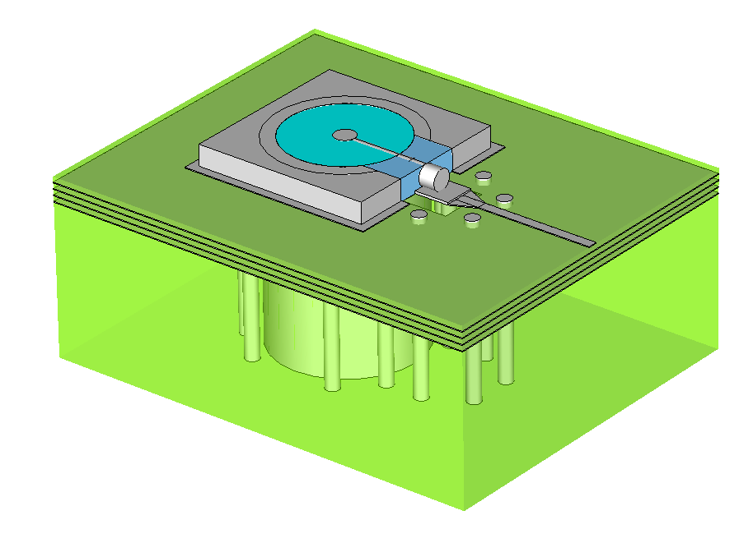
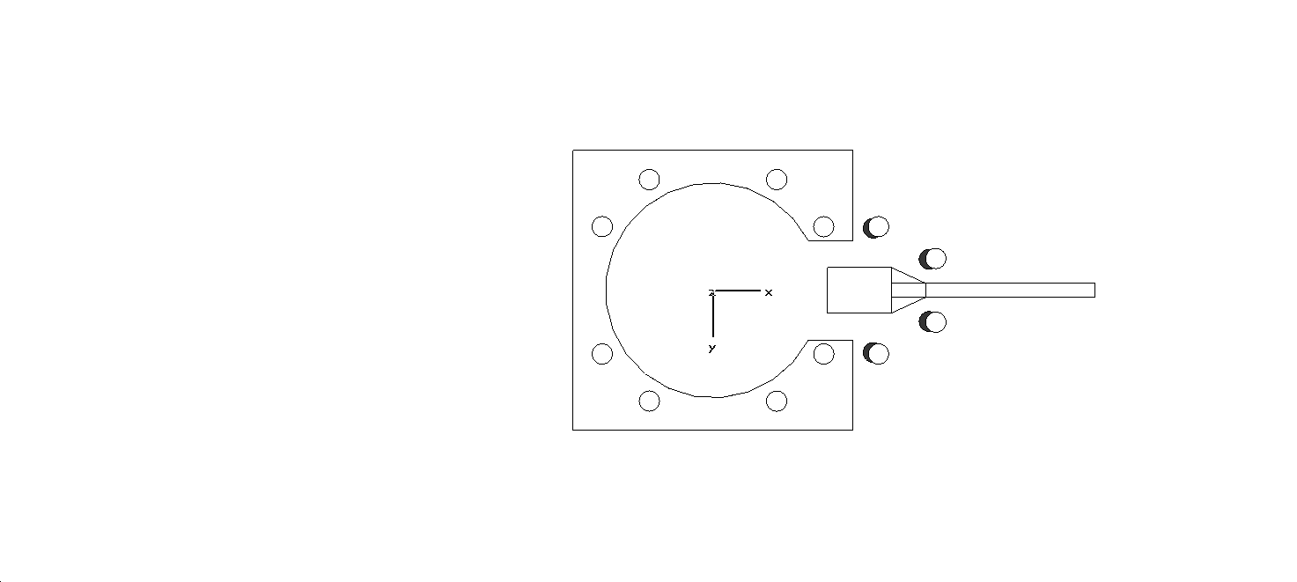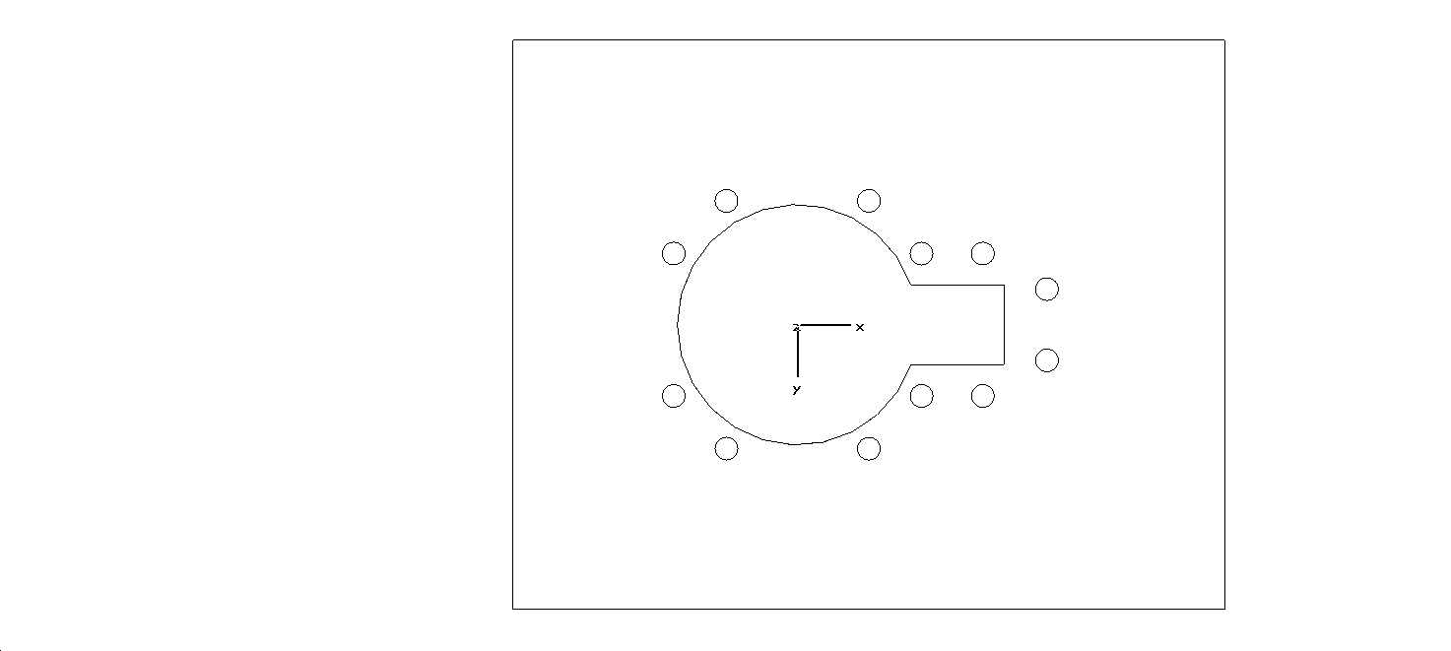
220
220
Φ169
36
20
30
30 degree taper
78
0,0
50,87
87,50
87,-50
50,-87
-50,-87
-87,-50
-50,87
-87,50
Φ16 x12
Φ169
145
Outer Layer Pads and Vias
Keepout for all other layers
Dimensions in mils
56
130,-50
175,-25
175,25
130,50

  - SMP Connector Footprint – Tester Side SMT Mount
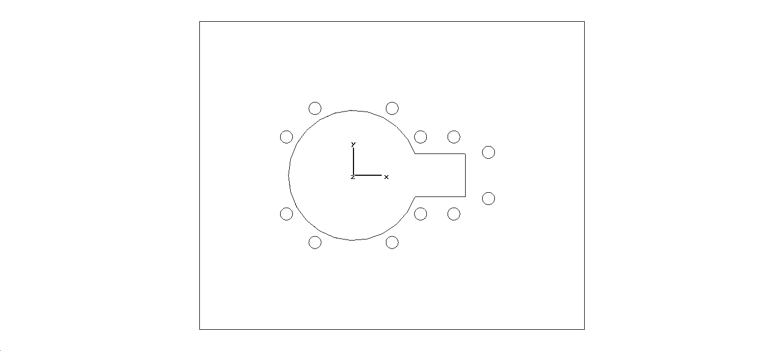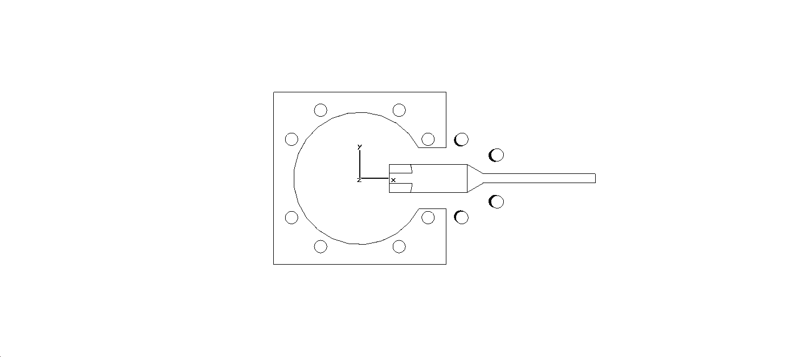
220
220
Φ169
36
73
27
30 degree taper
78
0,0
50,87
87,50
87,-50
50,-87
-50,-87
-87,-50
-50,87
-87,50
Φ16 x12
Φ169
145
Outer Layer Pads and Vias
Keepout for all other layers
Dimensions in mils
56
130,-50
175,-30
130,50
175,30
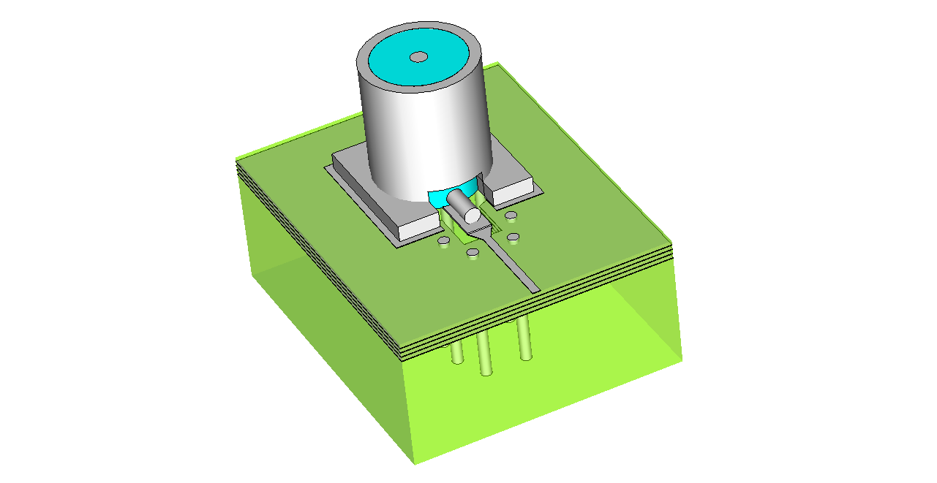

  - Port Scale RF Accessory Parts

For a list of Port Scale RF parts, part numbers, and related technical drawings see the topic “Key components of the high-density RF solution“ (topic ID: 128686) in the online DUT Board Design Guide.
Available parts include:
- Adapter plate kit
- Stiffener inlay
- RF Cables
- Connectors
- Adapters

