_

Filename: CompassHome Title: Compass Homepage

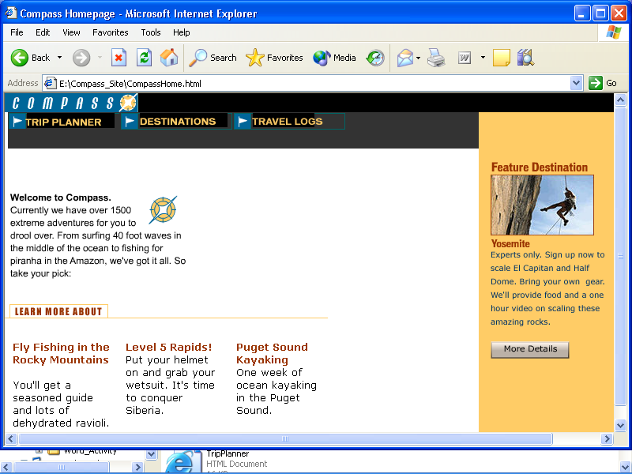

Filename: TripPlanner Title: Adventure Planner

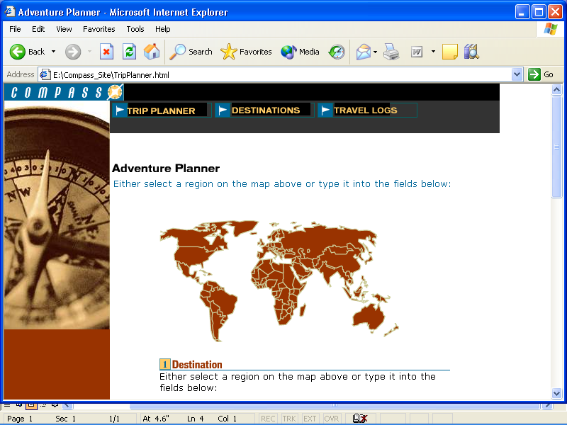

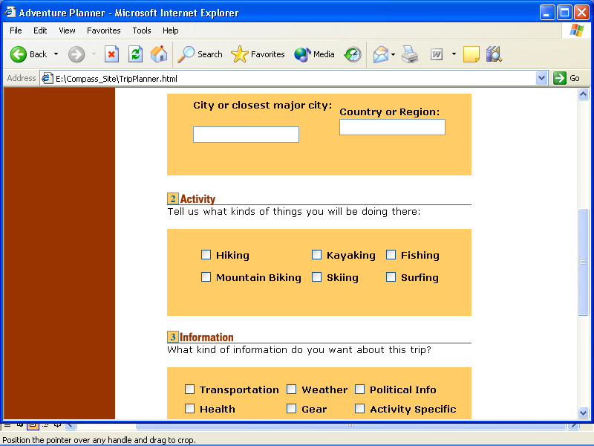

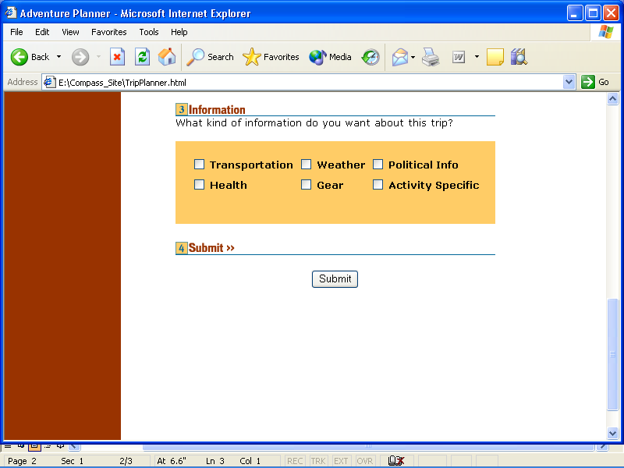

<html>

<head>

<title>Compass Homepage</title>

<meta http-equiv="Content-Type" content="text/html; charset=iso-8859-1">

<script language="JavaScript">

<!--

function MM_preloadImages() { //v3.0

  var d=document; if(d.images){ if(!d.MM_p) d.MM_p=new Array();

    var i,j=d.MM_p.length,a=MM_preloadImages.arguments; for(i=0; i<a.length; i++)

    if (a[i].indexOf("#")!=0){ d.MM_p[j]=new Image; d.MM_p[j++].src=a[i];}}

}

function MM_swapImgRestore() { //v3.0

  var i,x,a=document.MM_sr; for(i=0;a&&i<a.length&&(x=a[i])&&x.oSrc;i++) x.src=x.oSrc;

}

function MM_findObj(n, d) { //v4.0

  var p,i,x;  if(!d) d=document; if((p=n.indexOf("?"))>0&&parent.frames.length) {

    d=parent.frames[n.substring(p+1)].document; n=n.substring(0,p);}

  if(!(x=d[n])&&d.all) x=d.all[n]; for (i=0;!x&&i<d.forms.length;i++) x=d.forms[i][n];

  for(i=0;!x&&d.layers&&i<d.layers.length;i++) x=MM_findObj(n,d.layers[i].document);

  if(!x && document.getElementById) x=document.getElementById(n); return x;

}

function MM_swapImage() { //v3.0

  var i,j=0,x,a=MM_swapImage.arguments; document.MM_sr=new Array; for(i=0;i<(a.length-2);i+=3)

   if ((x=MM_findObj(a[i]))!=null){document.MM_sr[j++]=x; if(!x.oSrc) x.oSrc=x.src; x.src=a[i+2];}

}

//-->

</script>

</head>

<body bgcolor="#FFFFFF" text="#000000" leftmargin="0" topmargin="0" onLoad="MM_preloadImages('Compass_Site/Assets/images/MenuTripPlanner_on.gif','Compass_Site/Assets/images/MenuDestinations_on.gif','Compass_Site/Assets/images/MenuTravelLogs_on.gif')">

<table width="992" border="0" cellpadding="0" cellspacing="0" bgcolor="#000000">

  <tr>

    <td width="169" height="24" valign="top"><img src="Compass_Site/Assets/images/compass_logo.gif" width="169" height="24"></td>

    <td width="823"></td>

  </tr>

</table>

<table width="992" border="0" cellpadding="0" cellspacing="0" bgcolor="#333333">

  <tr>

    <td width="9" height="21"></td>

    <td width="141" valign="top"><a href="TripPlanner.htm" onMouseOut="MM_swapImgRestore()" onMouseOver="MM_swapImage('Image1','','Compass_Site/Assets/images/MenuTripPlanner_on.gif',1)"><img src="Compass_Site/Assets/images/MenuTripPlanner.gif" width="141" height="21" border="0" name="Image1"></a></td>

    <td width="7"></td>

    <td width="141" valign="top"><a href="Destinations.htm" onMouseOut="MM_swapImgRestore()" onMouseOver="MM_swapImage('Image2','','Compass_Site/Assets/images/MenuDestinations_on.gif',1)"><img src="Compass_Site/Assets/images/MenuDestinations.gif" width="141" height="21" border="0" name="Image2"></a></td>

    <td width="8"></td>

    <td width="141" valign="top"><a href="Travelog.htm" onMouseOut="MM_swapImgRestore()" onMouseOver="MM_swapImage('Image3','','Compass_Site/Assets/images/MenuTravelLogs_on.gif',1)"><img src="Compass_Site/Assets/images/MenuTravelLogs.gif" width="141" height="21" border="0" name="Image3"></a></td>

    <td width="386"></td>

    <td width="159" valign="top" bgcolor="#FFCC66">&nbsp;</td>

    </tr>

</table>

<table width="992" border="0" cellpadding="0" cellspacing="0" bgcolor="#333333">

  <tr>

    <td width="833" height="25"></td>

    <td width="159" valign="top" bgcolor="#FFCC66">&nbsp;</td>

    </tr>

</table>

<table width="992" border="0" cellpadding="0" cellspacing="0">

  <tr>

    <td width="6" height="60"></td>

    <td width="6"></td>

    <td width="380"></td>

    <td width="23"></td>

    <td width="418"></td>

    <td valign="bottom" colspan="2" bgcolor="#FFCC66" align="center"><object classid="clsid:D27CDB6E-AE6D-11cf-96B8-444553540000" codebase="http://download.macromedia.com/pub/shockwave/cabs/flash/swflash.cab#version=5,0,0,0" width="150" height="20">

        <param name=movie value="Compass_Site/Assets/swfs/txt_featureDestination.swf">

        <param name=quality value=high>

        <embed src="Compass_Site/Assets/swfs/txt_featureDestination.swf" quality=high pluginspage="http://www.macromedia.com/shockwave/download/index.cgi?P1_Prod_Version=ShockwaveFlash" type="application/x-shockwave-flash" width="150" height="20">

        </embed>

      </object></td>

  </tr>

  <tr>

    <td height="30"></td>

    <td></td>

    <td></td>

    <td></td>

    <td></td>

    <td colspan="2" valign="middle" rowspan="2" align="center" bgcolor="#FFCC66"><img src="Compass_Site/Assets/images/climber.jpg" width="148" height="77"></td>

  </tr>

  <tr>

    <td height="47"></td>

    <td rowspan="3" valign="top" colspan="3"><object classid="clsid:D27CDB6E-AE6D-11cf-96B8-444553540000" codebase="http://download.macromedia.com/pub/shockwave/cabs/flash/swflash.cab#version=5,0,0,0" width="240" height="130">

        <param name=movie value="Compass_Site/Assets/swfs/welcome.swf">

        <param name=quality value=high>

        <embed src="Compass_Site/Assets/swfs/welcome.swf" quality=high pluginspage="http://www.macromedia.com/shockwave/download/index.cgi?P1_Prod_Version=ShockwaveFlash" type="application/x-shockwave-flash" width="240" height="130">

        </embed>

      </object></td>

    <td></td>

  </tr>

  <tr>

    <td height="32"></td>

    <td></td>

    <td valign="top" colspan="2" align="center" bgcolor="#FFCC66"><object classid="clsid:D27CDB6E-AE6D-11cf-96B8-444553540000" codebase="http://download.macromedia.com/pub/shockwave/cabs/flash/swflash.cab#version=5,0,0,0" width="150" height="20">

        <param name=movie value="Compass_Site/Assets/swfs/txt_yosemite.swf">

        <param name=quality value=high>

        <embed src="Compass_Site/Assets/swfs/txt_yosemite.swf" quality=high pluginspage="http://www.macromedia.com/shockwave/download/index.cgi?P1_Prod_Version=ShockwaveFlash" type="application/x-shockwave-flash" width="150" height="20">

        </embed>

      </object></td>

  </tr>

  <tr>

    <td height="51"></td>

    <td></td>

    <td valign="top" colspan="2" rowspan="2" align="center" bgcolor="#FFCC66"><img src="Compass_Site/Assets/images/featureText.gif" width="144" height="95"></td>

  </tr>

  <tr>

    <td height="55"></td>

    <td></td>

    <td></td>

    <td></td>

    <td></td>

  </tr>

  <tr>

    <td height="23"></td>

    <td valign="top" colspan="3"><img src="Compass_Site/Assets/images/learnMoreAbout.gif" width="409" height="23"></td>

    <td></td>

    <td width="9" rowspan="4" valign="top" bgcolor="#FFCC66">&nbsp;</td>

    <td width="150" rowspan="4" valign="top" align="left" bgcolor="#FFCC66"><object classid="clsid:D27CDB6E-AE6D-11cf-96B8-444553540000" codebase="http://download.macromedia.com/pub/shockwave/cabs/flash/swflash.cab#version=5,0,0,0" width="100" height="22">

        <param name=movie value="Compass_Site/Assets/swfs/home_button.swf">

        <param name=quality value=high>

        <embed src="Compass_Site/Assets/swfs/home_button.swf" quality=high pluginspage="http://www.macromedia.com/shockwave/download/index.cgi?P1_Prod_Version=ShockwaveFlash" type="application/x-shockwave-flash" width="100" height="22">

        </embed>

      </object></td>

  </tr>

  <tr>

    <td height="9"></td>

    <td></td>

    <td></td>

    <td></td>

    <td></td>

  </tr>

  <tr>

    <td height="118"></td>

    <td></td>

    <td valign="top">

      <table width="100%" border="0" cellpadding="0" cellspacing="0">

        <tr>

          <td width="120" height="118" valign="top">

            <p><font face="Arial, Helvetica, sans-serif" size="2"><b><font color="#993300">Fly

              Fishing in the Rocky Mountains</font></b></font></p>

            <p><b><font face="Arial, Helvetica, sans-serif" size="2">You'll get

              a<br>

              season guide <br>

              and lots of dehydrated ravioli</font></b>.</p>

          </td>

          <td width="11"></td>

          <td width="106" valign="top">

            <p><font size="2" face="Arial, Helvetica, sans-serif"><b><font color="#993300">Level

              5 Rapids!</font><br>

              Put your helmet and grab your wetsuit. It's time to conquer Siberia</b></font></p>

          </td>

          <td width="33"></td>

          <td width="110" valign="top"><font size="2" face="Arial, Helvetica, sans-serif"><b><font color="#993300">Puget

            Sound Kayaking</font><br>

            One week of Ocean Kayaking in the Puget Sound</b></font></td>

        </tr>

      </table>

    </td>

    <td></td>

    <td></td>

  </tr>

  <tr>

    <td height="201"></td>

    <td></td>

    <td></td>

    <td></td>

    <td></td>

  </tr>

  <tr>

    <td height="0"></td>

    <td></td>

    <td></td>

    <td></td>

    <td></td>

    <td></td>

    <td></td>

  </tr>

</table>

</body>

</html>

Filename: Destinations Title: Featured Destinations

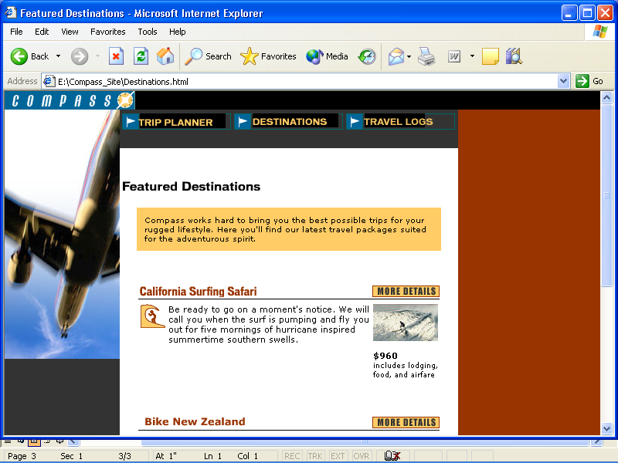

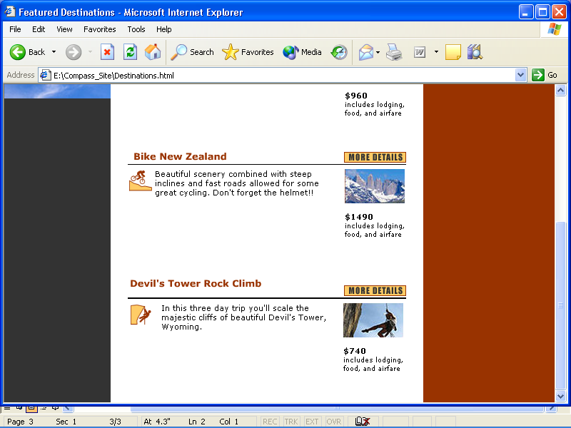

Filename: Travelog Title: Travelog

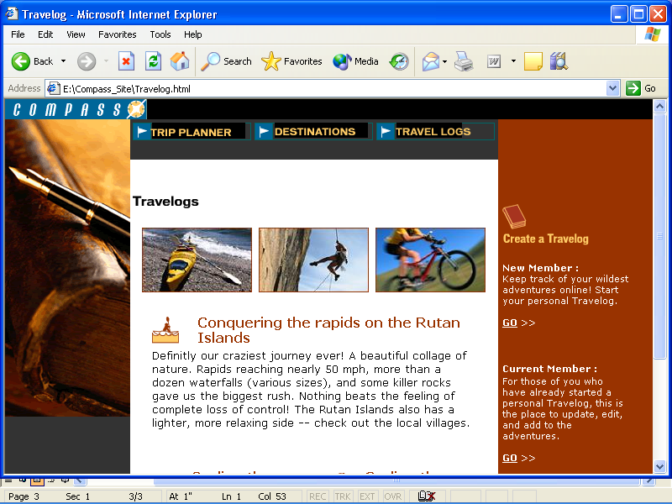

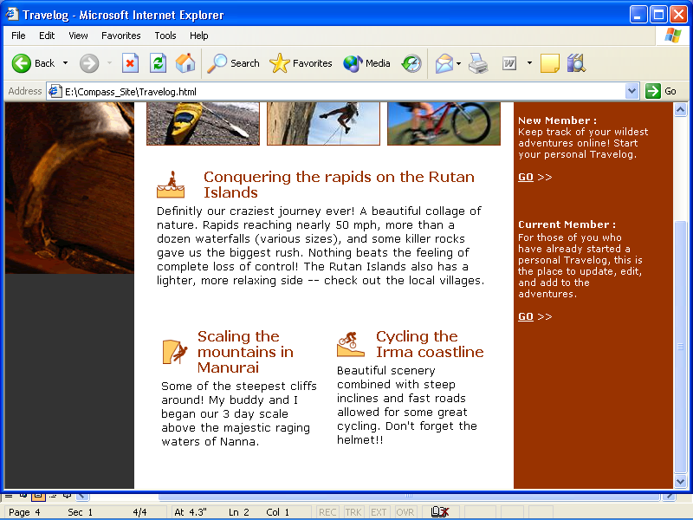

Note: This is a link to **More Details** flash button

Filename: Detail_surf Title: Travel Detail

