CPE301 – SPRING 2025

Design Assignment 7

Student Name: Carlos Funes

Student #: 5007995832

Student Email: [funesc2@unlv.nevada.edu](mailto:funesc2@unlv.nevada.edu)

Primary Github address: <https://github.com/CaFu0320>

Directory: <https://github.com/CaFu0320/submission_da/tree/main/DesignAssignments/DA7>

Video Playlist: <https://youtube.com/playlist?list=PLa3xS6s509hhSrDtIiRlyynXMlhipu13Z&si=vMDsBcMr7TgJm_Hq>

Submit the following for all Labs:

1. In the document, for each task submit the modified or included code (only) with highlights and justifications of the modifications. Also, include the comments.
2. Use the previously create a Github repository with a random name (no CPE/301, Lastname, Firstname). Place all labs under the root folder ESD301/DA, sub-folder named LABXX, with one document and one video link file for each lab, place modified asm/c files named as LabXX-TYY.asm/c.
3. If multiple asm/c files or other libraries are used, create a folder LabXX-TYY and place these files inside the folder.
4. The folder should have a) Word document (see template), b) source code file(s) and other include files, c) text file with youtube video links (see template).

1. **COMPONENTS LIST AND CONNECTION BLOCK DIAGRAM w/ PINS**

* ATMEGA328PB MINI BOARD
* UART
* SERIAL PLOTTER
* BMI160 6-DOF IMU SENSOR
* I2C OLED Display
* 2 BREADBOARDS

1. **C CODE TASKS**

/*

* DA7_7v2

* Author: Carlos Funes

*/

#define *F_CPU* 16000000UL //defining CPU frequency

#include <avr/io.h> //including AVR I/O register definitions

#include <util/delay.h> //for delay_ms()

#include <stdlib.h> //for functions

#include <stdio.h> //I/O functions

#include <math.h> //include this to calculate angles

#include <avr/pgmspace.h> //storing data into flash memory

#define DISPLAY_WIDTH 128 //oled width in pixels

#define DISPLAY_HEIGHT 64 //height in pixels

#define LCD_I2C_ADR 0x3C //i2c address

#define ACCEL_SCALE 16384.0f //accelerometer sensitivity

#define GYRO_SCALE 16.4f //gyroscope sensitivity

#define FONT ssd1306oled_font //font data being stored in PROGMEM

const *uint8_t* special_char[][2] = { {0,0}, {0xFF,0xFF} }; //placeholder for graphics

void oled_init(void); //turning on oled screen

void oled_clear(void); //clearing the screen

void oled_draw_string(*uint8_t* x, *uint8_t* page, const char *str); //drawing text at specific positions

//UART

void USART_Init(unsigned long BAUDRATE) { //setting up the serial plotter

*uint16_t* ubrr_value = (*F_CPU* / (16UL * BAUDRATE)) - 1;

UCSR0B = (1 << RXEN0) | (1 << TXEN0);

UCSR0C = (1 << UCSZ00) | (1 << UCSZ01);

UBRR0L = ubrr_value;

UBRR0H = (ubrr_value >> 8);

}

void USART_TxChar(char data) { //sending single characters to serial plotter

UDR0 = data;

while (!(UCSR0A & (1<<UDRE0)));

}

void USART_SendString(char *str) { //sending a full string over to serial

int i = 0;

while (str[i] != 0) {

USART_TxChar(str[i]);

i++;

}

}

//I2C

void i2c_init(void) { //preparing the i2c pins

TWSR0 = 0x00;

TWBR0 = 0x48; //100khz

TWCR0 = (1 << TWEN);

}

void i2c_start(void) { //starting conversations with device

TWCR0 = (1 << TWSTA) | (1 << TWEN) | (1 << TWINT);

while (!(TWCR0 & (1 << TWINT)));

}

void i2c_stop(void) { //ending conversations

TWCR0 = (1 << TWSTO) | (1 << TWEN) | (1 << TWINT);

*_delay_us*(10);

}

void i2c_write(*uint8_t* data) { //sending byte of data to i2c

TWDR0 = data;

TWCR0 = (1 << TWEN) | (1 << TWINT);

while (!(TWCR0 & (1 << TWINT)));

}

*uint8_t* i2c_read_ack(void) { //reading byte and acknowledges it

TWCR0 = (1 << TWEN) | (1 << TWINT) | (1 << TWEA);

while (!(TWCR0 & (1 << TWINT)));

return TWDR0;

}

*uint8_t* i2c_read_nack(void) { //reading byte without acknowledging it

TWCR0 = (1 << TWEN) | (1 << TWINT);

while (!(TWCR0 & (1 << TWINT)));

return TWDR0;

}

//SSD1306 (OLED) functions

#define OLED_ADDR 0x3C

static void oled_cmd(*uint8_t* c){ //sending command to screen

i2c_start();

i2c_write(OLED_ADDR<<1);

i2c_write(0x00);

i2c_write(c); i2c_stop();

}

static void oled_data(*uint8_t* d){ //sending pixel to screen

i2c_start();

i2c_write(OLED_ADDR<<1);

i2c_write(0x40);

i2c_write(d);

i2c_stop();

}

static void oled_setpos(*uint8_t* col,*uint8_t* page){ //moving cursor to specific pixel location

oled_cmd(0xB0|page);

oled_cmd(0x00|(col&0x0F));

oled_cmd(0x10|(col>>4));

}

const char ssd1306oled_font[][6] PROGMEM = { //data font for letters

{0x00, 0x00, 0x00, 0x00, 0x00, 0x00}, // sp

{0x00, 0x00, 0x00, 0x2f, 0x00, 0x00}, // !

{0x00, 0x00, 0x07, 0x00, 0x07, 0x00}, // "

{0x00, 0x14, 0x7f, 0x14, 0x7f, 0x14}, // #

{0x00, 0x24, 0x2a, 0x7f, 0x2a, 0x12}, // $

{0x00, 0x62, 0x64, 0x08, 0x13, 0x23}, // %

{0x00, 0x36, 0x49, 0x55, 0x22, 0x50}, // &

{0x00, 0x00, 0x05, 0x03, 0x00, 0x00}, // '

{0x00, 0x00, 0x1c, 0x22, 0x41, 0x00}, // (

{0x00, 0x00, 0x41, 0x22, 0x1c, 0x00}, // )

{0x00, 0x14, 0x08, 0x3E, 0x08, 0x14}, // *

{0x00, 0x08, 0x08, 0x3E, 0x08, 0x08}, // +

{0x00, 0x00, 0x00, 0xA0, 0x60, 0x00}, // ,

{0x00, 0x08, 0x08, 0x08, 0x08, 0x08}, // -

{0x00, 0x00, 0x60, 0x60, 0x00, 0x00}, // .

{0x00, 0x20, 0x10, 0x08, 0x04, 0x02}, // /

{0x00, 0x3E, 0x51, 0x49, 0x45, 0x3E}, // 0

{0x00, 0x00, 0x42, 0x7F, 0x40, 0x00}, // 1

{0x00, 0x42, 0x61, 0x51, 0x49, 0x46}, // 2

{0x00, 0x21, 0x41, 0x45, 0x4B, 0x31}, // 3

{0x00, 0x18, 0x14, 0x12, 0x7F, 0x10}, // 4

{0x00, 0x27, 0x45, 0x45, 0x45, 0x39}, // 5

{0x00, 0x3C, 0x4A, 0x49, 0x49, 0x30}, // 6

{0x00, 0x01, 0x71, 0x09, 0x05, 0x03}, // 7

{0x00, 0x36, 0x49, 0x49, 0x49, 0x36}, // 8

{0x00, 0x06, 0x49, 0x49, 0x29, 0x1E}, // 9

{0x00, 0x00, 0x36, 0x36, 0x00, 0x00}, // :

{0x00, 0x00, 0x56, 0x36, 0x00, 0x00}, // ;

{0x00, 0x08, 0x14, 0x22, 0x41, 0x00}, // <

{0x00, 0x14, 0x14, 0x14, 0x14, 0x14}, // =

{0x00, 0x00, 0x41, 0x22, 0x14, 0x08}, // >

{0x00, 0x02, 0x01, 0x51, 0x09, 0x06}, // ?

{0x00, 0x32, 0x49, 0x59, 0x51, 0x3E}, // @

{0x00, 0x7C, 0x12, 0x11, 0x12, 0x7C}, // A

{0x00, 0x7F, 0x49, 0x49, 0x49, 0x36}, // B

{0x00, 0x3E, 0x41, 0x41, 0x41, 0x22}, // C

{0x00, 0x7F, 0x41, 0x41, 0x22, 0x1C}, // D

{0x00, 0x7F, 0x49, 0x49, 0x49, 0x41}, // E

{0x00, 0x7F, 0x09, 0x09, 0x09, 0x01}, // F

{0x00, 0x3E, 0x41, 0x49, 0x49, 0x7A}, // G

{0x00, 0x7F, 0x08, 0x08, 0x08, 0x7F}, // H

{0x00, 0x00, 0x41, 0x7F, 0x41, 0x00}, // I

{0x00, 0x20, 0x40, 0x41, 0x3F, 0x01}, // J

{0x00, 0x7F, 0x08, 0x14, 0x22, 0x41}, // K

{0x00, 0x7F, 0x40, 0x40, 0x40, 0x40}, // L

{0x00, 0x7F, 0x02, 0x0C, 0x02, 0x7F}, // M

{0x00, 0x7F, 0x04, 0x08, 0x10, 0x7F}, // N

{0x00, 0x3E, 0x41, 0x41, 0x41, 0x3E}, // O

{0x00, 0x7F, 0x09, 0x09, 0x09, 0x06}, // P

{0x00, 0x3E, 0x41, 0x51, 0x21, 0x5E}, // Q

{0x00, 0x7F, 0x09, 0x19, 0x29, 0x46}, // R

{0x00, 0x46, 0x49, 0x49, 0x49, 0x31}, // S

{0x00, 0x01, 0x01, 0x7F, 0x01, 0x01}, // T

{0x00, 0x3F, 0x40, 0x40, 0x40, 0x3F}, // U

{0x00, 0x1F, 0x20, 0x40, 0x20, 0x1F}, // V

{0x00, 0x3F, 0x40, 0x38, 0x40, 0x3F}, // W

{0x00, 0x63, 0x14, 0x08, 0x14, 0x63}, // X

{0x00, 0x07, 0x08, 0x70, 0x08, 0x07}, // Y

{0x00, 0x61, 0x51, 0x49, 0x45, 0x43}, // Z

{0x00, 0x00, 0x7F, 0x41, 0x41, 0x00}, // [

{0x00, 0x55, 0x2A, 0x55, 0x2A, 0x55}, // backslash

{0x00, 0x00, 0x41, 0x41, 0x7F, 0x00}, // ]

{0x00, 0x04, 0x02, 0x01, 0x02, 0x04}, // ^

{0x00, 0x40, 0x40, 0x40, 0x40, 0x40}, // _

{0x00, 0x00, 0x01, 0x02, 0x04, 0x00}, // '

{0x00, 0x20, 0x54, 0x54, 0x54, 0x78}, // a

{0x00, 0x7F, 0x48, 0x44, 0x44, 0x38}, // b

{0x00, 0x38, 0x44, 0x44, 0x44, 0x20}, // c

{0x00, 0x38, 0x44, 0x44, 0x48, 0x7F}, // d

{0x00, 0x38, 0x54, 0x54, 0x54, 0x18}, // e

{0x00, 0x08, 0x7E, 0x09, 0x01, 0x02}, // f

{0x00, 0x18, 0xA4, 0xA4, 0xA4, 0x7C}, // g

{0x00, 0x7F, 0x08, 0x04, 0x04, 0x78}, // h

{0x00, 0x00, 0x44, 0x7D, 0x40, 0x00}, // i

{0x00, 0x40, 0x80, 0x84, 0x7D, 0x00}, // j

{0x00, 0x7F, 0x10, 0x28, 0x44, 0x00}, // k

{0x00, 0x00, 0x41, 0x7F, 0x40, 0x00}, // l

{0x00, 0x7C, 0x04, 0x18, 0x04, 0x78}, // m

{0x00, 0x7C, 0x08, 0x04, 0x04, 0x78}, // n

{0x00, 0x38, 0x44, 0x44, 0x44, 0x38}, // o

{0x00, 0xFC, 0x24, 0x24, 0x24, 0x18}, // p

{0x00, 0x18, 0x24, 0x24, 0x18, 0xFC}, // q

{0x00, 0x7C, 0x08, 0x04, 0x04, 0x08}, // r

{0x00, 0x48, 0x54, 0x54, 0x54, 0x20}, // s

{0x00, 0x04, 0x3F, 0x44, 0x40, 0x20}, // t

{0x00, 0x3C, 0x40, 0x40, 0x20, 0x7C}, // u

{0x00, 0x1C, 0x20, 0x40, 0x20, 0x1C}, // v

{0x00, 0x3C, 0x40, 0x30, 0x40, 0x3C}, // w

{0x00, 0x44, 0x28, 0x10, 0x28, 0x44}, // x

{0x00, 0x1C, 0xA0, 0xA0, 0xA0, 0x7C}, // y

{0x00, 0x44, 0x64, 0x54, 0x4C, 0x44}, // z

{0x00, 0x00, 0x08, 0x77, 0x41, 0x00}, // {

{0x00, 0x00, 0x00, 0x63, 0x00, 0x00}, // Â¦

{0x00, 0x00, 0x41, 0x77, 0x08, 0x00}, // }

{0x00, 0x08, 0x04, 0x08, 0x08, 0x04} // ~

};

static void oled_char(char c) { //drawing single character on the screen

if (c < 0x20 || c > 0x7E) { //valid ASCII range

c = '?'; //replacING invalid with '?'

}

*uint8_t* idx = c - 0x20; //index into font array

for (*uint8_t* i = 0; i < 6; i++) {

oled_data(pgm_read_byte(&ssd1306oled_font[idx][i])); //send each column

}

oled_data(0x00); //spacing column after character

}

static void oled_string(const char* s){ //drawing full string of characters

while(*s) oled_char(*s++);

}

void oled_clear(void){ //filling screen with black pixels

for(*uint8_t* p=0;p<8;p++){

oled_setpos(0,p);

for(*uint8_t* c=0;c<128;c++)

oled_data(0);

}

}

void oled_init(void){ //initializing screen with startup commands

const *uint8_t* seq[] = {

0xAE,

0xD5,

0x80,

0xA8,

0x3F,

0xD3,

0x00,

0x40,

0x8D,

0x14,

0x20,

0x00,

0xA1,

0xC8,

0xDA,

0x12,

0x81,

0xCF,

0xD9,

0xF1,

0xDB,

0x40,

0xA4,

0xA6,

0xAF

};

*_delay_ms*(100);

for(*uint8_t* i=0;i<sizeof(seq);i++)

oled_cmd(seq[i]);

oled_clear();

}

//OLED helpers

#define VAL_COL 64

//BMI160

#define BMI160_ADDR 0x69 //connected to vcc

*int16_t* accData[3], gyrData[3]; //storing accelerometer array

float pitch = 0.0f, roll = 0.0f, yaw = 0.0f, dt = 0.01; //holding calculated angles

void bmi160_write(*uint8_t* reg, *uint8_t* data) { //sending commands to sensor

i2c_start();

i2c_write((BMI160_ADDR << 1));

i2c_write(reg);

i2c_write(data);

i2c_stop();

}

void bmi160_read_bytes(*uint8_t* reg, *uint8_t* *buf, *uint8_t* len) { //reading data from sensor

i2c_start();

i2c_write((BMI160_ADDR << 1));

i2c_write(reg);

i2c_start();

i2c_write((BMI160_ADDR << 1) | 1);

for (*uint8_t* i = 0; i < len; i++) {

buf[i] = (i == len - 1) ? i2c_read_nack() : i2c_read_ack();

}

i2c_stop();

}

void bmi160_init(void) { //configuring the sensor

//reset to ensure clean configuration

bmi160_write(0x7E, 0xB6);

*_delay_ms*(50);

//configuring accelerometer (100hz ODR, +-2g)

bmi160_write(0x40, 0x2A); //ODR 100Hz, normal mode

bmi160_write(0x41, 0x03); //+-2g range

//configuring gyroscope (100hz ODR, +-2000dps)

bmi160_write(0x42, 0x1A); // ODR 100Hz, Normal mode

bmi160_write(0x43, 0x00); //+-2000dps range

//powering on sensors

bmi160_write(0x7E, 0x11); //accel normal mode

*_delay_ms*(50);

bmi160_write(0x7E, 0x15); //gyro normal mode

*_delay_ms*(50);

}

void bmi160_read_raw(void) { //reading accelerometer and gyro data to accData/gyrData

*uint8_t* data[12];

bmi160_read_bytes(0x0C, data, 12);

for (int i = 0; i < 3; i++) {

gyrData[i] = (*int16_t*)((data[i * 2 + 1] << 8) | data[i * 2]);

accData[i] = (*int16_t*)((data[i * 2 + 7] << 8) | data[i * 2 + 6]);

}

}

void complementary_filter(void) { //converting raw accelometer data to g forces

//converting raw accelerometer data to g's

float ax = accData[0] / ACCEL_SCALE;

float ay = accData[1] / ACCEL_SCALE;

float az = accData[2] / ACCEL_SCALE;

//calculating angles from accelerometer

float accPitch = *atan2f*(ay, az) * 180 / *M_PI*; //pitch angle from gravity

float accRoll = *atan2f*(ax, az) * 180 / *M_PI*; //roll angle from gravity

//gyro data to dps and integrating

pitch += (gyrData[0] / GYRO_SCALE) * dt; //updating pitch using gyro

roll -= (gyrData[1] / GYRO_SCALE) * dt; //same for roll

yaw += (gyrData[2] / GYRO_SCALE) * dt; //same for yaw

//mixing accelerometer and gyro data

pitch = pitch * 0.98f + accPitch * 0.02f; //98% for gyro, 2% for acceleormeter

roll = roll * 0.98f + accRoll * 0.02f; //same for roll

}

//MAIN

int main(void) {

char buffer[32]; //temporary string to hold numbers

i2c_init(); //i2c communication

USART_Init(9600);

oled_init(); //turning on screen

oled_clear(); //clearing the screen

//static labels once during setup

oled_setpos(0, 0); //moving cursor to top left

oled_string("Pitch:"); //writing pitch on the screen

oled_setpos(0, 2); //moving cursor to middle left

oled_string("Roll:"); //writing roll

oled_setpos(0, 4); //moving cursor to bottom left

oled_string("Yaw:"); //writing yaw

*_delay_ms*(500); //waiting for stability

bmi160_init(); //configuring the motion sensor

while (1) {

bmi160_read_raw(); //looping forever

complementary_filter(); //calculating pitch/roll/yaw

//UART output for pitch, roll and yaw

USART_SendString("Pitch: ");

*dtostrf*(pitch, 6, 2, buffer); //converting pitch into a string using 6 characters and 2 decimals

USART_SendString(buffer); //sending pitch value using a buffer

USART_SendString("\t\t");

USART_SendString("Roll: ");

*dtostrf*(roll, 6, 2, buffer); //same logic for the rest of these

USART_SendString(buffer);

USART_SendString("\t\t");

USART_SendString("Yaw: ");

*dtostrf*(yaw, 6, 2, buffer);

USART_SendString(buffer);

USART_SendString("\r\n");

//sending accelerometer data

USART_SendString("AccX: ");

*dtostrf*(accData[0]/ACCEL_SCALE, 6, 2, buffer);

USART_SendString(buffer);

USART_SendString("\t\t");

USART_SendString("AccY: ");

*dtostrf*(accData[1]/ACCEL_SCALE, 6, 2, buffer);

USART_SendString(buffer);

USART_SendString("\t\t");

USART_SendString("AccZ: ");

*dtostrf*(accData[2]/ACCEL_SCALE, 6, 2, buffer);

USART_SendString(buffer);

USART_SendString("\r\n");

//sending Gyro data

USART_SendString("GyroX: ");

*dtostrf*(gyrData[0]/GYRO_SCALE, 6, 2, buffer);

USART_SendString(buffer);

USART_SendString("\t\t");

USART_SendString("GyroY: ");

*dtostrf*(gyrData[1]/GYRO_SCALE, 6, 2, buffer);

USART_SendString(buffer);

USART_SendString("\t\t");

USART_SendString("GyroZ: ");

*dtostrf*(gyrData[2]/GYRO_SCALE, 6, 2, buffer);

USART_SendString(buffer);

USART_SendString("\r\n");

*_delay_ms*(100);

}

}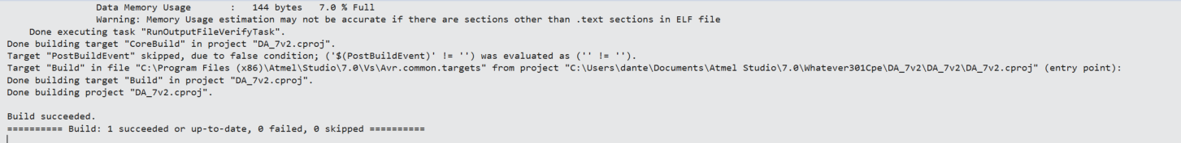

1. **SCHEMATIC**

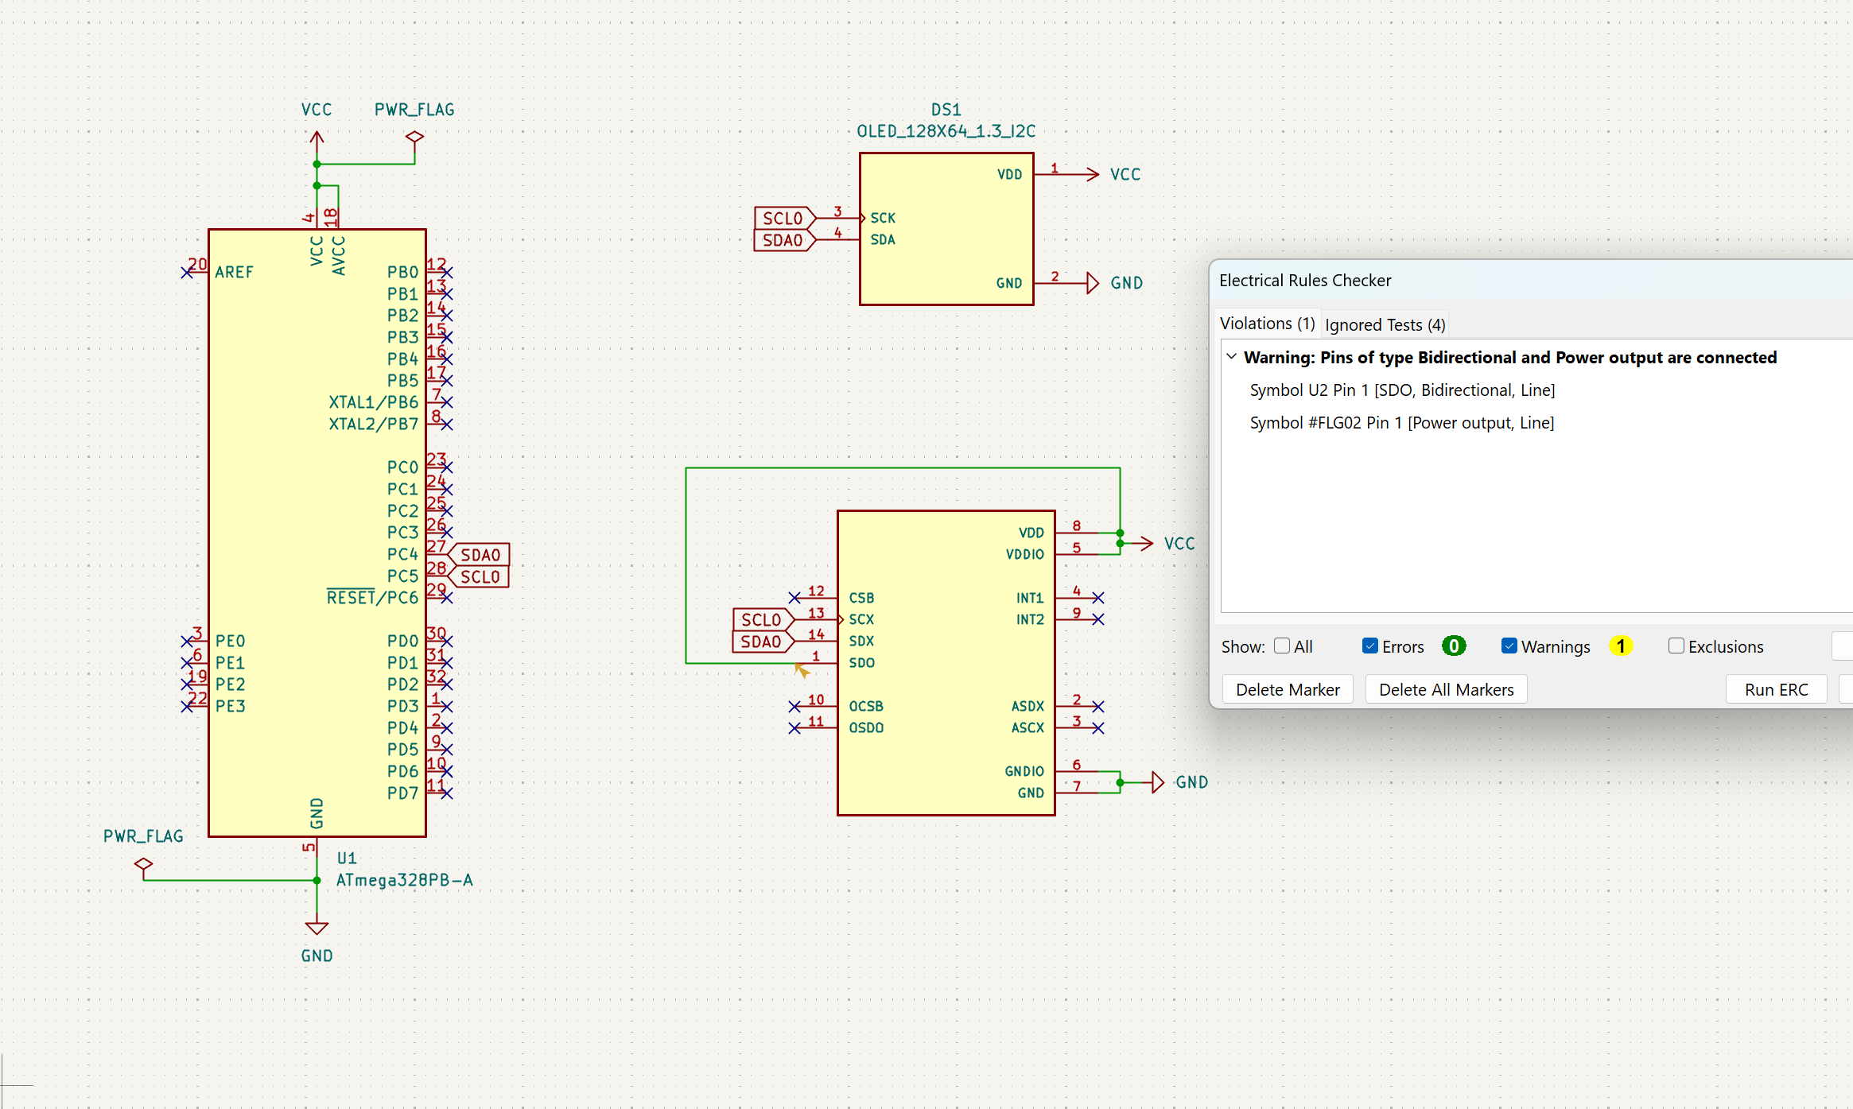

1. **SCREENSHOTS OF EACH TASK OUTPUT (**

**TASK 1**

**Accelerometer on terminal window:**

**Gyro:**

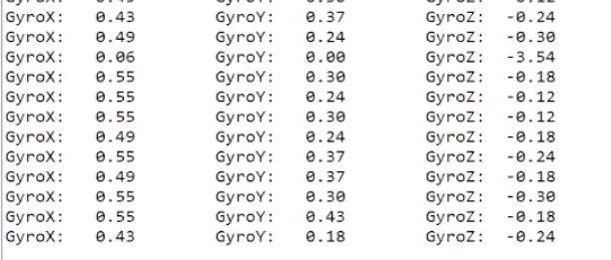

**Pitch, roll, yaw:**

**TASK 2**

**Accelerometer on serial plotter:**

**Gyro:**

**Pitch, roll, yaw:**

1. **SCREENSHOT OF DEMO**

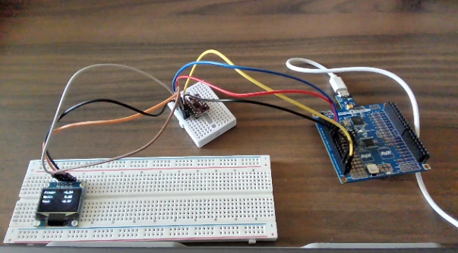

1. **VIDEO LINK FOR DEMOS**

Task (serial plotter):

<https://youtu.be/q7OJiuuBne4>

Task (terminal):

<https://youtu.be/JJvWWR_0mi0>

1. **GITHUB LINK OF THIS DA**

Tasks c code: <https://github.com/CaFu0320/submission_da/tree/main/DesignAssignments/DA7/DA_7v2/DA_7v2>

**Student Academic Misconduct Policy**

<http://studentconduct.unlv.edu/misconduct/policy.html>

“This assignment submission is my own, original work”.

Carlos Funes