KiCad PCB Design

Carlos Funes

**Goal:**

*The goal of this kiCad final project was to create a PCB using the parameters and components given in the canvas assignment. With the help of the videos provided by Dr. Venki and external resources, creating an Arduino shield that is also compatible with the atmega328pb microcontroller needed to be done.*

**Deliverables:**

*This report showcases the completed tasks to elaborate the desired Arduino shield for a microcontroller. Including the components needed, schematics, connections, ERC and DRC checks, github link for downloading the schematics, and results in a 3d model.*

# Literature survey[1]

Background information: Throughout this course, designing and troubleshooting different functionalities using an atemga328pb microcontroller with programs implemented with microchip studio were taught. These design challenges needed kicad schematics attached with them for showcasing the circuitry and connections of physical components. with this in mind, the final project required us to make an arduino shield with certain specifications as a printed circuit board.

# Components

## Component 1

Led’s connected in reverse bias for pins PD5 and PD6

## Component 2

DC motor connections using pins: DCMOT1, DCMOT2

## Component 3

Servo motor connections using pins: PD2, Vcc and ground

## Component 4

Potentiometer connected to pin PC0, with a 10k resistor and a 1uF capacitor for noise filtering.

## Component 5

7 Segment display using connected to ground, Vcc, PB4, PB5 and PB3

## Component 6

Oled screen connected to ground, Vcc, PC5 and PC4

## Component 7

Motor Driver connected to ground, Vcc, DCMOT1, DCMOT2, PD3, PD1, PD2

## Component 8

Ultrasonic sensor connector to attach PD2, Vcc and ground

## Component 9

BMI custom made chips connected to PC5, PC4, ground and Vcc

## Component 10

Pushbuttons with a pull up resistor value of 4.7k for pins PD3 and PD2

## Component 11

Pin headers for pins: VCC, 5V, 3V3, IOREF, RESET, GND, PD1, PD2, PD3, PD5, PD6, PC0, PB3, PB4, PB5, PC5, PC4, GND

# Schematic

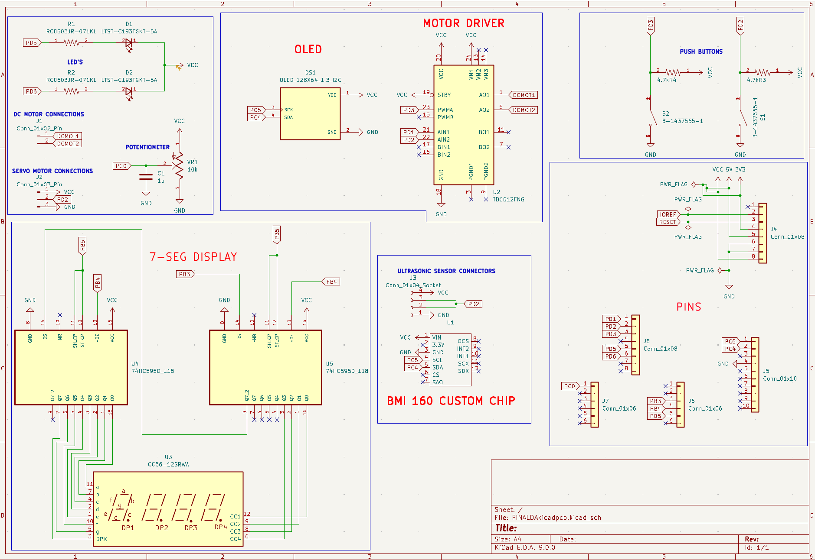

Figure 1: Final Circuit Schematic for Arduino Shield

Figure 2: Final Printed Circuit Board Schematic for Arduino Shield

# Implementation

Connecting previous design assignment KiCad schematic components with the given specifications for this assignment is what was implemented on a PCB. Using the KiCad software and external resources to complete this task were needed.

# Snapshots

Kicad Schematic editor ERC pass

PCB schematic editor DRC pass

3D design

# Links

Github: <https://github.com/CaFu0320/submission_da/tree/main/FinalProject/FINALDAkicadpcb>

# Conclusion

Overall, this project emphasizes getting hands-on experience of how to draw Printed Circuit Boards using a computer software called KiCad. In the electrical/computer engineering industry, knowing how to design circuits that perform various functions is critical. The problem-solving strategies needed for this final project required knowledge of previous kiCad schematics and context on how to draw a PCB using the tools provided by the software, which were found in Dr. Venki’s videos and external resources on how to install plug-ins for rerouting the PCB schematic. Finalizing this project was rewarding and much gratitude goes towards the instructor of this course for training undergraduate students on how to think like an engineer.

Appendix

Appendixes, if needed, appear before the acknowledgment.

References

1-Dr. Venki’s videos

“BMI chip tutorial and PCB tutorial” <https://www.youtube.com/watch?v=Am56gIe2smU&t=2730s&ab_channel=VenkiMuthukumar>

2- “KiCAD 8.0 Autorouter Installation in Under 4 Minutes!” by [Stuart Patterson](https://www.youtube.com/@StuartPatterson).

1.