SECTION TITLE 1
Effect of tasks for each group 1
Effect of tasks removing baseline condition 8
Effect of conditions and tasks across the group 8
Representative single subject filtered data 17
Representative single subject task activation 18
All subject's significant beta values across the channels 23
Effect of tasks in a representative single subject 24
Effect of tasks in a all subjects 27

SECTION TITLE
DESCRIPTIVE TEXT
filename = fullfile(pwd,'DataOut\KidsDCCS');
subNum = 10;
isGNG = 0;

Effect of tasks for each group
DESCRIPTIVE TEXT
load([filename '_Probe1020'])
load([filename '_GroupContrasts'])
GroupContrasts.probe = probe1020;
GroupContrasts.probe.defaultdrawfcn='10-20 map';
figs = GroupContrasts.draw('tstat',[],'p < 0.05');
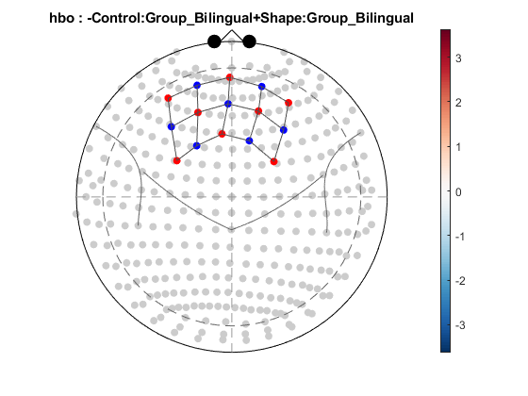
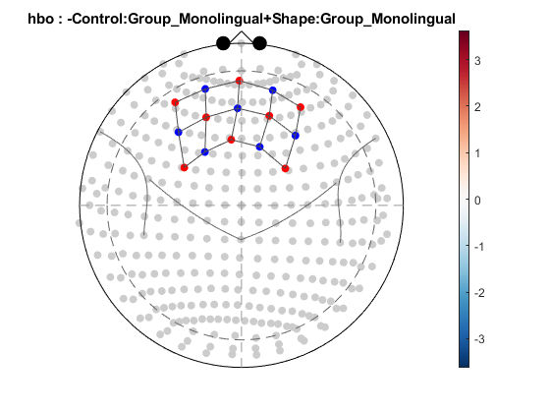
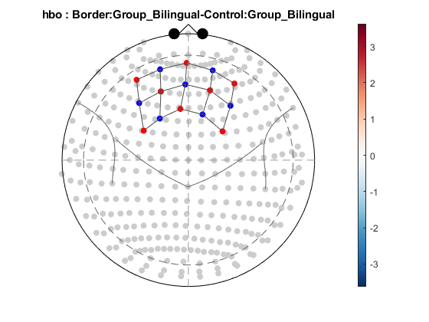
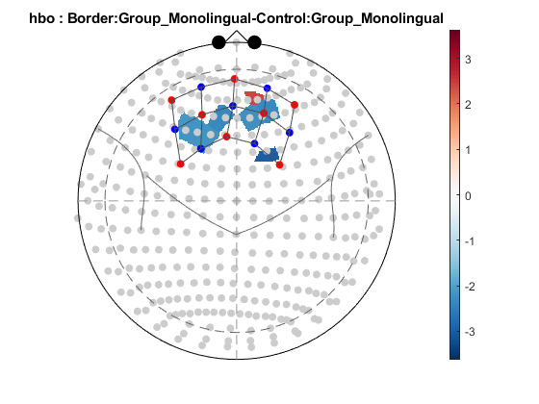
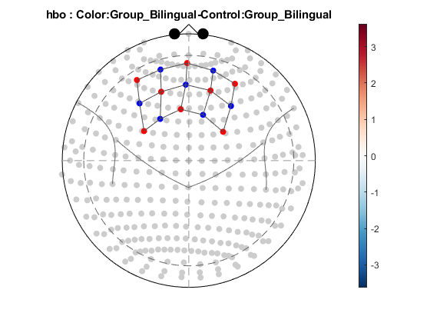
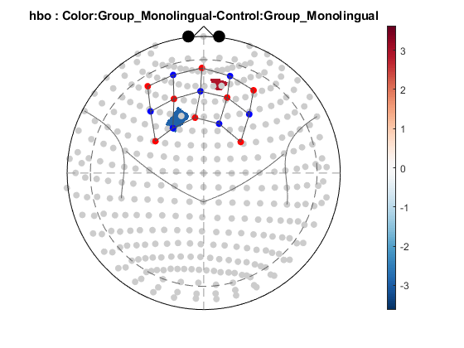
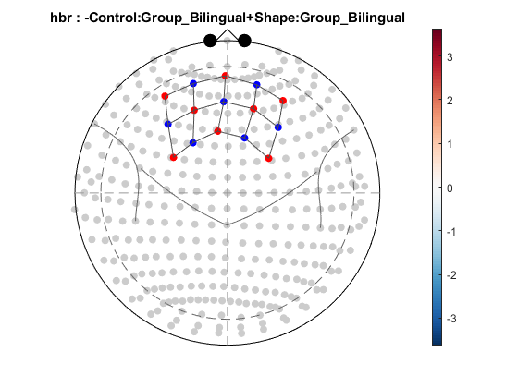
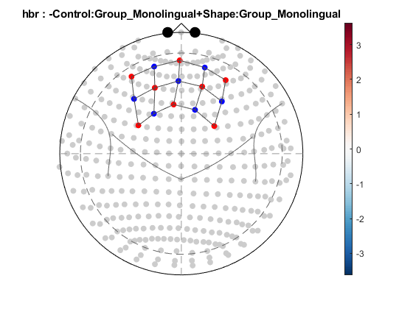
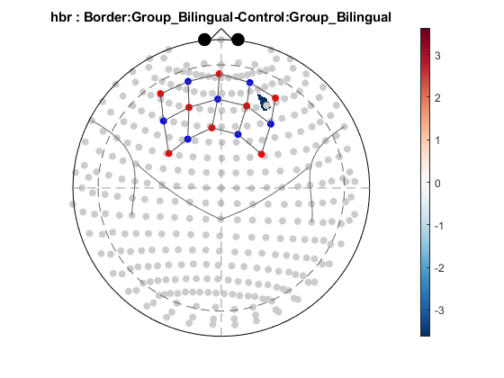
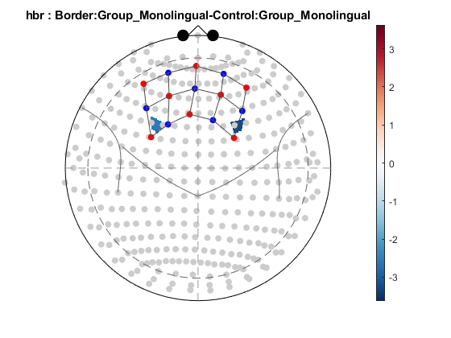
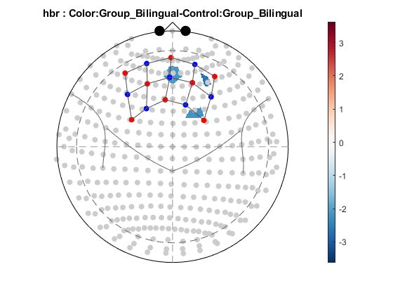
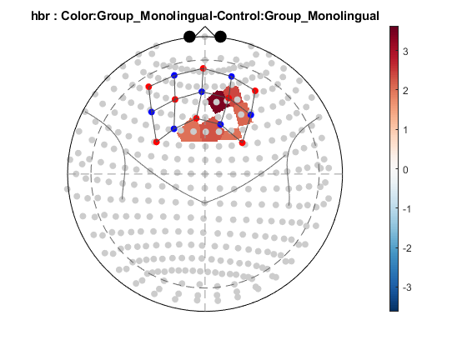

Effect of tasks removing baseline condition
DESCRIPTIVE TEXT
if isGNG==1
load([filename '_GroupContrastsNoBL'])
GroupContrastsNoBL.probe = probe1020;
GroupContrastsNoBL.probe.defaultdrawfcn='10-20 map';
figs = GroupContrastsNoBL.draw('tstat',[],'p < 0.05');
end

Effect of conditions and tasks across the group
DESCRIPTIVE TEXT
load([filename '_GroupStats'])
GroupStats.probe = probe1020;
GroupStats.probe.defaultdrawfcn='10-20 map';
figs = GroupStats.draw('tstat',[],'p < 0.05');
if isGNG==1
GroupStatsNoBL.probe = probe1020;
GroupStatsNoBL.probe.defaultdrawfcn='10-20 map';
figs = GroupStatsNoBL.draw('tstat',[],'p < 0.05');
end
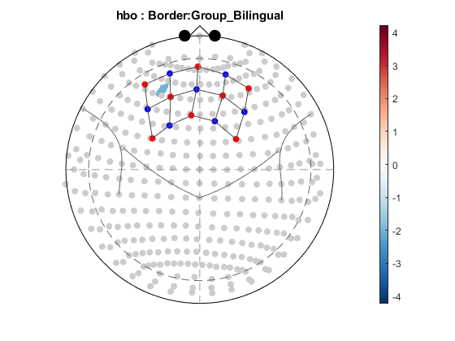
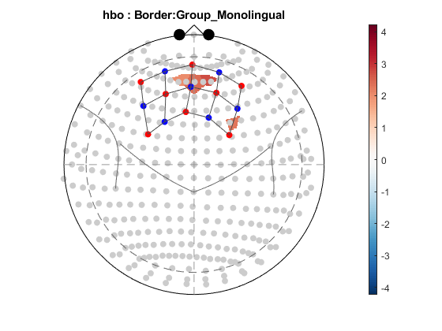
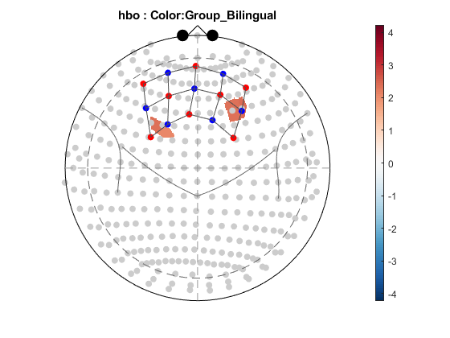
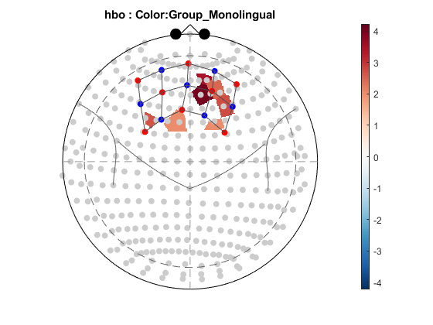
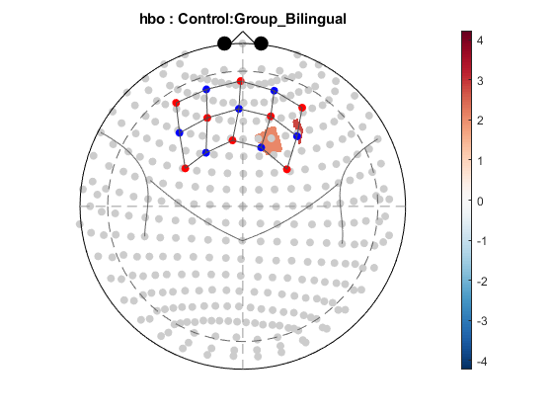
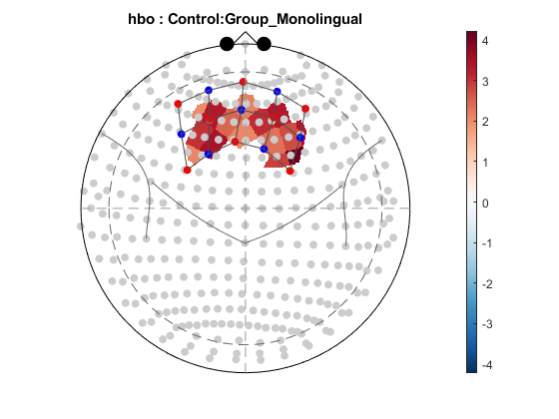
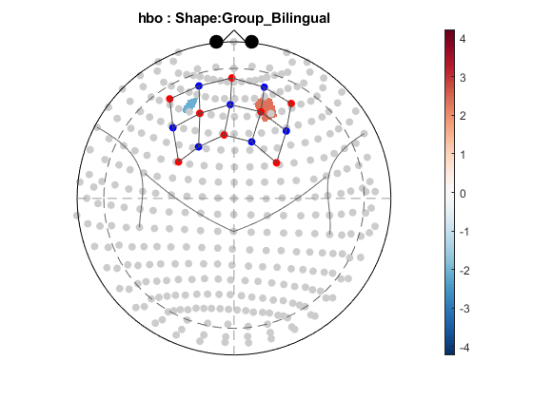
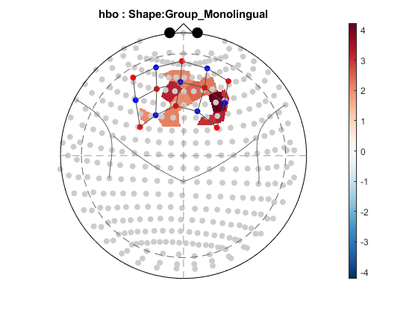
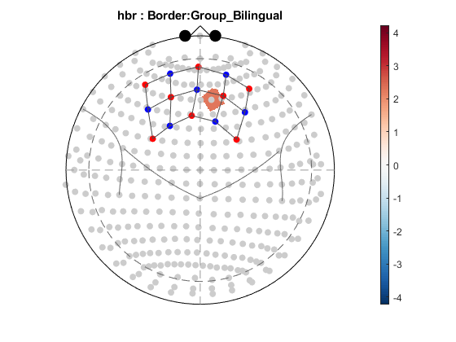
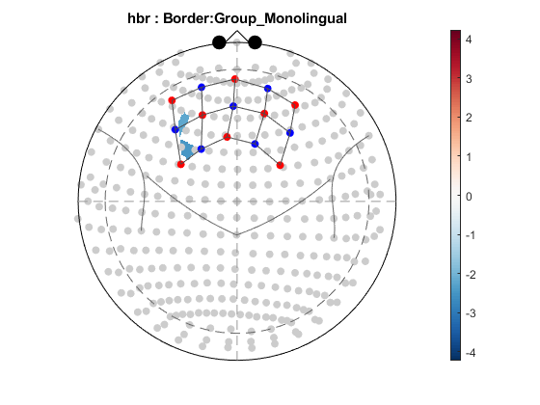
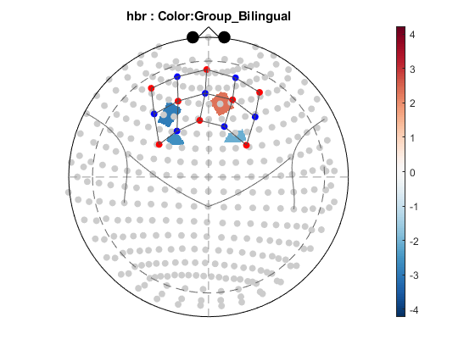
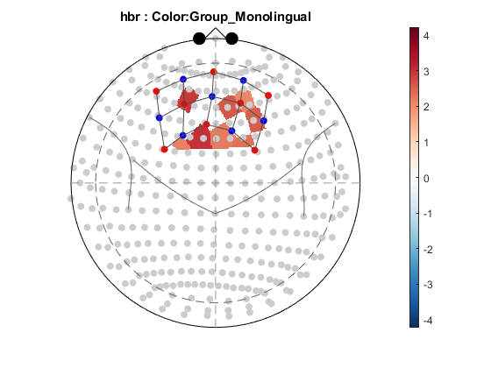
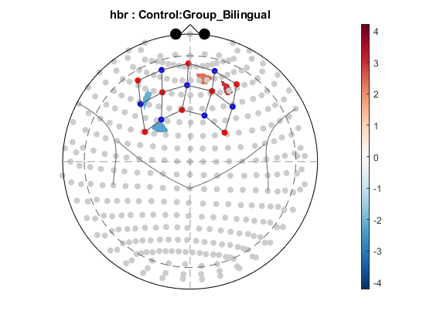
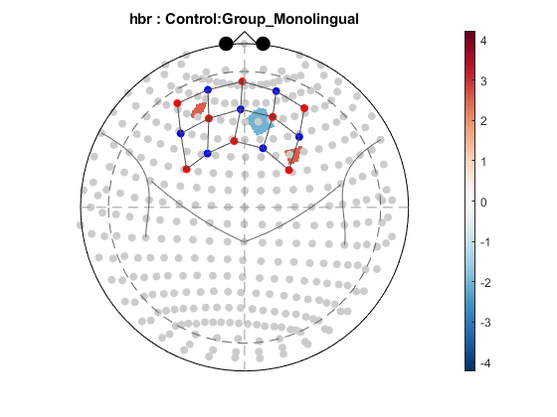
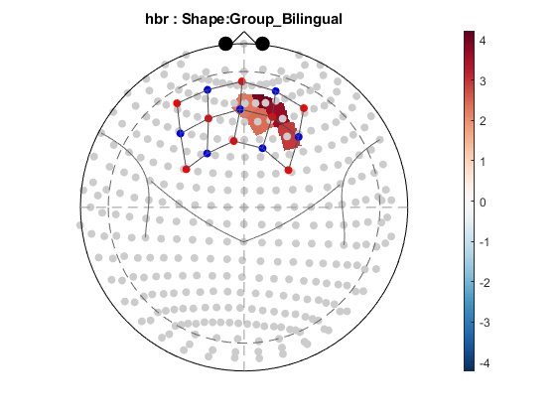
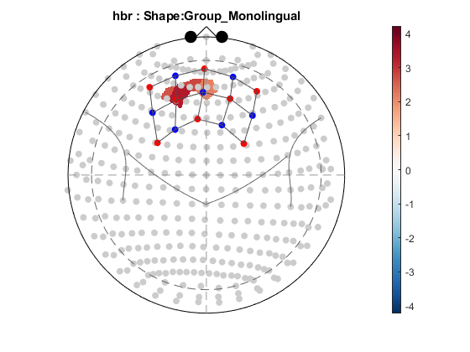

Representative single subject filtered data
DESCRIPTIVE TEXT
load([filename '_Processed'])
figure;
set(gcf,'Name',['hbO_' processed(subNum).demographics('Group') '_' ...
processed(subNum).demographics('Subject')])
draw(processed(subNum), 1:22)
ylabel('Oxy-hemoglobin (mM/cm)')
set(gca,'FontName','Arial','FontSize',14)
%set(gca,'YLim',[-200 200],'xTick',[])
xlabel('');
legend off
figure;
set(gcf,'Name',['hbR_' processed(subNum).demographics('Group') '_' ...
processed(subNum).demographics('Subject')])
draw(processed(subNum), 23:44)
ylabel('Deoxy-hemoglobin (mM/cm)')
%set(gca,'FontName','Arial','FontSize',14)
%set(gca,'YLim',[-200 200])
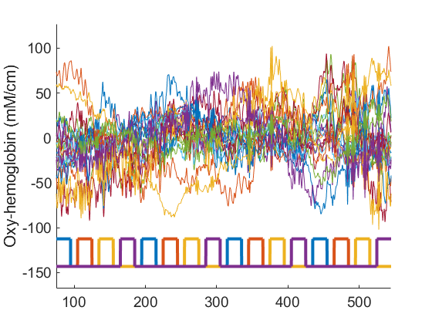
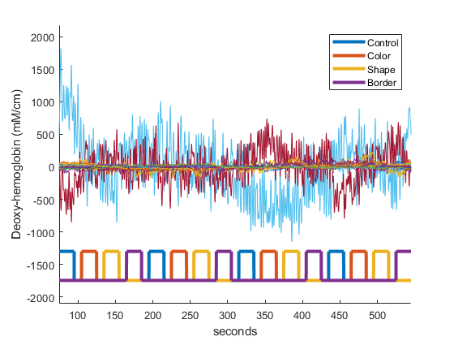

Representative single subject task activation
DESCRIPTIVE TEXT
load([filename '_SubjBetaStats'])
SubjBetaStats(subNum).probe=probe1020;
SubjBetaStats(subNum).probe.defaultdrawfcn='10-20 map';
figs =SubjBetaStats(subNum).draw('beta',[],'p<0.05');
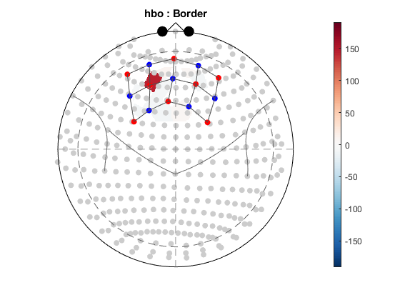
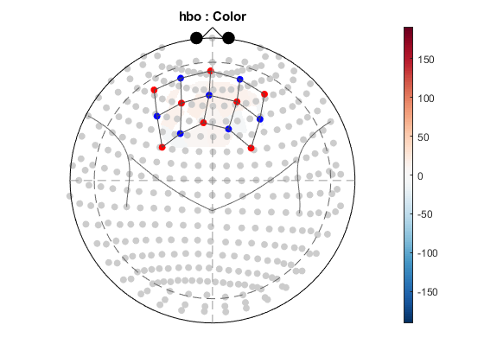
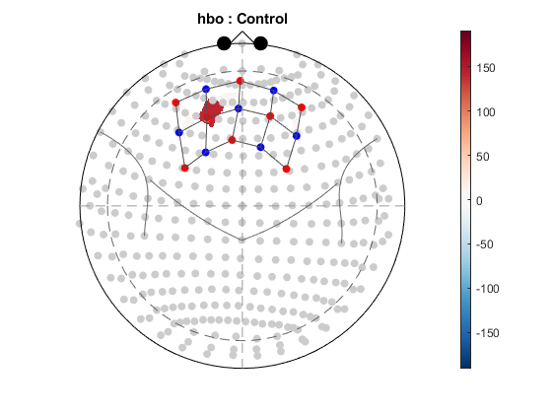
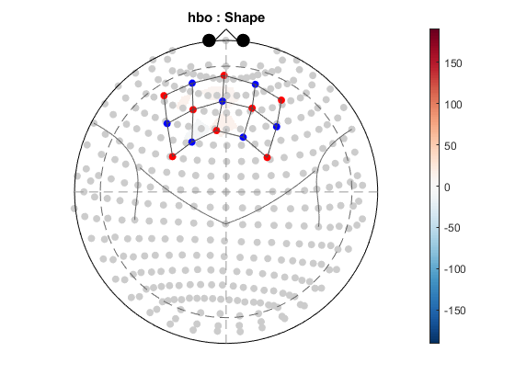
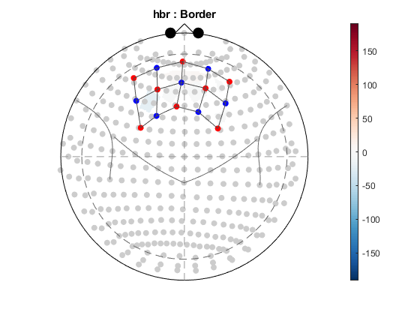
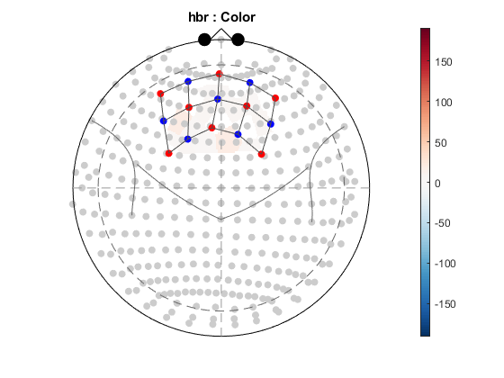
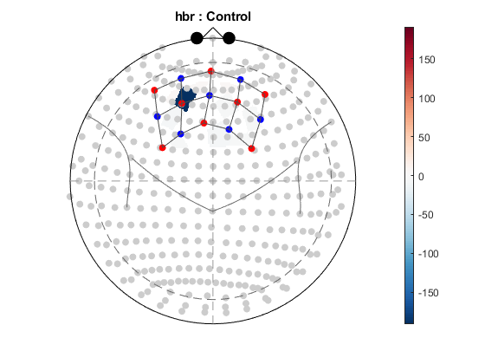
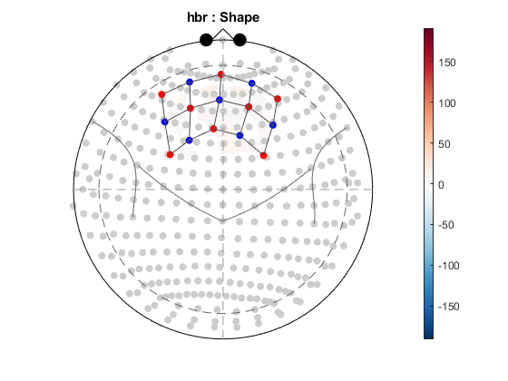

All subject's significant beta values across the channels
DESCRIPTIVE TEXT
[datahbo,datahbr,dataAll,GroupNames,CondNames,figs]=ChannelStatsHeatMap(SubjBetaStats,1,0.05,1,isGNG);
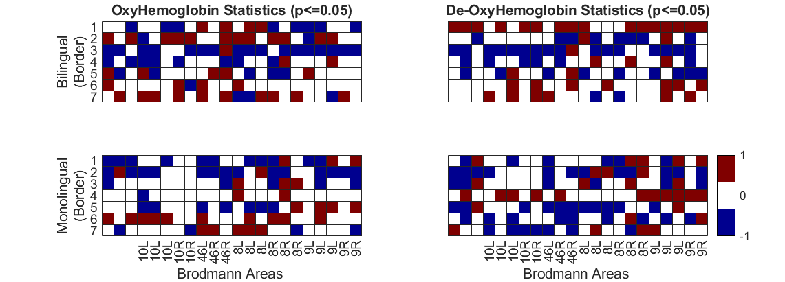
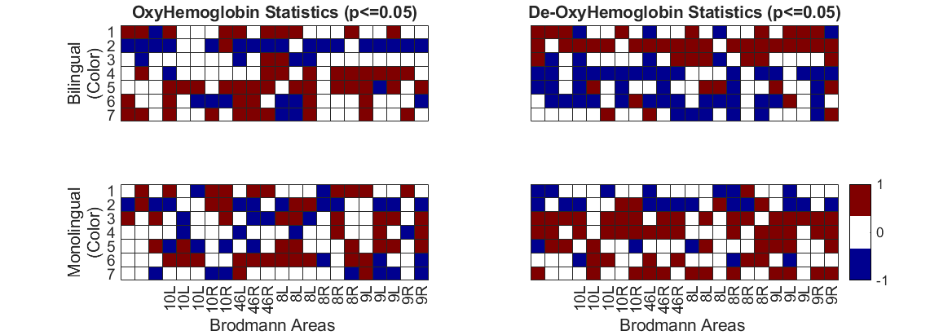
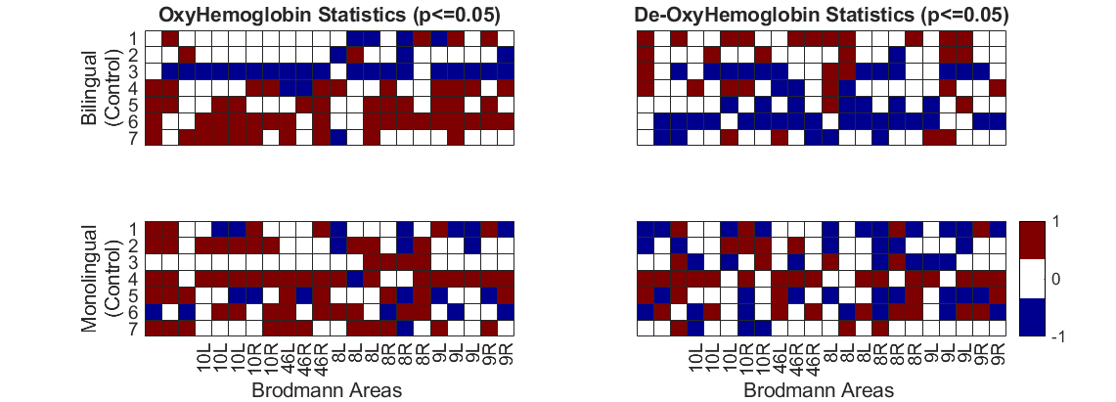
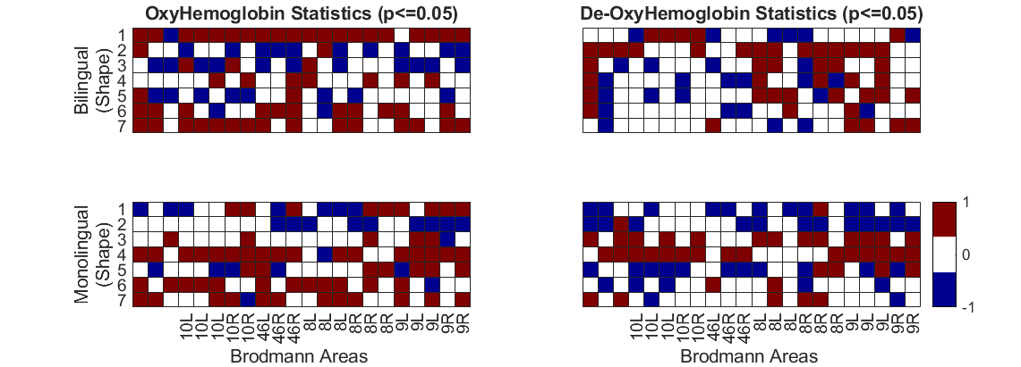

Effect of tasks in a representative single subject
DESCRIPTIVE TEXT
load([filename '_SubjContrasts'])
SubjContrasts(subNum).probe = probe1020;
SubjContrasts(subNum).probe.defaultdrawfcn='10-20 map';
figs=SubjContrasts(subNum).draw('tstat',[],'p < 0.05');
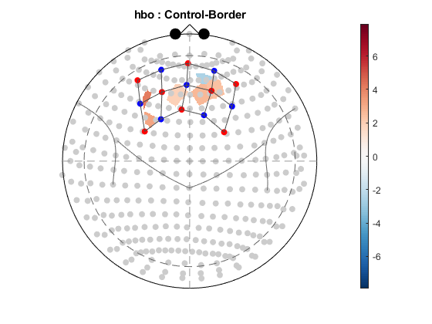
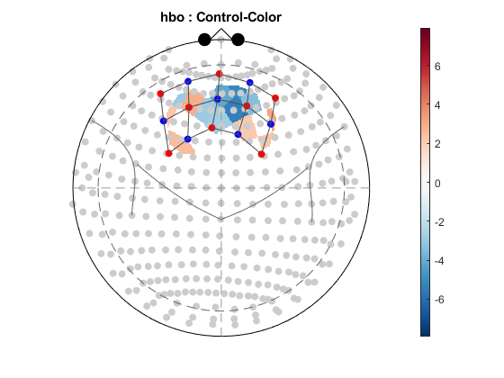
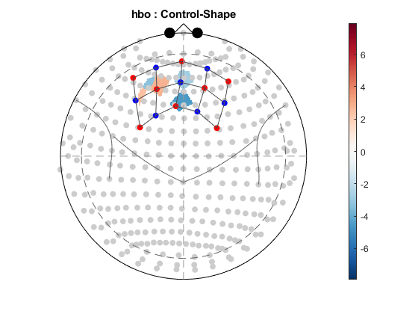
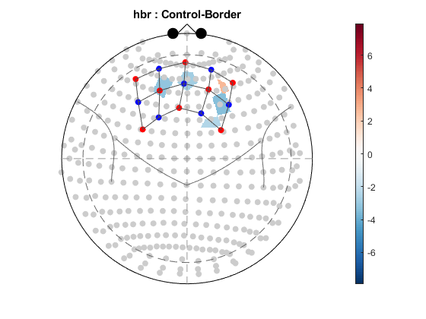
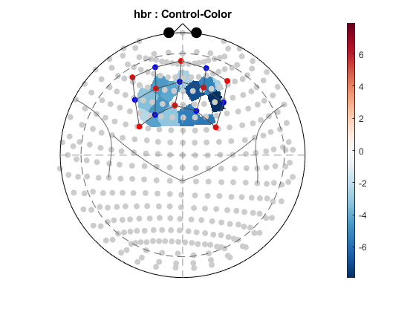
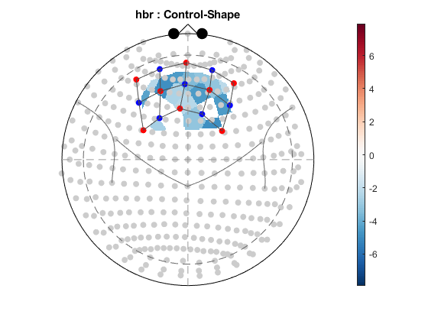

Effect of tasks in a all subjects
DESCRIPTIVE TEXT
[datahbo,datahbr,dataAll,GroupNames,CondNames,figs]=ChannelStatsHeatMap(SubjContrasts,1,0.05,1,isGNG);
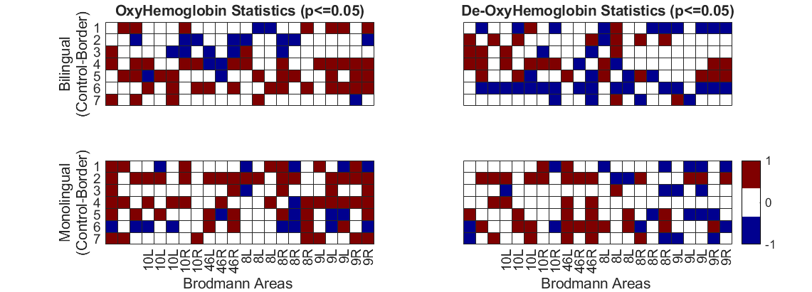
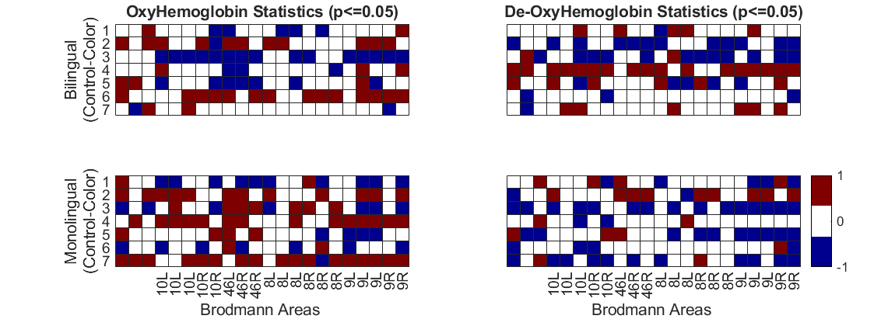
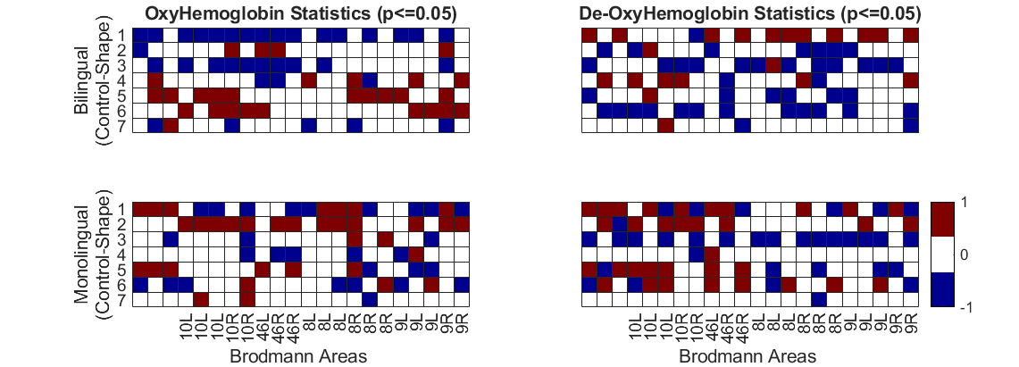
Published with MATLAB® R2018a

