Ejercicio-de-correlación.R

Usuario

2021-03-20

# Sarha Carolina Bravo Gzz  
# 1907306  
# 18.02.21  
# Ejercicio de correlación en clase   
  
conjunto <- read.csv("https://raw.githubusercontent.com/Caarolinee/PrincipiosEstadistica2021/main/Cuadro1.csv", header = TRUE)  
  
plot(conjunto$Diametro, conjunto$Altura)

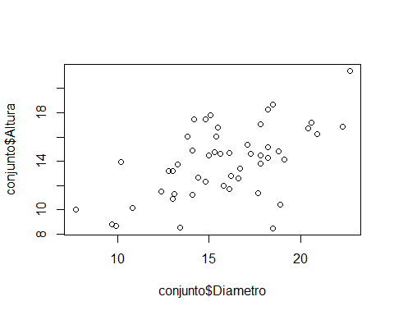

cor.test(conjunto$Diametro, conjunto$Altura)

##   
## Pearson's product-moment correlation  
##   
## data: conjunto$Diametro and conjunto$Altura  
## t = 4.7755, df = 48, p-value = 1.724e-05  
## alternative hypothesis: true correlation is not equal to 0  
## 95 percent confidence interval:  
## 0.3434347 0.7304827  
## sample estimates:  
## cor   
## 0.5675298

data("iris")  
  
head(iris)

## Sepal.Length Sepal.Width Petal.Length Petal.Width Species  
## 1 5.1 3.5 1.4 0.2 setosa  
## 2 4.9 3.0 1.4 0.2 setosa  
## 3 4.7 3.2 1.3 0.2 setosa  
## 4 4.6 3.1 1.5 0.2 setosa  
## 5 5.0 3.6 1.4 0.2 setosa  
## 6 5.4 3.9 1.7 0.4 setosa

summary(iris)

## Sepal.Length Sepal.Width Petal.Length Petal.Width   
## Min. :4.300 Min. :2.000 Min. :1.000 Min. :0.100   
## 1st Qu.:5.100 1st Qu.:2.800 1st Qu.:1.600 1st Qu.:0.300   
## Median :5.800 Median :3.000 Median :4.350 Median :1.300   
## Mean :5.843 Mean :3.057 Mean :3.758 Mean :1.199   
## 3rd Qu.:6.400 3rd Qu.:3.300 3rd Qu.:5.100 3rd Qu.:1.800   
## Max. :7.900 Max. :4.400 Max. :6.900 Max. :2.500   
## Species   
## setosa :50   
## versicolor:50   
## virginica :50   
##   
##   
##

setosa <- subset(iris, Ssescies = "setosa")  
  
plot(setosa$Petal.Length, setosa$Petal.Width)

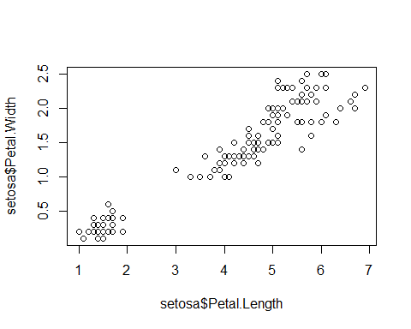

plot(setosa$Petal.Width, setosa$Petal.Length, col="red")

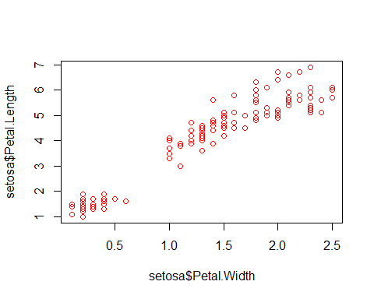

cor.test(setosa$Petal.Length, setosa$Petal.Width)

##   
## Pearson's product-moment correlation  
##   
## data: setosa$Petal.Length and setosa$Petal.Width  
## t = 43.387, df = 148, p-value < 2.2e-16  
## alternative hypothesis: true correlation is not equal to 0  
## 95 percent confidence interval:  
## 0.9490525 0.9729853  
## sample estimates:  
## cor   
## 0.9628654

virginica <- subset(iris, Species == "virginica")  
plot(virginica$Petal.Width, virginica$Petal.Length)

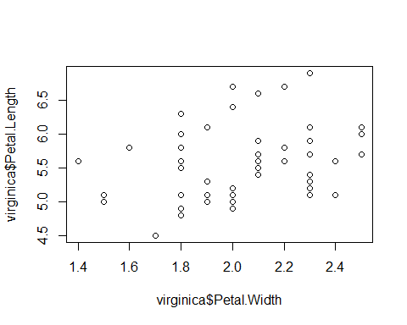

cor.test(virginica$Petal.Width, virginica$Petal.Length)

##   
## Pearson's product-moment correlation  
##   
## data: virginica$Petal.Width and virginica$Petal.Length  
## t = 2.3573, df = 48, p-value = 0.02254  
## alternative hypothesis: true correlation is not equal to 0  
## 95 percent confidence interval:  
## 0.0480704 0.5510499  
## sample estimates:  
## cor   
## 0.3221082

plot(virginica$Sepal.Width, virginica$Sepal.Length, col="purple")

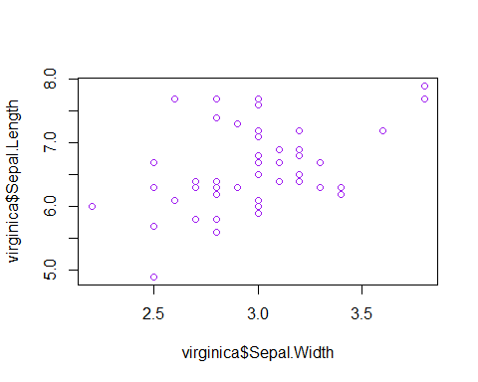

cor.test(virginica$Sepal.Length, virginica$Sepal.Width)

##   
## Pearson's product-moment correlation  
##   
## data: virginica$Sepal.Length and virginica$Sepal.Width  
## t = 3.5619, df = 48, p-value = 0.0008435  
## alternative hypothesis: true correlation is not equal to 0  
## 95 percent confidence interval:  
## 0.2049657 0.6525292  
## sample estimates:  
## cor   
## 0.4572278