Regresión.R

Usuario

2021-04-22

# Sarha Carolina Bravo Gzz  
# 1907306  
# 22.04.21  
  
# Exportar datos ----------------------------------------------------------  
  
copa <- read.csv("https://raw.githubusercontent.com/Caarolinee/PrincipiosEstadistica2021/main/canopy.csv", header = TRUE)  
  
summary(copa)

## Photo Forest Cnpy LAI4   
## Min. :4021 Length:180 Min. :18.81 Min. :0.870   
## 1st Qu.:4067 Class :character 1st Qu.:27.16 1st Qu.:1.170   
## Median :4122 Mode :character Median :29.77 Median :1.330   
## Mean :4118 Mean :29.90 Mean :1.332   
## 3rd Qu.:4168 3rd Qu.:32.36 3rd Qu.:1.480   
## Max. :4214 Max. :38.17 Max. :1.860   
## GLI   
## Min. :17.54   
## 1st Qu.:28.71   
## Median :33.25   
## Mean :33.51   
## 3rd Qu.:38.46   
## Max. :47.65

plot(copa$Cnpy, copa$LAI4, pch=16)

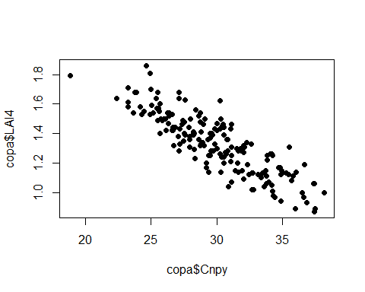

cor.test(copa$Cnpy, copa$LAI4)

##   
## Pearson's product-moment correlation  
##   
## data: copa$Cnpy and copa$LAI4  
## t = -22.421, df = 178, p-value < 2.2e-16  
## alternative hypothesis: true correlation is not equal to 0  
## 95 percent confidence interval:  
## -0.8933414 -0.8156204  
## sample estimates:  
## cor   
## -0.8593654

copa.lm <- lm(copa$LAI4 ~ copa$Cnpy)  
copa.lm

##   
## Call:  
## lm(formula = copa$LAI4 ~ copa$Cnpy)  
##   
## Coefficients:  
## (Intercept) copa$Cnpy   
## 2.73798 -0.04701

plot(copa$Cnpy , copa$LAI4, pch=16, xlab ="Apertura del dosel (%)", ylab = "Indice de área foliar")  
abline(copa.lm, col="red")  
text(23, 10, "Y = 2.737 - 0.047*(x)")

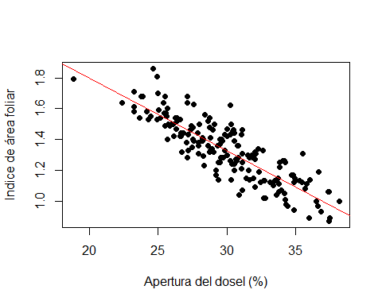

# ¿Cuáles son los valores de la regresión? Agregar una columna "predichos" en la BD copa  
  
copa.lm$fitted.values

## 1 2 3 4 5 6 7 8   
## 1.5663836 1.5955325 1.4770566 1.1691135 1.4403855 1.3755059 1.3731552 1.3637524   
## 9 10 11 12 13 14 15 16   
## 1.5127874 1.5616822 1.4972727 1.4093562 1.3858491 1.5344140 1.5283021 1.6444272   
## 17 18 19 20 21 22 23 24   
## 1.2979325 1.3844386 1.2899401 1.0144368 1.2325827 1.1004728 1.3449467 1.2570301   
## 25 26 27 28 29 30 31 32   
## 1.4638927 1.0548690 1.1484273 1.5236007 1.3153277 1.4878699 1.0440557 1.2212993   
## 33 34 35 36 37 38 39 40   
## 1.1056444 1.2043742 1.1310320 1.0783761 1.2894699 1.1277410 1.3346036 1.2175382   
## 41 42 43 44 45 46 47 48   
## 1.3031040 1.3402453 1.0962415 1.3444766 1.2339932 1.5019742 1.3562301 1.4601315   
## 49 50 51 52 53 54 55 56   
## 1.5875400 1.1493676 1.3867893 1.4859893 1.3162680 1.4037145 1.5179590 1.4112367   
## 57 58 59 60 61 62 63 64   
## 1.6143381 1.6467779 1.4455571 1.4657732 1.8536405 1.6453675 1.4483780 1.4258111   
## 65 66 67 68 69 70 71 72   
## 1.3703344 1.3125069 1.4530794 1.4140576 1.3924311 1.3031040 1.2767761 1.5630926   
## 73 74 75 76 77 78 79 80   
## 1.3510585 1.4888102 1.6265618 1.3360140 1.5381751 1.2527988 1.4972727 1.3035742   
## 81 82 83 84 85 86 87 88   
## 1.1803970 1.2283514 1.4432064 1.3773865 1.2321126 1.4098263 1.3261410 1.4234604   
## 89 90 91 92 93 94 95 96   
## 1.4234604 1.1517183 1.6218604 1.5551002 1.5306528 1.6867400 1.3092159 1.1300917   
## 97 98 99 100 101 102 103 104   
## 1.1366737 1.3148576 1.2908804 1.2307022 1.2763059 1.1583003 1.5043249 0.9810567   
## 105 106 107 108 109 110 111 112   
## 1.4836386 1.6016443 1.4855192 1.5395855 1.3562301 1.3270813 1.0591003 1.1630017   
## 113 114 115 116 117 118 119 120   
## 1.3491780 1.2495078 1.3256709 1.0703837 1.2937012 1.4808178 1.3853789 1.4244007   
## 121 122 123 124 125 126 127 128   
## 1.4102965 1.5085562 1.4060652 1.2739552 1.4441467 1.2866491 1.2509183 1.2372841   
## 129 130 131 132 133 134 135 136   
## 1.2006131 1.0976519 0.9754150 1.1192785 1.1291515 0.9796463 1.0454662 1.2133069   
## 137 138 139 140 141 142 143 144   
## 1.1949714 1.0153771 1.0228993 0.9434453 1.0981221 1.4253410 1.1258605 1.0050339   
## 145 146 147 148 149 150 151 152   
## 1.4272216 1.2777164 1.3049846 1.3110965 1.3590510 1.3139173 1.3515287 1.3919609   
## 153 154 155 156 157 158 159 160   
## 1.1427856 1.0675628 1.1479571 1.3035742 1.2433960 1.5654434 1.4624822 1.2015533   
## 161 162 163 164 165 166 167 168   
## 1.0934207 1.1498377 1.5442870 1.5414661 1.5377050 1.5804879 1.3646927 1.5311230   
## 169 170 171 172 173 174 175 176   
## 0.9787060 1.2748955 1.2937012 1.4403855 1.1982624 1.2739552 1.3863192 1.3505884   
## 177 178 179 180   
## 1.2386946 1.2622017 1.4606017 1.4638927

# ¿Dónde estan almacenados esos valores?  
  
# Estan almacenados en copa.lm$fitted.values  
  
copa$predichos <- copa.lm$fitted.values  
  
# ¿Cuántos grados de libertad (df) tiene el analisis regresión?  
  
# 178 GL o df   
  
# Determinar medeiante la ecuación de regresión los siguientes valores:   
  
# 20, 22, 24, 25, 26, 28.3, 30.3, 31.8, 33, 35  
  
valores <- c(20, 22, 24, 25, 26, 28.3, 30.3, 31.8, 33, 35)