1. **Android Platform Layers**

Android system is a stack of software divided into different sections and layers: Linux Kernel, Libraries, Android Libraries, Android Runtime, Application Framework and Applications.

**Linux Kernel**: Is the bottom of all of them. Provides the communication with the device hardware.

**Libraries**: Here we can find the web browser engine webkit, libc, sqllite, media libraries and ssl internet security libraries.

**Android Libraries**: Java-based libraries for android development. It seems that is time for C/C++ to also start filling the software stack with its own libraries.

**Application Framework**: It provides many higher-level services to applications in the form of Java classes.

**Application**: Where the application are installed and live.

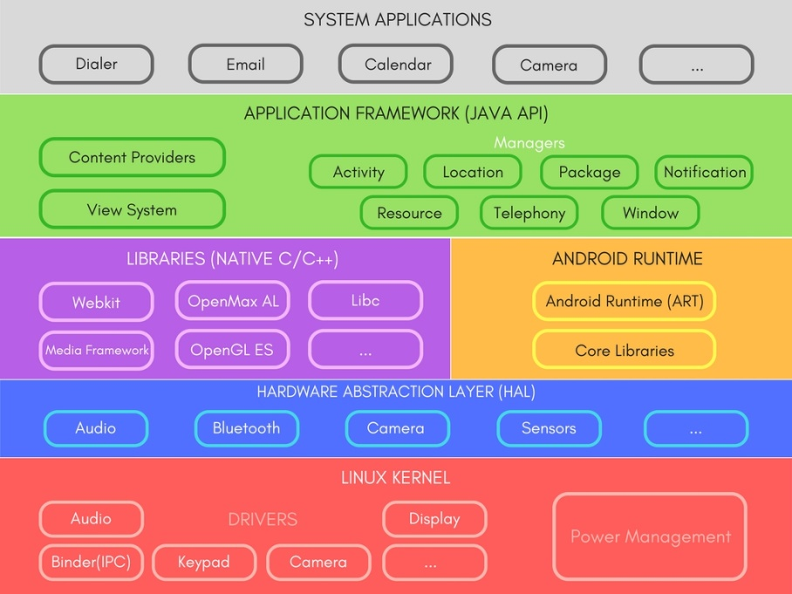

*Image taken from*: <https://www.studytonight.com/android/android-architecture>

1. **Android Components**

Android components are the essential building blocks of an Android application. These components are loosely coupled by the application manifest file AndroidManifest.xml that describes each component of the application and how they interact. There are 4 types of components:

**Activities**: Is the representation of a single screen with an user interface.

**Services**: Component running in the background to perform long-running operations.

**Broadcast Receivers**: Respond to broadcast messages from other applications or from the system.

**Content Providers**: Supplies data from one application to others on request.

1. **Lint**

Android lint is a tool is to do static code analysis to check up your Android project source files for potential bugs and optimization improvements for correctness, security, performance, usability, accessibility, and internationalization.

1. **Units of Measuring**

**Pixels** (**px**): corresponds to actual pixels on the screen.

**Inches** (**in**): based on the physical size of the screen.

**Millimeters** (**mm**): based on the physical size of the screen.

**Points**: **1/72** of an inch based on the physical size of the screen.

**Density-independent Pixels (dp/dip)**: an abstract unit that is based on the physical density of the screen. These units are relative to a 160 dpi screen, so one dp is one pixel on a 160 dpi screen. The ratio of dp-to-pixel will change with the screen density, but not necessarily in direct proportion.

**Scale-independent Pixels (sp):** this is like the dp unit, but it is also scaled by the user's font size preference. It is recommended you use this unit when specifying font sizes, so they will be adjusted for both the screen density and user's preference.