Tutorial – 9

Exercise – 1

I decided to create a class User and keep values like x_i, P_i and so on in it along with partial keys calculations and such.

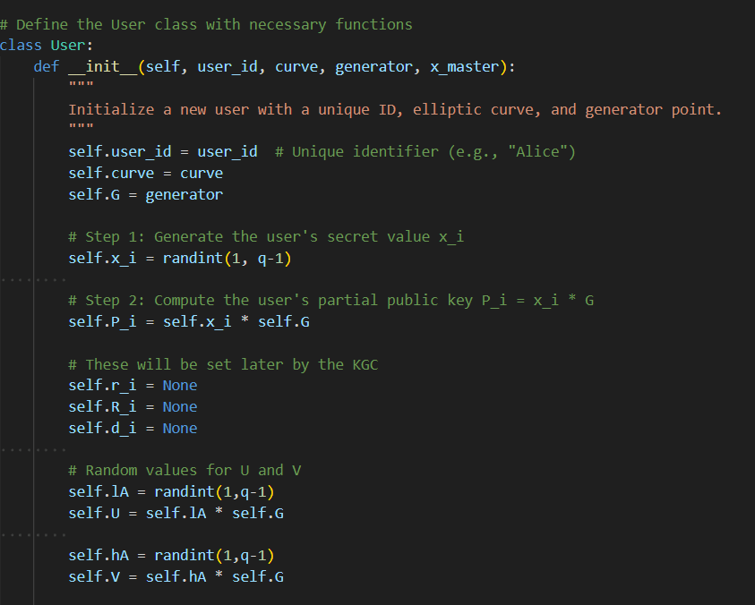

Here we have user_id as the unique ID for each user, curve and generators are the one already defined in the base file given to us.

Functions for partial key calculation

Hash is calculated with user_id, R_i and P_i and then d_i is calculated.

Function to calculate full keys.

Initialising x_master and Ppub_master and user alice and bob.

Condition to create full keys also in class User

Exercise – 2

Calculation of lA, hA, U and V (also done in class User)

Function for computing Y and T, also printing KAB to check later.

AES encryption

Function for encapsulation

Exercise – 3

Function to calculate Y and T again and check if they are the same.

Also, function to calculate KAB again as well and check if they match. Not sure why the H calculation needed to be done again, I skipped it.

Decryption using KAB_reverse

Working output

