Devops Exercise 1 Report

Platform information

- HW HP EliteBook x360 1030 G3
- OS Arch Linux x86_64

I have used podman instead of docker, there are no real differneces between them.
- podman version
Client: Podman Engine
Version: 5.6.1
API Version: 5.6.1
Go Version: go1.24.6
Git Commit: 1e2b2315150b2ffa0971596fb5da8cd83f3ce0e1
Built: Fri Sep 5 09:39:58 2025
OS/Arch: linux/amd64
- podman-compose version
podman-compose version 1.5.0
podman version 5.6.1

Network diagram

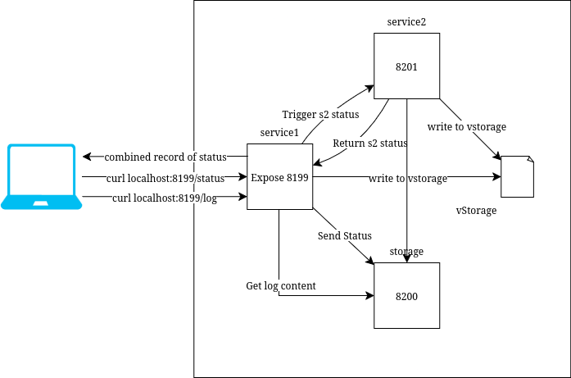
Log Analysis

curl output

curl localhost:8199/status
2025-09-28T14:06:03Z: uptime 1.78 hours, free disk in root: 434647 MBytes
2025-09-28T14:06:03Z: uptime 1.775 hours, free disk in root: 434647 Mbytes

The disk space and uptime are that of my device, so after every restart the uptime resets to zero.

These numbers arent super relevant and it would be better if the uptime and disk spcae of the container was shown. Container uptime could be calculated from time of creation, disk space perhaps could be changed to show space free in the volumes (if any mounted).

Storage Analysis

Mounting just a single file like vstorage doesn’t achive much and involved extra steps, easier way is to just mount a folder and then docker can create files inside that folder easily.

Clean Up instructions

echo "" > vstorage
echo "" > internal-storage/log.txt

or run cleanup script

./cleanup.sh which does the same

vstorage and internal-storage/log.txt can be cleaned up in any text editor as well.

Removing vstorage file can cause issues, since docker tries to recreate vstorage as a folder

What was difficult and main problems?

Figuring out the vstorage setup was a bit tricky since the instructions were a bit cryptic, first I assumed that each contaier has its own vstorage mount, then later I figured it needs to be a common mount so I shared vstorage folder commonly between all containers.
Later I realized that vstorage needs to be a file, so more issues came up. It would have been easier if it was told that vstorage is a common file for all containers at the start of the instructions.

Everything else was more or less easy, no other issues came up!

No big problems came up.

