Capstone Project Report – Anmol Arora

Challenge 1: SQL injection

Step 1:

1. Login into DVWA with given user creds
2. Set security level to Low

Step 2:

1. Identify table and check for sqli  
   A screenshot of a computer

   Description automatically generated
2. Use payloads to get info about table - <https://pentestmonkey.net/cheat-sheet/sql-injection/mysql-sql-injection-cheat-sheet>   
   ‘ UNION SELECT @@VERSION, NULL# - To get version details  
   ‘ UNION SELECT USER,PASSWORD FROM MYSQL.USER# - Gives logged in users rights to the table and shows passwords, apparently we are root  
   A screenshot of a computer

   Description automatically generated  
   But this isn’t what we want, we want bobs password, so more enumeration
3. First, we need to get database and table names and then columns!

' UNION SELECT NULL, TABLE_NAME FROM INFORMATION_SCHEMA.TABLES WHERE TABLE_SCHEMA =’dvwa’#

Now we get columns from users table.

Finally, we get hash.

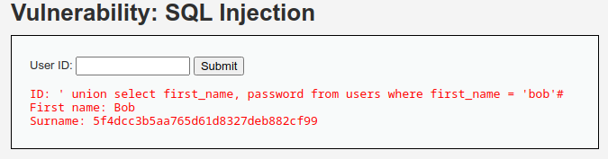  
  
Cracking hash 5f4dcc3b5aa765d61d8327deb882cf99

And username – smithy

Challenge 1 flag

Challenge 2: Web Server Vulnerability

The File inclusion directory has file1.php being referenced in the URL and simply changing that to /etc/passwd gives this.

But we don’t know where challenge 2 file is and I don’t like brute forcing so we upload reverse webshell.

Copy the php reverse shell, change port and ip and change url to

We have shell, now to find code.

There is a flags dir and it has fi.pfp file which has some b64 code.

ChatGPT to decode  
  
Turns out there is a code after all, pop reverse shell again-> go to var/www/html and grep for Challenge  
  
Via WEB IS   
  
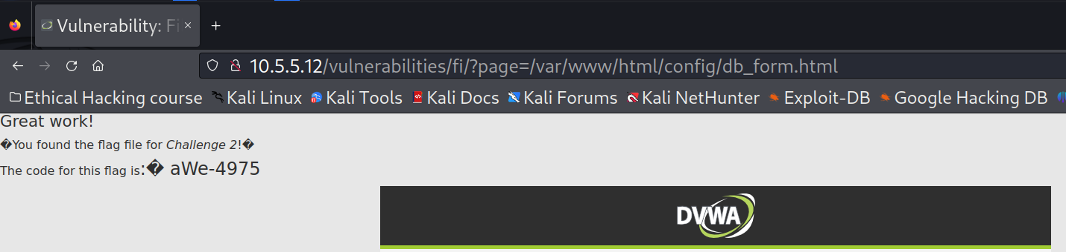

Code is aWe-4975

Challenge 3: SMB Vulnerability

Scan the range to see what hosts are up and we find one with 139 and 445 running services so that is the one with SMB.

Available shares and permissions

The file is in OTHER is called sxij42.txt

Code is: NWs39691

Challenge 4:

From the pcap file we see target is 10.5.5.11

Directories that are available in capture are - testoutput

Exporting all the files from http we can see theres only 2 big files

None of these files seem to have any Challenge codes.

Turns out my VM had some issues, imported it again and 10.5.5.11 now has a running web server.

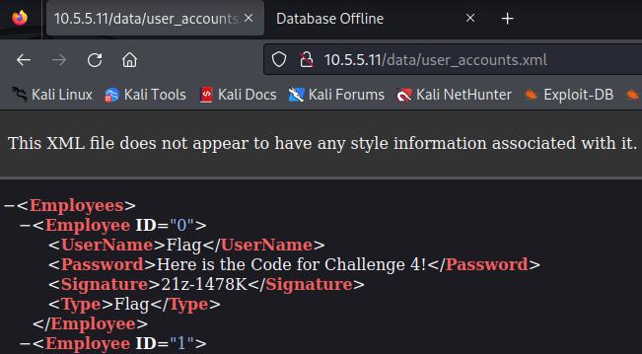

Code: 21z-1478K