Using my low pass filter
y(n) = a*x(n) + (1-a) *y(n-1)
blue: filtered
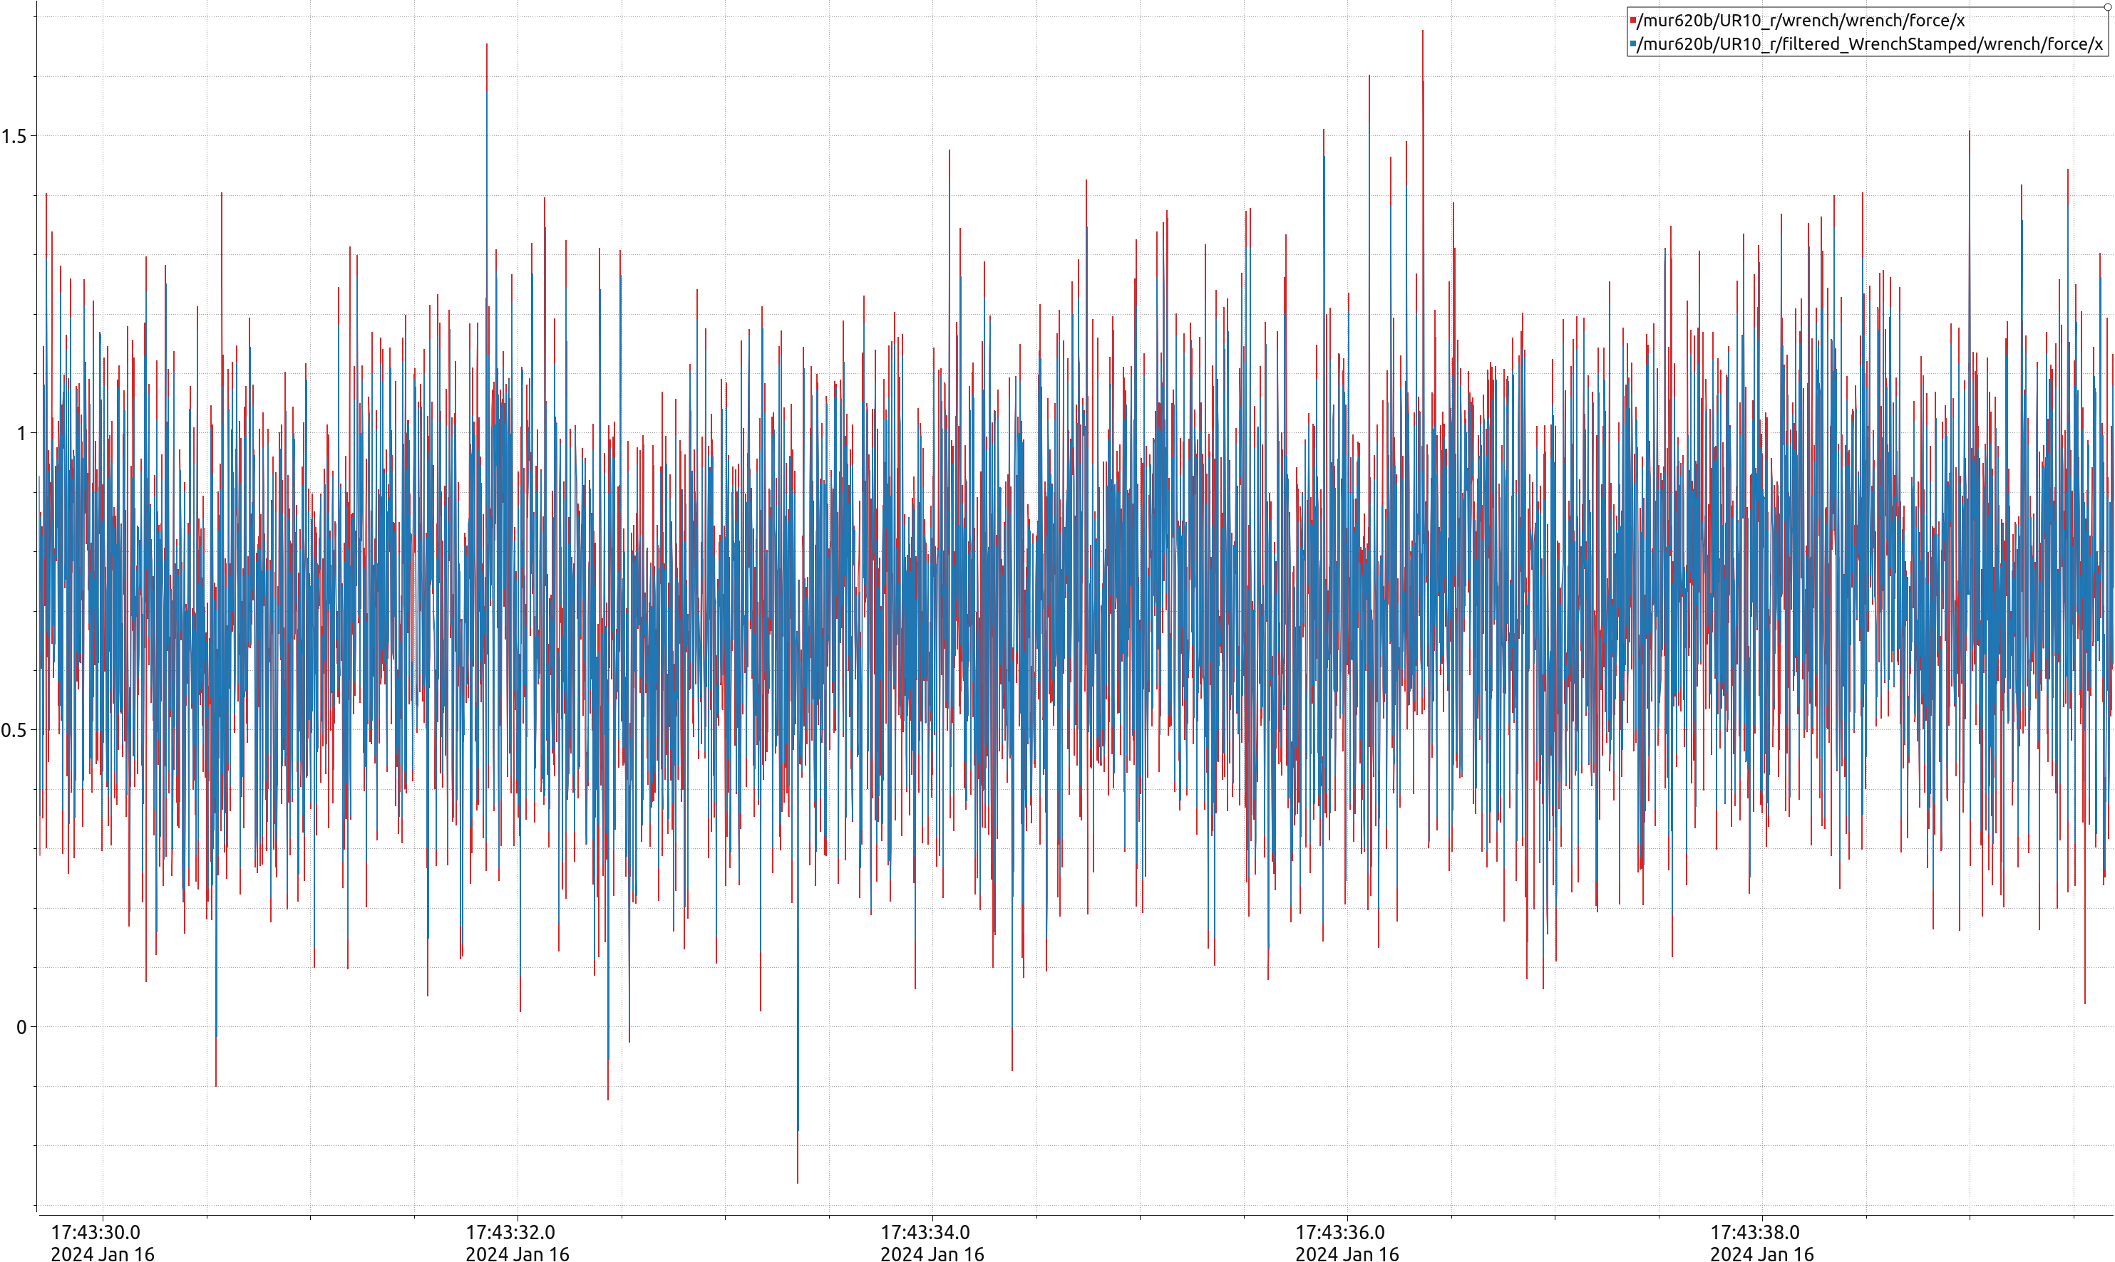
red:raw

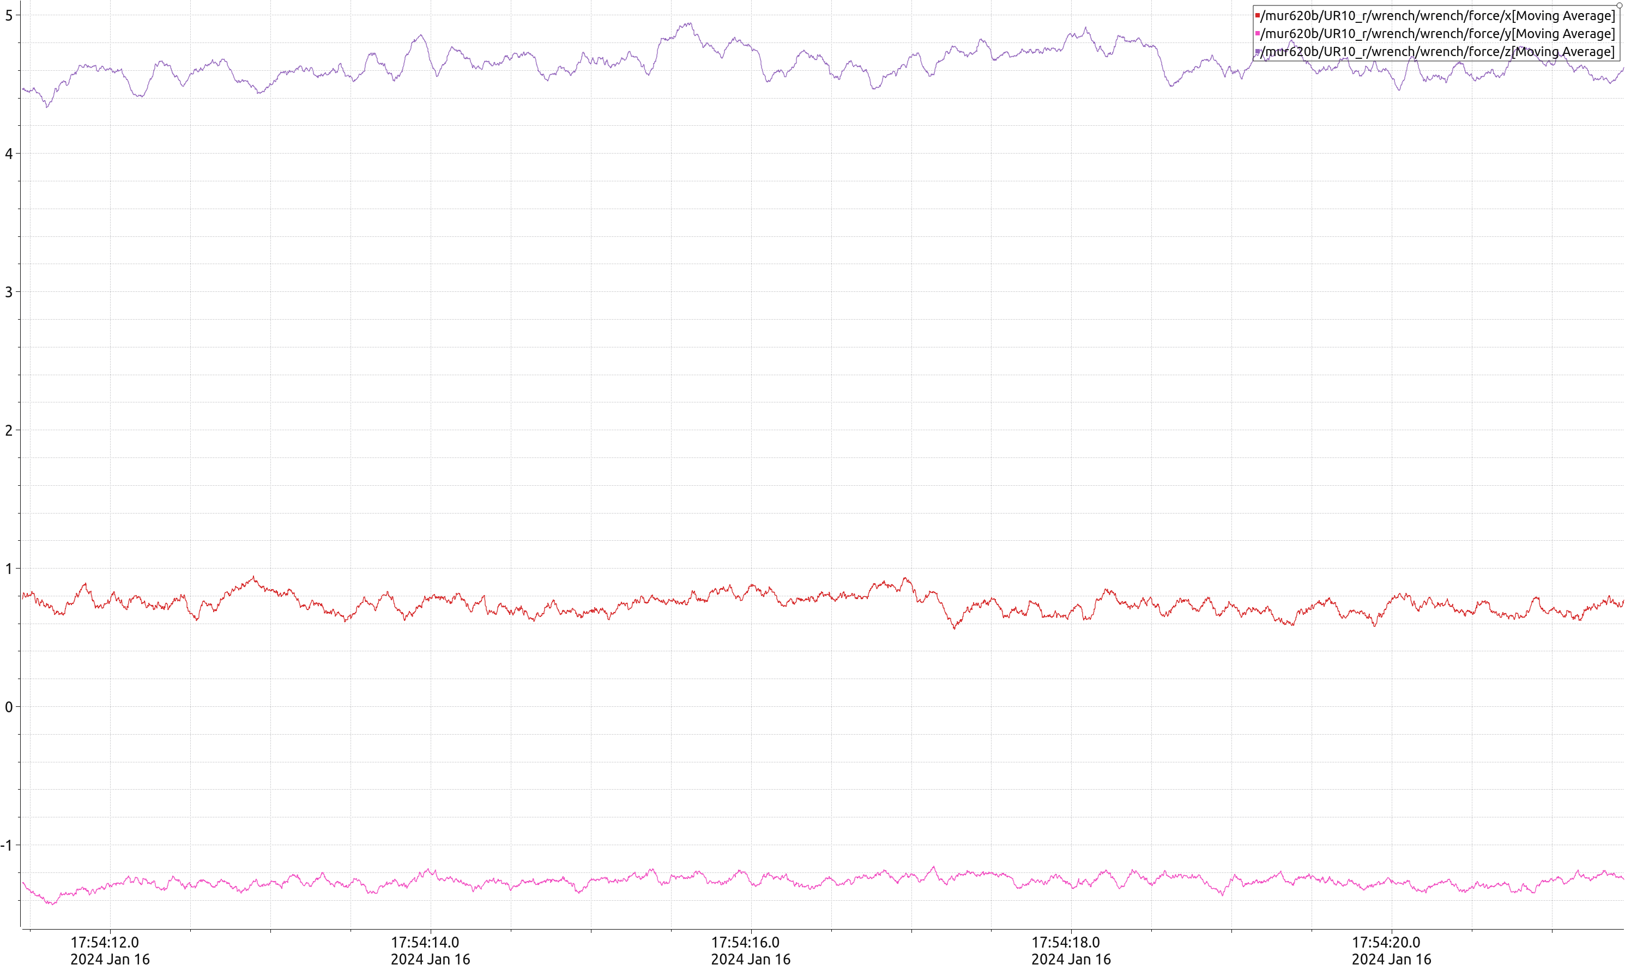
Filtered by using moving average filter (sample 40 after rosservice call /mur620b/UR10_r/ur_hardware_interface/zero_ftsensor)

