Caleb Lewandowski

January 31, 2020

Module 5.2 Assignment

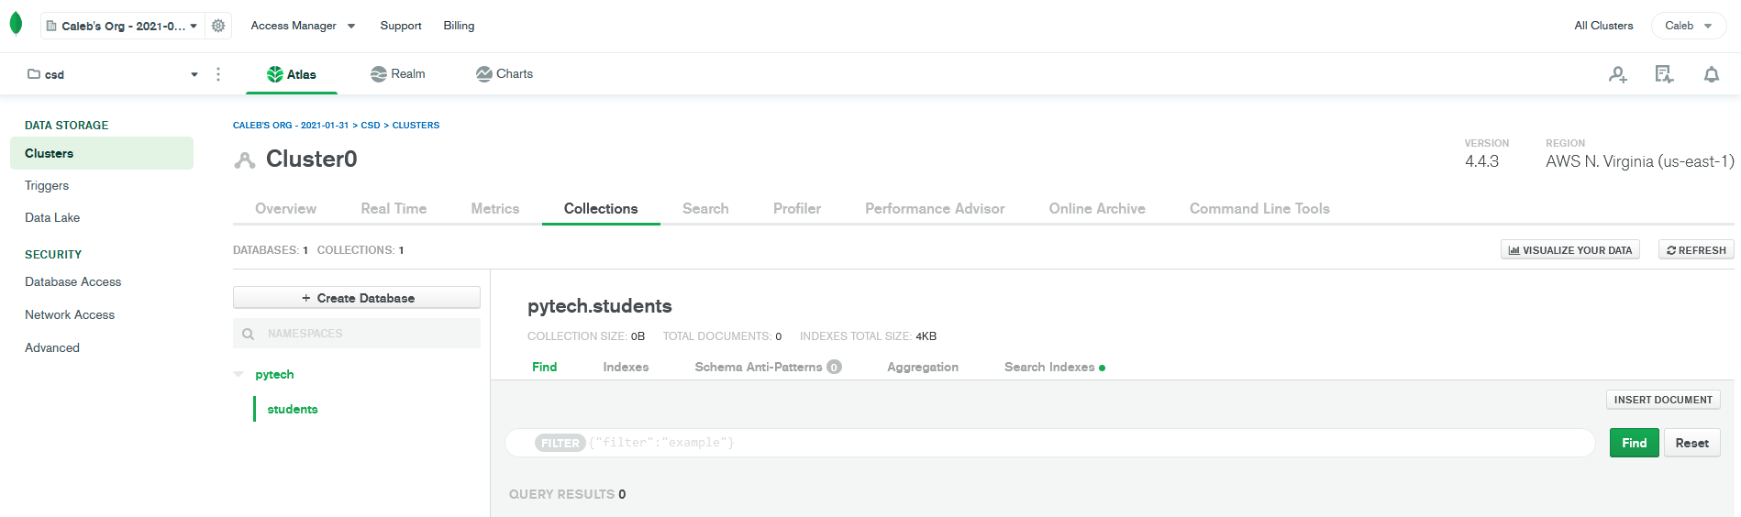

<https://github.com/CabesBlah/csd-310.git>