Caleb Lewandowski

May 11, 2021

Module 11.2 Assignment

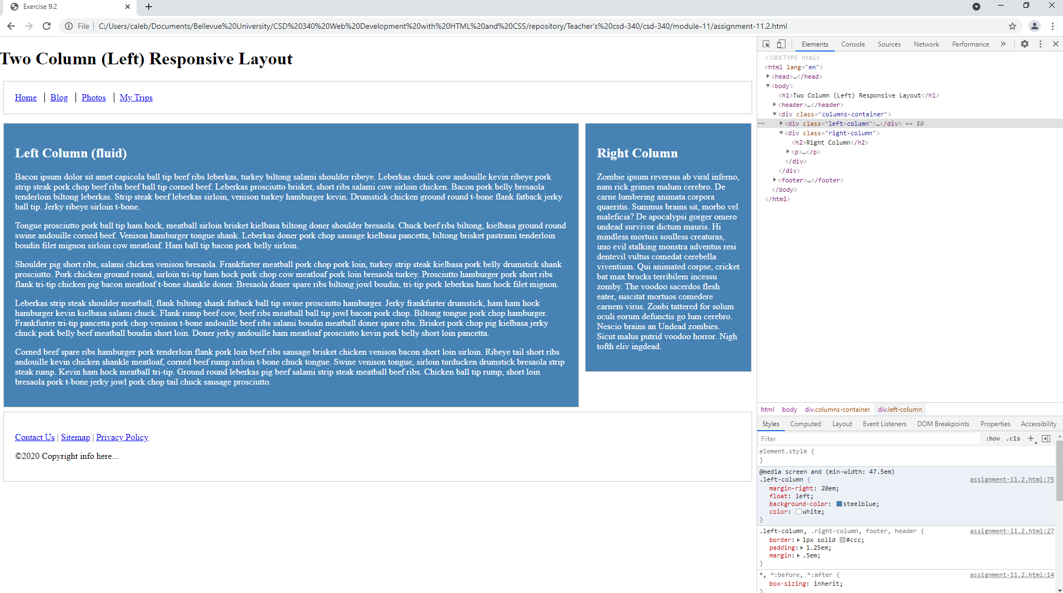

<https://cabesblah.github.io/csd-340/>