Hobbies:

Video Game – I really like to play video games. The satisfaction I get from learning a game, playing the game, and winning in the game is great. Of course, it is not as fun to lose.

Music – I occasionally try to create some music using LMMS. I never create an good songs, but I like creating a basic beat and melody. It is a musical outlet for me.

Programming – Sometimes, I create a program on my own time because I like the feeling of creating something. In addition, programming on my own time helps me to remember programming concepts and allows me to learn new ones.

Experience:

Courtesy Clerk – I worked as a courtesy clerk for my first job. I would bag groceries and bring in the grocery carts that were outside. I would also help out on other tasks I was called to do.

Dairy Stocker – After a couple months as a courtesy clerk, I was moved to dairy stocker where I would stock dairy and other refrigerated products like juice. I also had to restock the water.

English-Spanish Database – A while back, I attempted to make a MySQL database to store English-to-Spanish translations and a Java program to access and manipulate that data. I never finished it, but the program could at least translate words.

Primary Color:

#5BAEFF

#4F78FF

Images:



Caleb Lewandowski

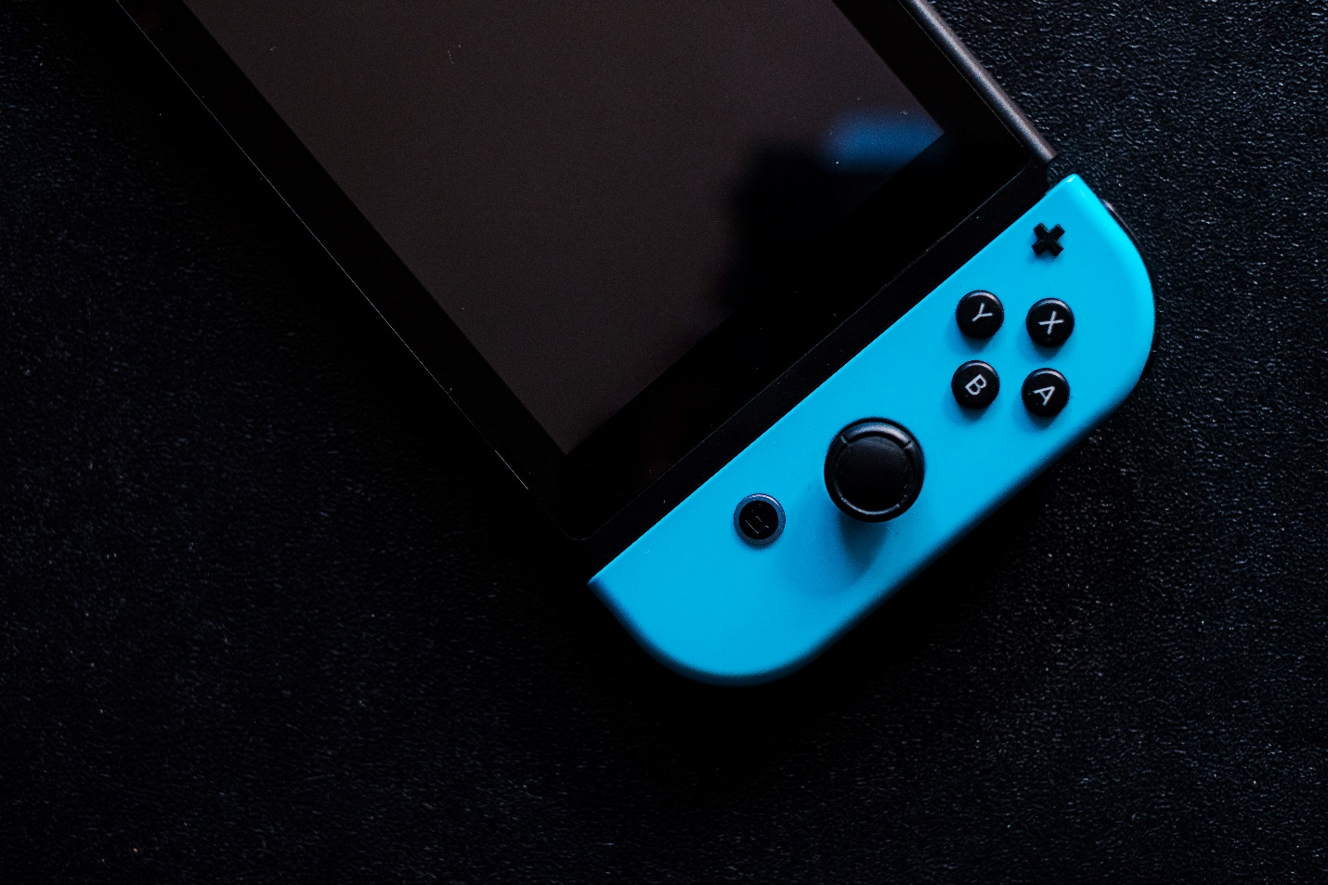

by Ehimetalor Akhere Unuabona on Unsplash

A Nintendo Switch.



by Sašo Tušar on Unsplash

A sound board.

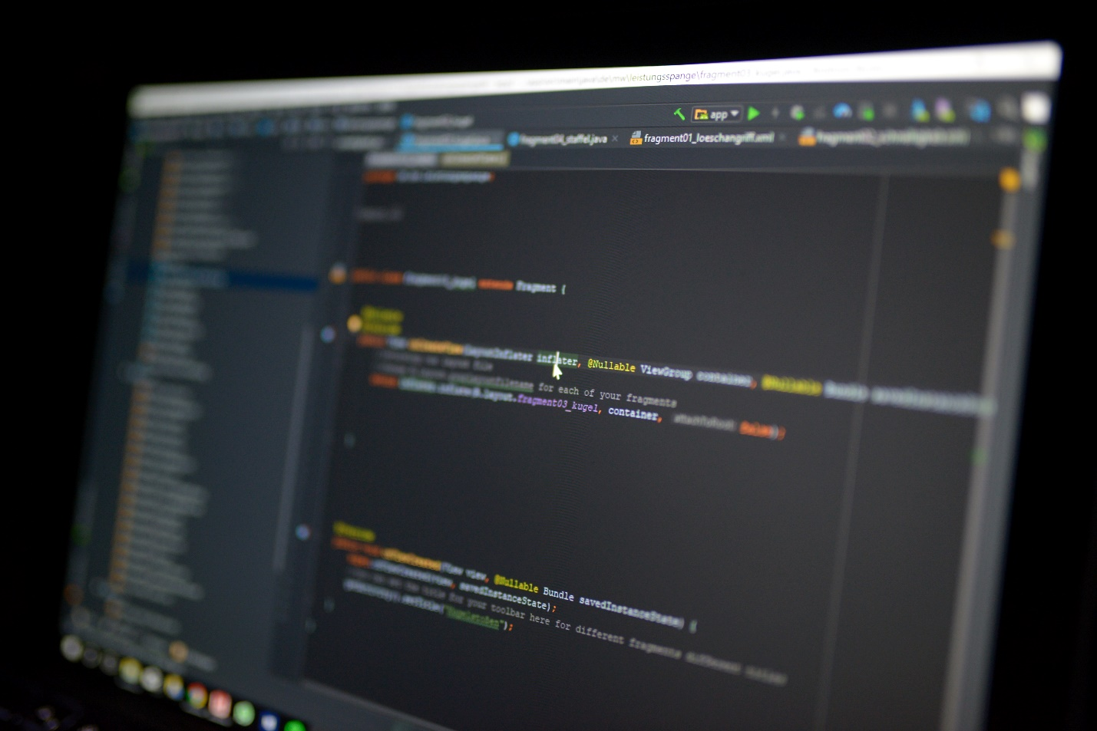

by Maximilian Weisbecker on Unsplash

Java programming on a computer.

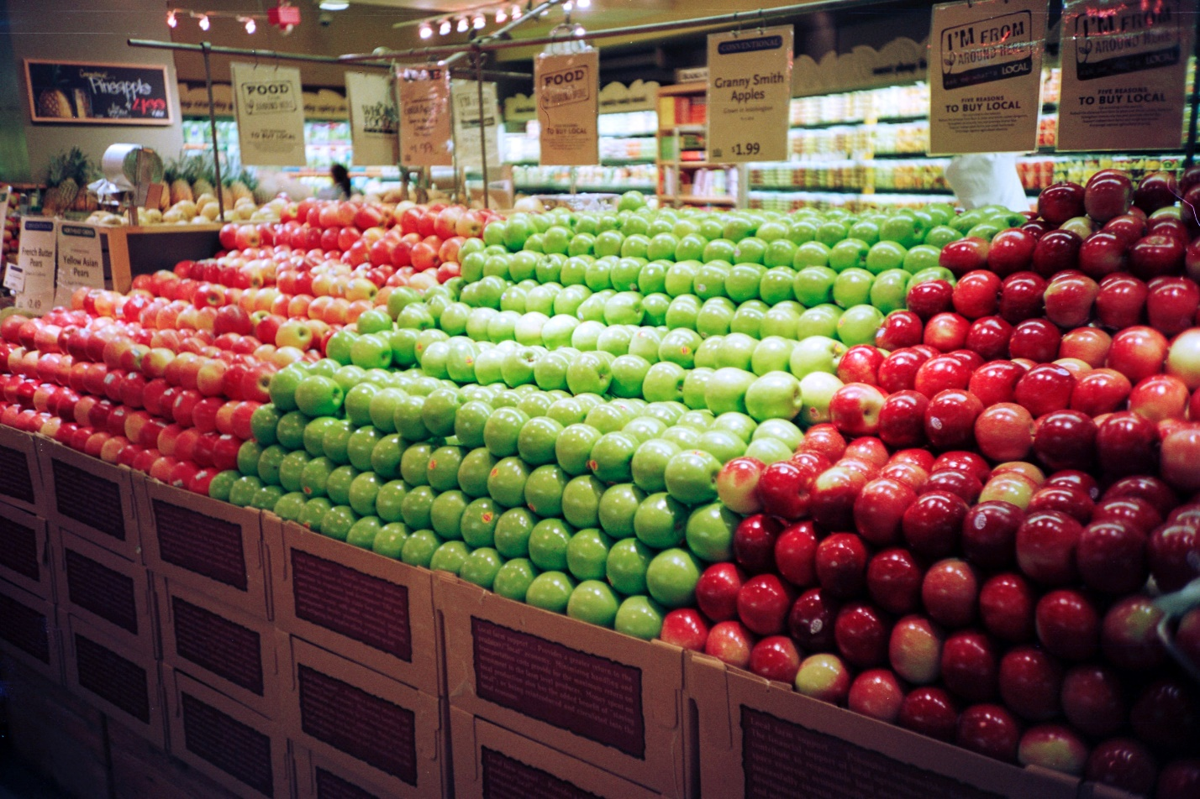

by Scott Evans on Unsplash

Apples at a grocery store.

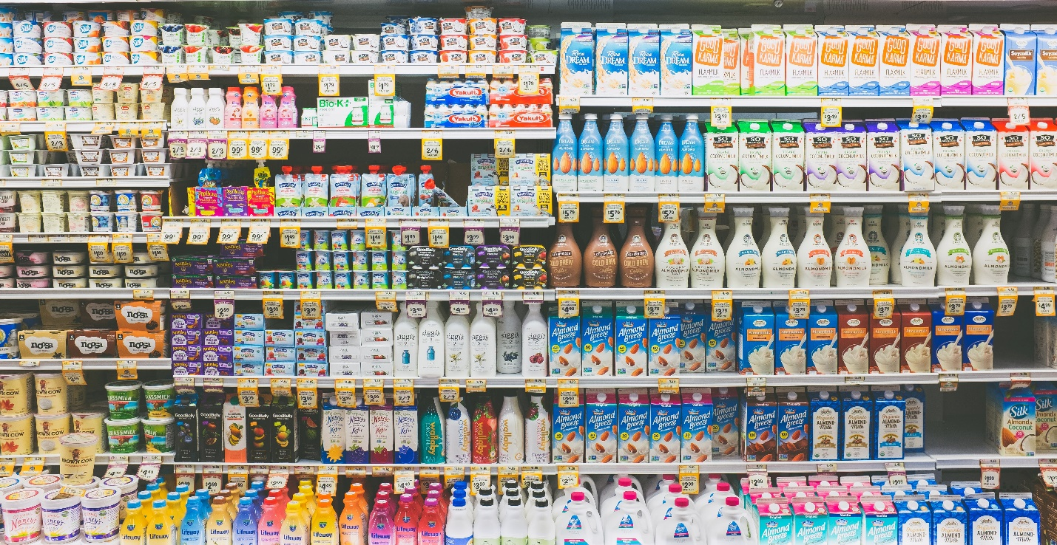

by NeONBRAND on Unsplash

Dairy section at a grocery store.

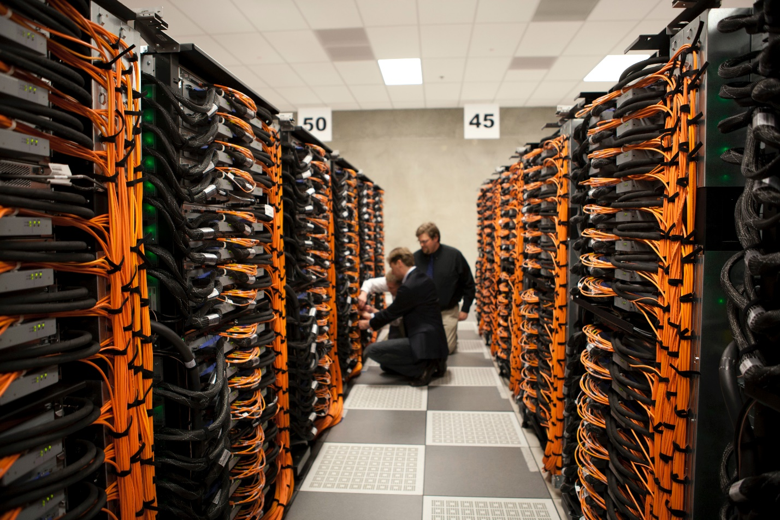

by Science in HD on Unsplash

A room full of servers.