Caleb Lewandowski

April 19, 2021

Module 6.2 Assignment

Style Guide:

Google Font:

* Lato

Color Palette:

* #72F227
* #F2EE27

General:

h1

Font Weight: 700

Titles an entire page. There should only ever be one on a single page.

h2

Font Weight: 700

Titles a section of a page.

h3

Font Weight: 700

Titles a subsection of a page.

h4

Font Weight: 700

Titles a sub-subsection of a page.

h5

Font Weight: 700

Titles a sub-sub-subsection of a page.

h6

Font Weight: 700

Titles a sub-sub-sub-subsection of a page.

p

Font-Weight: 400

A paragraph in a page.

hr

A horizontal line used to separate ideas and sections.

ol

List that uses numbers.

ul

List that uses bullet points.

li

An item in a list.

a

Inside p:

Normal:

Normal text

#72F227

Hover:

Underline

#F2EE27

Visited:

Normal text

#72F227

Outside p:

Hover:

Highlighted background

A link to another page or website.

figure

Text Align: center

A picture element with captioning.

figcaption

Font Weight: 300

Captioning for a figure element.

img

An image element.

Wireframes:

Landing page:

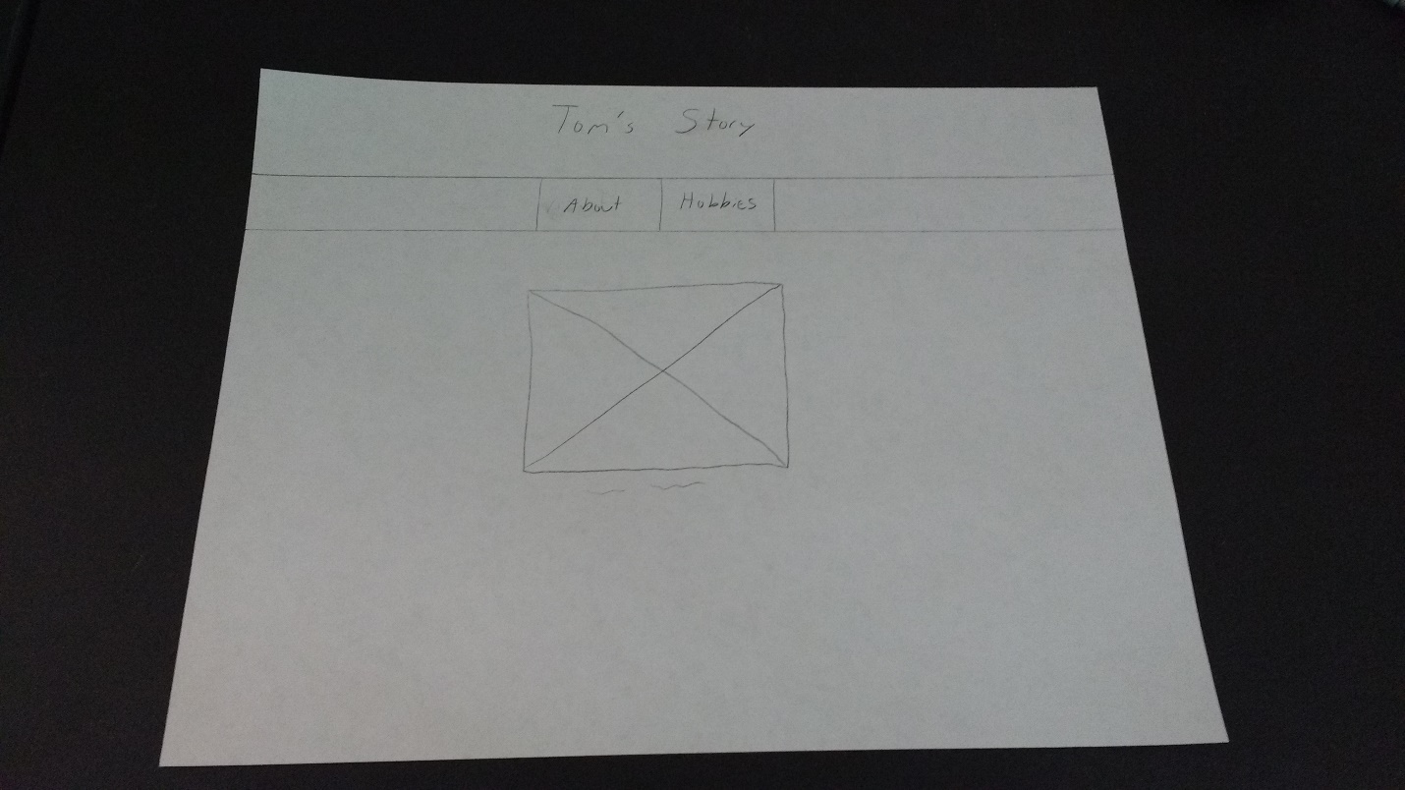

About and Hobbies pages:

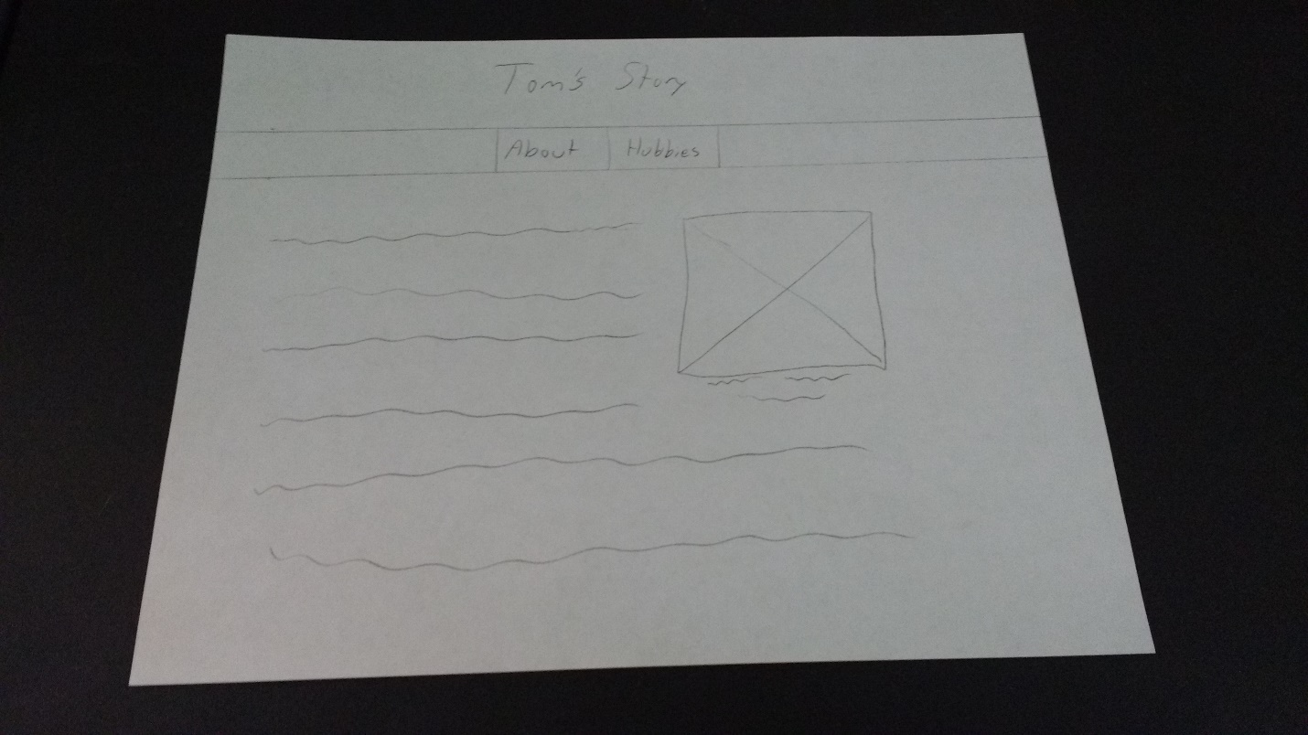

Interview Questions:

What is your name?

Thomas Lewandowski but goes by Tom.

Where did you grow up?

Toledo, Ohio

Did you go to a university? If so, what did you pursue?

University of Toledo. Two-year associate’s in electronics technology.

What got you interested in <pursued topic>?

He got a 25 in 1/ 40 in 1 electric experiment kit from radio shack for Christmas.

It contained switches, relay, bulb, motor. No electronics. Electric

What do you do in <pursued topic>?

You become a test technician/ QA. Testing functionality. Maybe repairman.

Do you enjoy <pursued topic>?

He did. He does not do it anymore. He hooked his keyboard to make drum kit. Computer to thermometer to monitor temperature.

Are you currently working a career in <pursued topic>? If not, how, and why?

No. Got into software development and enjoy it more.

Loved computers. 1979, SynthClar computer. Got TI-99/4a computer. Came with BASIC and made games like wheel of fortune, rocket ship game(side scroller with gravity, hit = crash).

Amiga bought in 86. Programmed. Still working on electronics. Much later, Learned c++, then visual basic. Created business and website, economy crashed, had to get a web app development job. Hired by bigger company for web app development for 6 years. Still going.

What are your hobbies?

No hobbies. Used to play video games. Watch current events on youtube; stream shows and movies; home improvement.

What do you do for personal entertainment?

None, same as previous. No video games; no software development.

Research:

I could not find an associate’s degree in electronics engineering on the University of Toledo’s website. The closest I can get is a bachelor’s degree in electrical engineering technology. He pursued the degree a while ago, so maybe that particular degree has been dropped. Since I cannot find the original degree, I cannot confirm what he said about the jobs you can attain with the associate’s degree. The website lists five jobs you can get with the bachelor’s degree, which includes automotive engineer, controls engineer, automation engineer, electrical engineer, and instrumentation engineer.

<https://www.utoledo.edu/Programs/undergrad/Electrical-Engineering-Technology>

I could not find the specific electronic kits that he said came from RadioShack. All I could find were variants like an All-in-One kit. The event happened a long time ago, so it would make sense that they do not sell that specific version anymore. These kits allow you to create electronic builds to help teach the builder what each component does.

<https://www.radioshack.com/products/mlkit1gse>

Sinclair computers were a series of cheap, affordable computers, the creation of which was led by Clive Sinclair. You could purchase them as a kit to put them together yourself. Although they were cheap, Sinclair computers had a decent processor and decent memory. The memory was expandable, but the computers had to be connected to a TV.

<https://www.techspot.com/article/2079-sinclair-computers/>

<http://www.oldcomputers.net/zx81.html>

Texas Instruments released the TI-99/4a computer in 1981. It sold pretty well. The computer’s capabilities could be expanded and increased. However, this was the last computer released by Texas Instruments.

<https://americanhistory.si.edu/collections/search/object/nmah_1064832>

Amiga computers were a series of computers developed by the Commodore company. The first one was the Amiga 1000 and was revealed in 1985.

<http://www.oldcomputers.net/amiga1000.html>

Biography:

Thomas Lewandowski, who also goes by Tom, was born and raised in Toledo, Ohio. When he was young, he received a 25-in-1 electric experiment kit for Christmas, which started his interest in electronics technology. During this time of his life, he became interested in computer programming. In 1979, he received a Sinclair computer, and then later got his hands on a TI-99/4a computer. With this computer, he learned the programming language BASIC and made several games. An example of such a game is a wheel of fortune game. Another game Tom created is a rocket ship side-scroller game. In this game, you had to fly a spaceship across a planet or moon, so you were affected by gravity. If you hit something, you lost. In 1986, he bought an Amiga computer and learned some more programming. Specifically, he learned about c++ and Visual Basic. He was still interested in electronics at the time as well. In fact, when he went to the University of Toledo, he achieved an associate’s degree in electrical technology. Later, in his adult life, he created a business and a website for that business. Eventually the economy crashed, and he had to find a job because the business was not providing enough revenue. The job he took up involved web application development. After a bit of time, he was hired by a bigger company. He has been working there ever since for the past 6 years. He has not obtained any significant hobbies. Lately he has not had much time for personal entertainment. Mostly, he stays informed of current events on YouTube and streams shows and movies. He used to play video games, but that time has been taken up by home improvement.

Images:

Hobbies:



By Christian Wiediger

Tom watches current events on YouTube.

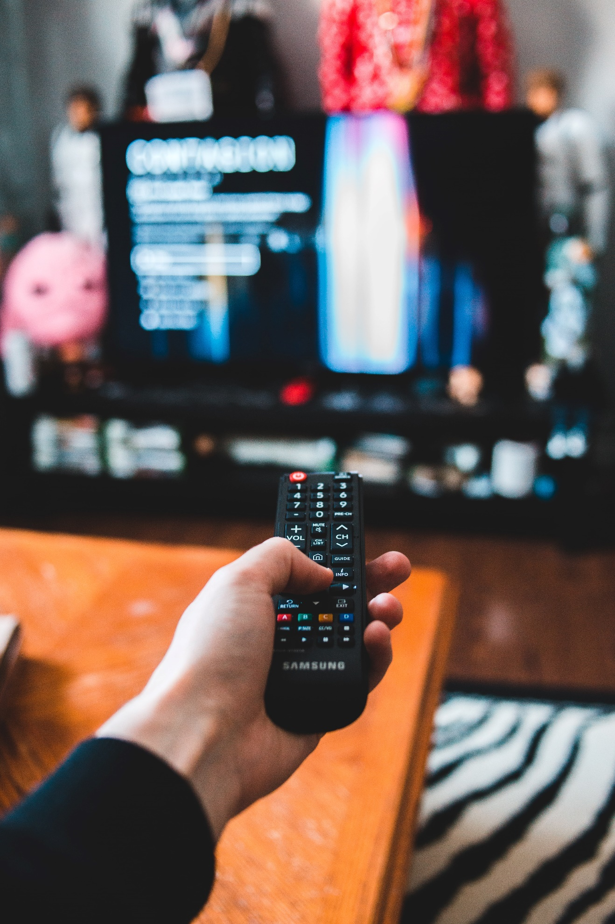

by Erik Mclean

Tom streams movies and shows.

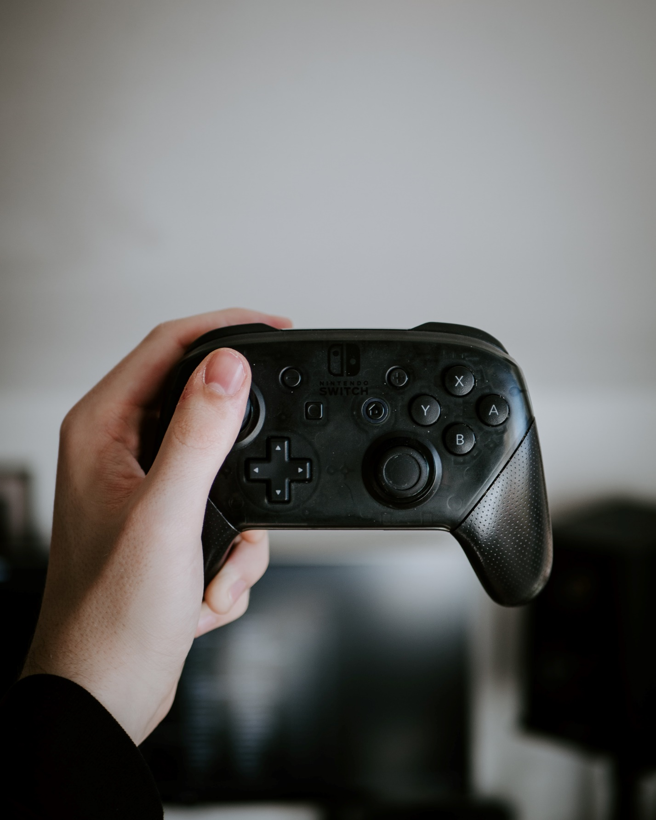

by Matthias Oberholzer

Tom used to play video games.

Accomplishments:

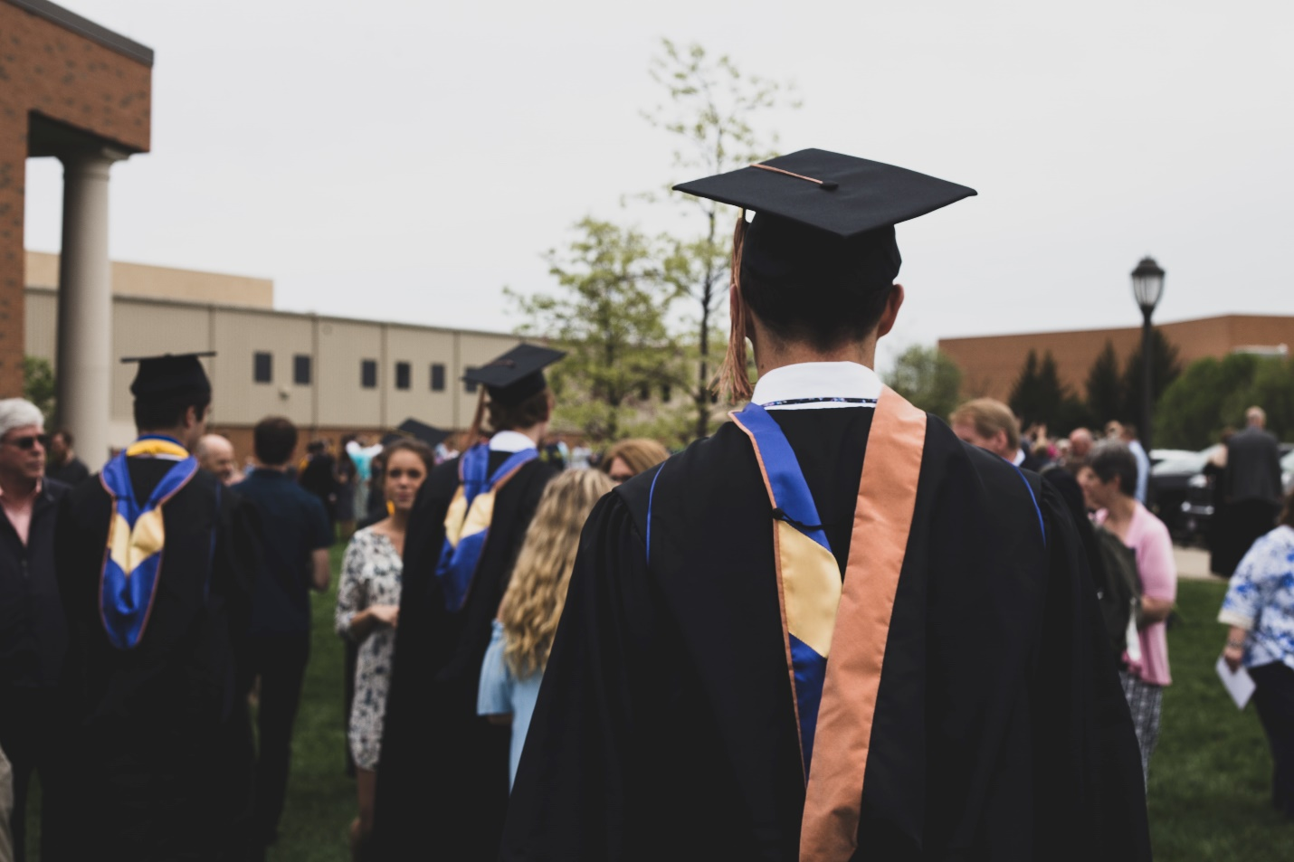

by Charles DeLoye

Tom graduated with an associate’s degree in electronics technology.



by James Harrison

Tom learned how to program when he was young.



by Scott Graham

Tom works as a web application developer.

Subject:



by Me