Mexico City, {{date}}.
I-REC Services:
I confirm that I have verified and audited the measurements of the electricity generated by the mexican device {plant}. From the month of :
{generation} {unit}
{month} {year}
– Electricity Generation:

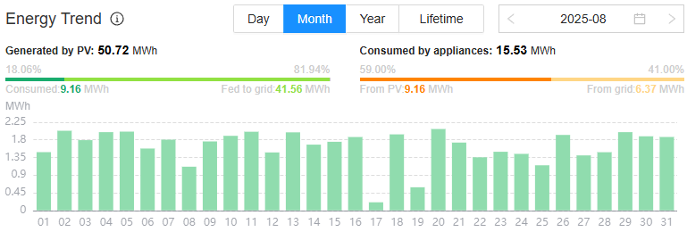

Third Party

_______________________________________
Leader Auditor: {LeadAuditor}.
Unit Business: Certification of Quality Management Systems
Sociedad Mexicana de Normalización y Certificación, S.C. (NORMEX)

