Basic Iterative Method Attack
Trevor Hollack
Department of Computer Science and Engineering
Wright State University, Dayton, OH
Email: hollack.2@wright.edu.com
Abstract. This paper is an exploration and explanation of the Basic Iterative Method gradient based image classification adversarial attack. This attack method is compared to the Fast Gradient Sign Method attack strategy, to see how the different implementations of these similar attacks differ visually and within a target model.
Keywords: Computer Vision and Pattern Recognition, Machine Learning, Adversarial Attack.
- Introduction
One of the most basic adversarial attacks on machine learning models is the Fast Gradient Sign Method Attack, which perturbs the pixel values of an image to make the target model be unable to correctly classify the image. The problem with this attack method is that the changes in pixel values are generated in one step and can very easily be noticed by the human eye. If the perturbation is noticeable to the human eye, the image will likely be removed from the data that is being collected. The goal, therefore, is to perturb an image so that the model will misclassify the label of the image, but also remain imperceptible enough that a human cannot tell that the image has been perturbed. The Basic Iterative Method is a variation of the Fast Gradient Sign Method, in which the maximum perturbation value is defined, and then many iterations of the perturbation are done to get close to that maximum value, but to never actually achieve it. The goal is to just barely perturb an image enough to misclassify it without being detectable.
- Datasets
The dataset used for this attack was the MNIST dataset, which is a collection of 60,000 training images and 10,000 test images. The images are handwritten numbers from 0 to 9, taken from United States Census employees and high school students. They are 28 x 28 pixels, are greyscale, and anti-aliased. This means that the pictures are in black and white, but each pixel has the capacity to vary in different shades of grey.
- Model and Methods
  - Model
The target model for this attack is a small convolutional neural network. The model is composed of 2 convolutional layers, 3 ReLU layers, 2 pooling layers, and 2 fully connected layers. The model was trained on the MNIST dataset mentioned, with 10 epochs for the model to train on the data. The model finished its training with an accuracy of 0.9789 and a training loss of 0.001. The macro and micro F1 scores were both 0.98.

  - Methods
The Basic Iterative Method attack equation is very similar to the Fast Gradient Sign Method equation, but with two differences. The equation for the Basic Iterative Method is as follows (see Fig. 1).
$adv_{x}^{t+1}=Clip_{\left\{x, ε\right\}} [adv_{x}^{t+1}+ α*sign(∇_{\left\{adv_{x}^{t}\right\}}Loss\left(adv_{x}^{t}, y, w\right)]$ (1)
The first difference between the Fast Gradient Sign Method and the Basic Iterative Method is $adv_{x}^{t+1}$, which is the adversarial image that has been created with the perturbation. This image is fed back into the equation several times to slowly increase the perturbation, thus the iterative nature of the attack. The second difference with the Basic Iterative Method is the presence of the clip form x to epsilon. This clip, which is not present in the Fast Gradient Sign method equation, is what limits the maximum perturbation size of the pixel value change. This ensures that the perturbation on the image for an epsilon value does not go higher than epsilon. The alpha value is the actual value of the perturbation of each pixel within each step, instead of the epsilon value like the Fast Gradient Sign Method. The way that the full equation works is by first calculating the gradient of the loss function with respect to the input image in the first iteration, which then becomes the adversarial image in subsequent iterations, get the sign value of the gradient, and then multiply that sign value to the alpha value, and finally add that combined value to the adversarial image to increase the perturbation. There are 3 main hyperparameters that can be manipulated, the epsilon value, the alpha value, and the number of iterations. Changin the epsilon value modifies that maximum possible perturbation that the function will compute towards, with higher values giving more perturbations, but will also be more noticeable to the human eye. Modifying the alpha value will change the size of the perturbation within each iterative step of the function, with higher values taking fewer steps, but also having a much higher change to the individual adversarial images per iteration, and too much of a drastic change between iterations could lead to too noticeable of a perturbation, The third hyperparameter is the number of iterations itself, which is (see Fig. 2).
$min⁡(4+\frac{ε}{α}, 1.25* \frac{ε}{α})$ (2)
which is the smaller value of either epsilon divided by alpha, plus 4-, or 1.25-times epsilon divided by alpha. This ensures that the number of iterations has a minimum number of times to run, but also that the number of iterations will not be too many such that the final perturbation will completely change every pixel value of the original image.
- Experimental Results
The first step of the experiment, after training the base convolutional neural network that was to be used in the attacks, is generate example adversarial images to ensure that the attack is implemented correctly, before then applying the attack to the entire dataset and feeding it to the model. The following images are the examples of the perturbed images that are generated with each attack, with varying epsilon values so that the influence of different values can be seen in the images:

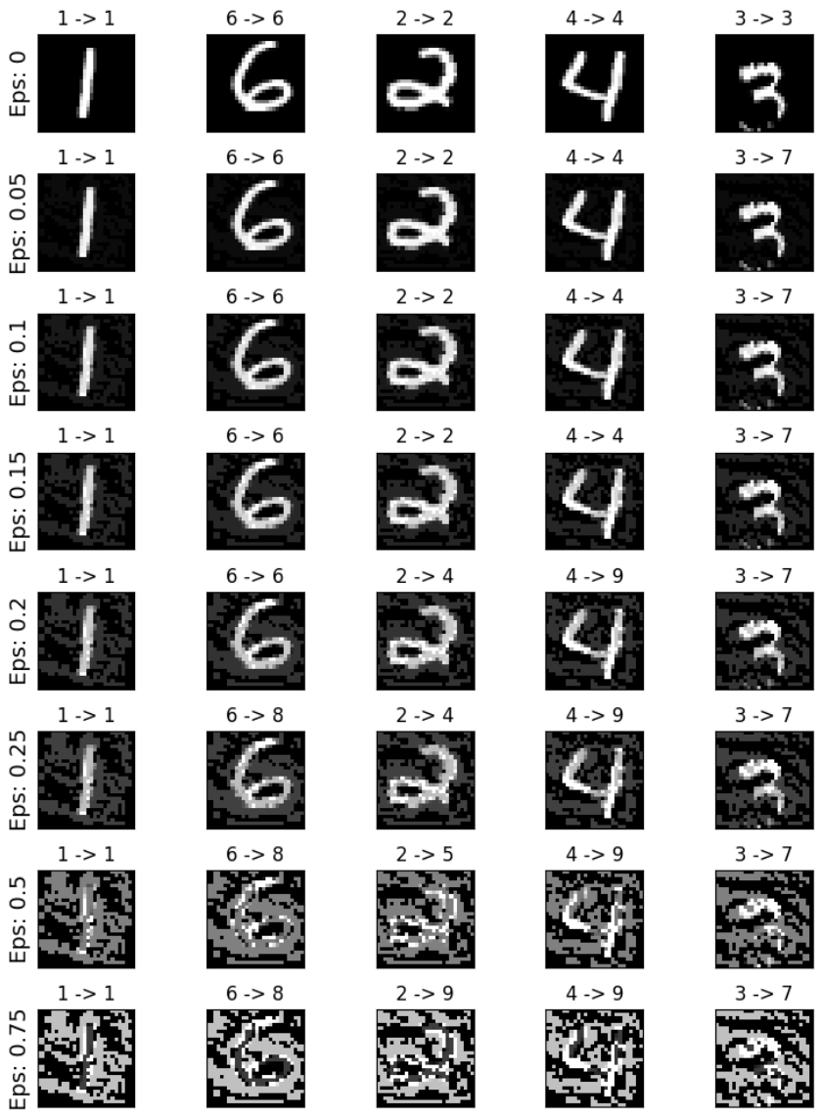
Fig. 1. Fast Gradient Sign Method adversarial example images
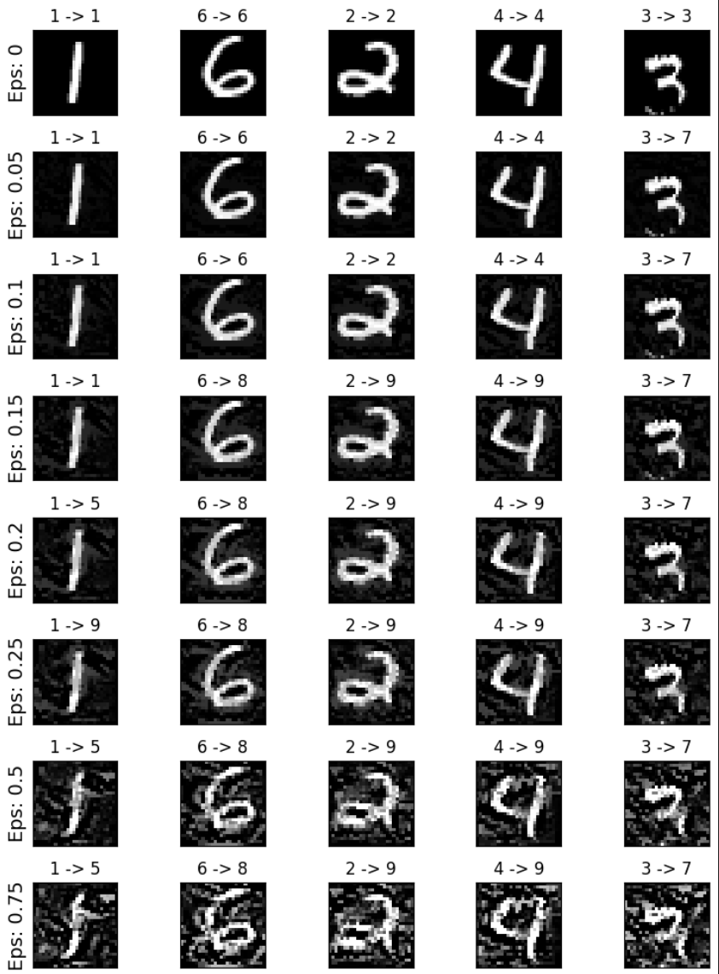
Fig. 2. Basic Iterative Method adversarial examples images

After the adversarial images are created, the Fast Gradient Sign Method and Basic Iterative Methods are both applied to the full dataset and then given to the trained model to classify. The following Table 1 shows the classification results for the Fast Gradient Sign Method and Basic Iterative Method attacks with respect to increasing epsilon values.

Table 1. Model Accuracy with Fast Gradient Sign Method and Basic Iterative Method Attacks Applied to Test Data
Epsilon Value | Fast Gradient Sign Method Accuracy | Basic Iterative Method Accuracy
0.0 | 0.9789 | 0.9789
0.05 | 0.8771 | 0.8476
0.10 | 0.6729 | 0.4822
0.15 | 0.4269 | 0.1503
0.20 | 0.2454 | 0.0187
0.25 | 0.1545 | 0.0025
0.30 | 0.1176 | 0.0019
0.35 | 0.1011 | 0.0015
0.40 | 0.0892 | 0.0012
0.45 | 0.0824 | 0.0009
0.50 | 0.0752 | 0.0007
0.55 | 0.0752 | 0.0006
0.60 | 0.0743 | 0.0005
0.65 | 0.0802 | 0.0003
0.70 | 0.0879 | 0.0003
0.75 | 0.0992 | 0.0001
0.80 | 0.1130 | 0.0001
0.85 | 0.1306 | 0.0001
0.90 | 0.1473 | 0.0001
0.95 | 0.1606 | 0.0001

- Discussion
The Basic Iterative Method attack is more effective at making the model misclassify the target label of the images than the Fast Gradient Sign Method attack. The Basic Iterative Method also affects the model faster than the Fast Gradient Sign Method attack, as an epsilon value of 0.10 makes the model less than 50% accurate with the Basic Iterative Method, compared to the 67% accuracy of the Fast Gradient Sign Method with the same epsilon value. As the epsilon value continues to increase, the model given the Fast Gradient Sign Method begins to plateau at its lowest accuracy being around 7% at an epsilon value of 0.60, with subsequent increasing epsilon values improving the accuracy of the model from its lowest point, more than doubling its accuracy at the near maximum epsilon value of 0.95. In contrast, the Basic Iterative Method attack continues to degrade the accuracy of the model with every epsilon value increase. The Basic Iterative Method only plateaus once the measurement of the accuracy reaches its least significant digit.
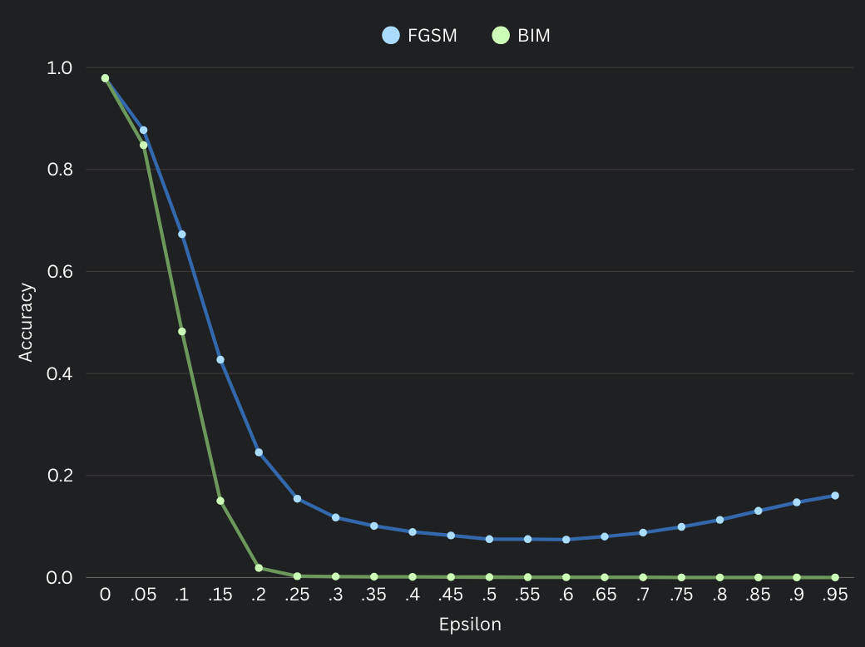
Fig. 3. Accuracy of Model after Fast Gradient Sign Method and Basic Iterative Method Attacks

Figure 3 plots the data from Table 1 into a visual form, showing how quickly the Basic Iterative Method attack degrades the model performance, and how the Fast Gradient Sign Method attack affects the same model, as well as the improvement in model accuracy as the epsilon value continues to increase after reaching its lowest point.
- Challenges and Future Steps
The biggest difficulty with implementing the Basic Iterative Method attack is to ensure that the maximum allowed perturbation per iteration, the clip, is correctly implemented. In my earlier implementations of the attack, I had incorrectly applied the attack method to only perturb the image until reaching only either the minimum or maximum number of perturbations. This mistake caused the Basic Iterative method to be the same as the Fast Gradient Sign Method in the case that the perturbation only hit the maximum allowed perturbation value, and the Basic Iterative Method was worse when allowed to only reach the minimum allowed perturbation value. In future research with the Fast Gradient Sign Method and the Basic Iterative Method, I would try to experiment with changes to the alpha value and see how increasing or lowing that value affects the effectiveness of the attack, and how the perturbations change visually within sample adversarial images. I would also like to explore more into why the Fast Gradient Sign Method attack had a noticeable increase in model accuracy after the 0.60 epsilon value mark, and what that could mean for image classification techniques.
- Conclusion
The Basic Iterative Method is much slower to implement than the Fast Gradient Sign Method, taking about 30 times longer in compute time to implement. However, this increase in time to rewarded with a more effective adversarial attack, perturbing the images in such a way as to be harder to see by the human eye while simultaneously achieving more misclassifications from the target model than the Fast Gradient Sign Method.

References
- Deng, L. (2012). The mnist database of handwritten digit images for machine learning research. IEEE Signal Processing Magazine, 29(6), 141–142.
- Chen, L. (2025). Adapted from: FGSM attack source code. Source Code.
- Kingma, D. P., & Ba, J. (2017). Adam: A method for stochastic optimization. arXiv.

