Motion-Controlled Games

Motion-controlled games use sensors to detect a player's physical movements and translate them into in-game actions. Instead of pressing buttons, players swing, wave, jump, or gesture to interact with the game. These inputs can come from:

- Depth cameras (like Intel RealSense or Kinect)
- Accelerometers and gyroscopes (found in Wii Remotes and VR controllers)
- Infrared sensors (used in early motion systems)
- Hand-tracking and body-tracking systems (common in VR setups)

Why Motion Controls Matter
- Immersion: Players feel physically present in the game world.
- Accessibility: For some users, motion input is more intuitive than traditional controllers.
- Fitness & Engagement: Games like Ring Fit Adventure and Dance Central promote physical activity.
- Innovation: Motion controls open doors to new genres and gameplay mechanics.

The Challenge
The key challenge lies in designing motion-controlled games that leverage existing sensors and hardware—without requiring players to use handheld controllers or wear head-mounted displays for interaction.
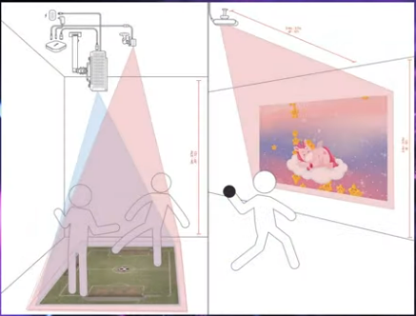

Research on Motion-Based Systems Without Visor or Handheld Controller for Game Dev
The initial phase involves researching motion-based hardware systems suitable for developing games that eliminate the need for handheld controllers or head-mounted displays.

1. Orbbec Astra2
2. Intel Realsense D435
3. Leap Motion Controller 2
4. Microsoft Azure Kinect DK
5. AI Computer Vision (standard camera)

Motion-Sensing Hardware Comparison

Feature | Orbbec Astra2 | Intel RealSense D435 | Leap Motion Controller 2 | Azure Kinect | AI Computer Vision (Webcam)
Tracking Type | Full-body & gesture | Depth & gesture | Hand & finger | Full-body & gesture | Basic motion & object detection
Controller-Free | Yes | Yes | Requires visor mount | Yes | Yes
Depth Sensing | Time-of-Flight | Stereo + IR | Stereo + IR | Time-of-Flight | Limited (2D only)
Precision | High | Moderate | Very high (hands/fingers) | High | Low to moderate
Field of View (FOV) | Wide | Moderate | Narrow | Wide | Varies by webcam
Lighting Sensitivity | Moderate | High | High (can misread reflections) | Moderate | Very high
Hardware Requirements | Depth camera | Depth camera | Mounted on visor | Depth camera | Standard webcam
Cost | PHP 20,000 | PHP 20,300 | PHP 36,900 | Discontinued | Minimal
Availability | Need to import directly from Orbbec | Available locally, DigiKey.ph | Available thru Shashinki.com | Limited, discontinued | Available
Country of Origin | China | Philippines | Malaysia | Limited | Anywhere
Best Use Case | Gesture-based games, full-body | Gesture-based games, prototyping | Hand-tracking, VR/AR | Full-body games, high fidelity | Prototyping, low-cost demos
Limitations | Requires high-end PC | Noisy depth in complex scenes | Requires visor, limited FOV | Discontinued | Low accuracy, false positives

The Leap Motion Controller 2 offers highly accurate hand and finger tracking, but its camera is typically mounted on a visor, making it less suitable for controller-free, non-wearable setups. Azure Kinect excels at full-body tracking and is well-suited for immersive motion-controlled games; however, it has been discontinued by Microsoft. AI-based computer vision solutions, which rely on standard webcams, present a cost-effective alternative that requires no specialized hardware. Despite their accessibility, these systems often struggle with spatial precision and are prone to false positives or missed detections—particularly in environments with challenging lighting or complex backgrounds.
Promising candidates include the Orbbec Astra2 and Intel RealSense D435, both of which offer depth-sensing capabilities ideal for controller-free interaction.

Orbbec Astra 2

Released in 2023 by Orbbec, a China-based company, the Astra2 is a 3D depth camera built on structured light technology. According to the vendor, it features Orbbec’s latest custom ASIC for enhanced depth processing, includes an integrated IMU, and supports depth data output ranging from 0.6 to 8 meters.
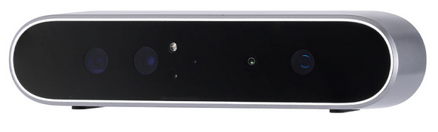

Intel RealSense D435

The Intel RealSense D435 is a compact, high-performance depth camera designed for real-time 3D perception. It uses stereo depth sensing combined with active infrared to capture depth data with impressive accuracy across a range of up to 10 meters. With a wide field of view, global shutter sensors, and a built-in RGB camera, the D435 is well-suited for dynamic applications like robotics, gesture recognition, and motion-controlled gaming.

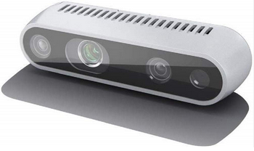

Both the Astra 2 and Intel RealSense D435 are widely adopted by developers building motion-controlled games. Interactive experience creators such as LavaVision (Poland) and Lumo Interactive (Canada) have successfully integrated the Orbbec Astra series and Intel RealSense D400 series cameras into their platforms, showcasing the versatility of these depth-sensing technologies in immersive environments.

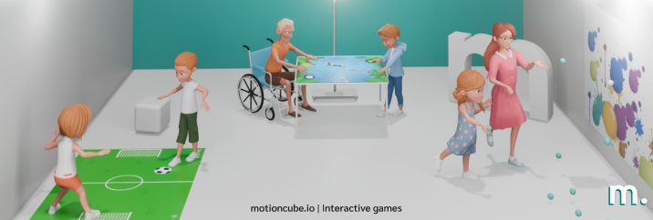

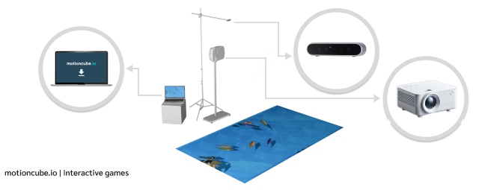

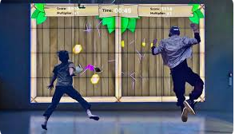
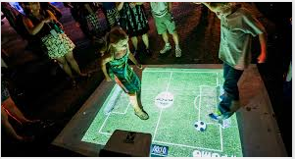

LUMOplay by Lumo Interactive of Canada

Installation Issue

An error occurred during the installation of the SDK and associated libraries for Orbbec Astra 2, as illustrated in the screenshot below.

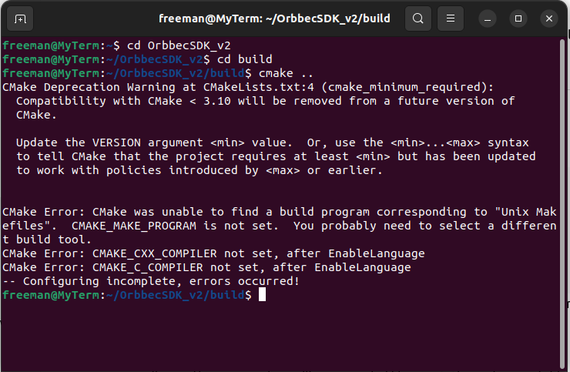

This obstacle led to the selection of Intel RealSense as the primary sensor, with a Python wrapper employed to streamline game development and integrate motion input effectively. Development with the Astra2 was discontinued in favor of transitioning to the Intel RealSense platform. A new virtual machine was set up with Ubuntu as the operating system to support this shift.
Two (2) Set-ups
1. Camera facing the player (standard Kinect-style setup)
Camera is placed below or above the projector/screen, pointing toward the player. The RealSense sees the player’s body directly. You map player’s motion (e.g., hand X/Y) → screen coordinates.
Pros:
Directly sees player’s gestures. Easier to detect whole-body movement.
Cons:
You need to map camera coordinates → projector coordinates (calibration step). If multiple players, they may block each other.

2. Camera facing the screen (same direction as projector)
Camera is placed next to the projector, pointing at the wall. The RealSense sees shadows/blobs of players on the projection surface. You detect collisions between projected balloons and silhouettes.
Pros:
Natural 1:1 mapping (camera view = projection view). No calibration needed (pixel coordinates match directly). Works nicely for shadow-play style games.
Cons:
RealSense was designed for 3D body tracking, not for silhouette-on-wall setups.
Because the game involves a single balloon projected onto a wall and popped through body movement, a front-facing camera setup—where the camera looks directly at the screen—offers a simpler configuration. This approach allows for direct silhouette overlap detection without the need for coordinate transformation, making it feel akin to an interactive shadow-play experience. The simplified geometry also accelerates prototyping, and notably, this setup has been adopted by platforms such as Lumo Interactive and LavaVision.

Chosen Camera Set-up
The camera is placed next to the projector, pointing at the wall. The Intel Realsense camera is facing the screen or the same direction as projector. The camera sees shadows/blobs of players on the projection surface. Detected collisions are between projected sprites and silhouettes
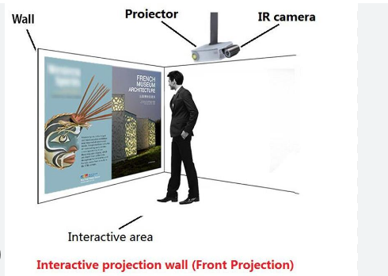
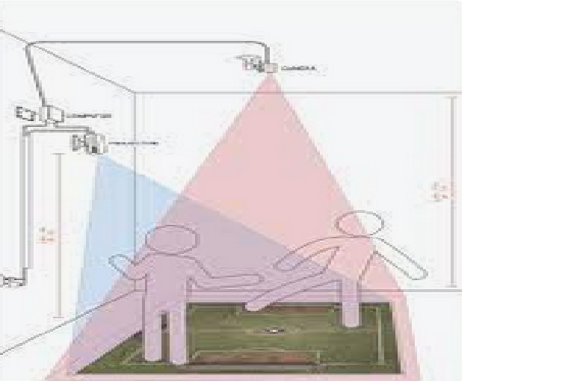

Game Overview
This project is a prototype for a motion-sensing balloon-popping game designed to explore controller-free interaction using the Intel RealSense depth camera. The core concept centers on physical engagement—players interact with virtual balloons projected onto a wall using hand gestures, with the RealSense camera capturing depth and motion to detect collisions in real time.
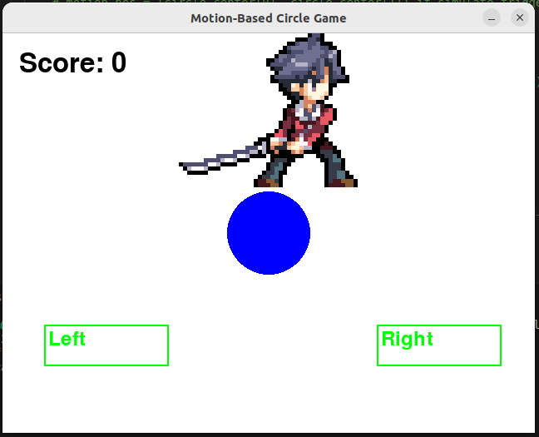

The game is built with a modular and scalable architecture, allowing for future expansion into more complex titles. While visual elements such as animations and UI transitions are minimal at this stage, the focus has been on establishing a robust interaction model and flexible input handling. The system currently supports two input modes: mouse hover for debugging and depth-based motion input from the RealSense camera. This dual-input design ensures development and testing can proceed even without immediate access to hardware.
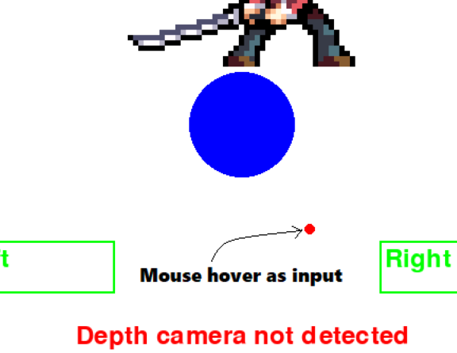

The gameplay loop includes balloon spawning, gesture-based collision detection, and score tracking upon successful interaction. When a player’s gesture collides with a balloon, it pops instantly and another balloon appears at a new random spot on the screen.
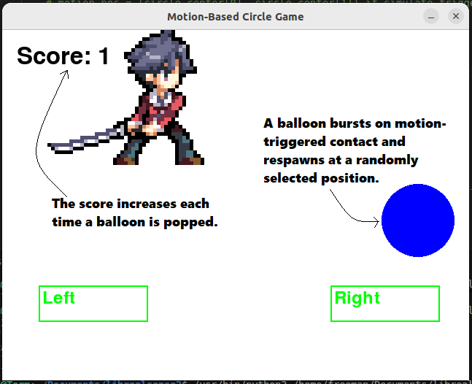

A player sprite has also been introduced as a foundation for a future platformer-style game, demonstrating the extensibility of the current framework. While physics elements like gravity are not yet implemented, the sprite can currently be moved using interactive UI buttons labeled "Left" and "Right."

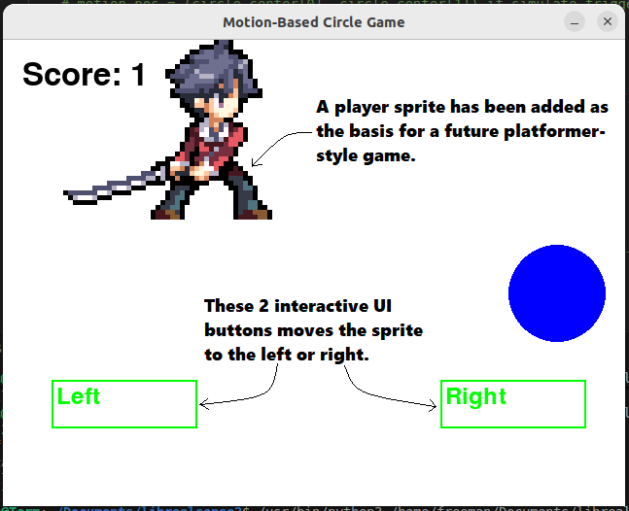

This prototype lays the groundwork for a new genre of interactive experiences that blend physical movement with digital gameplay, offering an accessible and immersive alternative to traditional controller-based systems.

System Architecture
The motion-sensing balloon-popping game is built on a modular architecture designed to support rapid development, flexible input handling, and future expansion into more complex interactive experiences.

1. Core Modules
File Structure – The system is organized into modular Python files, each responsible for a distinct aspect of game functionality. This separation ensures maintainability, scalability, and ease of debugging.
project_folder/
├── main.py
├── circle.py
├── score.py
├── realsense_input.py
├── player.py
└── ui_zone.py

1.1 main.py - Acts as the central controller for the game loop. Initializes modules, handles input switching, and manages frame updates. Coordinates interactions between UI, input, and game logic

1.2 circle.py - Manages balloon objects (spawn, position, collision detection). Handles random placement logic and visual rendering. Interfaces with input modules to detect hits

1.3. score.py - Tracks and updates player score. Triggers visual and audio feedback upon balloon pops. Can be extended for leaderboard or multi-player scoring.

1.4 realsense_input.py - Interfaces with Intel RealSense SDK. Processes depth frames and extracts motion data. Provides gesture-based collision detection for gameplay.

1.5 player.py - Defines the player sprite used in platformer-style extensions. Handles sprite rendering and movement logic. Currently supports directional control via UI buttons

1.6 ui_zone.py - Manages interactive UI elements projected on screen. Detects user interaction with virtual buttons (e.g., "Left", "Right"). Can be expanded for menus, settings, or in-game controls

2. Input Flexibility
- The system is designed to operate with or without the RealSense camera.
- Mouse hover input serves as a fallback for testing and debugging.
- Dynamic switching allows seamless transition between input modes without altering core game logic.

3. Extensibility
- The architecture supports easy integration of new features, such as:
  - Animated sprites and UI transitions
  - Additional gesture zones
  - Multiplayer support
  - Platformer mechanics using the player sprite and virtual button controls

4. Hardware Integration Layer
- Interfaces with the Intel RealSense SDK to access depth frames and motion data.
- Abstracted to allow simulation via prerecorded bag files or mock data when hardware is unavailable.

5. Rendering Pipeline
- Uses a projector to display game visuals on a physical surface (e.g., wall).
- Game elements are rendered in real time, with collision feedback and score updates triggered by user interaction.

Hardware Requirements
This game prototype is designed to operate with minimal hardware while supporting advanced motion-sensing capabilities. Below are the recommended components for optimal performance and testing:

1. Intel RealSense Depth Camera
- Model: D435 or D435i
- Purpose: Captures depth and motion data for gesture-based interaction
- Connection: USB 3.0
- SDK: Intel RealSense SDK 2.0 (latest stable release)
- Notes: Required for full motion-sensing functionality; fallback input via mouse hover is available for testing without hardware

2. Projector
- Resolution: Minimum 720p recommended
- Brightness: ≥ 2500 lumens for clear visibility on wall surfaces
- Purpose: Projects game visuals onto a physical surface for gesture interaction
- Setup: Positioned facing a flat wall; aligned with camera for accurate depth tracking

3. Computer System
- Operating System: Windows 10 or later
- Processor: Intel i5 or higher
- RAM: Minimum 8 GB
- Graphics: Integrated or dedicated GPU capable of handling real-time rendering
- USB Ports: At least one USB 3.0 port for RealSense camera

Project Repository
https://github.com/radbuild/02_playback_bag_file_working

