ToDoList Test Plan

Test #1 Adding Items
1. Fire up application. You should see a window like this
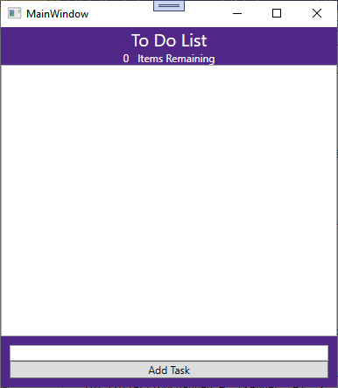
2. Type into the task panel the text "Test1"
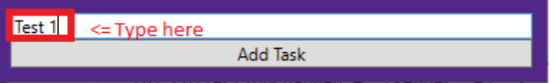
3. Click the "Add Text" button
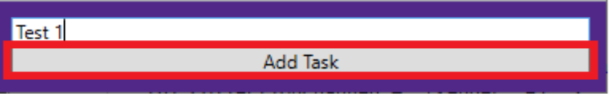
4. Your task should appear on the list and the items remaining should now be 1
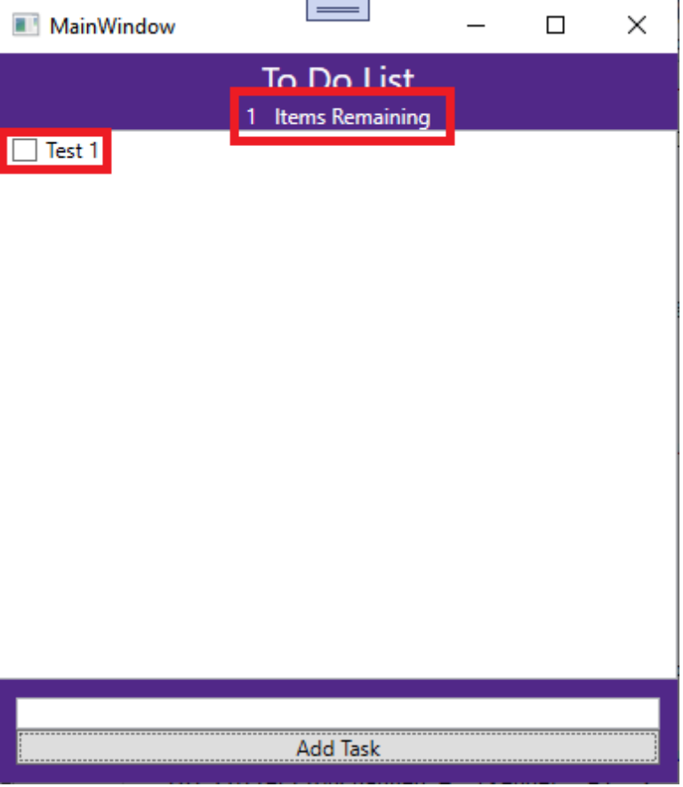
5. Check the box next to task 1 and items remaining should now be at 0
