Hi Pam,

Hanyang and I, we extract species from reported occurrence data in idigbio and gbif based on MLBS and Barlett experimental forest polygons. The species numbers are reduced as table below (red font):

|  |  |  |  |
| --- | --- | --- | --- |
| Site | V1: Mark’s list | V2: 10 km radius | V3: With polygons as we discussed |
| White_Mountain | 214 | 254 | 80 |
| Mountain_Lake | 296 | 381 | 175 |

V1: Species lists were compiled by Mark.

V2: Species lists were compiled by Miao using 10 km radius from center based on  from GBIF and iDigBio records.

V3: Species lists were extracted from GBIF and iDigBio based on MLBS and Barlett experimental forest polygons as we discussed; also sampled tree species were added from Jeremy’s lists.

Here are snapshots from these two sites with coordinates clipped, which were 10 km radius records but outside our polygon (red dots), and coordinates kept inside our focus polygons (green dots)

1. White_Mountain (we only keep those green dots. some are heavily overlapped at the same spot, so it seems lesser); those green dots represent 80 species

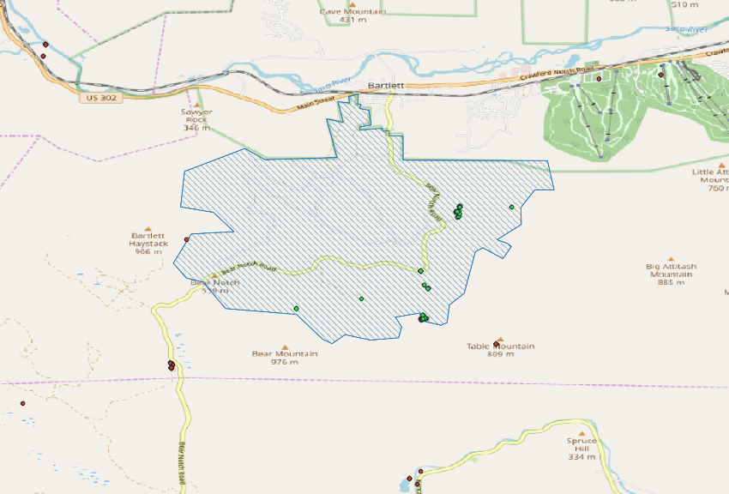

2. Mountain_Lake (we only keep those green dots; red dots are 10 km radius records but outside our polygon); those green dots represent 175 species

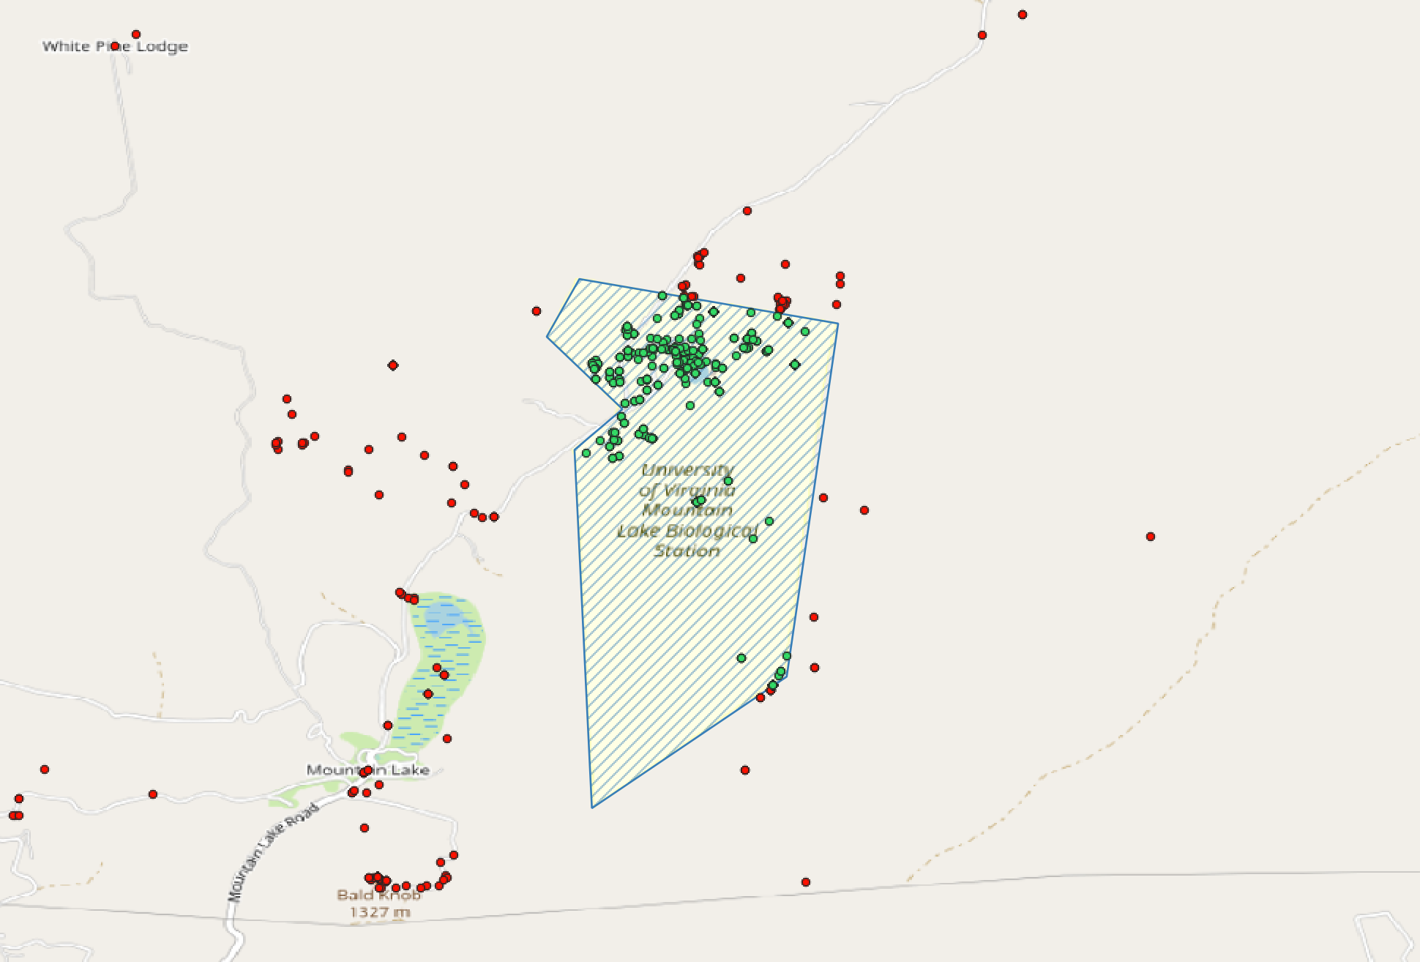

Note: Because of the zoom scale, some red dots look like on the polygon edge or inside, but when we zoom in the raster file, those records outside our polygon.

Shall we continue based on these number (White_Mountain 80; and Mountain_Lake 175)? For the rest four sites (Ordway, Talladega, Harvard,and Coweeta), the final species listswill be compiled based on the combination of Mark’s lists (you send to me the other day) and tree species sampled in Jeremy’s lists.

Thanks!

Miao

QGIS plots (dealing with iDigBio records):

1. White_Mountain

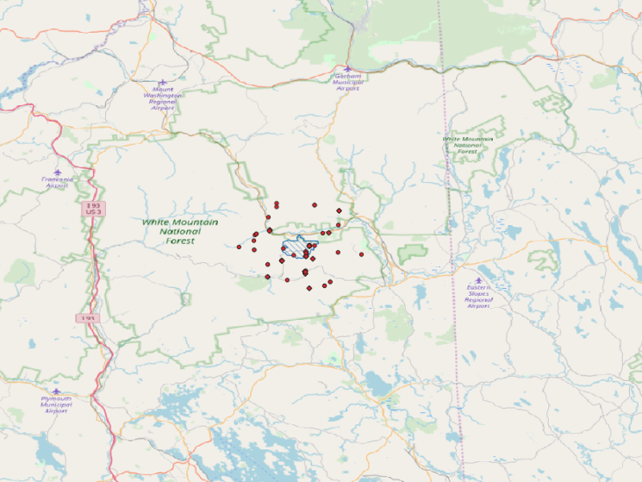Before filtering

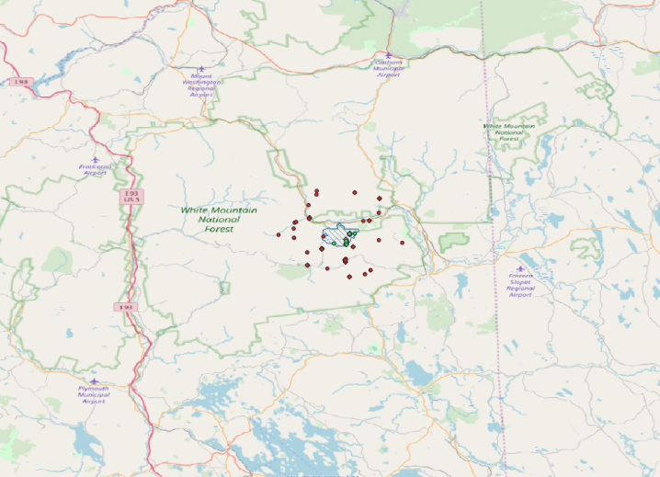

After filtering with customized polygon

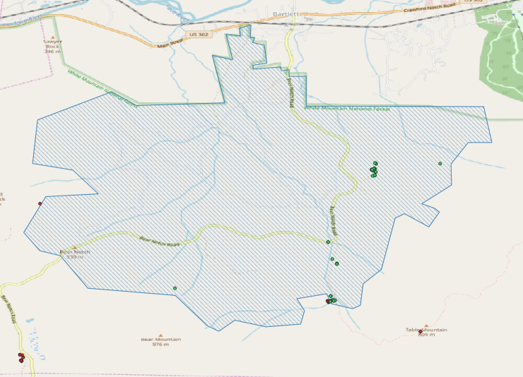

After filtering with customized polygon, zoom in

1. Mountain_Lake

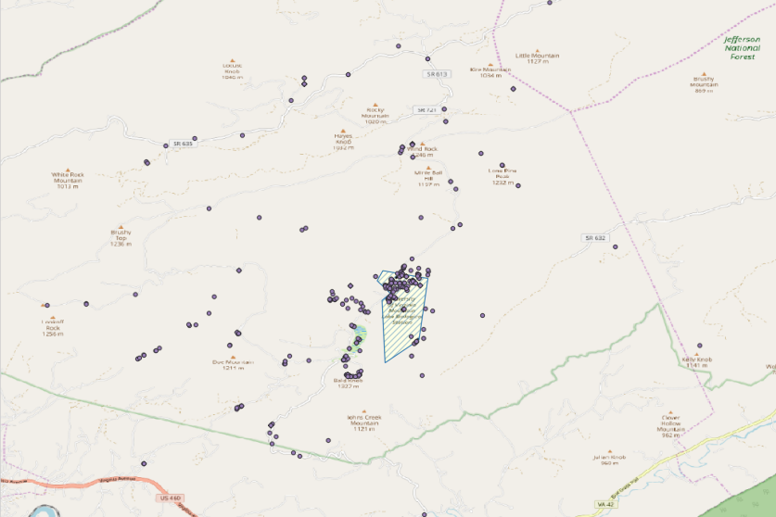Before filtering

After filtering with customized polygon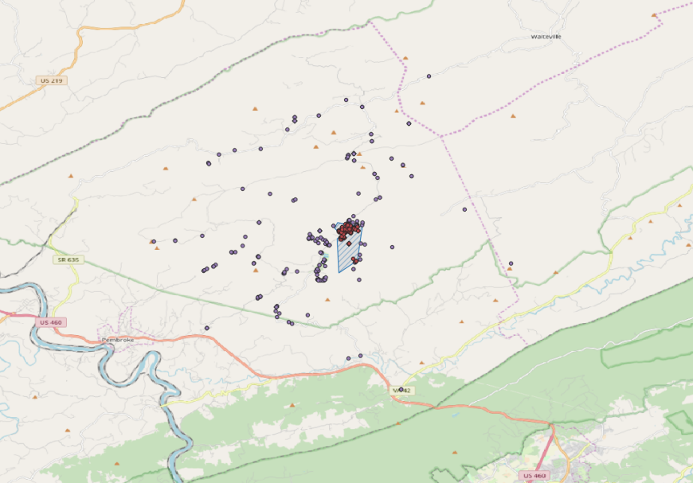

After filtering with customized polygon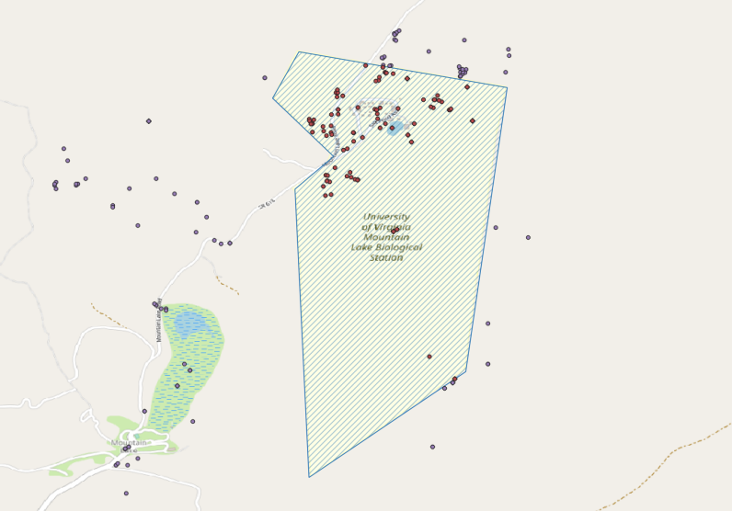, zoom in