https://github.com/Cactusolo/USA_Sites

1. not the top tip in the syn tree:

Phlox caroliniana Ilex caroliniana, but = Phlox carolina, but not tip tips, pytoy-issue

=Phlox carolina subsp. carolina

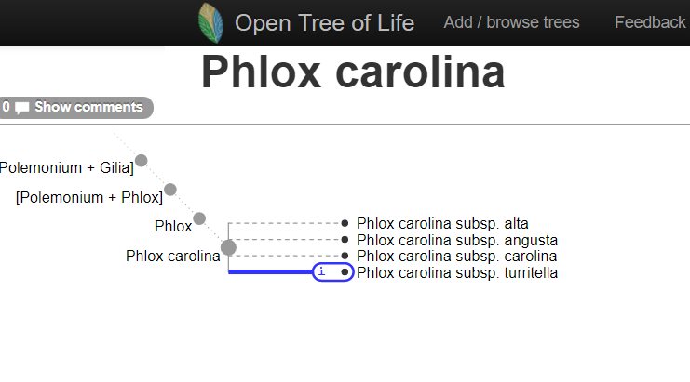

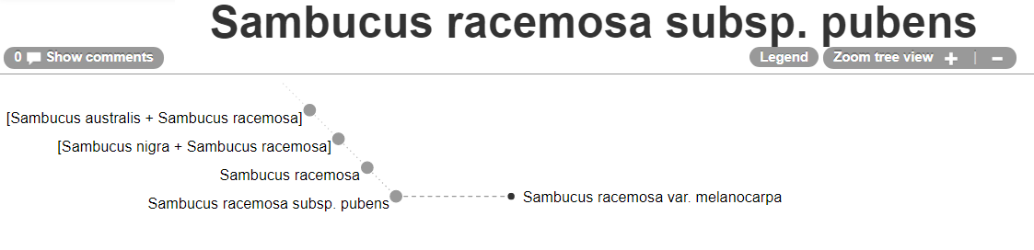

2. Non_seed plants

Lycopodium flabelliforme Diphasiastrum digitatum

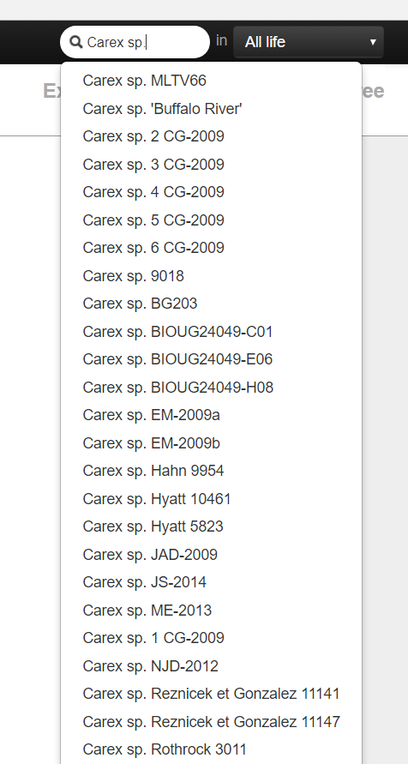3. Genus sp. hard to match otl, too many choices

4. containing "-" pytoy issue

Symphyotrichum novae-angliae

Symphyotrichum novi-belgii

5. Chamaecrista nictitans (L.) Moench ssp. nictitans var. aspera

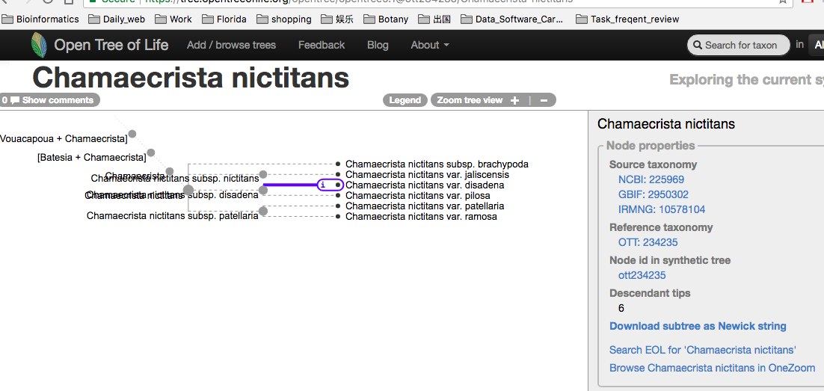

6. The results generated by “opentree_pytoys/src/get_ottids_for_taxa.py” is not consensus with Open tree web page.

Coweeta_species_names_ottids:Uvularia perfoliata 257170

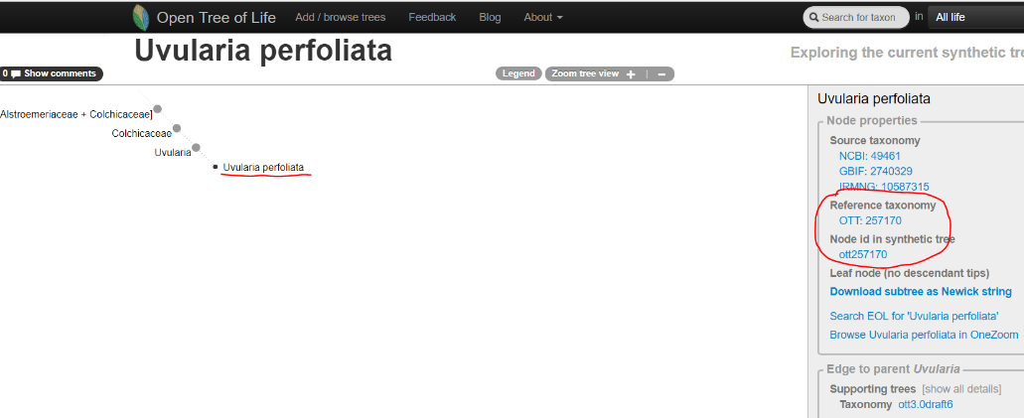Coweeta_species_names_ottids:Uvularia pudica 257170

