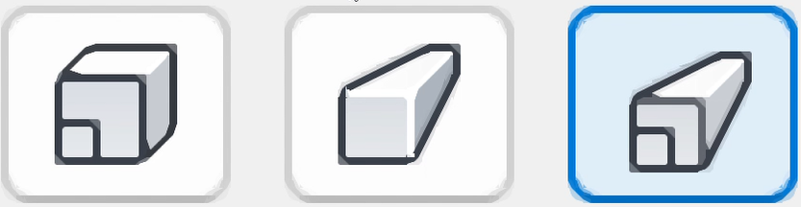 | 'SmartProjectEm' Add-In for Autodesk Inventor 2023-

Functionality

1. Autodesk Inventor for many years (at least since 2010) have had a limitation making it of impossible to set the popular 'Perspective with Ortho Faces' (a kind of combination of basic 'Perspective' and 'Orthogonal' methods) as the default projection method.
The combined method (unlike those basic) was not present at application settings and was available only from context menu of the View Cube which means the user have to activate it manually for each 3D-model open.
Thanks to many years of persistent user requests, Inventor developers have added the corresponding option in version 2024, but this has not improved the usability of this method in previous versions.
The 'SmartProjectEm' Add-In was created as workaround for the limitation described in Inventor 2023 (and earlier) - it automates activation of 'Perspective with Ortho Faces' projection method for (instead) of 'Perspective' method.

2. Slice Graphics command is automatically executed after sketch edit mode activation.

Add-In Changes History

Version 1.0.1:
+ The Help-file (this document) was included to delivery package.
+ Shortcut to Help-file was added to description for Control Panel.
+ "Open 'About SmartProjectEm'" button was added to welcome and exit screens of the installer.
+ Description for Autodesk Inventor Add-In Manager was fixed (clarified).

Version 1.0.2:
+ Added auto-execution of Slice Graphics command after sketch edit mode activation.

About the Author and Feedback

My name is Maxim Anatoljevich.
Practical usage of Autodesk Inventor is my specialization since 2005.
In the summer 2001, I defended the diploma of a mechanical engineer and was accepted as a designer
to the staff of the leading local industrial company.
Since 2011, I've headed the company's CAD department, which supported about 150 designers.
Since 2020, I provide software development and consulting services as an individual professional.

I'm looking forward for your feedback and/or cooperation propositions at CADman77@yandex.ru

Wish you to design efficiently and with pleasure!
August 2023.

