# Introduction

With increasing population and water use demands in Texas, accurate estimates of lake volumes is a critical part of planning for future water supply needs. Lakes are large and surveying them is expensive in terms of labor, time and cost. Over the years, the Texas Water Development Board has settled on a 500 ft spacing of survey lines oriented perpendicular to an assumed relic stream channel (stream channel center line?) for hydrographic data collection as a good balance between survey effort and level of data coverage. While this choice reduces the time spent in data collection, it significantly increases the time needed for post-survey processing.

Standard spatial interpolation techniques available in commercial software are not well suited to accurately reflect the lake bathymetry given raw data and the lake boundary. Therefore, an in-house Fortran program, HydroEdit, was developed to improve the anisotropic spatial interpolation required. This process involved a difficult to repeat, manual visual interpretation and manipulation of data in GUI's as well as a laborious manually guided interpolation process.

Next, through the use of built in spatial algorithms and GIS routines available in Python, along with in-house Python scripts, automation, efficiency and repeatability were introduced to lake volumetric estimates. The new interpolation method also provided a mechanism to apply new lake interpolation patterns to old lake survey data sets, increasing comparability between surveys. The heart of the interpolation improvements comes in the form of simple parallel line sketches enclosing major river channels and bathymetric features. This process inherently relies on the original Fortran software to perform the interpolations and the involved Python scripts reflect the structure of the Fortran program.

The latest lake bathymetric interpolation methodology is based on anisotropic, stretched inverse distance weighting interpolations along the thalweg (deepest point of cross-section) of the stream line (Should we say centerline for the lake interpolations?). By converting bathymetric data from (x,y) coordinates to (s,n) stream coordinates, directional interpolations are feasible without regard to data spatial distribution.

Using existing USGS topographic map blue stream lines, hypsography (aka topo lines) and Digital Elevation Model (DEM) (check the abbreviation), similarly accurate interpolations from lake bathymetry cross-sections are possible using the three methods described above, however the differences are efficiency of time, repeatability, and ability to check/apply against old surveys (cookie cutter method).

The Palmetto Bend Dam was completed in 1979, impounding the Navidad River and creating Lake Texana. At approximately 9,727 acres (3,936 ha), Lake Texana is a small to medium major reservoir in Texas; the minimum acreage of major reservoirs in Texas is 5,000 acres (2,023 ha). An internal study showed a 63% and a 91% reduction of processing time when implementing the line automation and stretched anisotropic inverse distance weighting interpolations for Lake Texana, respectively. The processing time reduced from 90 hours with the original interpolation methodology to 33 hours when incorporating the Python spatial algorithms, GIS routines and in-house scripts.

# HydroEdit

Standard spatial interpolation techniques available in commercial software are not well suited to accurately reflect the lake bathymetry given raw data and the lake boundary. Therefore, an in-house Fortran program, HydroEdit, was developed to improve the anisotropic spatial interpolation required. HydroEdit processes raw data, integrates boat GPS and sonar data, performs bathymetric interpolations and extrapolations given proper text input files, determines current bathymetric depths/elevations and calculates sediment thicknesses (Furnans and Austin, 2007). Due to the less frequent data collection sequence of the GPS compared to the sonar equipment, multiple sonar signals may be assigned to a single GPS location, therefore reducing survey density/detail before interpolation.

The main function of the Hydroedit software is to perform bathymetric data interpolations. Using GPS software, areas of desired interpolation from one lake bathymetric transect an adjacent transect are visually located and their point identification numbers are manually recorded into a text file. Lake Texana had approximately 3050 manually entered interpolations requiring approximately 90 hours to complete. Specialized interpolations are also available with the appropriate text input format, allowing creativity within the lake bathymetry interpolation.

# Raw sonar data un-packing

I have no idea what to call this section, but thought it needed its own section, maybe fold in elsewhere???

Due to the unsynchronized timing of data collection between the GPS and underwater sonar equipment, multiple sonar readings are attributed to a single GPS location and thus a reduction of data occurs. Likewise, the sonar equipment rotates through 3 frequencies, collecting data to multiple lake-bottom surface penetrating depths. Therefore, redistribution of sonar data is implemented to recreate the spatial distribution of data as collected. The GPS locations are 2D interpolated as necessary to accompany all necessary sonar pulses. For the current bathymetric surface measurements, only 200 kHz sonar readings are used as data point locations.

# Line automated HydroEdit interpolation

Seeking to improve upon the lengthy and tedious process required to manually create a HydroEdit input text file, Python programming was utilized to automatically generate the self-similar input text file using GIS line shapefiles. Due to directionality requirements, data input procedures and interpolations required between transects (lake cross-sections), multiple loops, sorting, multiple KDtrees and attributing numerous variables to lines and points was necessary to accommodate the existing requirements of the HydroEdit software.

Next, through the use of built in spatial algorithms, GIS routines available in Python, and in-house Python scripts; automation, efficiency and repeatability were introduced to lake volumetric estimates. The line automated interpolation program improved efficiencies and speeded overall interpolations significantly, however the program was limited and structured based on the necessary inputs to the sequential HydroEdit software. The resulting interpolation point spatial structure provided inconsistent point density.

# Anisotropic, stretched inverse distance weighting interpolation (ASIDW)

Originally designed for stream line interpolations, the Anisotropic, Stretched Inverse Distance weighting (ASID) incorporates a stream line coordinate system (s,n) to reproject data points before performing the interpolations. Due the fact that all major reservoirs in Texas are impounded stream lengths their shape and attributes follow closely with natural stream networks, therefore the stream line coordinate conversion and interpolation approach was incorporated into lake bathymetric surveying.

The basis of the ASID interpolation is rooted in coordinate conversion from the x,y plane into a distance along a stream line (s) and a perpendicular distance away from the stream line (n). For stream interpolations, this method is extremely useful for interpolating along the thalweg (deepest part of the stream). In (s,n) coordinates, all points are now in reference to the input stream/center line. Interpolation point locations are arranged in a uniform grid structure with user specified spacing to provide a consistent distribution throughout a region.

To implement this technology for lakes, the lake must be divided into sections of relic stream network/channel areas and the associated center line/stream line. For instance, Lake Texana was divided into 25 regions, including two major stream sections.

To supplement the bathymetric data, USGS 24,000 topographic contours and delineated blue stream lines were used to determine the placement of the interpolation stream line. A 200 ft and 100 ft radial buffer polygon was created in GIS for the main lake and primary branch relic stream channel segments, respectively. Where blue stream lines were not available and for floodplain areas of the lake bathymetry, a center line following the general shape of the polygon/cove section while connecting transect thalweg points was the basis of the data coordinate conversion.

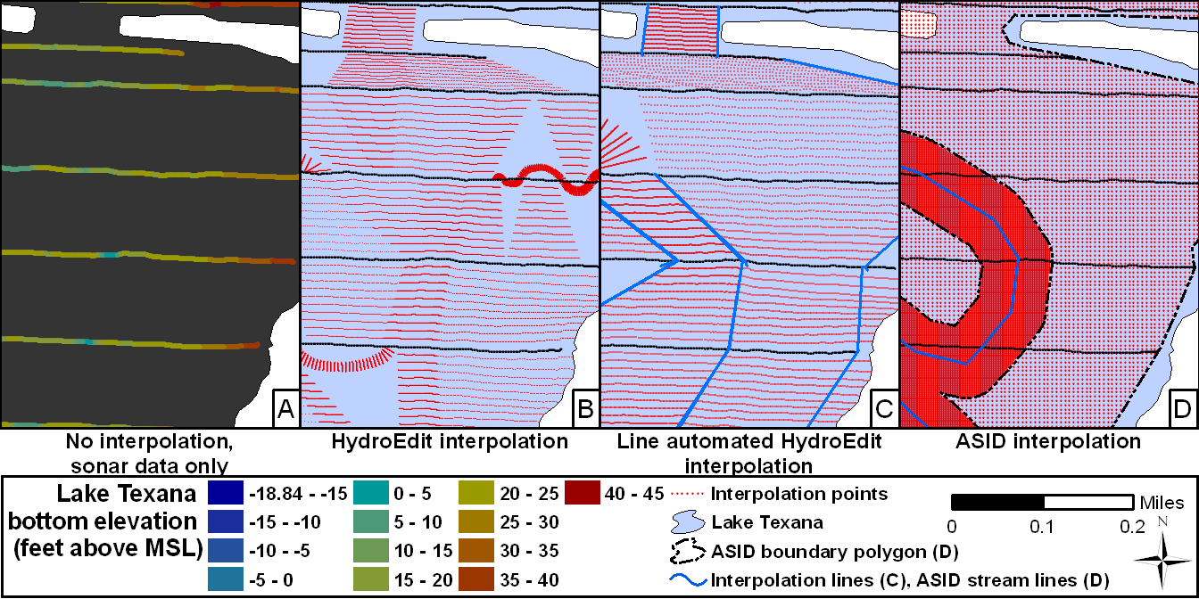

**Figure 1: Interpolation implementation comparison**

Some cove sections have been eliminated due to the lack of data; presence of previous data extrapolation in those areas; and the unnatural interpolations which result from this method of interpolation (small areas where line interpolations already occurred, small coves perpendicular to ‘main’ channel within the polygon).

# Results

The Palmetto Bend Dam was completed in 1979, impounding the Navidad River and creating Lake Texana. At approximately 9,727 acres (3,936 ha), Lake Texana is a small to medium major reservoir in Texas; the minimum acreage of major reservoirs in Texas is 5,000 acres (2,023 ha). An internal study showed a 63% reduction of processing time when implementing the line automation interpolation for Lake Texana. The same internal study showed a 91% and 71% reduction of processing time when implementing the ACID interpolation methodology for Lake Texana when compared to HydroEdit and line automated HydroEdit interpolations, respectively. A summary and comparison table is presented below in Table 1.

**Table 1: Volume and time comparison of interpolation methods**

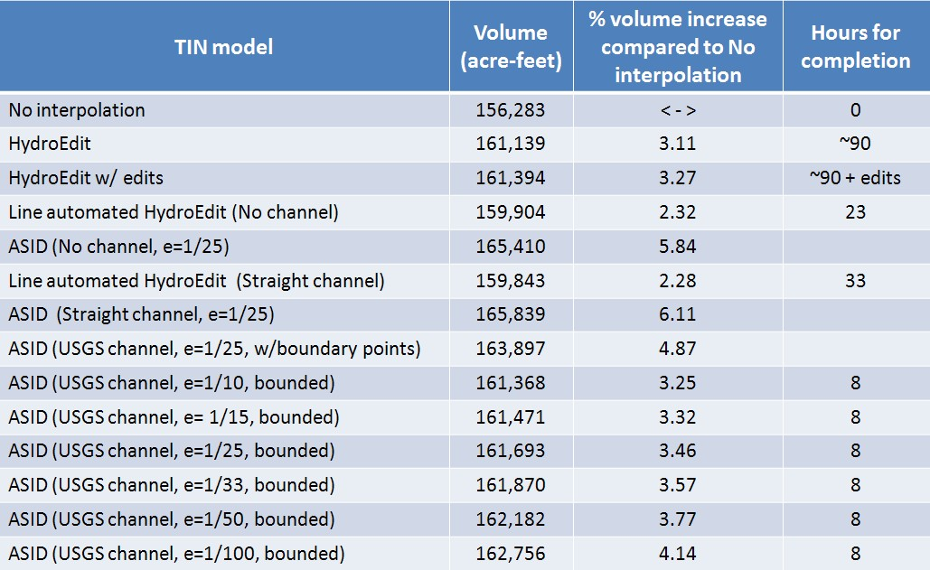

Note: e is the eccentricity of the ellipse

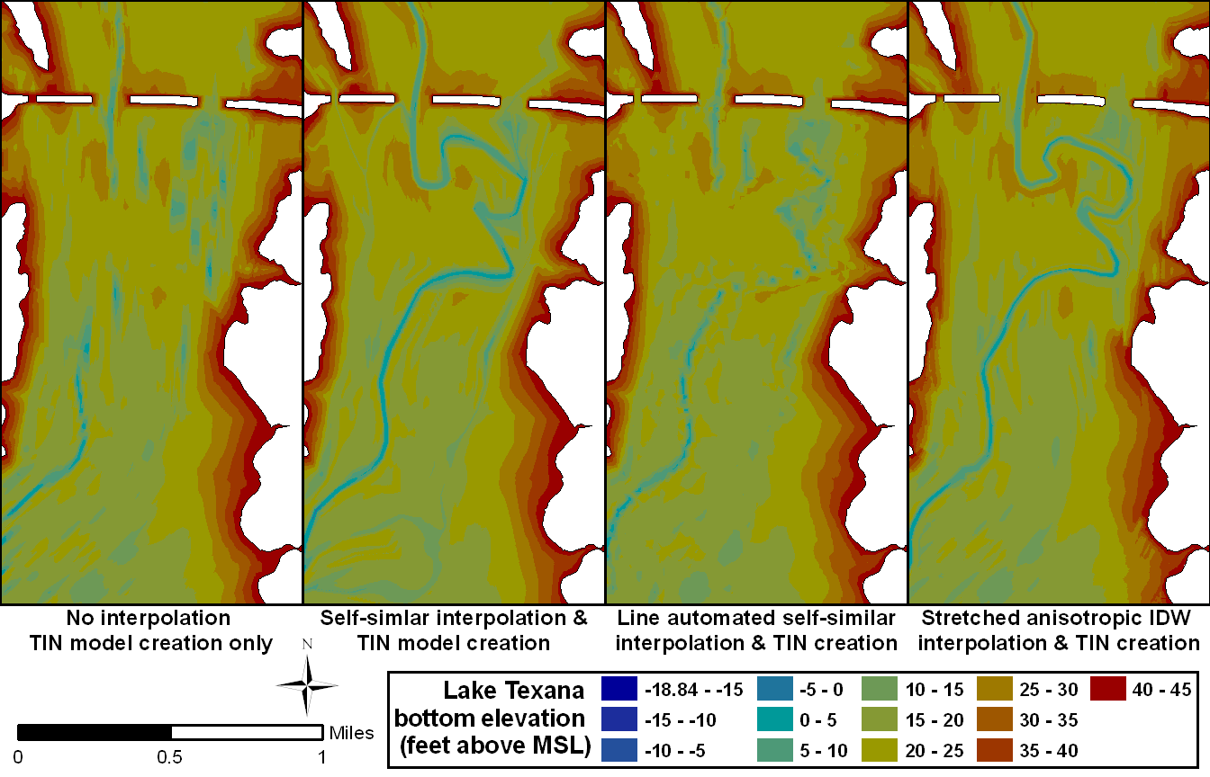

**Figure 2: Close-up interpolation comparison of resulting TIN models for Lake Texana**

In Figure 2, detailed comparison of the interpolation results is presented for a small portion of Lake Texana where the USGS mapped stream channel was highly sinuous. In Figure 2A the boundary polygon and the raw data were input into the commercial GIS TIN creation software. The TIN model is created using Delauney’s method for triangulation (Citation needed). The TIN model is unable to connect high sinuosity portions of stream channel and often produces unnatural topography near the lake boundary between survey transects. The HydroEdit interpolation in Figure 2B is guided by USGS topographic lines and the delineated blue stream line created prior to impoundment of Lake Texana. The TIN model in Figure 2C is the result of line automated HydroEdit interpolations. The disconnected nature of the stream channel resulted from interpolation guide-lines extending into the floodplain. The broad definition of the stream channels allowed the HydroEdit program to interpolate the channel. Figure 2D illustrates the ASID interpolation with the USGS delineated stream line. The stream channel is well defined due to the agreement between the survey data and the USGS stream line. Also evident from Figure 2D is the need for some additional work on interpolations near the boundary.

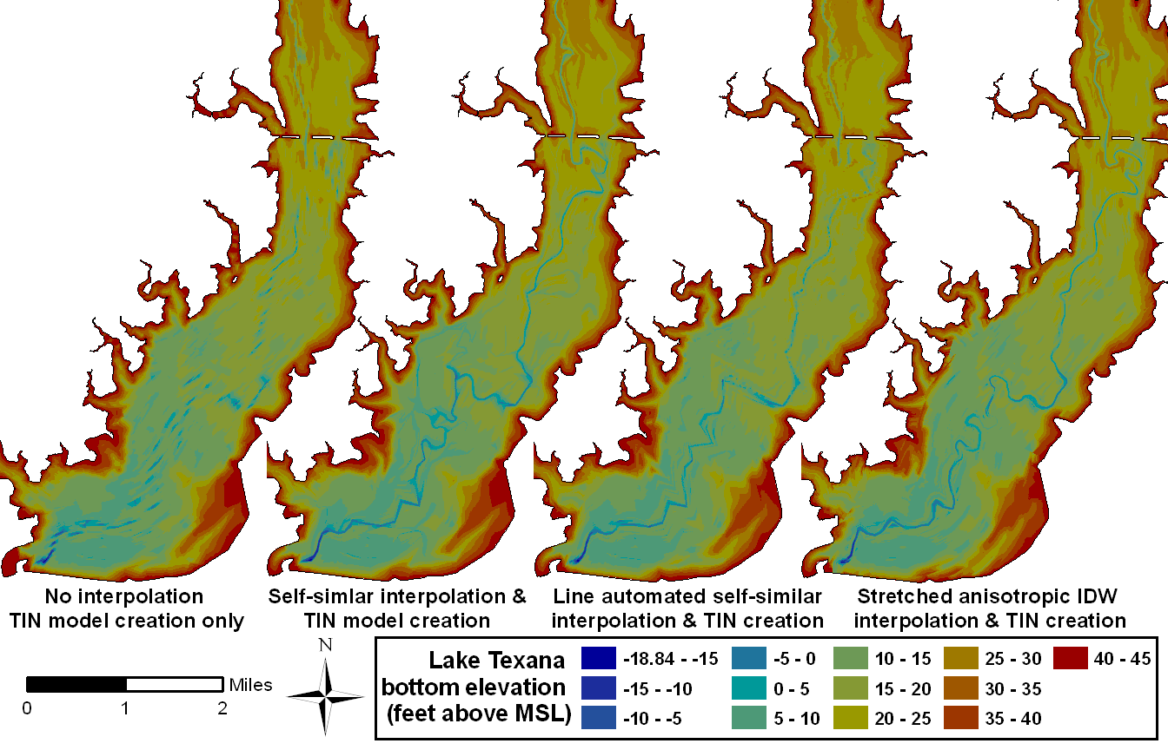

**Figure 3: Interpolation comparison of resulting TIN models for lower part of Lake Texana**

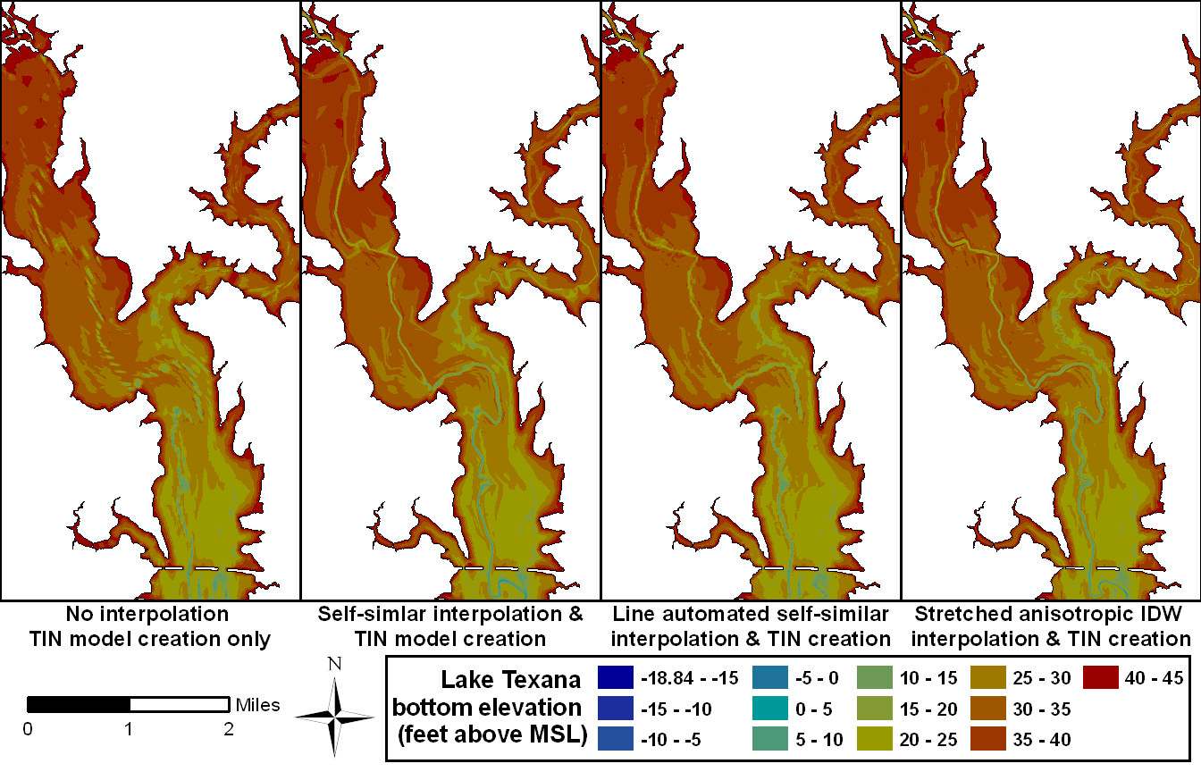

**Figure 4: Interpolation comparison of resulting TIN models for upper part of Lake Texana**

# References

Furnans, J. and Austin, B., 2007, Hydrographic survey methods for determining reservoir volume, Environmental Modeling & Software.