**Talent Acquisition System**

**1Ms. Dhanashree Hadsul**  
[dhanashreehadsul@gmail.com](mailto:dhanashreehadsul@gmail.com)

**2Deepak Mali 2Pritesh Tupe 2Swati Suvarna 2Swapnali Tambe**  [Deepakmmali8898@gmail.com](mailto:Deepakmmali8898@gmail.com) [priteshtupe@gmail.com](mailto:priteshtupe@gmail.com) [swatisuvarna18@gmail.com](mailto:swatisuvarna18@gmail.com) [swapnalitambe13@gmail.com](mailto:swapnalitambe13@gmail.com)

1Assistant Professor, Information Technology, Fr.CRIT, Vashi

2B.E. Department of Information Technology, Fr.CRIT, Vashi

***Abstract***

***Talent Acquisition System is an interactive environment in which user has to follow a certain “storyline”. During the story, user will encounter “situations”, which are those points in storyline where the user has to make a “choice”. Although there is no right or wrong choice, each choice has a different consequence on the succeeding story. Talent Acquisition System will map each situation to the choice made by a certain user and create a unique “pattern” of same for that user. Then it will check the pattern for partial matches against pre-defined patterns. Saved patterns will be accrued from information provided by the work of Carl Jung and Meyers-Briggs Research Data. Also, Talent Acquisition System will intelligently save the resultant pattern and its output into the database, thereby learning on the go. The results will be presented to the user again in another interactive environment where each aspect of the user’s personality can be explored. Then again this output may be used by people wanting to recruit very specific type of people needed to do that special job. Talent Acquisition System will be developed as a Web app using JSON for backend data exchange and other Web languages for UI, animations and compatibility. Note that Talent Acquisition System will run in any compatible browser without the need of an Internet connection.***

# Introduction

# The concept of understanding a person by conducting some tests is not new but when people have to work in team or group, it requires people to have some self-reflection, understanding and learning. This can be possible only when they have access to the tools that can map a character and help in understanding same. It is very difficult to achieve using conventional testing methods as quiz like methods for same are ambiguous and other exams focus more on memory and processing capabilities of the brain than the humane person. 1.1 Pros of the Existing System - Intuitive, make use of sliders for relative accuracy of input. Good UI. Top notch presentation of o/p. 1.2 Cons of the Existing System - Unverifiable sources, accuracy of output not deterministic, seems like another pass-time, requires internet. A research survey conducted <reference of survey> shows that 88.5% people are interested in such systems.

Talent Acquisition system is aims at inculcating the conventional personality tests into an interactive environment or a so-called virtual reality. This reduces the ambiguousness of perception of situations and thus provides more reliable output. The output will cover major aspects of human character and depending upon requirement; can be used for various purposes as mentioned above.

# Proposed System

Nearly every personality testing system takes quiz to know the personality of its user. But to read and choose a choice for each question in the test is very tedious. And today, time is very crucial and people search for interesting stuff everywhere. So, we design a system that will overcome all the issues faced by users in giving such test.

The existing system that is MBTI excel quiz has a set of questions and answers mapped on an excel Spread sheet. Upon completion of answering, a new sheet shows what type of personality user belongs to. Then user must open the pdf file containing the personality-specific information. The previous system did give high accuracy of all answers but it is dull, unintuitive, user may lose interest, and the user has to open pdf to know the result.

Talent Acquisition System will provide a very user friendly interface which is very interesting for users and everything will be present in front of the user, he/she need not open some other application for viewing result. The approach of this system is to be more of customer oriented then product or service oriented. Thus Talent Acquisition System aims at making customer happy and also makes it interesting and simple for them to use the system and know their personality type. So, Talent Acquisition System aims at providing an environment that will help users interact with the system and know their appropriate personality. Thus, it will eliminate the problem of giving tedious test and getting fake results.

Talent Acquisition System is an interactive environment in which user has to follow a certain “storyline”. During the story, user will encounter “situations”, which are those points in storyline where the user has to make a “choice”. Although there is no right or wrong choice, each choice has a different consequence on the succeeding story.

Talent Acquisition System will map each situation to the choice made by a certain user and create a unique “pattern” of same for that user. Then it will check the pattern for partial matches against pre-defined patterns. This system will consist of a two pages- main page and the story page.

**2.1.** In the main page, there will be a common situation of every user and a set of options. Based on the option selected by a user, he/she will be directed to a story that is different from the other user selecting other option (in the main page).

**2.2.** The story page will show the next situation and a set of options. Based on the options of the user, many stories will be generated and a story pattern is generated in the knowledge of the system. This pattern is then compared with the predefined pattern in the knowledge base to tell the personality of the user as result. If the pattern doesn’t exist in the knowledge base, the new pattern will be saved in it.

# Design

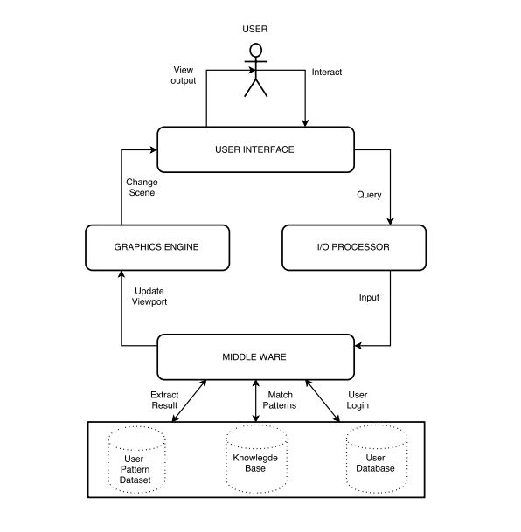 **Fig 3.1: General Architecture of the proposed system**

## The TAS will consist of following components:-

## 1. User Interface

## 2. I/O Processor

## 3. Middleware

## 4. Graphics Engine.

## User Interface: The user will interact with the application through the user interface. As the user will be provided with a set of graphical situation and choices, the selection of choices will be the query given by the user to the system.

## I/O Processor: The user will enter the query or his/ her choice selection through some input-output processor. This I/O processor can be either keyboard or mouse or both.

## Middleware: The query will be given to the middleware as input via the I/O processor. The middleware is a software layer that lies between our application and the backend processes. The backend processes are:-

## User database for user login.

## Knowledge base to compare the pattern generated by the user with the predefined patterns here. Part of learning is done here.

## User pattern dataset to extract result, i.e., the personality trait of the user will be extracted from this process.

## Graphics Engine: The result extracted from the user pattern dataset will be given to the graphics engine via middleware to update the viewport. Updating the viewport by the graphics engine means the result of the interactive test given by the user will be displayed graphically in the same screen. Finally, the graphical result thus obtained will be shown to the user via the user interface. It is the same user interface that we the user will use to take the test. Thus, from the beginning till the end, talent acquisition system will give users an interactive environment with easy-to-use functions.

## 4. Conclusion

## Talent Acquisition System is the need of the hour. The Literature Survey suggests that the similar system called MBTI Excel Quiz has many cons. Only the tedious quiz with no GUI is present. Our Project- Talent Acquisition System aims to eliminate the issues of previous systems and help the customers know their personalities through interesting GUI. This will save the time of the users and will increase customer satisfaction. The modules and design for this project have been conceptualized and the hardware and software requirements for development and usage have been analyzed and documented successfully.

# 5. References

[1] http://www.iep.utm.edu/art-inte/

[2] http://www.myersbriggs.org/my-mbti-personality-type/mbti-basics/

[3] https://www.cpp.com/products/mbti/index.aspx

[4] http://www.16personalities.com/free-personality-test

[5] http://entertainment.howstuffworks.com/computer-animation.htm

[6] http://www.adobe.com/products/flashplayer.html