APPIC

Atlas of Protein Protein Interactions in Cancer

User Guide

Version 1.0

September 2023

Contact: Benjamin Ahn, benjamin_ahn@brown.edu

**Start**

Navigate to https://appic.brown.edu

This is the landing page. Click on “START” to begin.

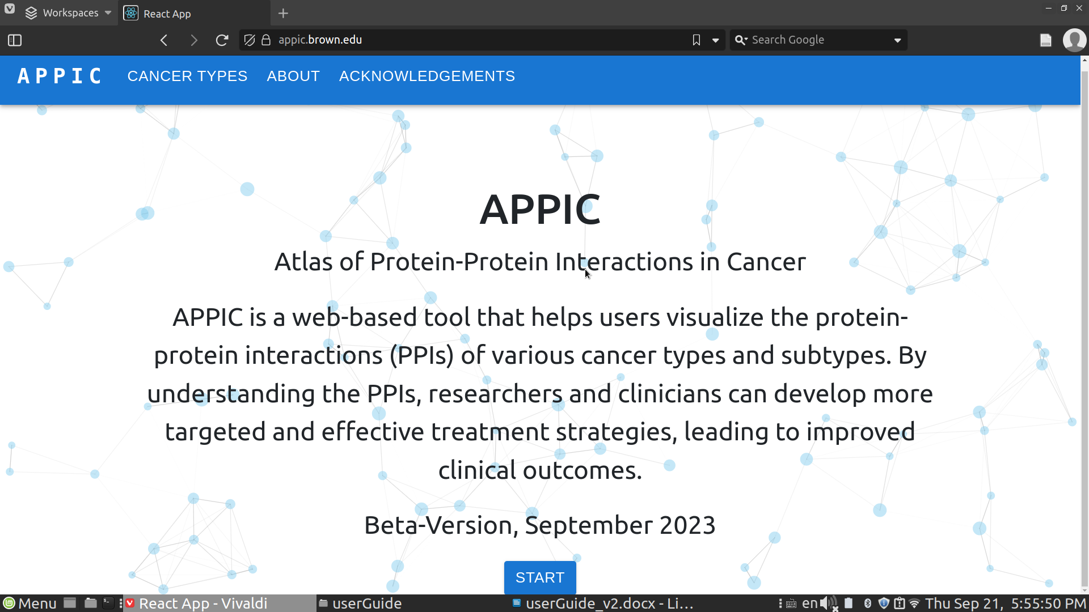

**Body Diagram Page**

After clicking “START”, the web tool will bring you to this page. Here, you can click on each organ which will drop down a list of different subtypes within that tissue.

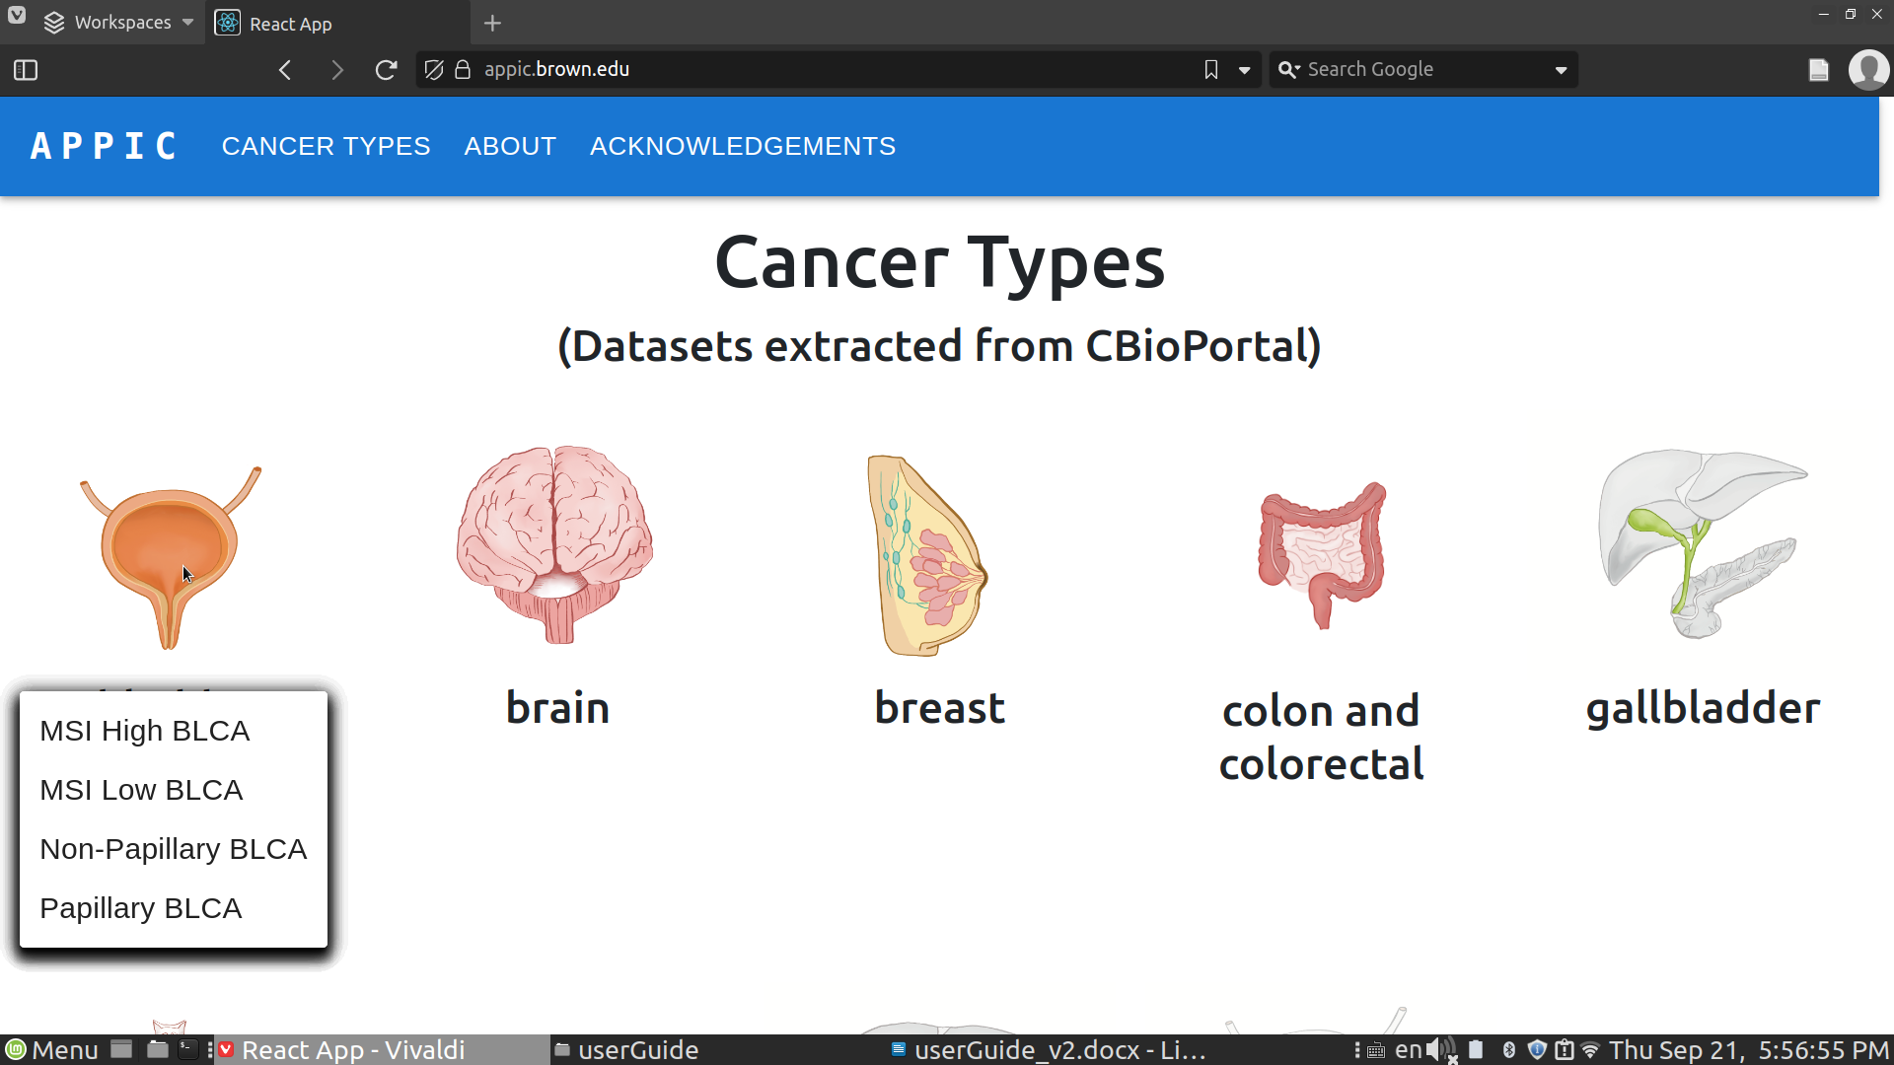

Users can also hover their mouse over each subtype to generate a popup box which describes the dataset used to create the cancer subtype. Clicking on a cancer subtype will bring the user to the network diagram page.

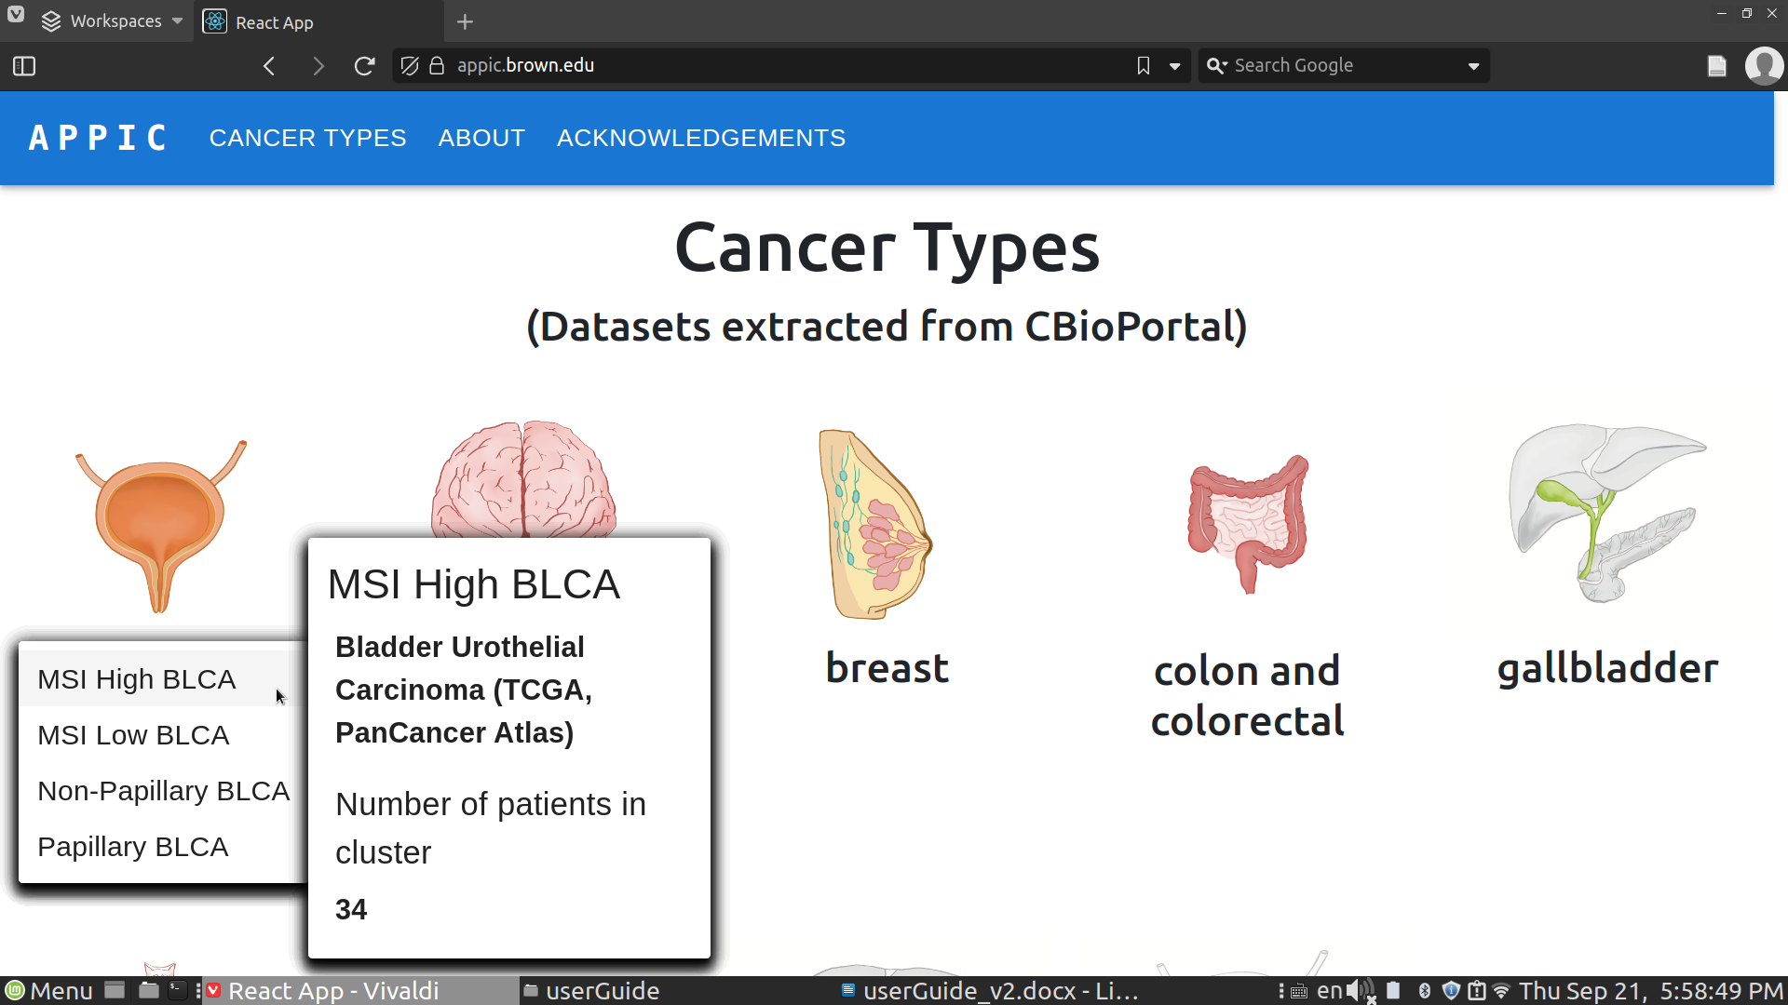

**Network Diagram Page**

Here, the protein-protein interaction network for this cancer subtype is displayed on the left. Nodes colored in red indicate existing drug targets (see Clue.io database notes).

On the right hand side, info tiles represent the several databases connected to APPIC. Click on the tabs to browse different databases.

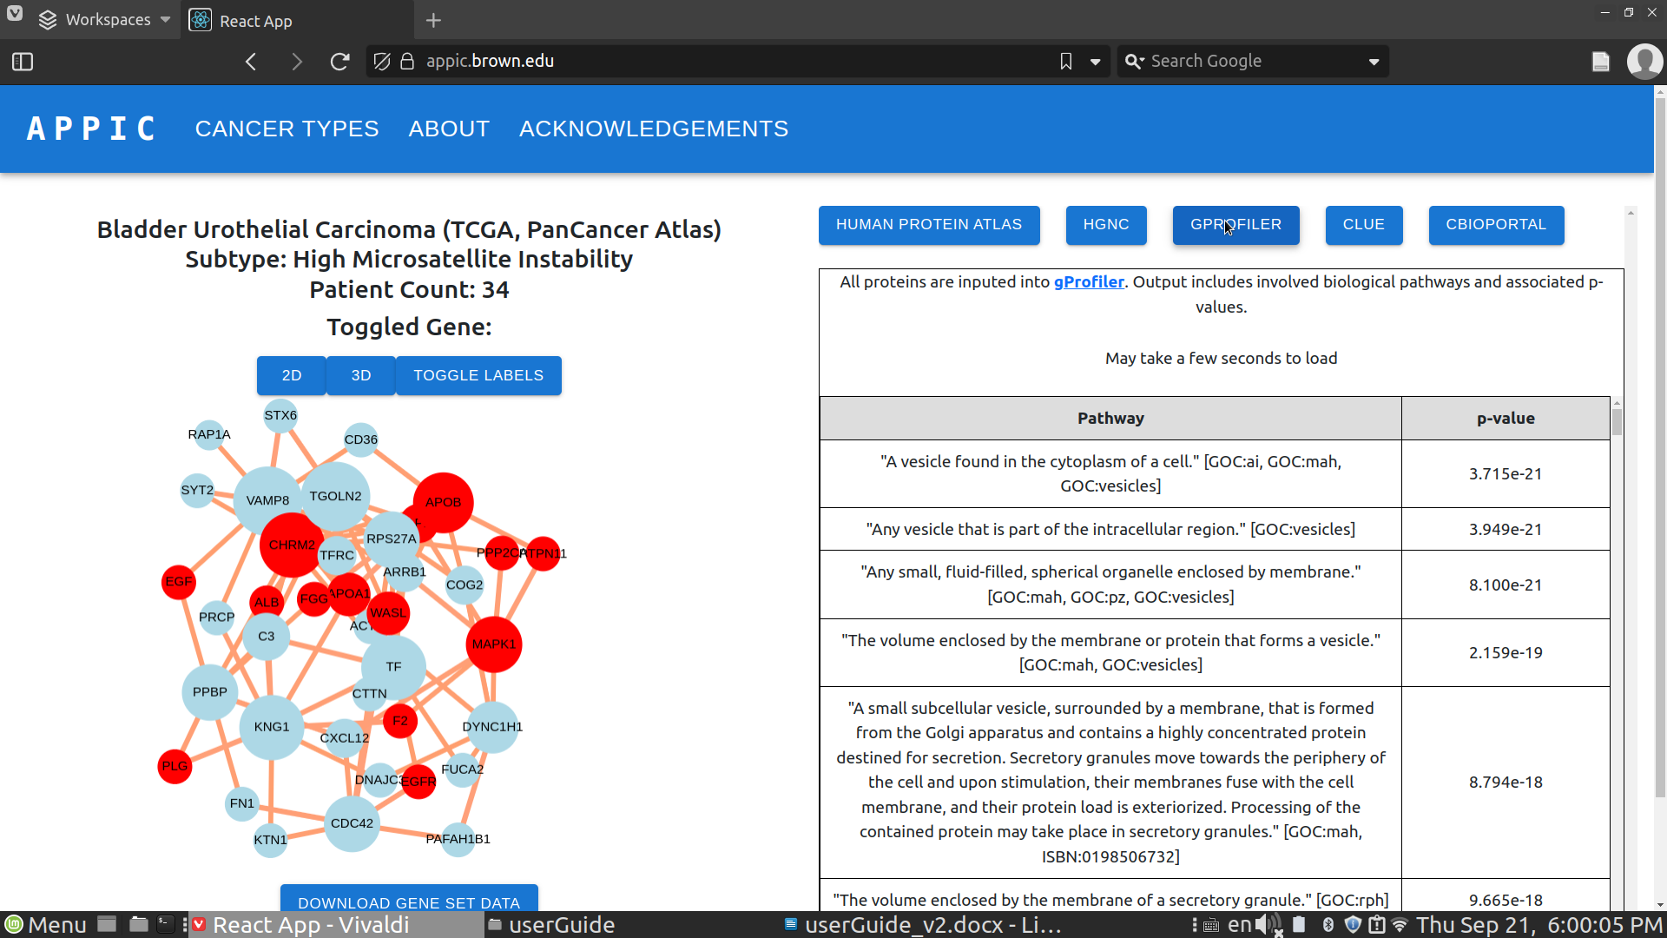

**Human Protein Atlas**

Users can click on a node in the network diagram to create a response.

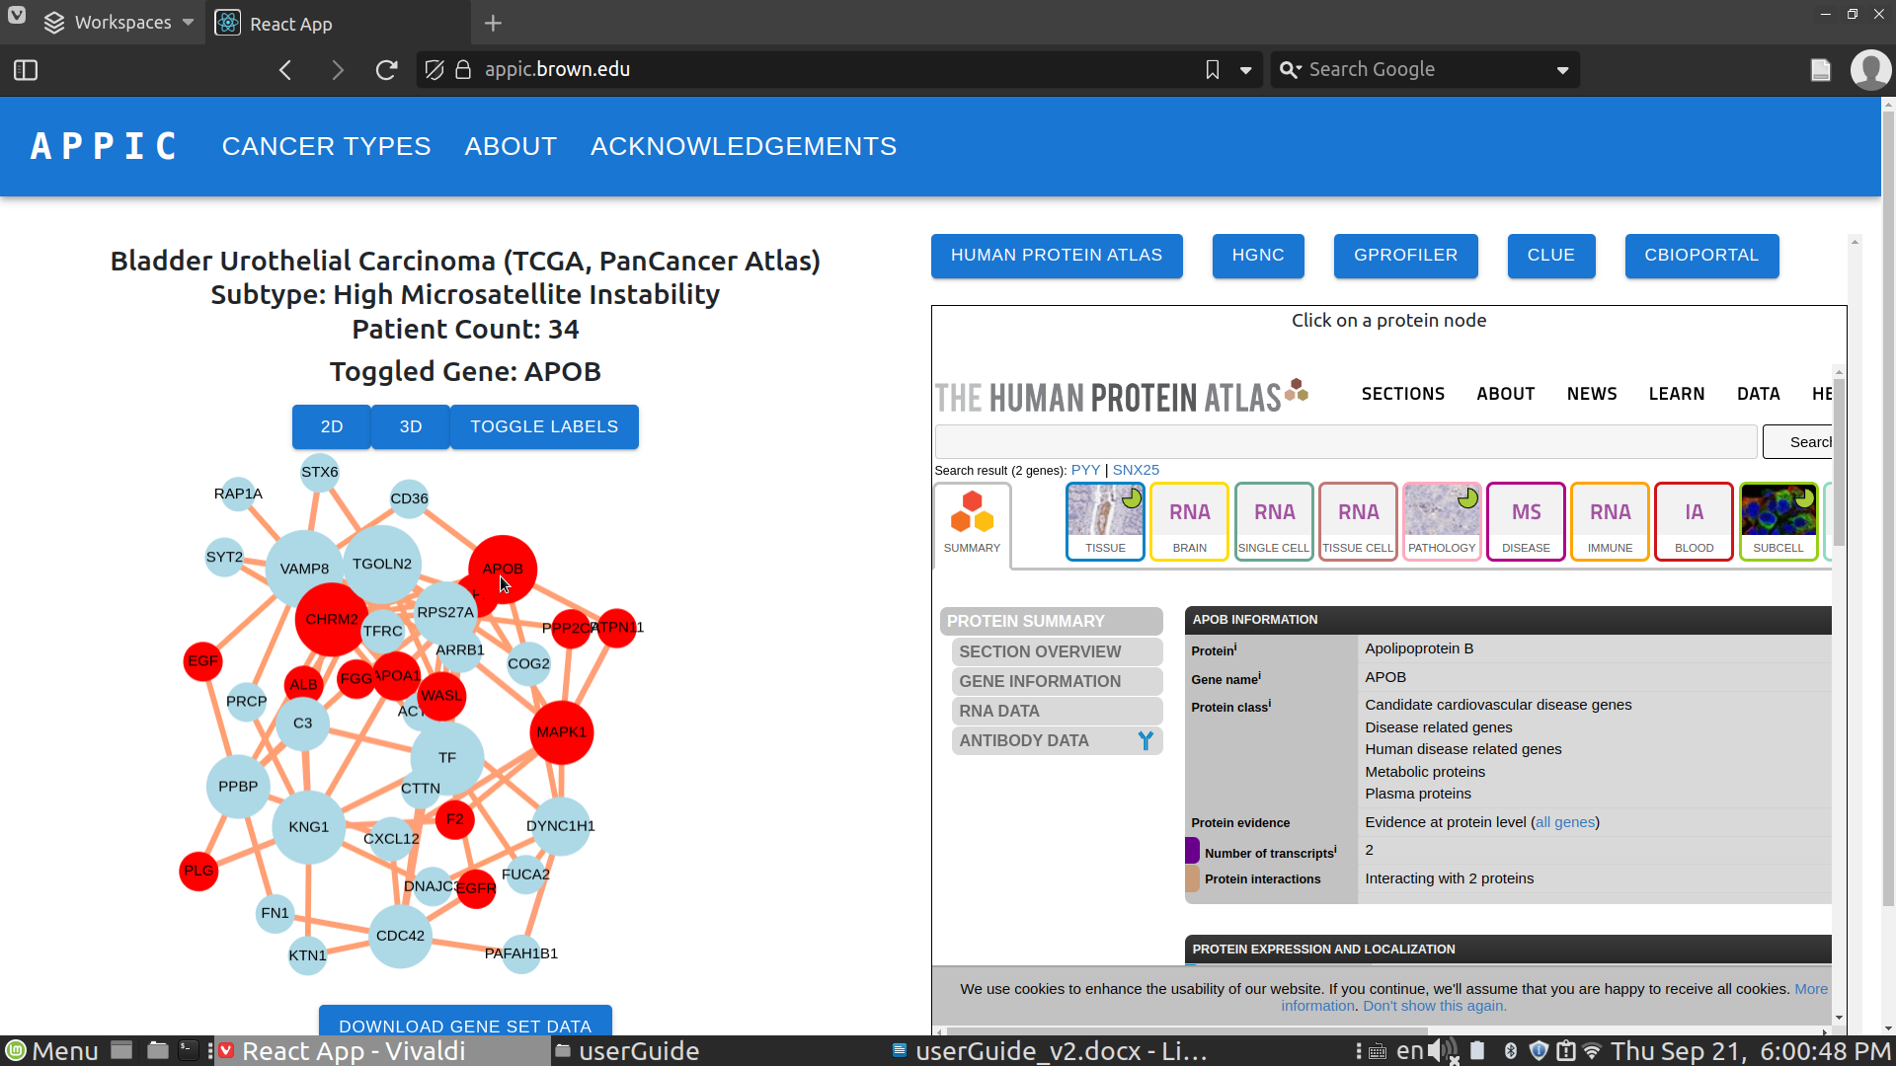

**HGNC**

Users should click on a node in the network diagram to create a response.

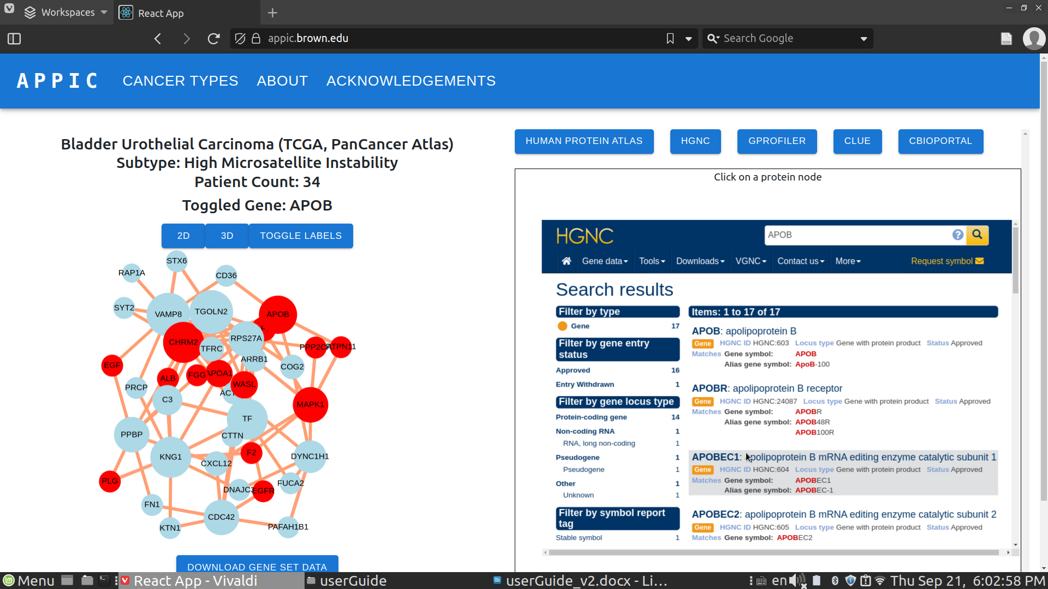

**g:profiler**

All proteins are passed into g:Profiler. The output is a table that represents biological pathways related to the protein-protein interaction network. Biological pathways are ordered by p-value.

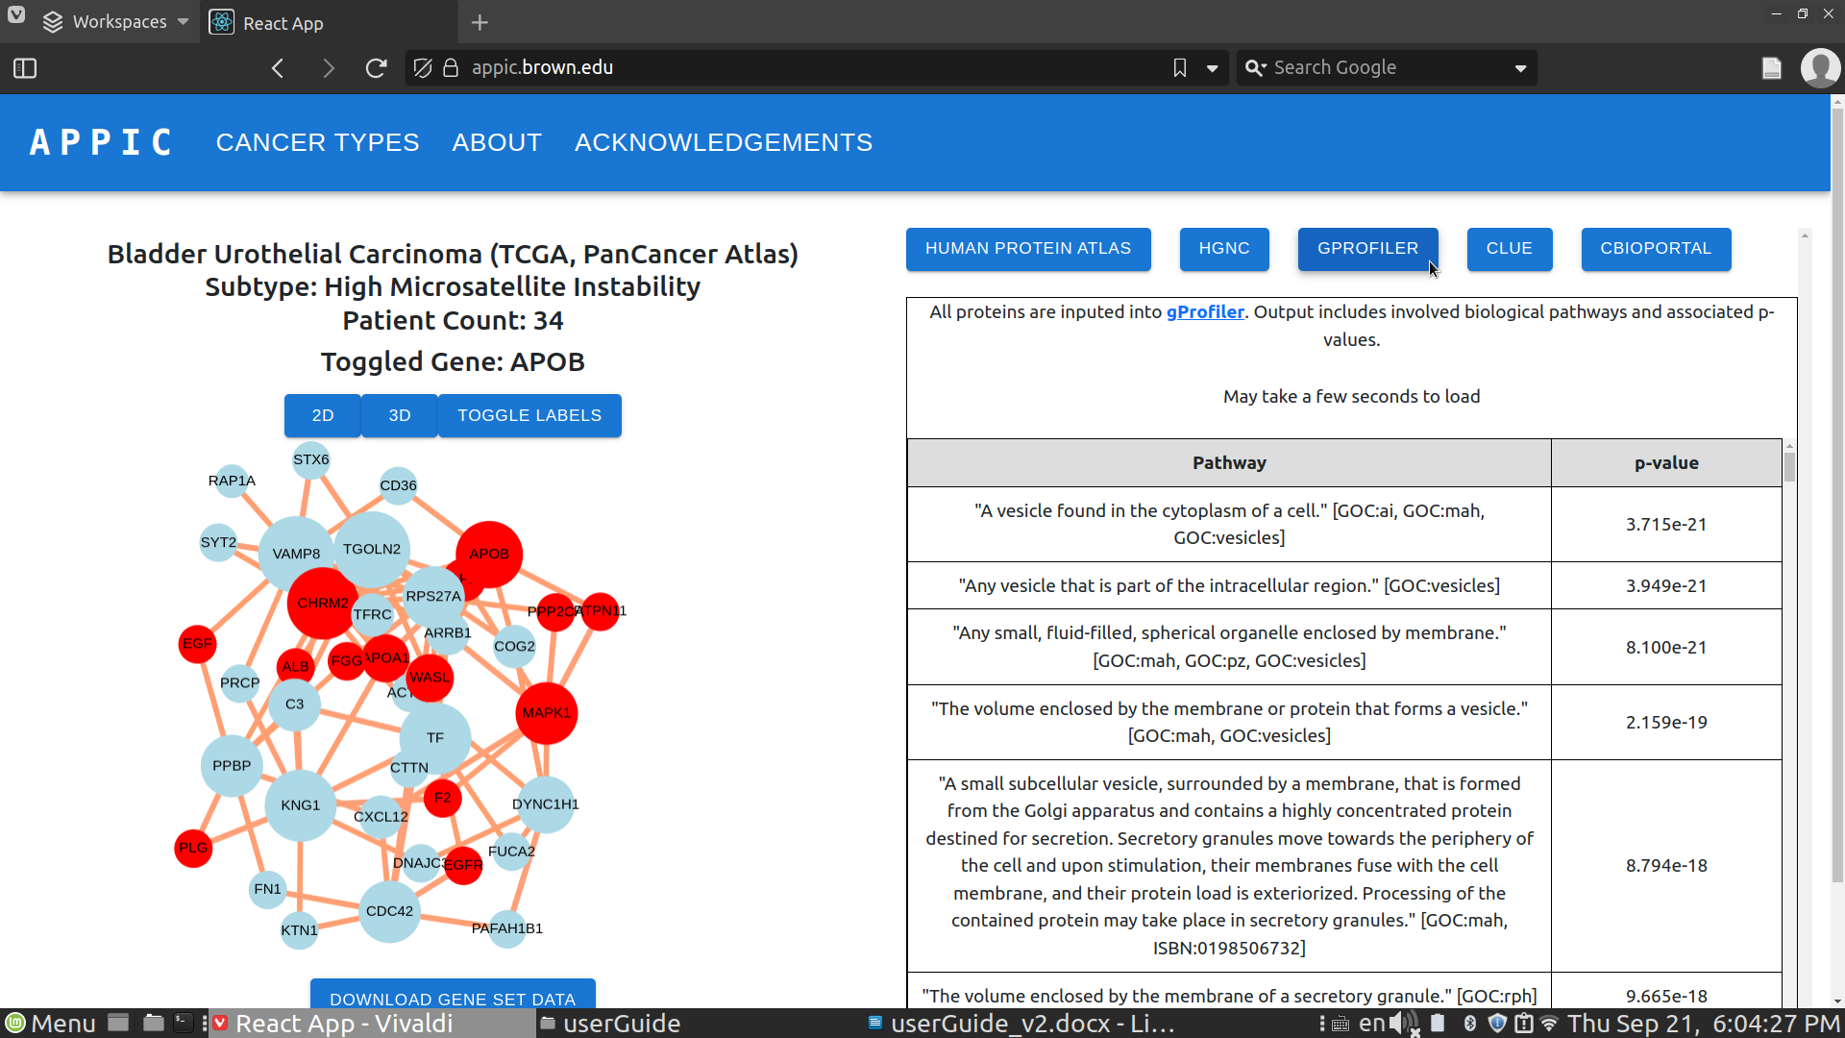

**Clue.io**

All proteins in the protein-protein interaction network are searched in the Clue.io database to see if they are targets for any existing drugs. The drug name and gene target are included in the table. The gene targets are colored red in the network diagram.

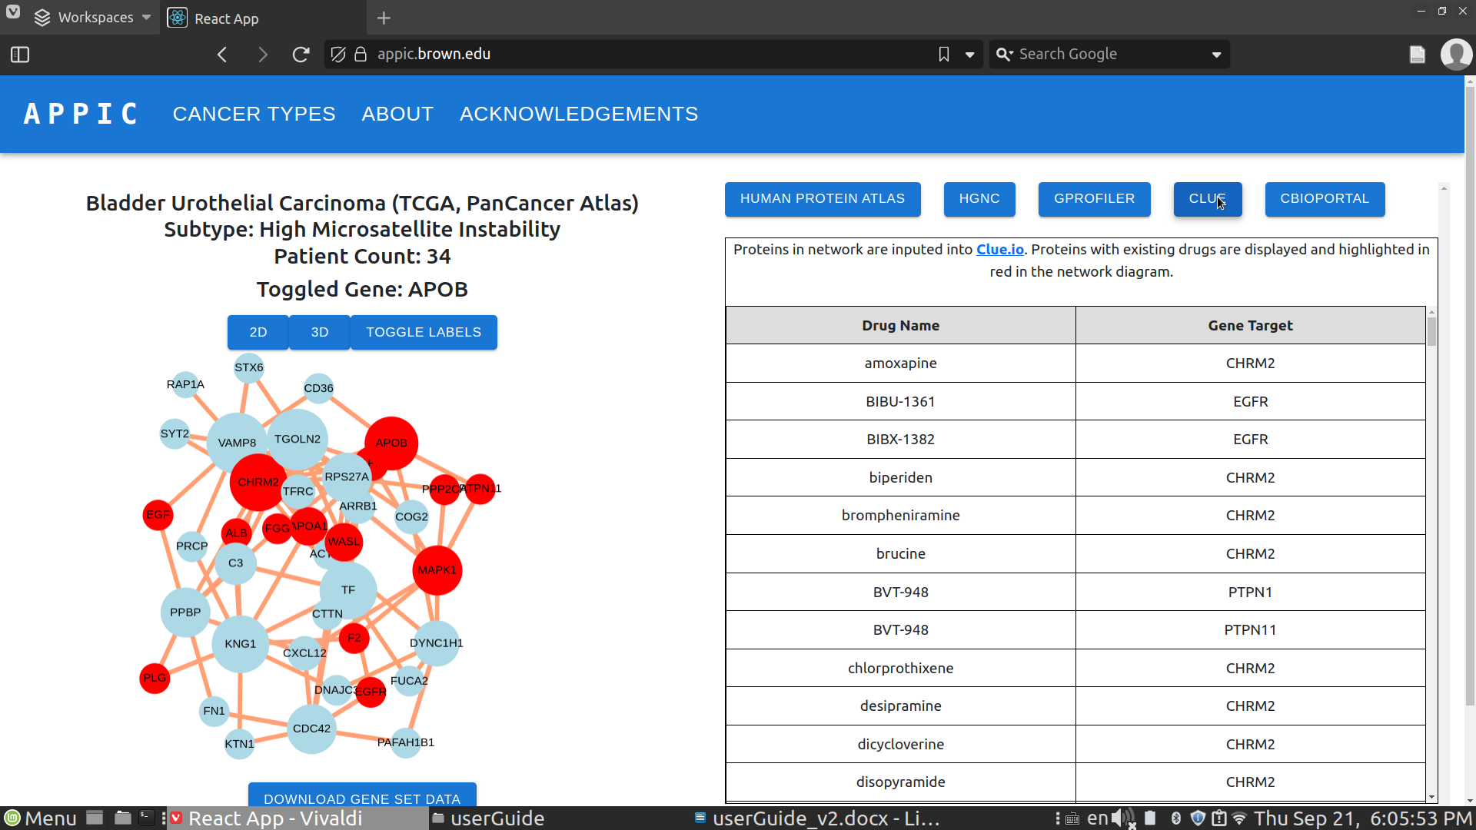

**cBioPortal**

The specific patient IDs that create the cancer subtype are displayed. The Kaplan-Meier survival plot of the specific patients in the cancer subtype is displayed. Users have the options to download the Patient ID list as well as full cBioPortal clinical data set.

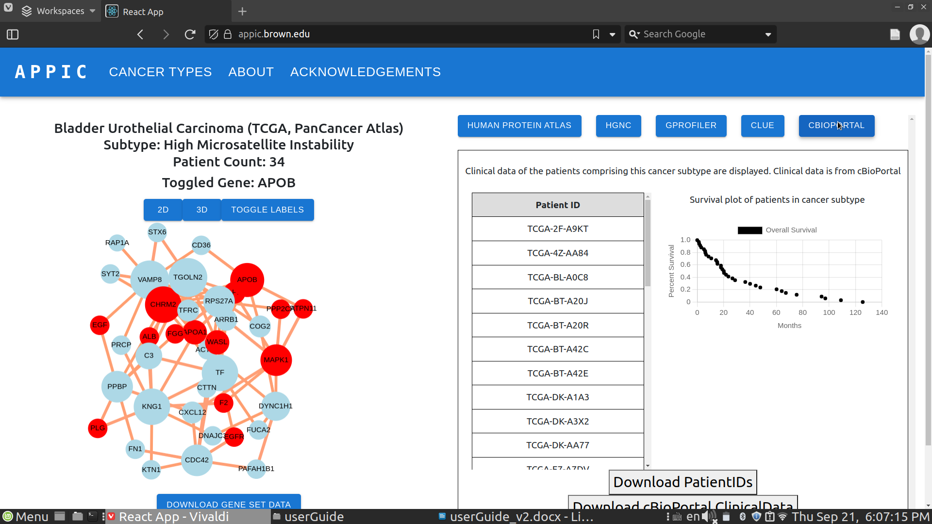

**3D network diagram**

Users can visualize the network diagram in 3D. Clicking on “Toggle Labels” will add or remove the protein labels for the 3D model. Users can also click and drag around the network diagram to move the nodes. Users can also download the protein-protein interaction data files.

