assessment 2: Team project

COSC2196 – Introduction to Information Technology A2

Contents

Team25 - Profile 1

Team Name 1

Team25 Members 1

Niki Arrogante 2

Debborah Bryce 4

Samuel Claydon 6

Caden Maxwell 8

Group Processes – Looking Back on A2 10

Career Plans 10

Niki 10

Debborah 10

Samuel 11

Caden 11

Comparing Our Plans 11

Tools 12

Microsoft Teams 13

GitHub 15

Credits 17

# Team25 - Profile

## Team Name

Our team collectively decided to name ourselves **Team25**. It was named after the group number we joined in Canvas. It’s easy to remember, straightforward, and involves a nice, rounded number that everyone can appreciate.

The team has seen some unexpected changes, and we have shrunk down to a four-person group since our last foray. Regardless, we intend to take things in stride, and hope our report will represent our efforts.

## Team25 Members

The four members of Team25 are (in alphabetical order):

### Niki Arrogante

Sydney-born and raised, Niki is currently a full-time student following years working in various sectors including telecommunications and logistics. He is a big fan of virtual reality and hopes to find ways to implement the technology in new, exciting ways. Outside of studies, he enjoys gaming, motorcycles, and spending time with his two-year old daughter and partner.

[Niki’s Website](https://s3851498.github.io/intro-to-it-assessment1/)

Ideal Job: Hardware/Software Developer (VR)

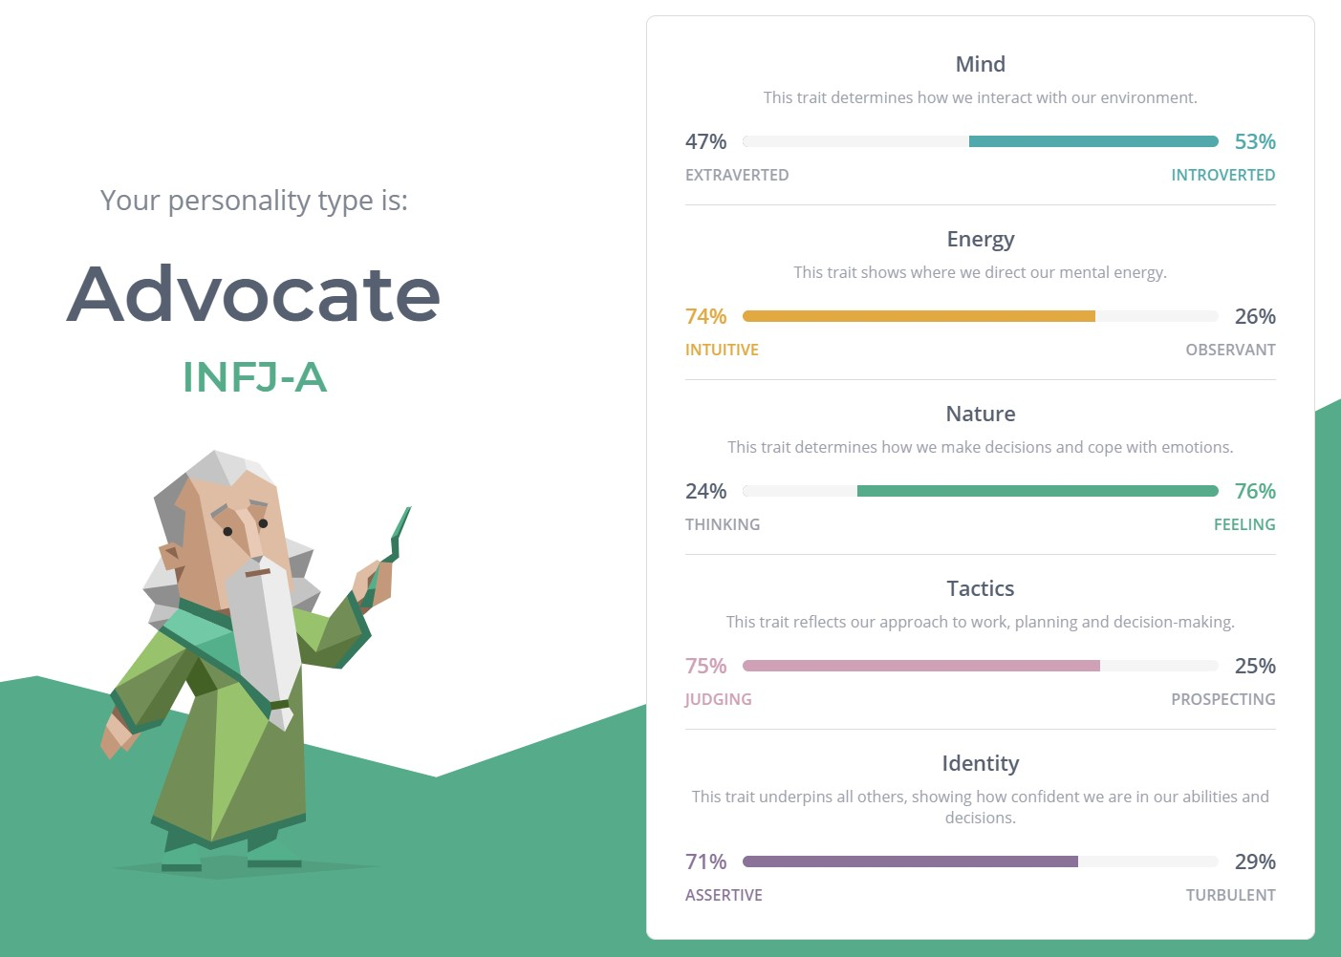

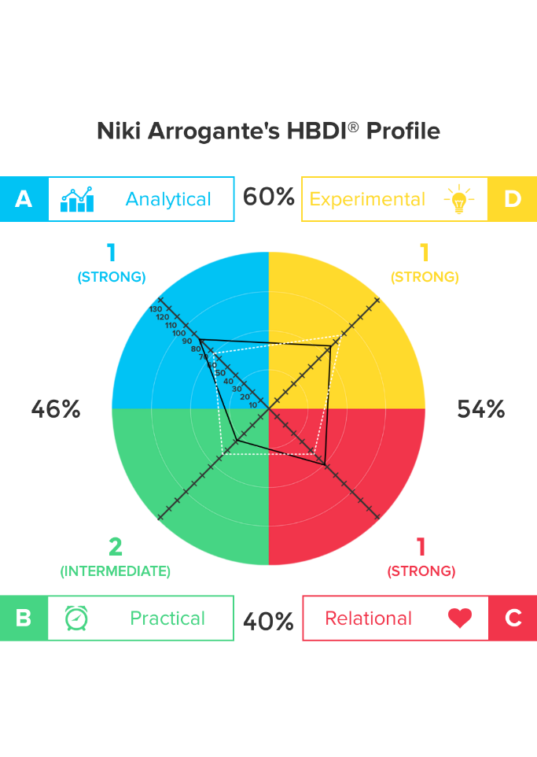

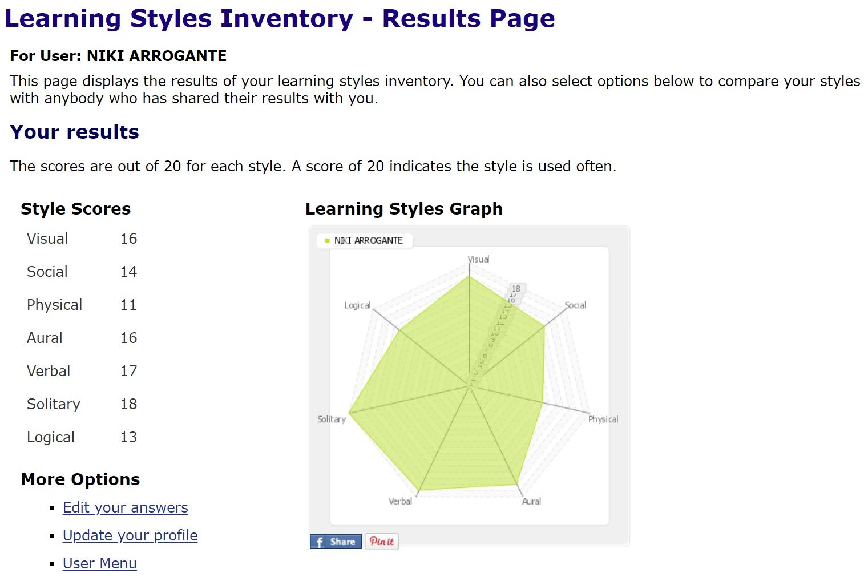

### Debborah Bryce

Mum of four kids, two cats, and two dogs, Debborah was born and raised in Australia with English Scottish heritage. Debborah plays netball on the weekends and currently works in IGA. She is fascinated with modern technology and enjoy learning new skills, languages and reading.

[Debborah’s Website](https://xerxasjade.github.io/Team25/Clone-of-Debs/)

Ideal Job: Data Analyst

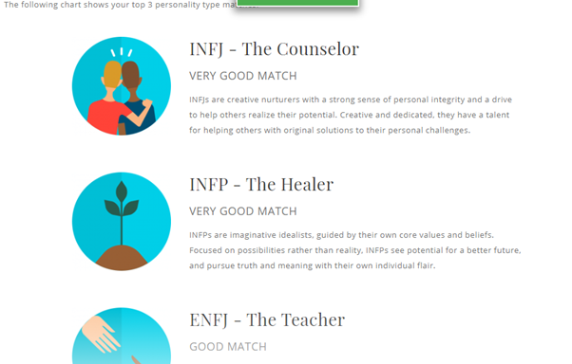

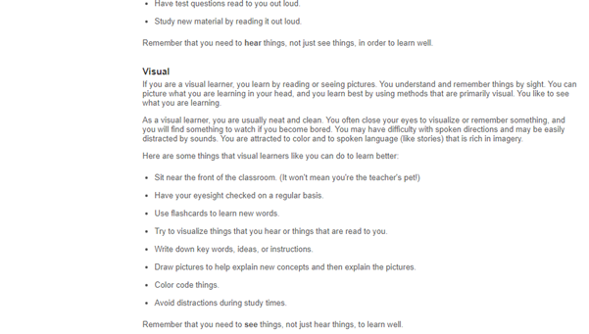

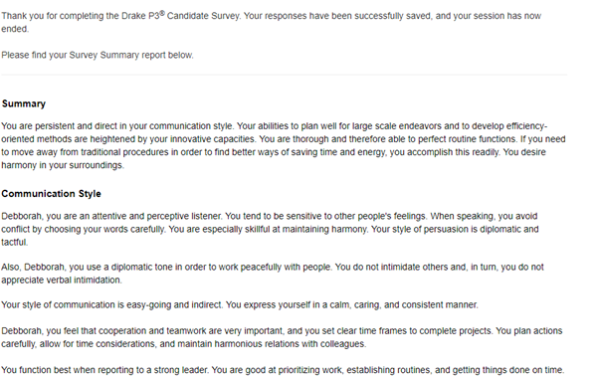

### Samuel Claydon

Sam is a proudly born and raised Tasmanian, living in a rural town named Kempton, which has a population of roughly four hundred. At the age of twenty-three, he is currently undertaking two online courses, our current “Introduction to IT” course, as well as an “Academic and Professional Communications” course. Sam’s passion for video games was discovered thanks to an old computer given to him by a family friend, and he has loved them ever since. After spending a lot of time with a professional computer repairer, he was inspired to pursue a career in the IT industry. <https://cadenmaxwell.github.io/Caden-Profile/>When he isn’t exploring the ins and outs of computers, Sam likes to spend quiet moments with a good book.

[Samuel’s Website](https://samclaydon96.github.io/My-Profile/)

Ideal Job: Computer Repair Technician.

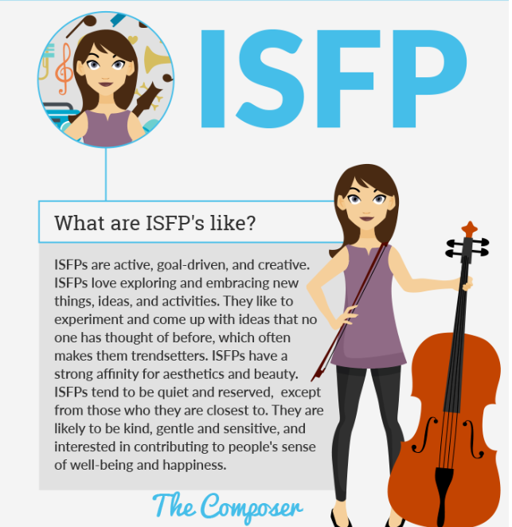

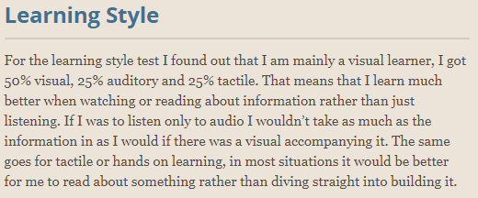

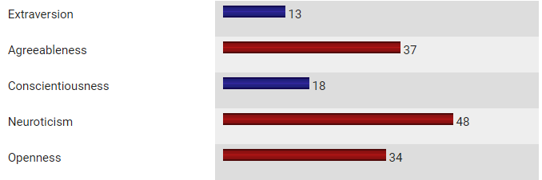

### Caden Maxwell

Caden hails from Wagga Wagga in New South Wales and is of Australian-New Zealand descent. He recently completed his high school and HSC, during which he studied many IT-focused subjects including “Information and Digital Technology”, “Software Design and Development”, and “Information Processes and Technology. Caden is now working his way towards a Certificate III for IT.

Caden was the newest member to the team, but quickly assimilated and contributed greatly to our report.

[Caden's Website](https://cadenmaxwell.github.io/Caden-Profile/)

Ideal Job: Software Developer (Gaming/General Application)

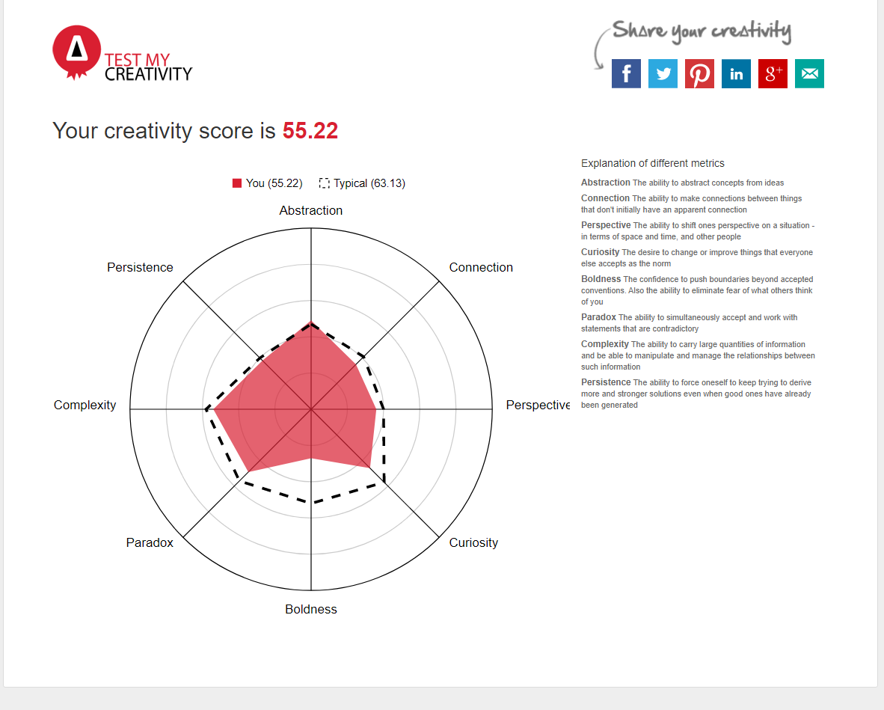

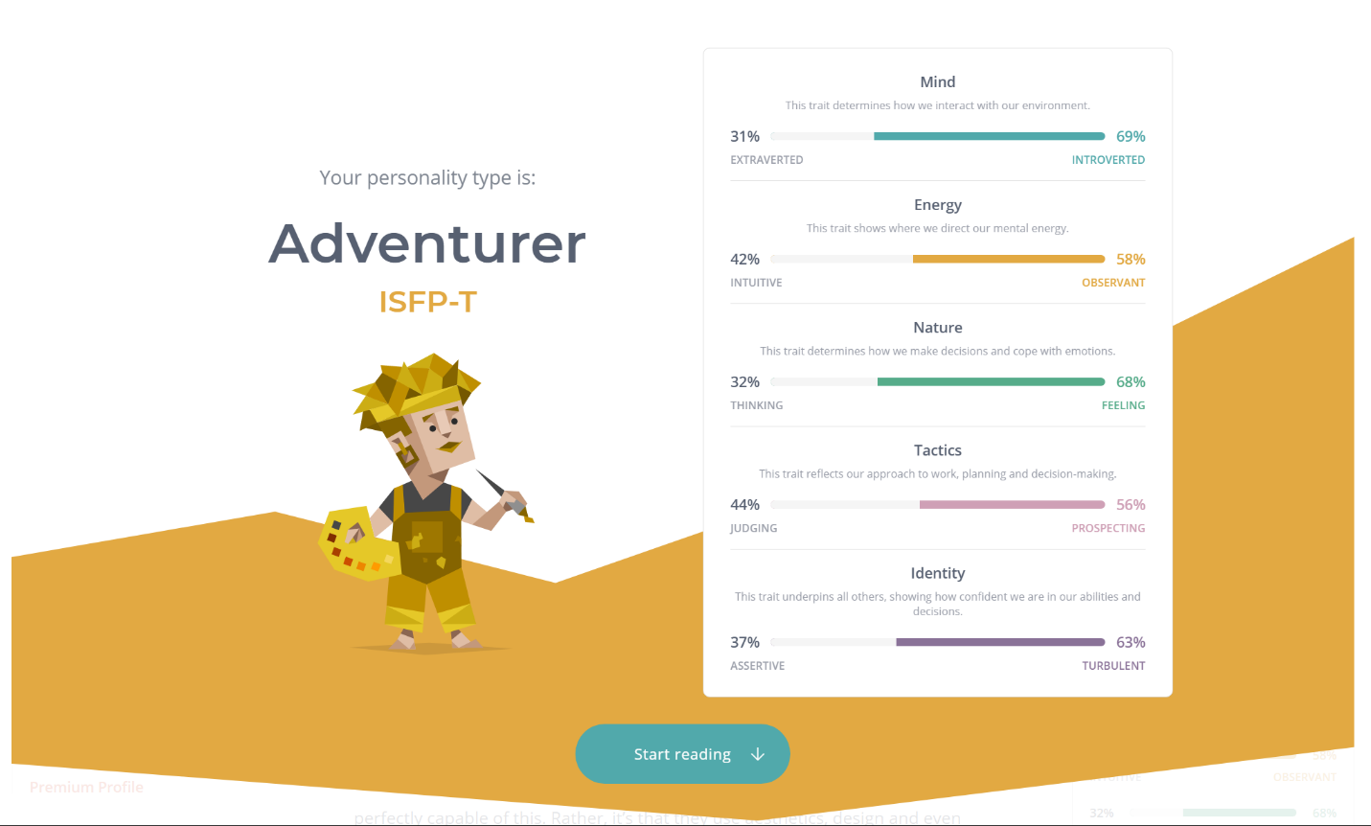

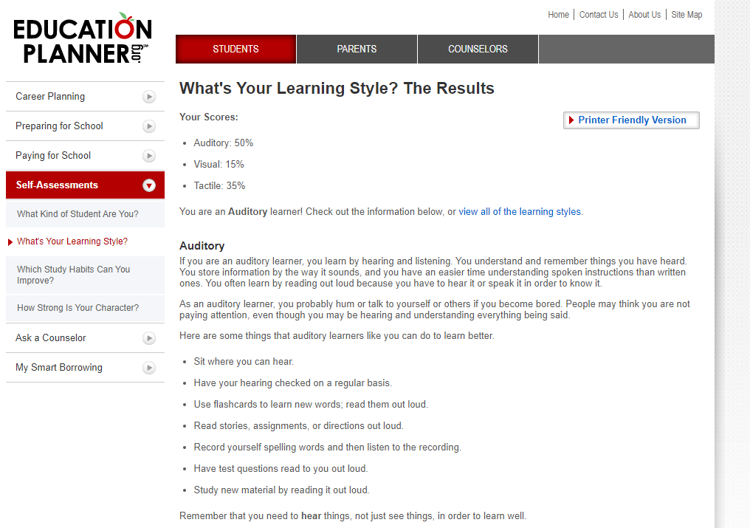

# Group Processes – Looking Back on A2

Operations in our previous assignment ran smoothly thanks to strong communicative practices and agile time management. Unfortunately, we received some scathing feedback on the quality of our output in the previous assessment regarding the quality of our answers, and the underwhelming lack of imagery.

In response, we decided to take it back to the drawing board to find a more attainable project, which will be detailed further in this report. While this change foresaw roughly a fortnight’s loss due to the intensity of the change, we concluded that moving to a smaller project would allow us to produce a more polished and focused product.

In a stroke of poor luck, we unfortunately lost some members during our preparation for this project. This resulted in almost a week’s worth of productivity lost.

We intend to take this feedback to help guide us throughout this report and attempt to correct the errors made previously.

# Career Plans

The team took a moment to consider their career plans and discuss what we thought of them. Here is what we had to say:

Niki

Right now, my hope is to find a flexible working life in the future. While I do plan on entering the industry within an established company (preferably working as a programmer/developer but my working history gives me plenty of options), I intend to build a strong portfolio with independent projects and take a stab at working as a freelancer/indie from home. Honestly, I just want to spend more time with my partner and daughter, and my plans are always open to change with that in mind.

Debborah

My career plan is to become qualified and accredited to be able to use data analysis software, data entry, data visualisation, MS excel and other programs. I will also work towards certification in programming languages such as Python, SQL, Oracle etc. I will also need to do a mathematics course to refresh my knowledge. I would really like to work in medical research or social health setting.

For the next 3 years I will work towards a degree in Data science or data analysis as well as a degree in Information Technology, so I can have flexible work options such as working remotely or onsite. I would also like to work or volunteer for charities in a business analysis role, which would require a certificate or degree in business analysis.

Samuel

My career plan is to get a degree in information technology so that I can eventually get a job as a computer technician. I’m not sure where exactly I would want to work but I’d like to work on a variety of PC’s and systems so being a contractor sounds good for what I want to do. I don’t have any experience, so I’d probably need to start in a different position than I want. From there I would learn as I work to become qualified enough to join a bigger company or maybe start my own.

Caden

My career plans are to finish university with either a degree in computer science or information technology, from there I want to be able to work as a contractor for software development so that I can be my boss and work from home. After earning enough money and skills, I would like to start my own business in the software development world.

If I can start up as a contractor I would find a reasonable business to work for, one that I would find enjoyable to do development for and that pays pretty decently, I would join the company as high of a position that they would offer me and try to work my way up so that one day I would be able to run my own business.

## Comparing Our Plans

It appeared that most of us had a vision of working contractually after achieving our degrees. We shared sentiments of the nature of what the IT industry was like in terms of employment, and for the most part agreed that building a portfolio of our own as contractors would yield more success in finding secure employment.

We all valued flexibility as part of our career plans, lockdown status notwithstanding. Our individual lifestyles appreciated the idea of having our careers work around our personal lives, be it family, ulterior goals, or simply to have more time to enjoy hobbies (which luckily could coincide with some of our careers anyway!).

There were unique aspects in each of our goals: Niki was prioritising the flexibility to spend more time with his family; Debborah was the only one whose plan was strictly aimed at employment with a company and not pursue contracts; Samuel shows more interest in the physicality of the IT industry over the digital; and Caden has set his goals for higher, more demanding positions.

It is surprising to us how different and similar our goals were at the same time and emphasised how vast the industry was. We also deduced there was great potential to diversify our plans as we discovered more about the field. However we all definitely agree that studying has helped us plot our paths more accurately, and are eager to see where we’ll be in another three years.

# Tools

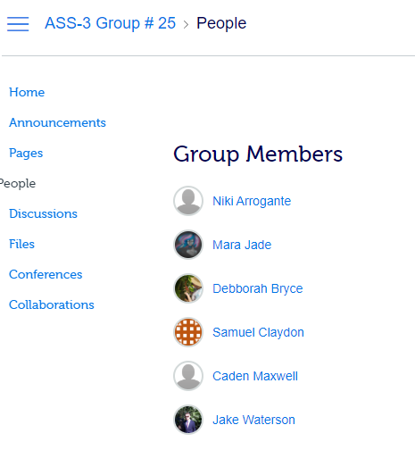

As with our previous assessment, we all fell in line with Canvas’s group but had no real use for it as we were already established with our previous tools, **Microsoft Teams** and **GitHub**. We previously also used

Much like our old team website, we have set up our [website](https://s3851498.github.io/Team25a3-5/) on Github [here](https://github.com/s3851498/Team25a3-5).

## Microsoft Teams

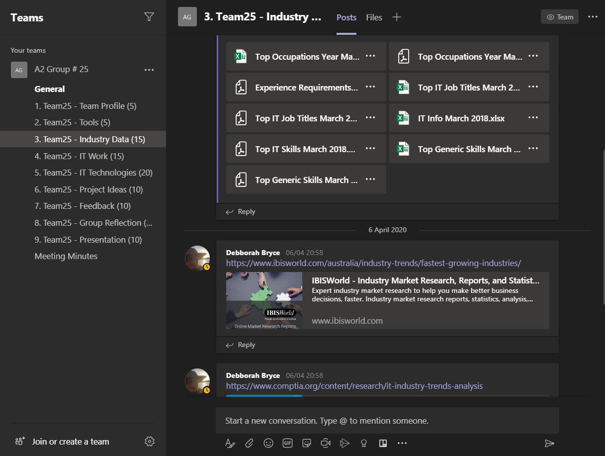

Within [Microsoft Teams](https://teams.microsoft.com/l/team/19%3adae7093f81814e8382f89f14f1afb602%40thread.tacv2/conversations?groupId=df9a1261-3af1-45a1-8b78-c360f7343451&tenantId=d1323671-cdbe-4417-b4d4-bdb24b51316b), we organised separated channels to log our work in different divisions of the assessment as we would be splitting our resources among the sections of the report. Microsoft Teams became the centre of our direct communications, including text and voice meetings and file sharing. Meeting minutes were logged after each meeting for posterity and absent members to make sure we were always up to date with our work and expectations.

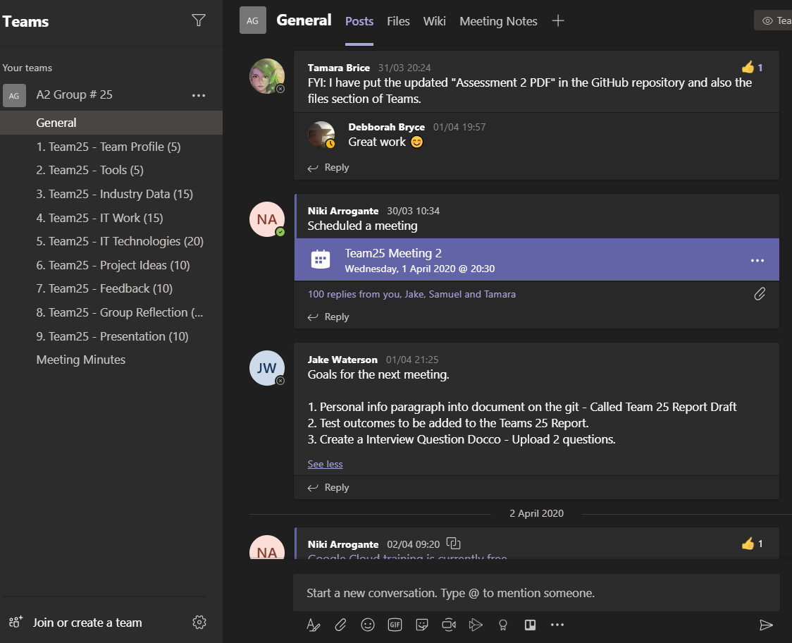

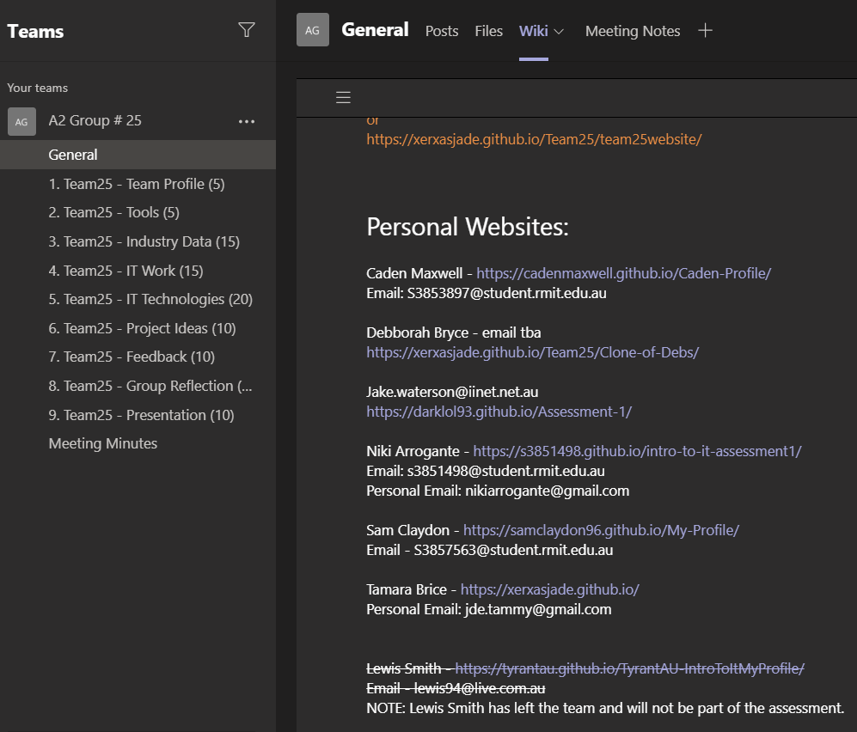

Microsoft Teams proved helpful for keeping our communications steady while we managed our individual availabilities and has been integral to our current success. Through the course of our collaboration this semester, we see ourselves continuing to use Microsoft Teams

## GitHub

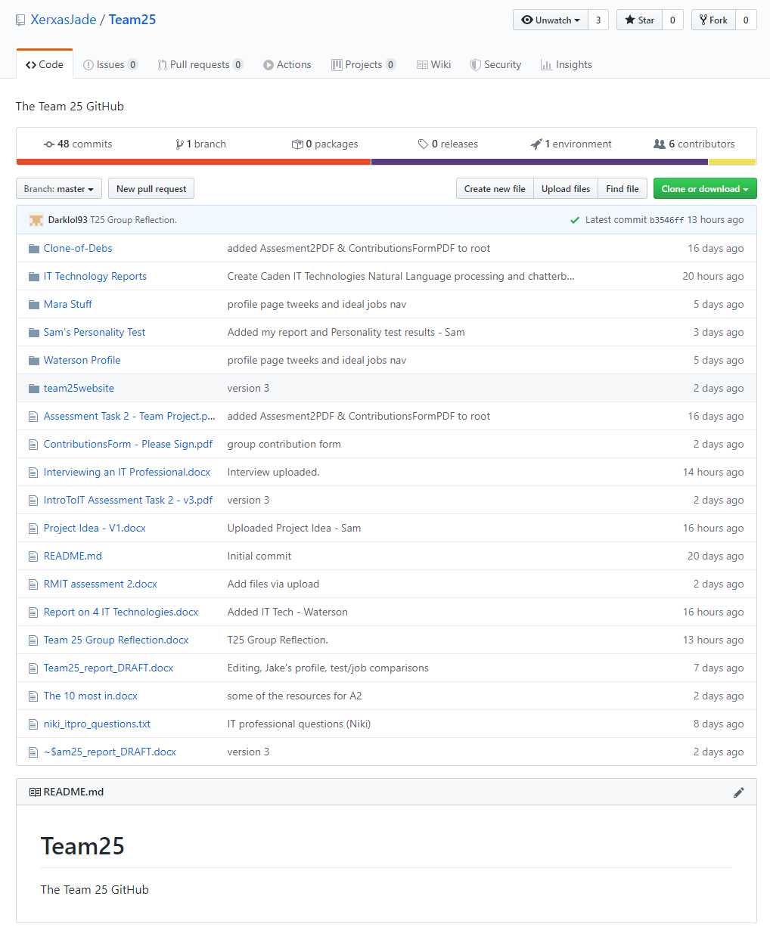

A [GitHub](https://github.com/XerxasJade/Team25) repository was set up to facilitate the team website and act as the repository for our work. Tamara initiated the repository on our behalf, and for the weeks of our assignment it has been seeing regular updates as we made progress. We have found it suitable for tracking our continuing progress, although we were still generally new to the concepts of GitHub.

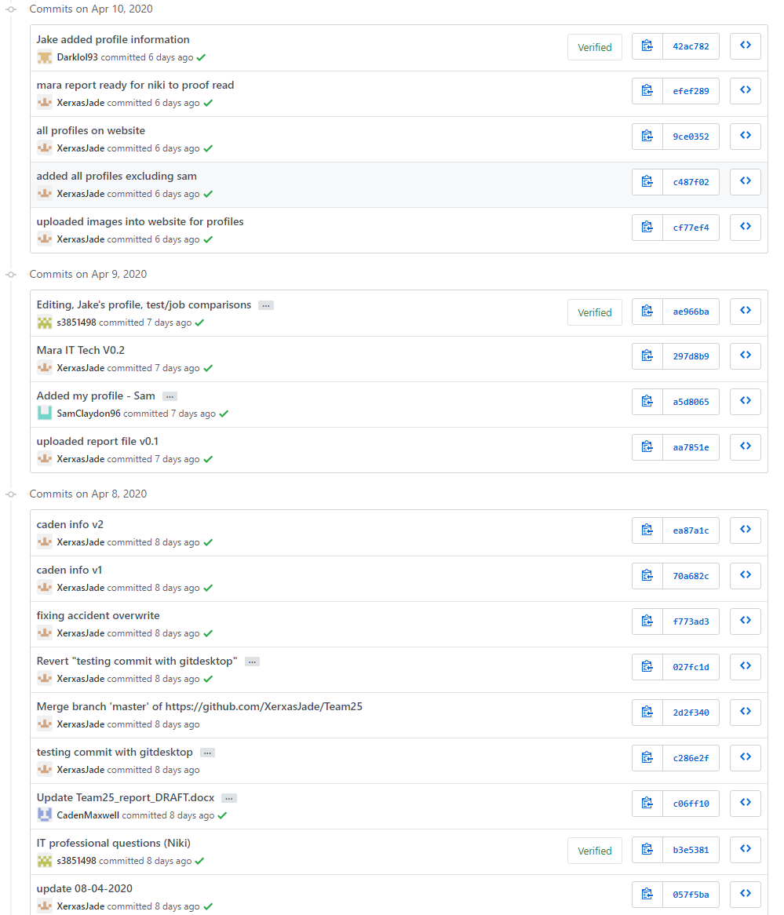

The history of commits was useful motivationally, as it could demonstrate visibly the progress we were making. It was also appreciably helping us all become more acclimated to the GitHub environment, considering many of our ideal jobs would be utilising it in the future.

While we do not believe any of us are able to use GitHub to its full potential, we did agree that it will be very helpful knowledge to us in the long run.

# Credits

Niki Arrogante – s3851498 – Report Editor/Designer, Organiser

Debborah Bryce – s3853719 – Industry Data Researcher, Head of Project Concept

Tamara Brice – s3851505 - Cybersecurity Researcher, Website Manager

Samuel Claydon – s3857563 - Cloud Researcher, Project Idea Writer

Caden Maxwell – s3853897 – NLP/Chatterbot Researcher

Jake Waterson – s3857894 - Interviewer, RPA Researcher, Meeting Manager