1. User Group Profile
Who they are
Our app is for active-duty service members, U.S. veterans, and their families using the post-9/11 GI Bill to attend college. Veterans are often older than traditional students (mid-20s to late 30s), many are first-generation students, and most balance family or jobs with their studies.
Problems they face
- Lost credits when moving: Deployments or relocations often mean transferring schools, and credits don’t always carry over.
- Complicated benefits: The GI Bill, Yellow Ribbon, and Tuition Assistance are hard to navigate, and campus advisors are not always trained.
- Feeling isolated: Veterans sometimes feel out of place among younger students.
Habits
- Use VA.gov, TA DECIDE, and ArmyIgnitED for official benefit info.
- Check ACE Military Guide or Transferology to see how credits transfer.
- Seek peer advice on Reddit or veteran student associations.

2. Market Size & Opportunity
Total Beneficiaries
- In FY2024, 573,732 people used the post-9/11 GI Bill for education and training
- Across all VA education programs, the total number of beneficiaries was 901,463
- The VA spent $9.65 billion on post-9/11 GI Bill benefits in FY2024
Veterans in higher education
- Veterans make up around 3.7–5% of U.S. undergraduates (PNPI, 2023).
Opportunity
This large market shows demand for better tools that:
- Protect credits during school transfers.
- Help plan and combine GI Bill, TA, and Yellow Ribbon benefits.
- Adjust degree plans around deployments and relocations.

3. Competitor Analysis
Competitor | Strengths | Gaps
TA DECIDE (DoD) | Reliable, official tool to compare schools, costs, and outcomes. | Doesn’t cover credit transfers or deployment planning.
ArmyIgnitED | Helps service members manage Tuition Assistance and degree plans. | Mainly a records system, not a planning or advising app.
ACE Military Guide | Standard resource for turning military training into credits. | It doesn’t connect with VA benefits or degree planning.
Takeaway: Current tools are fragmented. No single app combines credits, benefits, and flexible planning into one solution.

4. Unique Value Proposition (UVP)
“Helping veterans and service members finish what they start.”
Our app is unique because it:
- Simplifies credit transfer by automatically showing how training and past classes apply to degrees.
- Optimize benefits by guiding veterans on the smartest use of GI Bill, Yellow Ribbon, and TA together.
- Offers flexible planning so students can pause, restart, or transfer without losing progress.
- Supports veterans directly with reminders, checklists, and easy-to-follow instructions.
Unlike current databases, our app acts like a personal guide to finishing a degree without wasted effort.

5. Visualization
To show the importance of veteran programs, here is a chart of federal spending by departments in FY2024. The Department of Veterans Affairs accounted for 4.8% of all federal spending, highlighting the scale of investment in veteran support:
This spending power demonstrates the size of the opportunity for tools that help veterans and their families maximize education benefits.
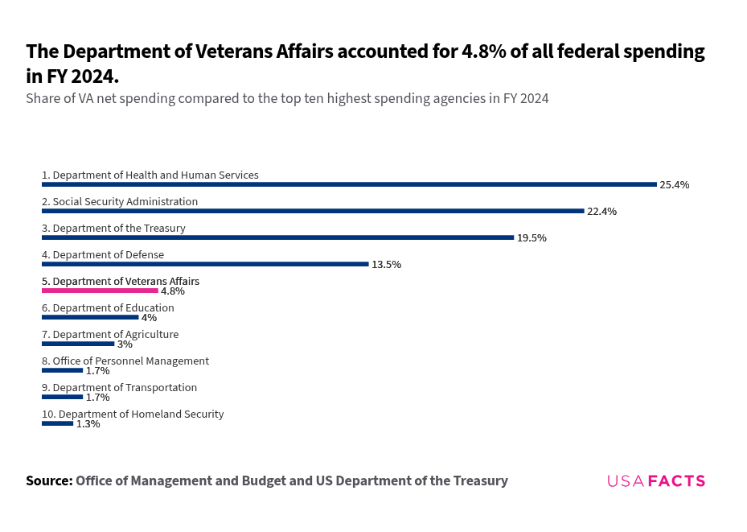

6. AI Use Section
Tools used
- ChatGPT (to draft, simplify, and organize content).
- Web searches of VA reports, PNPI fact sheets, and AIR studies.
Prompts used
- “How many people used the post-9/11 GI Bill in FY2024?”
- “What share of undergraduates are veterans?”
- “Summarize TA DECIDE, ArmyIgnitED, and ACE Military Guide.”
Fact-checking
- Numbers verified with VA FY2024 Annual Benefits Report.
- Veteran undergraduate share cross-checked with PNPI (2023).
- Competitor details checked with official DoD, Army, and ACE sites.

References
- U.S. Department of Veterans Affairs, Annual Benefits Report FY2024.
- Postsecondary National Policy Institute (PNPI), Veterans in Higher Education Fact Sheet, 2023.
- American Institutes for Research, Study on Post-9/11 GI Bill Benefit Use, 2024.
- Department of Defense, TA DECIDE program details.
- ArmyIgnitED portal and support guides.
- American Council on Education, Military Guide.

