|  |
| --- |
| Eastern Oregon University |
| Herbicide Calculator |
| Design Document |

|  |
| --- |
| Caden Ricker  4-3-2022 |

Contents

1 Design Specification 3

1.1 UI Layouts 3

1.1.1 Field and Spray Information Form 3

1.1.2 Crop Input Form 4

1.1.3 Weed Input Form 4

1.1.4 Spray Selection Screen 5

1.1.5 Result Screen 5

1.1.6 Supplier Login Form 6

1.1.7 New Herbicide Form 7

1.2 Development Plan 8

1.3 Design 8

1.3.1 ER Diagram for the Database 8

1.3.2 Sequence Diagrams 8

# Design Specification

## UI Layouts

### Field and Spray Information Form

This form has three numeric inputs and a button to advance the step. The numeric inputs are for the following:

1. For the area of the field in acres
2. For the size of the tank on the sprayer.
3. For the rate at which the sprayer outputs spray in gallons per acre.

The next button advances the user to the Crop Input Form after information has been added.

### Crop Input Form

This screen can have a single to many text-entry boxes for the crops. Each box will hold one weed name and has a searchable drop-down list. The add another button will display another box and appear under the next text entry box. The next button advances the user to the Weed Input Form after information has been added.

### Weed Input Form

This screen can have a single to many text-entry boxes for the weeds. Each box will hold one weed name. The add another button will display another box and appear under the next text entry box. and has a searchable drop-down list. The next button advances the user to the Spray Selection Form after information has been added.

### Spray Selection Form

This screen will display a table with the suggested sprays, their application rate, projected cost of spay, the weeds it will be effective on and effectiveness rating. Each row is selectable and will advance the user to the next screen which will display a report for the spray.

### Result Screen

This screen will be a field of text that reports the information the user needs.

### Supplier Login Form

This screen has a text input for username and password. It has a button for submitting the form.

### New Herbicide Form

Each crop has a text field for crop name and a number field for Pints Per Acre. Each weed has a text field for weed name and a number input for the effectiveness rating. Both crop and weeds have a button that will display more fields. There is also a field for uploading files instead of filling out the form.

## Development Plan

The first step is getting ubuntu set up with Flask, MySQL, GitHub, and other applications. My next step is getting the Flask server running and displaying html. Then I will need to create the database for the application and define the tables. I will then research for data for my application and streamline inputting the data into the database using python and MySQL. Once the database has enough data, I will begin creating the queries to find the data the user needs. I will create the .html pages according to the UI layouts. Then I will write Python code to put the data from the database into the .html pages.

## Design

### ER Diagram for the Database

### Sequence Diagrams

#### User

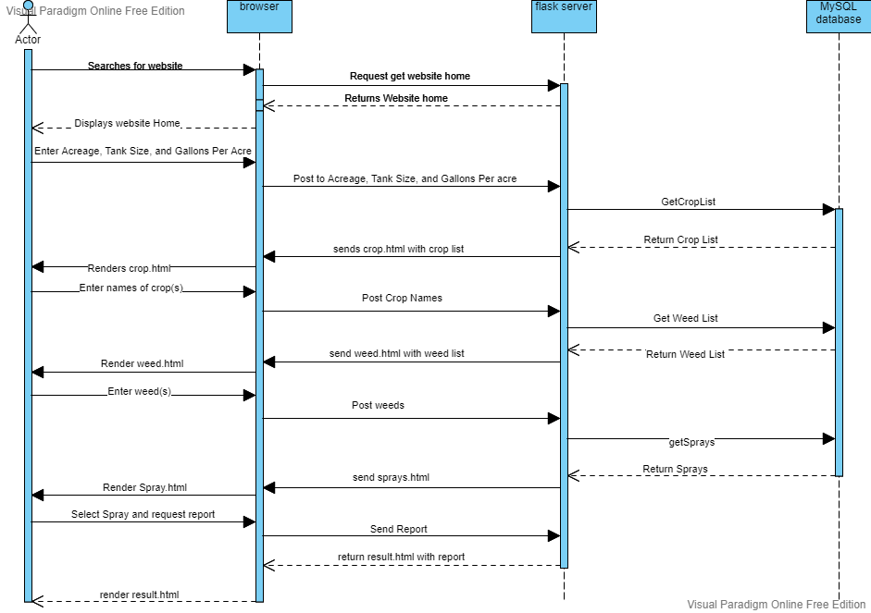

#### Diagram Description automatically generatedSalesmen or Admin