Meeting with Client (Leanne) to demonstrate prototype and discuss progress 27/10/14

* Discussed new method for tagging ingredients in a meal
* Walked Leanne through updated prototype
* Discussed how application database will be updated and pushed to users’ devices
* Discussed the format that data is saved in
* Discussed the ability to constantly update data
* Showed Leanne the newly added search function for adding and removing ingredients
* Discussed application Icon, Leanne recommended a camera on a plate instead of the company’s logo that is currently in place
* Discussed home screen design of application, types of photos or images to be used
* Walked through each page and discussed the aesthetics
* Discussed how final ORAC rating is displayed, whether rating should be percentage or ORAC score
* Added functionality to review a captured meal and how each ingredient contributes to the final score
* Final App name: Rate My Plate
* Black:#000000
* Blue:#263248
* Grey:#7E8AA2
* White:#FFFFFF
* Orange:#FF9800



Pictures from the meeting

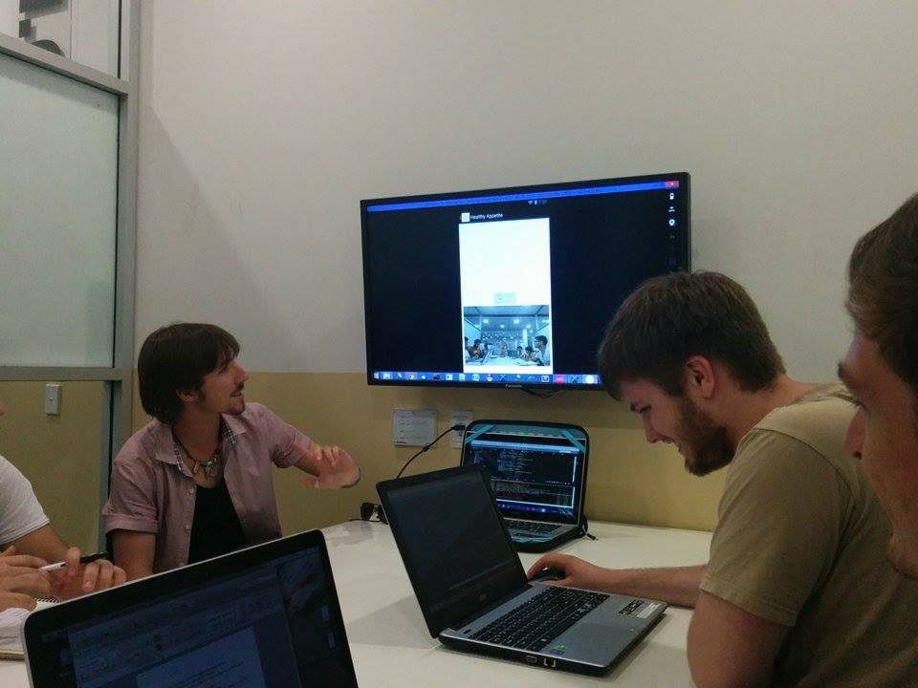

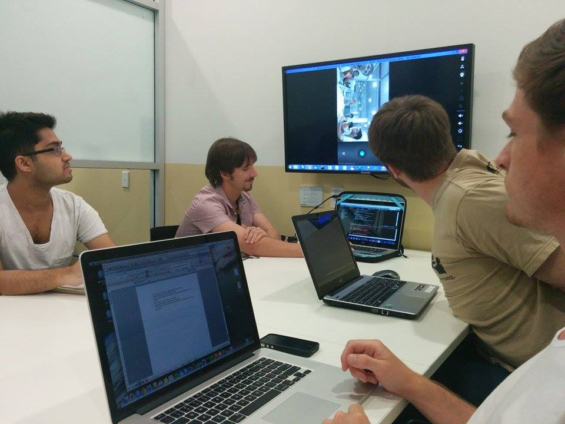

Testing the camera app works within main application

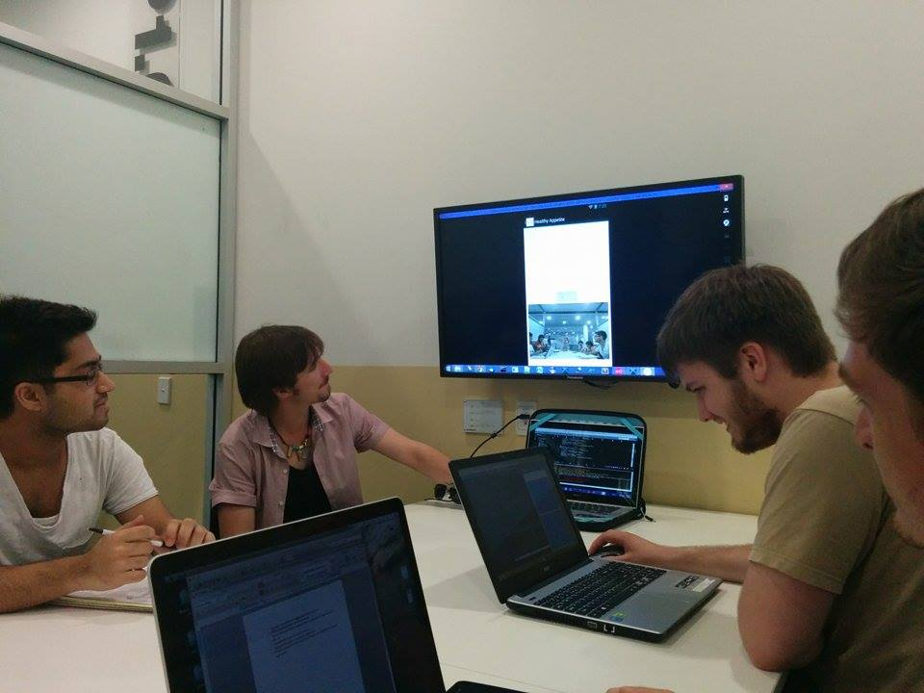

Working out a picture we need for the application button, Leanne’s sons playing on the laptop in the background.

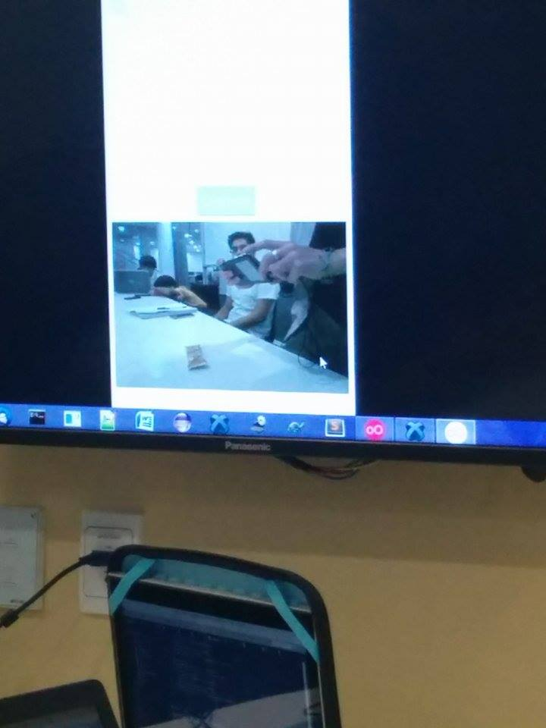

Ingredient tagging page, bit buggy but almost %100 functional

